S/4HANA Configuration Case
Phase II – Scenario
In this second phase, a basic procurement process is implemented in S/4HANA according to Global Bike specifications. Enterprise structures and business processes are set up in the SAP system, master data is loaded and the end-to-end process is tested.

Product  S/4HANA 2020  Global Bike  GUI 7.70  Level  Intermediate  Advanced  Focus  ERP Configuration  Materials Management  Authors  Simha Magal  Stefan Weidner  Version  4.1  Last Update  November 2023 | MOTIVATION  After Global Bike has approved and kicked off the implementation project with phase I (financial accounting) the next process is procurement within the Materials Management module of S/4HANA.  Similar to phase I, conversations between GBI employees help you understand current issues in the organization and existing systems. |  | PREREQUISITES  It is highly recommended to have worked through phase 0 of the S/4HANA Configuration Case in order to relate the ERP implementation of Procurement to real tasks in GBI and their mapping to S/4HANA processes. It is also recommended to complete the Introduction to S/4HANA using Global Bike curriculum material for the MM module (chapter 5).  NOTES  This case study uses the Global Bike data set which has been created for SAP UA global curricula exclusively.  ACKNOWLEDGEMENT  This case study was prepared with the assistance of student interns at the Seidman ERP program at Grand Valley State University and research assistants at SAP UCC Magdeburg.

Step 1: Introduction to Global Bike Configuration Case
Learning Objective Understand objective and structure of ERP configuration case. Time 15 min
Overall Case Objective The ERP configuration case intends to develop a basic understanding of ERP implementation projects based on a comprehensive scenario in a fictitious mid-size company (Global Bike). Based on theoretical concepts taught in lectures, the case provides real-life conversations within and across Global Bike departments for students to identify and analyze problems in business processes in order to derive possible solutions. After the best solution has been selected, it is configured in the S/4HANA system.
Overall Case Structure As visualized in the graphic below, the introductory part (Phase 0) of the ERP Configuration Case is independent of any specific ERP solution and any functional module. It consists of a case study document and lecturer notes.
The subsequent phases focus on ERP configuration tasks for specific functional areas such as Financial Accounting, Procurement and Fulfillment. They are executed in a particular S/4HANA module like FI (Finance), MM (Materials Management) and SD (Sales and Distribution).
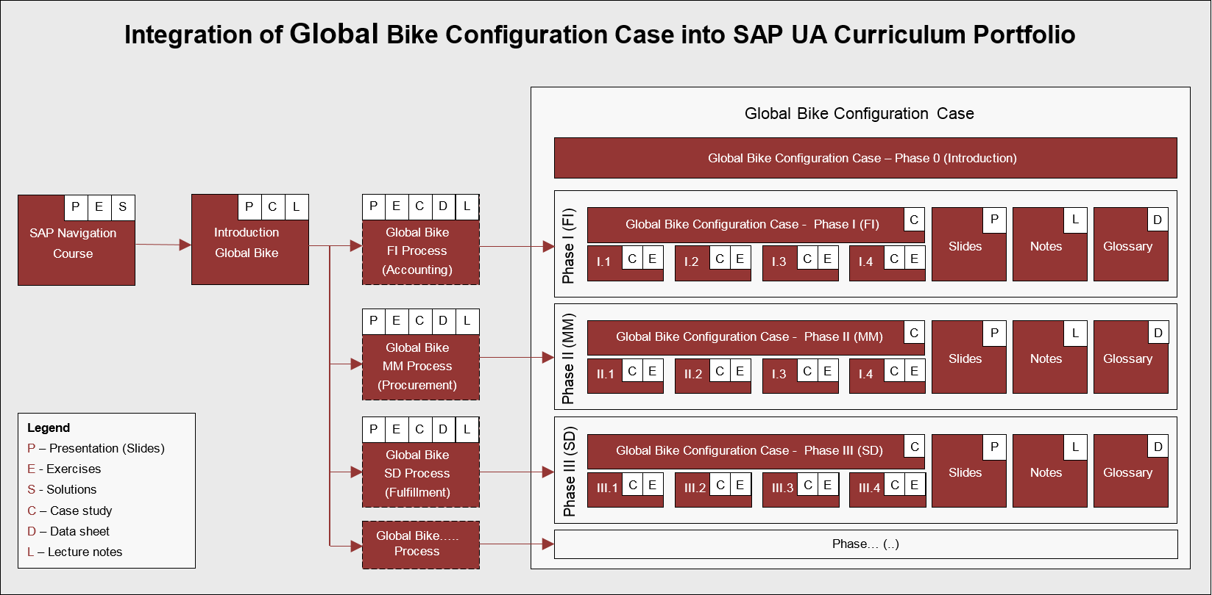
Other than Phase 0 for which no prerequisites are necessary before you start with the actual configuration phases, you should have had previous exposure to the S/4HANA system and ERP process execution (presentations, exercises and case studies), preferably using the Global Bike dataset.
All phases except the introduction follow the same structure (as shown in the detailed graphic below): phase-specific scenario (case study), handbook (exercises) and a glossary (data sheet) together with slides and lecturer notes.
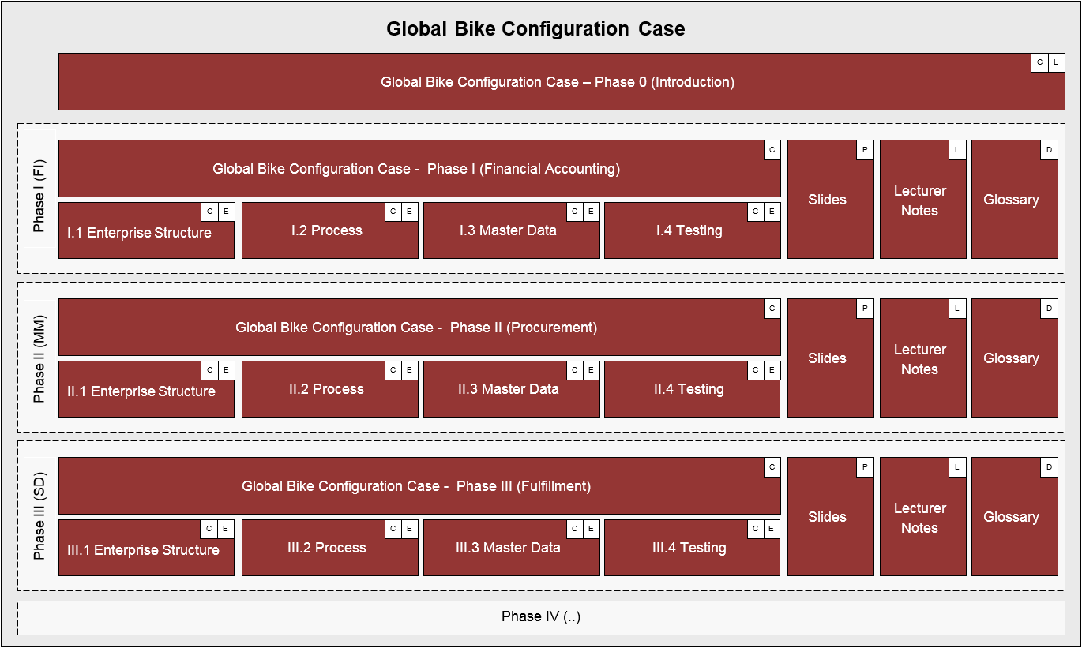
Case Study Objective Whether or not you already have previous ERP knowledge or practical experience, an introduction to the company’s organizational structures as well as its business processes is necessary. Thus, it is recommended, but not mandatory to go through the introductory case study (Phase 0) which helps develop scenario analysis, critical thinking and project planning skills in the ERP implementation domain.
This second implementation case study (Phase II) starts with the basic implementation of Procurement in a S/4HANA system in order for you to understand the implications of purchase business activities. By doing so, you will acquire the following skills:
- ERP proficiency, e.g. What is a plant in an S/4HANA system?
- ERP configuration skills, e.g. How to create a new organizational unit in an S/4HANA system?
- Project-driven and scenario-based integration of tasks in complex environments, e.g. Why do we need to assign a plant to a company code in S/4HANA?
Case Study Structure This case study is structured in 5 steps as visualized below. Similar to phase I, it presents a realistic scenario between different Global Bike departments for which all issues, problems and a reference solution need to be found (Steps 2 to 4).
Similar to phase I, this case study provides a detailed description of how to implement units and a procurement process in the S/4HANA system. In order to help you understand different aspects and degrees of detail throughout the case study, three separate documents were created.
The scenario (this case study document) guides you through the overall learning process along realistic project steps (here steps 2 to 4). It refers to two other documents; the handbook and the glossary. The handbook consists of a sequence of interdependent tasks to configure the S/4HANA system, to add master data and to test the business process, in this case Procurement. In order to keep the scenario document lean, all common or technical definitions were compiled into one glossary document which can be used as a reference guide.

 | Step 2: Scenario Analysis
Task Read the scenario and highlight the most important and relevant Time 45 min information.
Short Description Read through the scenario and critically analyze the challenges employees are facing in this unit. Focus particularly on the core statements during the conversation.
Name (Position) Silvia Cassano (Accountant Payable Specialist GBI US)
Ricardo Robles (Warehouse Supervisor)
Jermain Kumins (Shop Floor Worker 1)
Units involved Accounting GBI US, Warehouse Dallas
Before you start analyzing the Procurement scenario, you should be familiar with the overall company structure and know the gaps that exist in the organizational units prior to this implementation process. Thus, it is recommended to have read and understood the Global Bike story document (see Phase 0 Step 2). You may skip this step if you have already used other GBI curricula and feel that you are well informed about the company. |  | Global Bike Inc.
Silvia Cassano (Accountant Payable GBI US) starts working on sorting the next document about the 30 black frames of the Dallas warehouse. She grabs the G/R document which she had received from MM in her inter-mail and starts processing the financial document in the system.  Silvia realizes that in order for her to create the FI document in the system she needs to know the $ value of the ordered material and the quantity of the material movement in question. As the quantity is listed on the G/R document she only needs the $ value to proceed.  Although Financial Accounting is already implemented in S/4HANA, she cannot access any MM documents (Purch.Req., Purch.Order, G/R document). Thus, she cannot find the $ value of this purchase process on her own.  The only way for her to get this information is by calling Ricardo again to find out the $ value of the frames listed on the PO document.  Here is what happened during the phone conversation: |  | Scenario setting I
SILVIA  “Hello Ricardo, this is Silvia from Accounting. Here we go again, this time I need information about a purchase order of 30 frames. I wonder if you could quickly look it up” |  | Silvia Cassano  [Accounts Payable]
RICARDO  “Hey Silvia!! Good to hear from you. Sure I do have time for you; I’ll do anything for accounting to keep the books clean.” |  | Ricardo Robles  [Warehouse Supervisor]
RICARDO [Laughing with sarcasm]
“Gimme the G/R number” [(slang.) gimme = give me]
SILVIA [Rolling up her eyes and laughs in response out of courtesy]
“Great, thank you. Here is the number: 5-0-0-0-0-3-5-7-3”
RICARDO
“Okay. Got it. The system is taking its time, it is slow today. While we are waiting for the system to respond, I am wondering why you have to call me to get the purchase prices all the time. Aren’t you the department dealing with $ values! I am just the warehouse guy. Don’t you have a system telling you my answers?”
SILVIA
“Good point! Unfortunately, I have no access to any work done on your end, with $ amounts or not! For example; in this case purchasing of 30 black frames, I can only see the quantity on the G/R slip, but not the $ value.”
RICARDO
“Man oh man! So, that’s why you are bugging me every time we purchase material, you need to find out the price of the goods purchased before you can pay the vendors; this is bizarre!”
SILVIA
“Yes, it is frustrating for both of us. Back in college, in basic accounting they had already taught us the synchronization of data across departments, so that I would see what you do.”
RICARDO
“Whatever. I do not like to be watched, you know! In any case, if this implies you don't call me constantly; then, perhaps I like it. But, back to reality. Here we have a display. Ok, what do you need to know?”
SILVIA
“I need the $ value for the 30 black bike frames received at Dallas Warehouse. How much is the value per frame?”
RICARDO [staring at the computer screen]
“Ok, the value of black bike frames, let’s see. [Mumbling to himself] Where is the purchase order?”
Right in the middle of the phone conversation Ricardo gets distracted by Jermain. The warehouse just received new inventory of women’s bike frames and Jermain needs to know from Ricardo where to put it.
JERMAIN  “Hey Rick, where do you want these women bike frames to go. Just  got‘em in.” [(slang.) ’em = them] |  | Jermain Kumins  [Shop floor worker]
RICARDO
“Hold on, Silvia. [covering the receiver with his hand and yelling at Jermain] Can’t you see I am on the phone?”
JERMAIN
“Sorry boss, wondering where you want me to put these women bike frames we just got? Keep’em all or ship’em to production?”
RICARDO
“Hmm, women bike frames, I need to check in the system. Wait a second, Jermain. [back to Silvia on the phone] Hi Silvia, I have to put you on a quick hold while trying to get this information for you okay, just hold please.” [Ricardo puts the receiver down]
Ricardo continues on the same screen. However, instead of putting in the black frames request he enters the material number of women frames to look up the purchase order for Jermain. The system displays the order for 30 women frames.
RICARDO
“Okay, Jermain, here is the order. These women frames can go to storage, ‘cause they are for next week’s assembly.”
JERMAIN
“Okay, thanks Boss!”
Ricardo feels rushed to answer Silvia who has been on hold for a while. So he quickly navigates to the line item and reads the dollar value of the 30 frames. Then, he grabs the phone again to give her the information.
RICARDO
“Okay Silvia, thanks for holding; I have an answer for you and the value is $90.00 per frame.”
SILVIA [writes the amount down]
“No problem. I got some things done in between. Great thank you, I appreciate it. Have a good day. Bye.”
RICARDO
“Bye bye now.”
So Silvia goes on with her job and starts processing the financial document. She calculates $90.00 x 30 bike frames and posts the financial document in the amount of $2,700.00. She was happy and impressed that this time getting information from Ricardo went smooth.
A few days later Silvia receives an invoice from the supplier for the 30 black frames in the amount of $6,000.00. She is shocked and surprised by the amount.
SILVIA [talking out loud to herself]
“Didn’t I create the financial document for the 30 black frames in the amount of $2,700.00? Where do I have it? [she starts looking for the financial document] Oh! Here it is.” [she starts comparing the invoice against the financial document and finds the discrepancy]
SILVIA [talking to herself]
"See, it was in the amount of $2,700.00, but this invoice is not! What the heck happened? I guess I have to call Ricardo again in this case.”
Silvia grabs the phone and dials Ricardo’s number.
SILVIA
“Hello Ricardo, this is Silvia from accounting; I need a minute of your time to go over the purchase of the 30 black frames again please.”
RICARDO
“Hey Silvia, always happy and good to hear from Ya. What is it today?” [(slang) Ya = you]
SILVIA
“Well, a couple of days ago I called you about the black frames and you quoted me a price of $90.00 per frame. Today, I receive the invoice from the supplier and the total value of the invoice is $6,000.00 which means, if I am doing the math right, the price per frame is $200.00 and not 90.00. Why are they overcharging?”
RICARDO
“Well, let’s look in the system and see what price our Purchasing agreed upon with the vendor. I am not involved in pricing. Hold on, let me check… Okay, black frames, right… system is slow again. Okay, here we go. The price is $200.00 per frame. Yup, the supplier’s invoice is right; each frame’s value is $200.00. Looks like you can go ahead and pay the invoice. Back at ya.”
SILVIA
“No, we cannot go ahead. We have a discrepancy in the books. You told me on Monday the value per bike is $90.00 and therefore I totaled the financial document for $2,700. Now we have a $6000 invoice; this is a $3,300 difference! We are talking money here not peanuts.”
RICARDO [puzzled]
“Well, I am clueless! I see $200.00. Maybe you got it mixed up with another purchase order? “
SILVIA
“I am sure you said $90.00 per frame. I don’t make mistakes.”
RICARDO
“Well, we only purchase three types of frames: Men’s, women’s and touring bike frames. If I am not mistaken, touring frames were always around the $200 range. Only the off-road frames are cheaper.”
SILVIA
“I don’t know! These mix-up’s always happen. Why can’t we all see the same data in one place? If I could just look up the purchase orders myself then I would not need to call you on things that you did not put into the system yourself.”

 | Step 3: Problem Identification
Task Revisit the reference symptoms/issues and condense them to the problems Time 30 min
specific to this case.
Short Description You (in the role Mona Falco) need to come to a clear understanding of the most relevant symptoms in Procurement in order to identify the causes and underlying problems including the issue of invoice discrepancy.
Name (Position) Bianca Cavarini (Chief Information Officer)
Mona Falco (System Design and Development Manager)
Following phase I, where Bianca Cavarini and Mona Falco helped implement Financial Accounting in S/4HANA, they have now moved on to the purchasing department. Bianca has given Mona the task to start analyzing the procurement processes in detail (project phase II).  Based on the reference highlights from the scenario in step 2 (listed below), identify together with your peers symptoms, causes and effects in GBI’s Materials Management and Financial Accounting units. |  | Scenario setting
- The A/P individual has to create a financial document in the system for 30 touring black frames based on the G/R document received from Dallas Warehouse. |  | Reference symptoms and issues
- There exists a problem when posting the financial document in the system. The material quantity is listed on the G/R document but not the price of the frames. Because the financial accounting system and the material management system are not linked the A/P individual has no access to this or any other MM information in the system.
- The warehouse administrator gets distracted during the conversation and has to answer to another request about women’s frame bikes but still manages to quote A/P individual the price of black touring frames ($90 per frame).
- A/P individual posts the financial document in the system for the amount of $2,700.00. However, a few days later the invoice arrives from the supplier in the amount of $6,000.00. A total discrepancy of $3,300.00!
- The A/P clerk is frustrated by multiple phone calls to warehouse unit and tedious data entry and correction.

 | Step 4: Problem Analysis / Solution Finding
Task Revisit the reference problems and identify possible solutions for Global Time 30 min Bike.
Short Description In the role of Mona Falco (System Design and Dev Manager) and Sarah Garcia (Business Analyst 2), analyse all relevant problems in Purchasing and Accounting and find possible solutions.
Name (Position) Mona Falco (System Design and Development Manager)
Sarah Garcia (Business Analyst 2)
Mona Falco and Sarah Garcia’s (Business Analyst) task is to revisit the problems and come up with a detailed structure for this project phase.  Based on the reference problems you identified in Step 3 (listed below), track, together with your peers, the connection between these symptoms across the Materials Management unit, identify the source of each issue and its effects. |  | Scenario setting
Symptoms  - The A/P representative cannot access information in material management and needs to make multiple phone calls to check on the price of 30 black touring frames in order to produce the financial document in the system. During the manual exchange of information, the warehouse administrator quoted the price inaccurately to the A/P clerk. The financial document is posted for $2,700.00. The problems escalate when the supplier sends an invoice asking for $6000.00. |  | Reference problems
Particular effect
- Discrepancies in financial accounting system lead to a cost increase as extra tedious manual work is needed to rectify the error. Inefficiencies happen due to long waiting times to get the information. Communication and lack of coordination of information make the exchange of data vulnerable and prone to human error which affect accuracies of data.
Underlying cause/problem
- Lack of system integration means disaggregated processes between organizations to simplify/control the procure-to-pay cycle as well as the automated integration to FI;
- Disaggregated system leads to the following:
  - Longer times to get information increase inefficiency
  - Increases cost of processing due to increase of manual management to process financial documentation in the system.
  - Hinders transparency of data across organizational units where applicable
Corporate effect
- Lack of org. unit and management integration/communication leads to
  - Ineffectiveness
  - Cost increase
  - Double effort in data entry and manual correction of documents
  - No real-time visibility and transparency of data
- Ineffective work procedures induce hidden costs due to increased processing cycle time on both operational and managerial level, e.g. higher personnel cost etc.
- Isolation of data (processing) results in overall incorrect/unreliable data which may lead to incompetent decisions eventually affecting cash flow negatively.
- Incorrect/unreliable data prevents interpretation to meaningful information
- Without meaningful information on past/present business transactions no accurate forecasting is possible

 | Step 5: Implementation Phase II
Task Revisit the reference solution and come up with a concrete implementation Time 10 min plan.
Short Description Mona Falco and Sarah Garcia are called upon to define the scope of implementing S/4HANA for Purchasing at Global Bike. Therefore, in this phase they need to structure the project by defining steps and milestones.
Name (Position) Mona Falco (System Design and Development Manager)
Sarah Garcia (Business Analyst 2)
After the Global Bike executive board has selected the S/4HANA solution and after Financial Accounting has been implemented successfully in Phase I the Procurement module was chosen as the next project. As for the first project, the US company is set up first (with Germany following later).  Based on the results of steps 2 to 4 and the reference solution (find below) this document presents the detailed project scenario. It offers links to the handbook with particular configuration steps in the S/4HANA system. Although optional, it is highly recommended to do these exercises to gain hands-on work experience in a live system. Please refer to the glossary for detailed definitions of terms that are frequently used in this case study. |  |  | Scenario setting  Handbook  for Glossary
Overall solution  The benefits of implementing an ERP system for Procurement are:  - Increase efficiency by streamlining and partially/fully automating end-to-end procurement process from purchase requisition and ending with a ready-to pay invoice.  - Save time because it enables suppliers to submit their invoices directly to the unit responsible for invoice verification.  - Seamlessly integrate between purchasing and accounting units, here: verification and payment of vendor invoice.  - Increase transparency by monitoring the process cycle in real-time and hence improve communication between departments.  - Make informed decisions and produce more reliable forecasts based on one integrated reliable data source (realize saving opportunities, reduce cost of inventory etc.). |  |  | Reference solution
This partial ERP implementation will be configured in the below order.  Process  Configuration  Master Data  Process  Execution  Enterprise Structure |  |  | Project structure
 |  | Phase 2.1 – Enterprise Structure
Task Define the Global Bike enterprise structure for Materials Management and Time 30 min
prepare its configuration in the S/4HANA system.
Short Description Review Global Bike’s organizational structure and identify all relevant organizational units in Procurement. Then, map them to the organizational units in S/4HANA.
Name (Position) Mona Falco (System Design and Development Manager)
Sarah Garcia (Business Analyst 2)
Global Bike operates (produces, procures, and sells) in two regions: the US and Germany. Global Bike Inc. in the US has three plants: one production facility in Dallas and two distribution centers in Miami and San Diego. Whereas Dallas stores raw materials, semi-finished goods, and finished goods, Miami and San Diego manage stocks for trading goods and finished goods. All three locations have additional storage space for miscellaneous materials. In Germany, Global Bike operates a manufacturing facility in Heidelberg and a distribution center in Hamburg with analogous storage spaces to the plant types in the States. |  |  |  | Scenario setting
Global Bike plans and controls procurement both on global and regional level. Due to its high-quality end products, raw materials can be sourced from strategic suppliers in the US and in Germany at any time. In contrast, trading goods are only procured from local vendors. Those purchase orders are managed by local teams in the US and Germany for their respective plant locations.
When setting up an enterprise in S/4HANA, the largest organizational unit beneath the system itself is the client. Within the client, one or many company codes can be set up to represent financially independent subsidiaries. From all accounting organizational units configured during phase I, the three elements mentioned above are the foundation for the organizational structure for SAP logistical processes. |  |  |  | S/4HANA terminology
The three modules in S/4HANA that are closely related to Logistics are SD (Sales and Distribution), MM (Materials Management) and PP (Production Planning). Global Bike decided to start with the procurement function which is part of MM.
A plant in S/4HANA can have multiple functions including purchasing, manufacturing, distribution, and maintenance. One or many plants can be assigned to one company code. Storage locations are places in a plant where materials are stored and usually represent areas designated for different types of material such as raw materials and finished goods. A plant must have at least one storage location.
The first organizational unit specifically used in the procurement process is the purchasing organization. It organizes vendor selection, negotiates general conditions of purchase and contracts for one or more plants, and determines pricing conditions. In the S/4HANA system, there exist three types of purchasing organizations:
- Enterprise-Level (assigned to plant)
- Company-Level (assigned to plant and one company code)
- Plant-Level (assigned to plant and its company code)
A purchasing group represents a buyer or a group of buyers. As it is not assigned to any purchasing organization, it is only relevant for purchasing statistics and reporting.
After Mona and Sarah analyzed and modeled Global Bike’s organizational structure and made themselves familiar with the SAP terminology, they are now in the process of linking both worlds in order to start the integration process. Again, for this part of the implementation project Mona and Sarah were asked to focus on the US region. |  |  |  | Linking Global Bike to SAP terminology
The client that was set up in phase I represents the Global Bike enterprise. Company code US00 links all business transactions (e.g. purchase orders in this context) to financial accounting and is, for that reason, often mentioned in organizational charts for materials management as well.
For their operations, Global Bike would need to implement a total of five global locations in the SAP system. Because the project focus lies on the US exclusively, plants need to be created for Dallas, Miami, and San Diego only. Storage locations will be implemented according to Mona’s and Sarah’s list. One global purchasing organization (for raw materials) and two regional ones (for trading goods) with their respective purchasing groups will be defined in the new system.
GBI organizational chart
Logistics
Next, all organizational units identified above (including the procurement-specific organizational elements) are integrated in one model. In addition, each unit is given an alphanumerical ID.
As you can see all numbers for logistics units in the SAP system (except for client and purchasing group) have four unique characters. The first two characters are always mnemonic and describe the unit, e.g. GL for global. The last two digits are used for numbering purposes (not in this document).
Organizational chart
S/4HANA
Global Bike Logistics

GL00 Global RM00 Raw Materials  US00 US SF00 Semi-Finished Goods  DE00 Deutschland/Germany FG00 Finished Goods  DL00 Dallas MI00 Miscellaneous  MI00 Miami TG00 Trading Goods  SD00 San Diego N00 North America  HD00 Heidelberg E00 Europe  HH00 Hamburg |  |  |  | Legend
As displayed in the graphic above the client forms the framework for all other Global Bike organizational units. According to the GBI story and the results of the phase I sub-project (Financial Accounting), company codes are defined for financially independent units in the US and in Germany. From the logistics perspective, all five plants as well as their respective storage location types have been added to the chart. For procurement operations, one global and two regional purchasing organzations together with their purchasing groups were identified.
Now that Sarah Garcia has recorded the organizational structure for GBI‘s procurement department and mapped it to SAP terminology, she presents the results in her next meeting with the external consulting team. The SAP Logistics consultant approves the blueprint after verification. Now, the first configuration steps are agreed upon and can be executed in the S/4HANA system.
[Optional] If you have access to an S/4HANA system with the Global Bike dataset you may now ask your instructor for login details, open the handbook and go through the tasks listed below.  - Introduction Phase II – Procurement  - General Notes and Cautions  - Phase II.1 – Enterprise Structure  - Tasks II.1.1 to II.1.4 (Definition)  - Tasks II.1.5 to II.1.8 (Assignment) |  |  |  | Handbook  [Time: 70 min]

 | Phase 2.2 – Process Configuration
Task Configure business processes for Procurement in the S/4HANA system. Time 15 min
Short Description Get familiar with basic S/4HANA process configuration settings for Procurement, define the values for GBI and make the changes in the system.
Name (Position) Mona Falco (System Design and Development Manager)
Sarah Garcia (Business Analyst 2)
[external] (Senior SAP Logistics consultant)
After defining the enterprise structure for procurement in the ERP system, the project team is now revisiting the problems identified in the preparation phase and configuring the ERP system to avoid the lack of integration between procurement and financial accounting. |  | Scenario setting
The first step is to configure the material ledger types for the respective valuation area. Valuation of materials could be done at plant or company code level. In this particular case, materials are valuated at company code level.  This task ensures that the currencies and valuations for the materials used in the procurement process are managed in the S/4HANA system. It includes assigning and activating material ledger types to valuation areas as well as setting valuation areas as productive. |  | Material Ledger Types  Valuation Area
[Optional] Log back on to the S/4HANA system, open the handbook and go through the tasks listed below.  - Tasks II.2.1 to II.2.3 |  | Handbook  [Time: 15 min]
Next, step is to configure tax handling in the procurement process, e.g., how many tax amounts and tax codes the system allows during invoice verification. It includes the setup for automatic posting to G/L accounts for sales taxes and the definition of default values for tax codes. |  | Tax handling
A complex, but important configuration step is the G/L posting automation. Here, the integration between procurement and financial accounting is technically implemented by assigning the correct G/L accounts to all purchasing-related procedures such as inventory posting, price differences, or GR/IR clearing. |  | Automatic posting
[Optional] Log back on to the S/4HANA system, open the handbook and go through the tasks listed below.  - Tasks II.2.4 to II.2.7 |  | Handbook  [Time: 40 min]
The next procurement-related configuration step in the ERP system is the setting of tolerance limit for price variances in purchase orders, goods receipts, invoices, and outgoing payments. |  | Tolerance limits
[Optional] In the S/4HANA system, go through the tasks listed below.  - Tasks II.2.8 to II.2.11 |  | Handbook  [Time: 30 min]
The last three tasks are related to defining default values for inventory, plants and material types in order to optimize data entry by end users.
[Optional] In the S/4HANA system, go through the tasks listed below.  - Tasks II.2.12 to II.2.14 |  | Handbook  [Time: 35 min]

 | Phase 2.3 – Master Data
Task Create procurement-related master data in the S/4HANA system. Time 15 min
Short Description Identify and migrate all legacy master data for the procurement process in Global Bike to the new ERP system.
Name (Position) Mona Falco (System Design and Development Manager)
Sarah Garcia (Business Analyst 2)
[external] (Junior SAP MM consultant)
Sarah Garcia together with her colleague Mona Falco and an external expert for materials management master records analyzes and prepares all Global Bike procurement master data in legacy system(s). In this phase, they are testing the creation of trading goods and vendor master records in the new system. |  | Scenario setting
A trading good is a material type that is always procured externally and then sold to customers. It needs purchasing and sales data. For this test, Sarah creates the master record for a variety of trading goods including pads and helmets. |  | Trading good
A vendor master record describes a business partner that delivers goods or provides services. As an example, Sarah enters the supplier Olympic Protective Gear in Atlanta in the new system. |  | Vendor
[Optional] Log back on to the S/4HANA system, open the handbook and go through the tasks listed below.  - Tasks II.3.1 to II.3.2 |  | Handbook  [Time: 40 min]

 | Phase 2.4 – Process Execution
Task Test business processes in the S/4HANA system. Time 15 min
Short Description Use Global Bike’s pre-defined purchasing test case to verify that the basic Procurement configuration was successful.
Name (Position) Sarah Garcia (Business Analyst 2)
After essential G/L posting cases were tested in phase I, Sarah can now test the integration of procurement and financial accounting using the given test case for Global Bike’s purchasing core process.
Firstly, Sarah needs to create a purchase requisition in order to trigger the procurement process in the new system. For this test, she requests goods she had entered into the system in the previous task. |  | Purchase requisition
Then, she creates a purchase order referencing the purchase requisition from the first step specifying Olympic Protective Gear as the vendor. |  | Purchase order
A couple of days later, the purchased items arrive in the Miami distribution center and need to be put away in the trading goods storage location. This process is documented by a goods receipt. |  | Goods receipt
The vendor invoice can be received either at the same time (together with the goods), ahead of time (invoice advice note) or later (e.g., by mail). In this example, the bill arrives after the goods are received. |  | Vendor invoice
Lastly, the vendor needs to be paid. Here, Sarah posts a vendor payment for the full amount towards Olympic Protective Gear. |  | Vendor payment
[Optional] Log back on to the S/4HANA system, open the handbook and go through the tasks listed below.  - Tasks II.4.1 to II.4.5 |  | Handbook  [Time: 50 min]

