S/4HANA Configuration Case Phase 0 Lecturer Notes
This document helps instructors comprehend the ERP configuration case scenario and manage the learning process in and outside the classroom. The main focus lies on prerequisites and common tasks.

Product  S/4HANA 2023  Global Bike  Fiori 3.0  Level  Instructor  Focus  Core business processes  IT project management  ERP configuration  Author  Stefan Weidner  Version  4.3  Last Update  August 2025 | MOTIVATION  Classic lectures explain concepts, principles, and theories through reading and discussion. Thus, they enable students to gain theoretical knowledge and interrelations.  In contrast, case-based teaching allows them to develop abilities to analyze complex problems, learn and develop possible solutions, and make sound decisions.  The main objective of the ERP configuration case is for students to understand the concept of ERP integration. The overall scenario and the following phases will allow students to understand importance and advantages of implementing enterprise structures as well as business processes in an S/4HANA system. |  | PREREQUISITES  None for Phase 0. For subsequent phases, please refer to the respective cover pages.  NOTES  This case study uses the Global Bike data set, which has been created for SAP UA global curricula exclusively.  ACKNOWLEDGEMENT  This case study was prepared with the assistance of student interns at SAP UCC Magdeburg.



Table of Content
[In electronic document, use Ctrl+Click to navigate to chapter.]
Case Study Didactics 3
Working with Case Studies (Notes for Students) 6
Skimming 6
Research and Analysis 6
Creating Alternatives 6
Group vs. Class Discussion 6
Creating Action Plan 7
Course Post-Processing 7
Student Assessment 8
Time Estimation 9
[OPTIONAL] Step 6: Project Planning 10

 | Case Study Didactics
Motivation Before using the case study in your classroom understand the didactics for each step.
Make sure that your students have read and understood the objective and structure of the ERP Configuration Case presented in Step 1 of the case study document. The below graphics visualize the content of the overall case and the introductory case study for you again. |  | Step 1
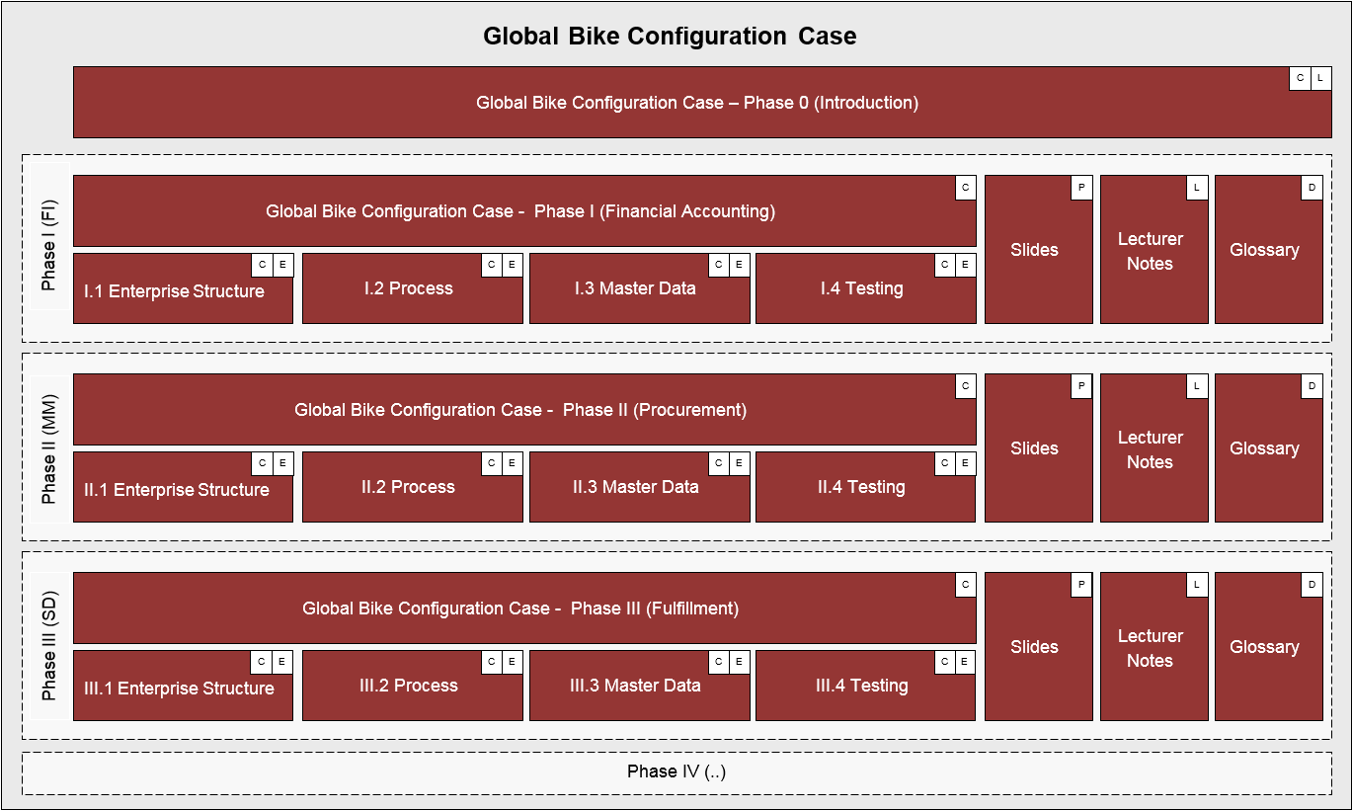 |  | Overall case structure
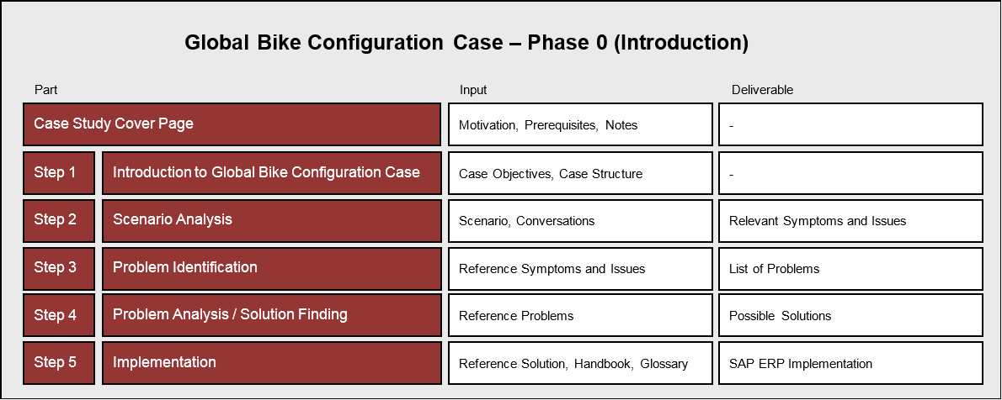 |  | Case study structure
In order for your students to familiarize themselves with the Global Bike enterprise, please download and make available to them the current GBI story document. You can find it in folder 03 GBI of the SAP UA curriculum “Introduction to ERP using GBI”. |  | Step 2  GBI story document
Please use the leading questions given in the case study document to guide your students and to stir group discussion. |  | Leading questions
Note The first three questions focus on Global Bike’s history and structure, which are described in detail in the story document. Students should not face any problems while collecting the relevant information and sketching the Global Bike enterprise structure. Question 3 is aimed at implications of cross-country differences in global ERP implementation projects such as accounting principles, taxation, jurisdiction and consolidation. |  | Questions 1-3
In contrast, questions 4 and 5 regarding the IT strategy and the S/4HANA system are not answered in the story document in great detail. This was designed on purpose (insufficient input) to create a more realistic project setting. Students need to learn to ask for missing details if not given to them. As no particular reference answers are necessary at this stage of the case study you may use the opportunity to discuss with your students all kinds of ERP implementation project aspects (organizational, technological, socio-cultural, or project management-related) in mid-size enterprises such as Global Bike. |  | Questions 4-5  Insufficient input
In addition to insufficient input, another didactic technique is commonly used in this case study. Irrelevant data is given to students not only in the story document, but also in the conversations in Step 3. Hence, details on the different goods purchased, traded, assembled and sold as well as customer and vendor information are not of relevance before the S/4HANA system is configured (in Phase 1 and later). Students need to learn to critically evaluate all input given to them in order to differentiate between relevant and irrelevant data. |  | Irrelevant data
In Step 3, students are presented conversations between Global Bike employees within and across departments. For ease of reading, they are formatted as a bilateral chat. Students are again asked to sort out less or non-relevant details to identify the most common issues and their symptoms within the described business processes. |  | Step 3
Note You can form small student teams to foster group discussions about what may or may not be relevant within the scope of this implementation project. |  | Team work
If your participants are struggling to comprehend the different employees’ roles and concerns, you may assign respective parts of the conversation to students and ask them to act out these roles. |  | Role play
After the scenario analysis in groups, allow time for students to present and discuss their findings with all peers. At the end, motivate the technique of a reference result. Because different results are possible and correct, in order to focus on one or a few aspects throughout the process of this case study at the beginning of each consecutive step a reference input is given to the students. |  | Reference result
Reference input for Step 4 (reference results from Step 3) are issues and symptoms identified during scenario analysis. They are given to students as input for the problem identification task. In this step, discuss with all your students possible underlying problems within the Global Bike organization. |  | Step 4
In the role of Mona Falco (System Design and Development Manager) and Rick Sanchez (Business Analyst), your students need to analyze reference problems provided to them at the beginning of this step. Again, there exist multiple solutions for both specific and general problems. Discuss in class the importance of a central S/4HANA system to overcome reoccurring issues and their effects on a corporate level. |  | Step 5
Based on the reference solution (to implement an S/4HANA system), this last and optional step asks your students to prepare a project proposal for a Global Bike executive board meeting. Make sure that the participants find and use the project proposal template. |  | Step 6
Note You may use the scenario and results developed in the different steps of this case study to support a project management course or even a social skill seminar with focus on teamwork, critical thinking, decision-making, inter-cultural projects and communication. For your class preparation, you find background knowledge on IT project management at the end of these lecturer notes. |  | Project management
Note You may also take the Global Bike scenarios described in this ERP configuration case as the basis for situated learning on the following topics and management disciplines:
- Business Process Management
- Change Management
- Business Strategy
- IT Strategy
- Business-IT Alignment

Working with Case Studies (Notes for Students)

Motivation In order to reach the case study learning objectives it is essential for the lecturer to detect at the beginning of the learning process whether or not the participants know how to work with complex scenarios and realistic cases. If you sense deficits in reading, comprehending, analyzing or interpreting case study content, the following guideline may help your students.
In order to derive solutions for complex problems, a structured step-by-step approach is essential. The format of this case study supports not only logical iteration but also fosters the development of specific and generic solutions through deduction and induction.
After the specific scenario has been comprehended further research should be done in order to reflect the concrete situation in a more generic context. In group discussion of each student’s ideas and possible solutions can be evaluated. When the group has identified one solution to proceed with, an action plan is created and details shared throughout the project. Below you find more details for each process step.

Skimming
First, in order to grasp the specific case situation skim over the case study text. One day (or better one week) before your first group meeting quickly scan the case scenario, identify the context and list most relevant facts. The idea is not to thoroughly read and analyze the text yet.

Research and Analysis
Next, read the case scenario in detail and highlight or note down all relevant facts. Make sure to detect irrelevant data and to explicitly cross out that part of the scenario. Then, try to relate main points to underlying facts and start detailing the case problem. When you feel that relevant data is missing in the case description, make notes and address them during class or group meetings. If necessary, research the problem context online or in a library. In that case, list all references you found and share them with your peer students. If needed input data is still missing after all, it is useful to make assumptions, which need to be defined and communicated precisely.

Creating Alternatives
Analytical thinking, synthesis and evaluation of alternative solutions are essential skills acquired in case study teaching. Thus, develop possible solutions together with your peer students and evaluate (and defend) them in group discussions by identifying strengths and weaknesses. Try to include costs and benefits aspects into your decision-making process: At the end, agree in your group upon one solution to proceed with.

Group vs. Class Discussion
Alternative options should be discussed in groups of six students. Ideas of other participants need to be understood, critically reviewed and evaluated in order to come up with and agree upon one final solution.
Eventually, the group’s solution is outlined to and discussed with the whole class. Students gain practical presentation and argumentation skills. Every solution is evaluated by the instructor and the other students. Finally, the class agrees upon one reference solution to proceed with.

Creating Action Plan
The aim of this last step is to identify and formalize concrete steps taking into account all factors influencing the project. You need to evolve an action plan (project plan) that describes what (tasks) shall be done when (deadlines), by whom (roles) and with which results (deliverables).

Course Post-Processing
Post-processing in case study teaching is as important as the previous learning process. In order to allow (and accept) other ideas it is necessary to understand and follow other students’ chain of thoughts by reviewing and reconstructing their findings. Keep in mind that though one reference solution is selected, other options were found and were just put aside in order to continue with one defined action plan. At the end of the project, you may reflect your result and compare it to other possible ideas that were sorted out along the way. This re-iteration revisits ideas which – in retrospect – may have been neglected due to incorrect assumptions in earlier process steps.

 | Student Assessment
Motivation Learning objectives – whether for individuals or groups – should be assessed during and after the course from multiple perspectives. Besides classical tools such as quizzes and home assignments modern methods include continuous self-assessment or peer reviews, for example by an industry advisory board.
Because this case study phase (Phase 0) aims at the motivation and the understanding of ERP implementation projects without getting into system details, student assessment is highly qualitative. |  | Qualitative assessment
Primary case study learning objectives are:  - Understand and describe basics of ERP implementation projects  - Be able to identify and analyze problems in real-life business processes  - Develop scenario analysis, critical thinking and project planning skills |  | Primary objectives
Secondary (soft) case study learning objectives are:  - Practice to distinguish relevant from irrelevant information  - Learn to detect insufficient data input  - Be able to analyze case texts, identify problems and develop possible solutions  - Learn and practice to vocalize and defend your solution in group and class discussion  - Be able to develop a project plan taking into account all relevant aspects (scope, staffing, costs, benefits) |  | Secondary objectives

Time Estimation

Motivation One of the most difficult tasks for lecturers is the mapping of given teaching content to their own course and class environment. Besides the modular nature of this ERP Configuration Case the approximate time duration (in minutes) is given on the first page of every case study step.
Note Please understand that the duration given is an approximation based on the author’s teaching experience, but varies depending on many aspects such as:
- socio-cultural environment,
- educational systems,
- teaching philosophy,
- learners’ background,
- instructors’ didactic skills.
The table below lists the average duration for students working on every case study step individually and, thus, excludes time for discussion.
Case Study Step | Duration
Step 1 Introduction to GBI Configuration Case | 15 min
Step 2 Introduction to Global Bike Inc. | 45 min
Step 3 Scenario Analysis | 60 min
Step 4 Problem Identification | 30 min
Step 5 Problem Analysis / Solution Finding | 30 min
Step 6 [OPTIONAL] Project Planning | 60 min
Total | 240 min (4 hours)

 | [OPTIONAL] Step 6: Project Planning
Motivation After students made themselves familiar with a realistic ERP implementation case and after they agreed upon a final solution for the problems at Global Bike they can optionally prepare the ERP implementation project. This step provides an ideal interface to talk about IT Project Management (PM) methodologies in your class. This last part of these lecturer notes provide you with common definitions and background information on this topic.
IT project management comprises planning, executing and controlling of an organization's specific IT portfolio assets. It may include supervision of projects for hardware/network installation/maintenance, cloud computing, software development, smart data management and analytics projects as well as IT service management. |  | IT project management
IT projects follow typical phases of the project management life cycle:  - Initiation Identify project goal and problem. Assign project manager. Create project charter.  - Planning Create project plan. Iteratively (re)staff project, (re)define scope, re(define) tasks. [Define evaluation methods.]  - Execution Execute project plan. Perform tasks. Create deliverables.  - Monitoring and Controlling Regularly check scope, cost, benefit, time, quality, and risk. Escalate to steering committee, if necessary.  - Closing Complete project phase or entire project by checking full completion, review/approval, and transfer of ownership from project team to operations.  - [Evaluation] Collect information about tasks and outcomes at project milestones or at end of the project. Analyze information. Report your conclusions.  [PMI, ISO 9000] |  | Project management  life cycle
Whereas typical projects still follow the waterfall method, IT projects are more likely to change during their execution (see Project risks) therefore other models have been introduced in order to positively affect success of an IT project. Iterative methods allow iterations of planning (top-down and step-by-step) of tasks and benefits released to the organization throughout the project. Agile methods such as Scrum expect change to the IT project and thus use iterations of planning and execution as well, but usually for a two-week horizon. They are ideal for software development project. |  | Project methodologies
In addition to typical problems that can cause project failure, factors that can negatively affect the success of an IT project include advances in technology during the project's execution, infrastructure changes that impact security and data management and unknown dependencies between hardware, software, network infrastructure and data. If a technology has not been implemented or used in the organization before, complications may affect project success negatively. |  | Project risks
According to the PMBOK standard of the Project Management Institute (PMI) there exist ten project management knowledge areas. These areas segment different actions completed by the project manager throughout the project. |  | Project management knowledge areas
- Project Integration Management Identify, define, combine, unify, and coordinate various processes and project management activities during project management life cycle.
- Project Scope Management Ensure that the project includes all work required, and only the work required, to complete the project successfully.
- Project Time Management Manage timely project completion.
- Project Cost Management Plan, estimate, budget, finance, fund, manage, and control costs so that the project can be completed within the approved budget.
- Project Quality Management Determine quality policies, objectives, and responsibilities so that the project will satisfy the needs for which it was undertaken.
- Project Human Resource Management Organize, manage, and lead the project team.
- Project Communications Management Ensure timely and appropriate planning, collection, creation, distribution, storage, retrieval, management, control, monitoring, and the ultimate disposition of project information.
- Project Risk Management Conduct risk management planning, identification, analysis, response planning, and controlling risk on a project.
- Project Procurement Management Purchase or acquire products, services, or results needed from outside the project team. Processes in this area include Procurement Planning, Solicitation Planning, Solicitation, Source Selection, Contract Administration, and Contract Closeout.
- Project Stakeholder Management Identify all people or organizations impacted by the project, analyzing stakeholder expectations and impact on the project, and developing appropriate management strategies for effectively engaging stakeholders in project decisions and execution.
These ten knowledge areas are to be managed iteratively throughout the project. With the exception of procurement, a project manager will likely encounter all ten areas in every project. As there is no set order in which the areas should be managed, the project manager (re)prioritizes the management tasks based on the project status.

