

S/4HANA Configuration Case
Phase I – Handbook
This handbook comprises all tasks that need to be executed in the S/4HANA system in order to configure the basics of the Financial Accounting module for Global Bike.

Product  S/4 HANA 2020  Global Bike  Fiori 3.0  Level  Intermediate  Advanced  Focus  ERP Configuration  Financial Accounting  Authors  Simha Magal  Stefan Weidner  Tom Wilder  Version  4.2  Last Update  March 2024 | MOTIVATION  In the initial GBI configuration case you have identified and analyzed problems as well as developed and discussed possible solutions.  Now, you configure the enterprise structure and business processes for Financial Accounting.  After setting up the organization units and process parameters you will create necessary master data and test the business process. |  | PREREQUISITES  Before you use this case, you should be familiar with navigation in the SAP system.  It is also recommended that you have gone through the Intro to ERP Financial Accounting exercises and case studies based on Global Bike.  NOTES  This case study uses the Global Bike data set which has been created for SAP UA global curricula exclusively.  ACKNOWLEDGEMENT  This case study was prepared with the assistance of student interns at the Seidman ERP program at Grand Valley State University and the SAP Club at CSU Chico as well as student and research assistants at SAP UCC Magdeburg.


 | Phase I – Financial Accounting
Learning Objective Understand and configure Financial Accounting. Time 280 min
Phase Scenario After defining the overall strategy and work packages for the entire configuration project at Global Bike, in Phase I enterprise structures and processes in Financial Accounting are implemented and tested.
Name (Position) Bianca Cavarini (Chief Information Officer)
Mona Falco (System Design and Development Manager)
Sarah Garcia (Business Analyst 2)
[external] (Senior SAP FI/CO consultant)
[external] (Junior SAP FI/CO consultant)
After both Co-CEOs approved the S/4HANA implementation project, Bianca Cavarini and Mona Falco analyzed GBI’s Financial Accounting processes in detail. A senior and a junior SAP FI/CO consultant from an external firm are contributing their functional and technical experience with ERP configuration. Three different data types need to be implemented in the system: organizational data (enterprise structure and process configuration), master data, and transactional data. |  | Scenario setting
The graphic and table of content below display the four parts of this phase.  Master Data  Process  Configuration  Process  Execution  Enterprise Structure  Table of Content  Phase I – Financial Accounting 2  General Notes and Cautions 3  Introduction to SAP Implementation Guide (IMG) 4  Phase I.1 – Enterprise Structure 9  Phase I.2 – Process Configuration 40  Phase I.3 – Master Data 51  Phase I.4 – Process Execution 67 |  | Project structures

General Notes and Cautions
Warning: When working with other classmates at the same time in the same transactions within S/4HANA Configuration (transaction SPRO), tables will tend to lock up and you will only be able to display them. This is due to the fact that the system will not let multiple users work in the same transaction at the same time. To get pass this message, wait until the current user is finished in the transaction and then proceed.
The ## Symbol: When working with other classmates at the same time, you will be assigned your own unique identifier which is called the ## Symbol or the “Pound Pound” Symbol. This will be your identifier and is ASSIGNED FOR YOUR OWN USE ONLY!!! Please be cautious about other classmates attempting to use your identifier whether it is on purpose or not and if you suspect other classmates using it, inform your professor immediately so that fixes can be made accordingly. For example, if Ashley has an identifier of 09 and David has an identifier of 13, Ashley’s company code will be US09 and David’s company code will be US13. So, every time you see “##” in this document, it is referring to 09 for Ashley and 13 for David.
The Search Tool: At times in this document, the instructions will ask you to search for something to put in a field. When it does this, simply click on the field itself and click on the icon to the right of it. Clicking on it will bring up another window and you will search from there. You may also search other fields by clicking on the downward arrow that may be on the left or right of the field. It will bring up a drop-down menu that has options to choose from and click.
Please specifically note that when it says SAP menu in the navigation, it is referring to SAP Easy Access menu. This menu is where all of the transactional and master data are entered. The SAP configuration menu, also referred to as the SAP Implementation Guide (IMG), is different. For an introduction, please use the navigation exercise (next task).
Saving: In this document, the instructions will tell you to save data and when it does, always press enter to validate. If there are error(s) that occur, they must be corrected before continuing to the next task. You will find errors from a transaction when there are red icons that appear in the message area. Messages that are yellow contain warnings and not errors. At times, these must be fixed in order to move on. However, most of the time, they do not need to be fixed and you can simply press enter to go through them. Green messages are obviously showing that nothing went wrong.
Data Entry: When a data value is in italics then you will need to search for the correct data value using the search tool. When a data value is not italicized then you enter the data as it appears in the tasks. ALWAYS change ## to your identifier. For example: if Data Value is Your Company Code or US## and your identifier is 09, then you would enter US09 into the data field. Also, if the Data Value is United States Dollar, then you would need to use the search tool to locate the appropriate data entry, which will probably be USD.

 | Introduction to SAP Implementation Guide (IMG)
Task Familiarize yourself with the SAP configuration menu. Time 10 min
IMG is a menu within the system which lists all configuration activities and tasks. Just like the SAP Easy Access menu for master and transactional data, this menu is the main menu for enterprise structure and process configuration. In contrast to the Easy Access menu, the IMG menu is not accessible by most employees, but it is used by external consultants or internal key users. |  | IMG menu
There are three ways to proceed to the IMG menu.
- in the Fiori Launchpad, in the Customizing area, open the app SPRO  SAP Fiori Menu ► Customizing ► SPRO► Sap Reference IMG |  | Menu path
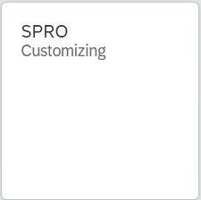
- In the Customizing: Execute Project screen, on the top left click on the icon.
- Now, you see the Display IMG screen. This is where most tasks will ask you to start from.
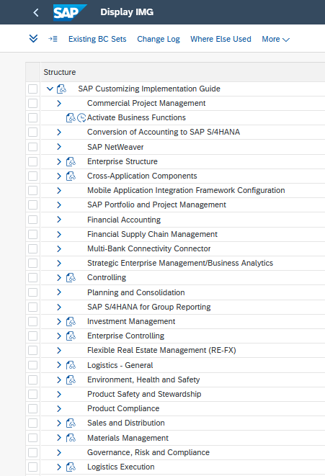
Alternative 1 From the SAP Easy Access menu, you may also use the following short cut to start the IMG menu.
- In the SAP Easy Access menu, click on the black arrows on the left to open the following menu path and double-click on Execute Project.  SAP Menu ► Tools ► Customizing ► IMG ► Execute Project |  | Menu path
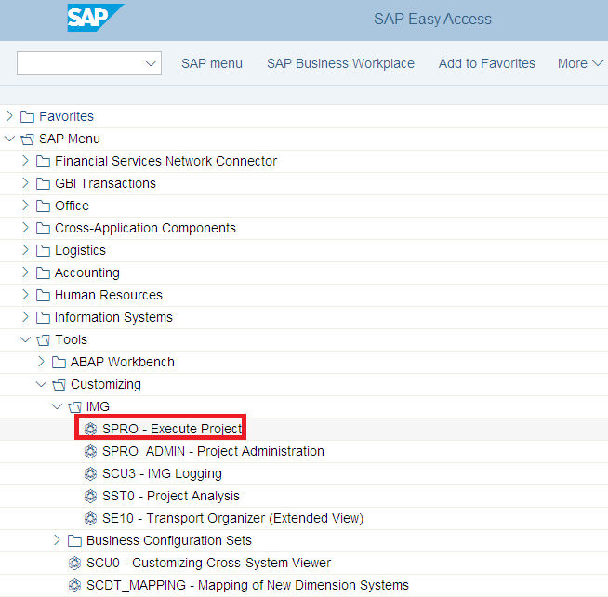
- In the Customizing: Execute Project screen, on the top left click on the icon.
- Now, you see the Display IMG screen. This is where most tasks will ask you to start from.
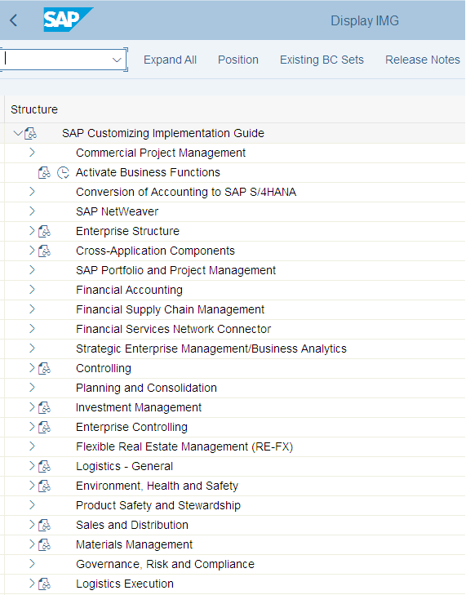
When this handbook later on refers to the definition and the assignment of organization units, it means the Enterprise Structure folder at the beginning of the menu (see above). All folders below contain IMG activities which are configuring business processes within the S/4HANA system.
Note Similar to the SAP Easy Access menu where you as learners see all possible functions in the S/4HANA system, here in the IMG menu you also have access to all configuration activities. In a real company even, external consultants would be restricted to IMG activities related to their specific project and their ERP configuration skills. However, in this case study you will be taking on different project roles and need to see and be able to use the entire ERP system.
Alternative 2 From the SAP Easy Access menu, you may also use the following short cut to start the IMG menu.
- Locate the transaction code field in the top left corner of your screen and simply type in SPRO. |  | SPRO
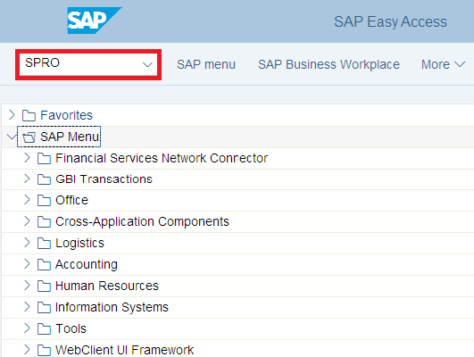
- Then, press Enter.
- In the Customizing: Execute Project screen, on the top left click on the icon.

 | Phase I.1 – Enterprise Structure
Task Configure Global Bike’s enterprise structure for Financial Accounting. Time 100 min
Short Description Based on Sarah Garcia’s results (organizational charts Financial Accounting, Controlling, S/4HANA) review Global Bike’s organizational structure, study the mapping of S/4HANA organizational units and configure them in the system.
Name (Position) Mona Falco (System Design and Development Manager)
Sarah Garcia (Business Analyst 2)
In the preparation phase, Sarah Garcia sketched the organizational charts for Financial Accounting (and basics of Controlling). Then, she mapped the Global Bike units to ERP terminology and defined a unique number for each object. The graphic below illustrates these configuration objects and their relationship to each other. The company codes for the US and for Germany, for example, are assigned to the same global credit control area. |  | Scenario setting  Sarah Garcia  [Business Analyst 2]
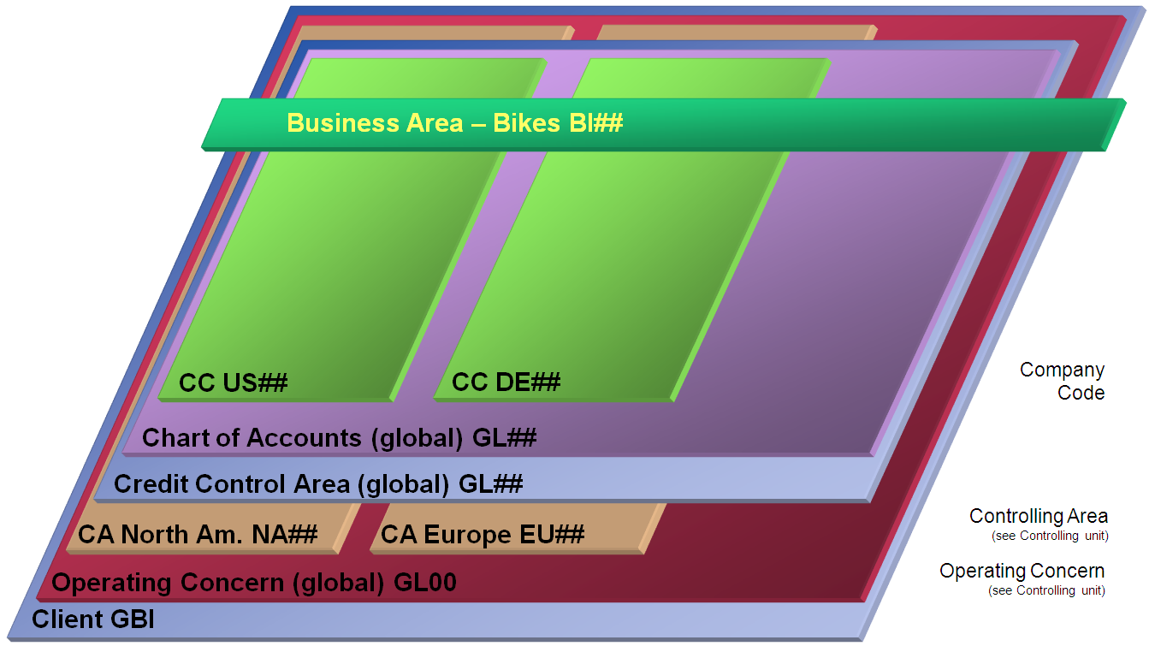 |  | Organizational chart  S/4HANA  Global Bike Accounting
Note The graphic used in this handbook differs slightly from Sarah’s original as the numbering digits (00) have already been replaced by ##. In all tasks, please make sure to use your own unique identifier instead of the ## symbol.
Note As you can see from the graphic above, you will not create your own operating concern. This is why its number will be GL00 for you and your classmates.
Process  Execution  Master Data  Process Configuration  Enterprise Structure |  | Project structure

Table of Contents
Phase I.1 – Enterprise Structure 9
I.1.1 Define Company Code 11
I.1.2 Define Business Area 14
I.1.3 Define Empty Chart of Accounts 15
I.1.4 Define Controlling Area 17
I.1.5 Define Credit Control Area 19
I.1.6 Define Variant for Open Posting Periods 21
I.1.7 Define Field Status Variant 23
I.1.8 Enter Global Parameters for a Company Code 25
I.1.9 Assign Company Code to Controlling Area 27
I.1.10 Assign Controlling Area to Operating Concern 29
I.1.11 Assign Company Code to Ledger 30
I.1.12 Define Default Values for Postings in Controlling 32
I.1.13 Define Ledger for CO Version 34
I.1.14 Enter Global Parameters for a Controlling Area 36
I.1.15 Initialize the Posting Period 38

 | I.1.1 Define Company Code
Task Configure a company code for Global Bike’s headquarters in the US Time 10 min (Dallas).
In this step you are defining the most important organizational unit in the Financial Accounting module, if not in the whole S/4HANA system. By referencing them to a company code, Global Bike business tranactions are linked to financial accounting. |  | Motivation
- In the Display IMG screen, follow the menu path:  SAP Customizing Implementation Guide ► Enterprise Structure ► Definition ► Financial Accounting ► Edit, Copy, Delete, Check Company Code |  | Menu path
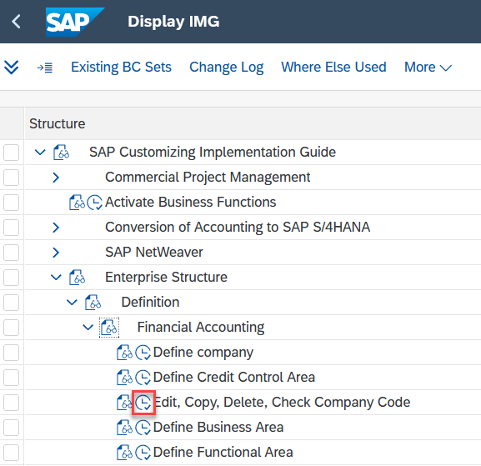
- In the Select Activity pop-up, double-click on Edit Company Code Data.
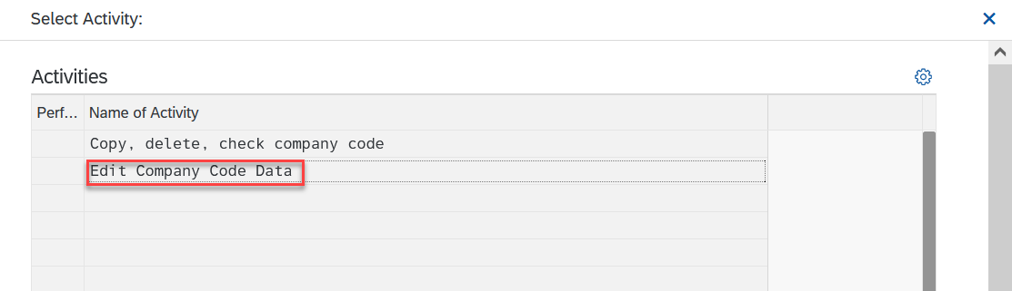
- In the Change View “Company Code”: Overview screen, click on the 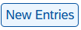 icon.
- In the New Entries: Details of Added Entries screen, enter the data below:
 |  | US##  ## Global Bike Inc.  Dallas  US  USD  EN
  Attribute | Data value
  Company Code | US##
  Company Name | ## Global Bike Inc.
  City | Dallas
  Country | USA (US)
  Currency | United States Dollar (USD)
  Language | English (EN)
- Click on MoreGotoAddress.
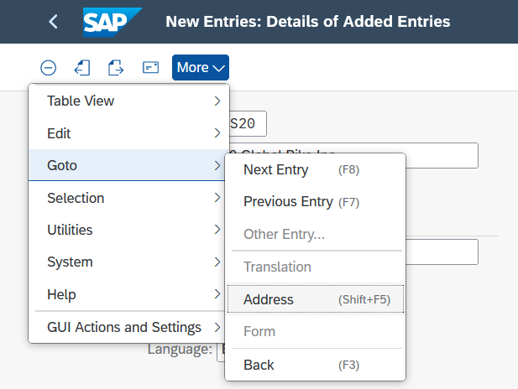
- In the Edit address: US## pop-up, enter the following information:
 |  | Company  ## Global Bike Inc.  0##  5215 N. O’Connor Blvd  75039  Dallas  US  TX
  Attribute | Data value
  Title | Company
  Name | ## Global Bike Inc.
  Search term 1/2 | 0##
  Street/House number | 5215 N. O’Connor Blvd
  Postal Code | 75039
  City | Dallas
  Country | USA (US)
  Region | Texas (TX)
- In the Street Address part, click on the icon and enter the following information:
 |  | TX0000000
  Attribute | Data value
  Jurisdict. code | Texas Jurisdiction Code (TX0000000)
- Click on the  icon.
- In the New Entries: Details of Added Entries screen, click on the icon.
- In the Edit Address: US## pop-up, click on the icon.
- You will receive the following message:
- Click on 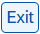 and then on (cancel) to return to the SPRO menu.

 | I.1.2 Define Business Area
Task Configure Global Bike’s business area (Bikes). Time 5 min
As Global Bike’s main product group is bicycles, financial accounting will be grouped by the Bikes business area only. |  | Motivation
- In the Display IMG screen, follow the menu path:  SAP Customizing Implementation Guide ► Enterprise Structure ► Definition ► Financial Accounting ► Define Business Area |  | Menu path
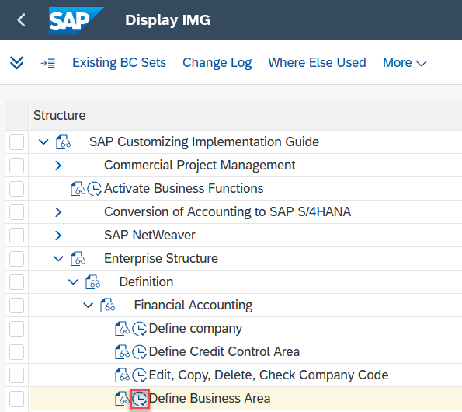
- In the Change View “Business areas”: Overview screen, click on the icon.
- In the New Entries: Overview of Added Entries screen, enter the following information:
 |  | BI##  ## Bikes
  Attribute | Data value
  Business Area | BI##
  Description | ## Bikes
- Click on . You will receive the message
- Click on 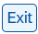 to return to the SPRO menu.

 | I.1.3 Define Empty Chart of Accounts
Task Define an empty chart of accounts for Global Bike. Time 5 min
According to Sarah’s organizational chart, Global Bike is using one global chart of accounts. The frame is created now. The list of G/L accounts is loaded later. |  | Motivation
- In the Display IMG screen, follow the menu path:  SAP Customizing Implementation Guide ► Financial Accounting ► General Ledger Accounting ► Master Data ► G/L Accounts ► Preparations ►Edit Chart of Accounts List |  | Menu path
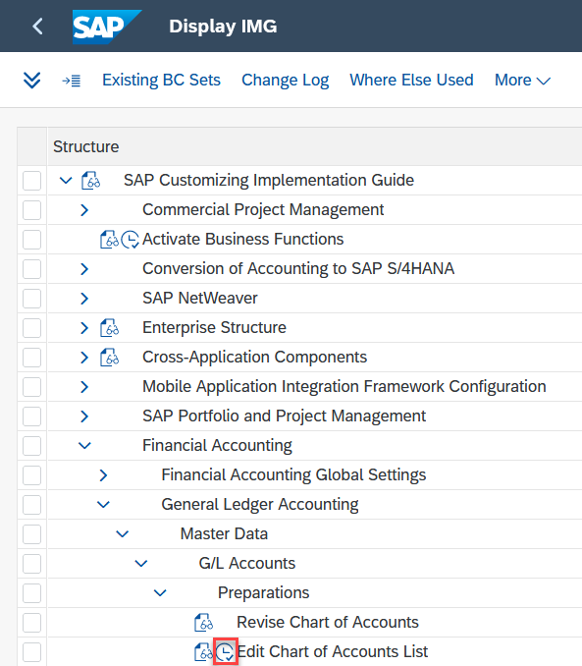
- On the Change View “List of All Charts of Accounts”: Overview screen, click on the .
- In the New Entries: Details of Added Entries screen, enter the data below:
 |  | GL##  ## GBI COA  English
  Attribute | Data value
  Chart of Accts | GL##
  Description | ## GBI COA
  Maint. Language | English
- Click on . You will receive a message that says
- Click on to return to the SPRO menu.

 | I.1.4 Define Controlling Area
Task Define Global Bike’s controlling area for North America. Time 10 min
As identified in the preparation phase, Global Bike separates its managerial accounting activities into two regions; North America and Europe. With the project focus on the US, controlling area North America is defined for now. |  | Motivation
- In the Display IMG screen, follow the menu path:  SAP Customizing Implementation Guide ► Enterprise Structure ► Definition ► Controlling ► Maintain Controlling Area |  | Menu path
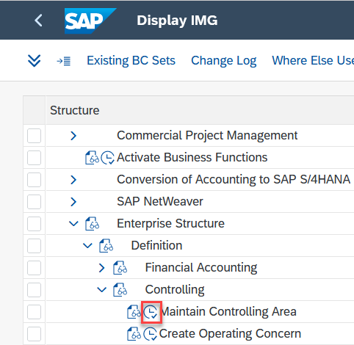
- In the Select Activity pop-up, double-click on Maintain Controlling Area.
- In the Change View “Basic data”: Overview screen, click on .
- In the New entries: Details of Added Entries screen, enter the data below:
 |  | NA##  ## GBI North America  Cross-company-code- cost accounting  10  USD  GL##  K1
  Attribute | Data value
  Controlling Area | NA##
  Name | ## GBI North America
  CoCd CO Area | Cross-company-code cost accounting
  Currency Type | Company code currency (10)
  Currency | United States Dollar (USD)
  Chart of Accts | Your Charts of Accounts (GL##)
  Fiscal Year Variant | Cal. Year, 1 Special Period (K1)
- Click on. If you receive a Document lines: Display messages pop-up with warning messages, click on to proceed.
- Click on .
- In the Exit maintenance pop-up, click on the 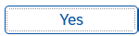 icon.
- You will receive a message that says
- In the Select Activity pop-up click on  to return to the SPRO menu.

 | I.1.5 Define Credit Control Area
Task Define the global credit control area for Global Bike. Time 10 min
Global Bike is managing customer credit limits on a global level. Thus, a global credit control area is created. |  | Motivation
- In the Display IMG screen, follow the menu path:  SAP Customizing Implementation Guide ► Enterprise Structure ► Definition ► Financial Accounting ► Define Credit Control Area |  | Menu path
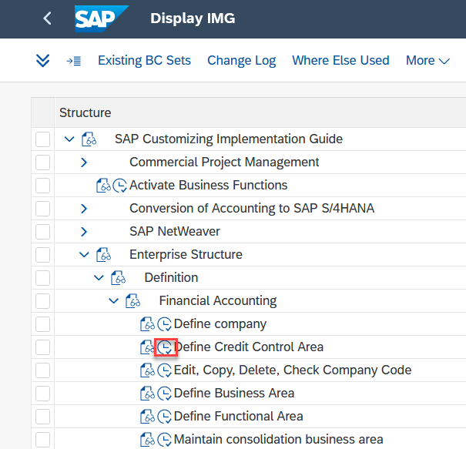
- In the Change View “Credit Control Areas”: Details screen, click on the icon
- In the New Entries: Details of Added Entries screen, enter the data below:
 |  | GL##  USD  000012  K1
  Attribute | Data value
  Cred. Contr. Area | GL##
  Currency | United States Dollar (USD)
  Update | Open order value on time axis, delivery and bill.doct value (000012)
  FY Variant | Cal. Year, 1 Special Period (K1)
- Click on . You will receive a message that says
- Click on .
- In the Change View “Credit Control Areas”: Overview screen, enter the following below:
 |  | ## Global Bike Inc
  CCAr | Description
  Your Credit Control Area (GL##) | ## Global Bike Inc.
- Click on . You will receive a message that says
- Click on to return to the SPRO menu.

 | I.1.6 Define Variant for Open Posting Periods
Task Define variant for month-end closing in Global Bike. Time 5 min
Posting period variants are needed for month-end closing. Thus, a GBI variant is created. |  | Motivation
- In the Display IMG screen, follow the menu path:  SAP Customizing Implementation Guide ► Financial Accounting ► Financial Accounting Global Settings ► Ledgers ► Fiscal Year and Posting Periods ► Posting Periods ► Define Variants for Open Posting Periods |  | Menu path
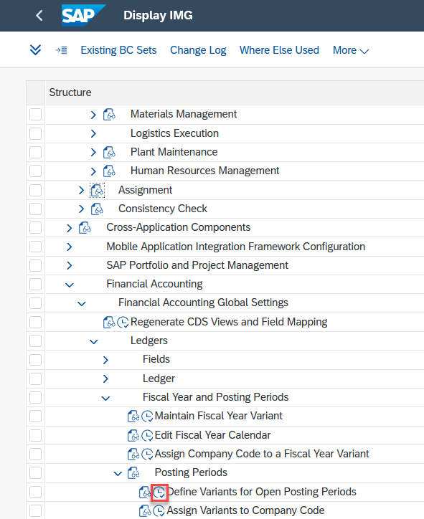
- You are in the Change View “Posting Periods: Define Variants”: Overview screen, click on the icon.
- In the New Entries: Overview of Added Entries screen, enter the data below:
 |  | GL##  ## GBI Posting Periods
  Attribute | Data value
  Variant | GL##
  Name | ## GBI Posting Periods
- Click on . You will receive a message that says
- Click on to return to the SPRO menu.

 | I.1.7 Define Field Status Variant
Task Define field status variant Time 10 min
The Global Bike field status variant that is created here comprises of several field status groups. Later, each of these groups categorizes specific types of G/L accounts and defines their status of input fields such as required entry or optional entry. |  | Motivation
- In the Display IMG screen, follow the menu path:  SAP Customizing Implementation Guide ► Financial Accounting ► Financial Accounting Global Settings ► Ledgers ► Fields ► Define Field Status Variants |  | Menu path
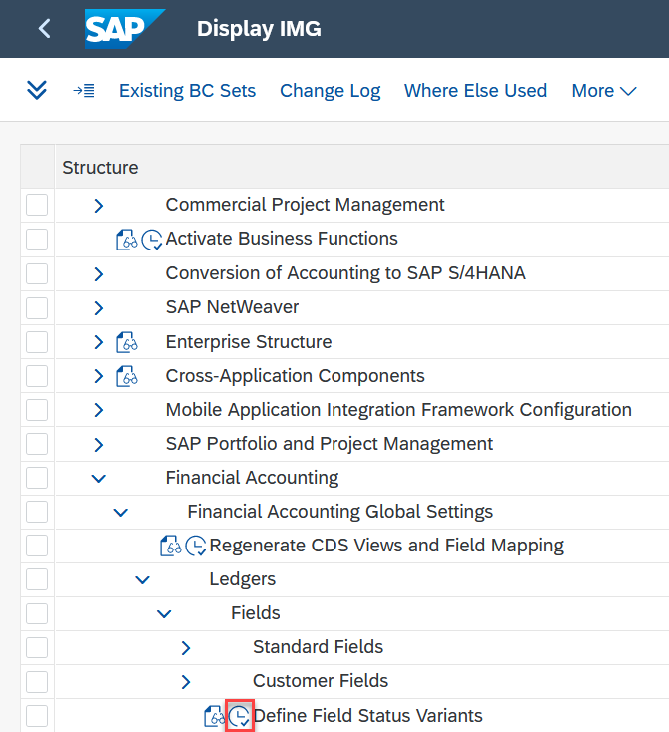
- In the Change View “Field status variants”: Overview screen, select the GL00 row. |  | GL00
- Click on the  icon.
- In the Change View “Field status variants”: Overview of Selected Set screen, enter the following information:
 |  | GL##  ## Global Bike Field Options
  Attribute | Data value
  FStV | GL##
  Field Status Name | Global Bike Field Options
- Click on .
- In the Specify object to be copied pop-up, click on the 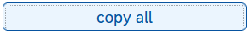 icon. In the Information pop-up, click on the  icon.
- In the Change View “Field status variants”: Overview screen, highlight the GL## row and double-click on . |  | GL##
- In the Change View “Field status groups”: Overview screen, check the information below and add your identifier (##) for every row. |  | ##
 |  | ## Expense Accounts  ## General Balance Sheet Accounts  ## Material Management GR/IR Accounts  ## Reconciliation Accounts  ## CO<->FI reconciliation posting  ## Revenue Accounts  ## Secondary Cost Elements
  Attribute | Data value
  ZEXP | ## Expense Accounts
  ZGBS | ## General Balance Sheet Accounts
  ZMMA | ## Material Management GR / IR Accounts
  ZRAA | ## Reconciliation Accounts
  ZRCF | ## CO <-> FI reconciliation posting
  ZREV | ## Revenue Accounts
  ZSEC | ## Secondary Cost Elements
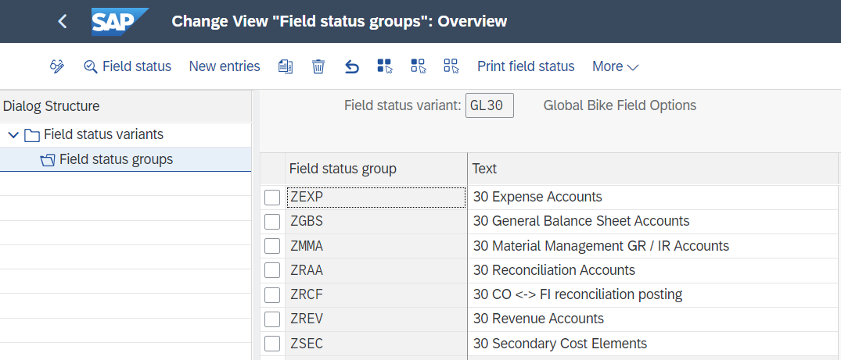
- Click on . You will receive a message that says
- Click on to return to the SPRO menu.

 | I.1.8 Enter Global Parameters for a Company Code
Task Enter company code parameters for the US. Time 10 min
In this task, you enter global parameters for your company. This consists of combining what you defined in previous steps into one global parameter such as credit control area and your variants, and your chart of accounts within the entire system. |  | Motivation
- In the Display IMG screen, follow the menu path:  SAP Customizing Implementation Guide ► Financial Accounting ► Financial Accounting Global Settings ► Global Parameters for Company Code ► Enter Global Parameters |  | Menu path
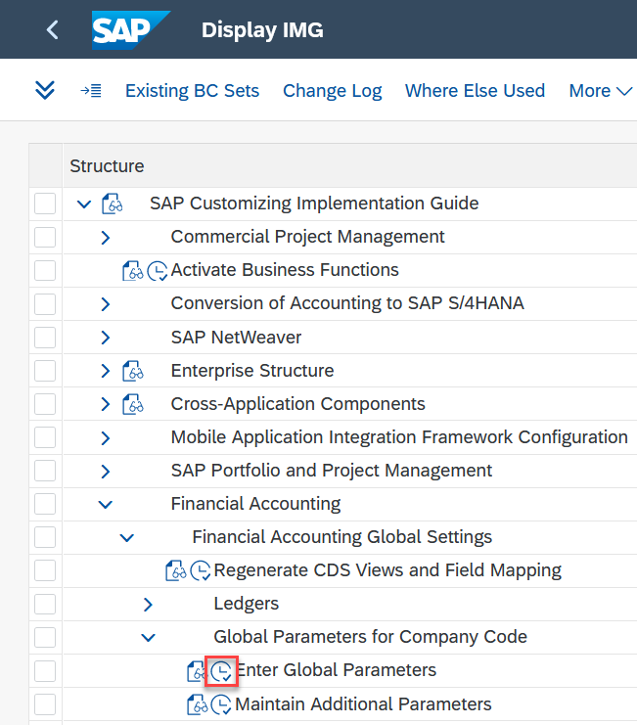
- In the Change View “Company Code Global Data”: Overview screen, double-click on US##
- In the Change View “Company Code Global Data”: Details screen, enter the following information:
 |  | GL##  GL##  K1  GL##  GL##  10  1
  Attribute | Data value
  Chart of Accts | Your GBI COA (GL##)
  Credit Control Area | Your Global Bike Inc. (GL##)
  Fiscal Year Variant | Cal. Year. 1 Special Period (K1)
  Field status variant | Your GBI Field Options (GL##)
  Pstng period variant | Your GBI Posting Periods (GL##)
  Max. exchange rate deviation | 10%
  Cost of Sales Accounting actv. | In preparation (1)
  Propose fiscal year | Selected
  Define default value date | Selected
  Financial Assets Mgmt active | Selected
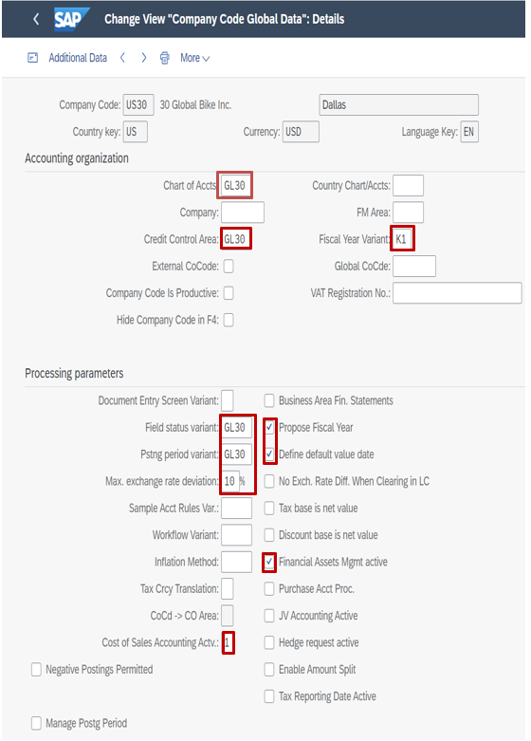
- Click on . You will receive a message that says
- Click on to return to the SPRO menu.

 | I.1.9 Assign Company Code to Controlling Area
Task Assign the US company code to the North America controlling area. Time 5 min
According to Sarah’s organizational chart, the company code in the US is assigned to the controlling area for North America. |  | Motivation
- In the Display IMG screen, follow the menu path:  SAP Customizing Implementation Guide ► Enterprise Structure ► Assignment ► Controlling ► Assign company code to controlling area |  | Menu path
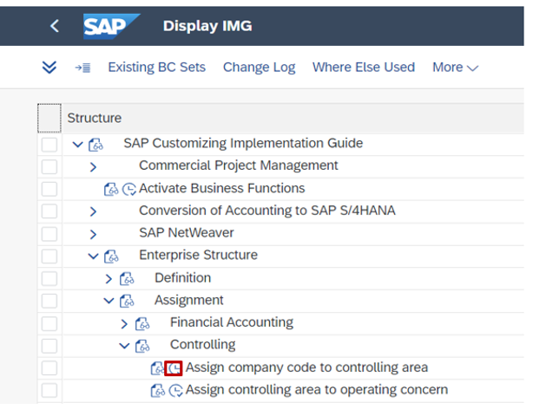
- In the Change View “Basic data”: Overview screen, highlight the NA## row.
- Double-click on Assignment of company code(s).
- In the Change View “Assignment of company code(s)”: Overview screen, click on the .
- In the New Entries: Overview of Added Entries screen, enter the below data:
 |  | US#
  Attribute | Data value
  CoCd | Your Global Bike Inc. (US##)
- Click on . If you receive a Document lines: Display messages pop-up, click to proceed.
- Click on to return to the SPRO menu.

 | I.1.10 Assign Controlling Area to Operating Concern
Task Assign the North America controlling area to the existing operating concern. Time 5 min
In this step you are assigning your controlling area for North America to the already existing global operating concern. |  | Motivation
- In the Display IMG screen, follow the menu path:  SAP Customizing Implementation Guide ► Enterprise Structure ► Assignment ► Controlling ► Assign controlling area to operation concern |  | Menu path
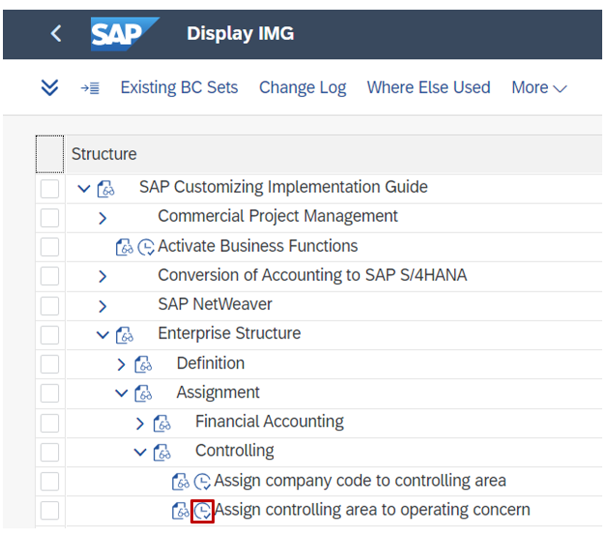
- In the Change View “Assignment Operating concern CO Area”: Overview screen, enter the following information:
 |  | GL00
  CoAr | OpCo
  Your GBI North America (NA##) | GL00
- then click on and you will receive a message that says:
- Click on to return to the SPRO menu.

 | I.1.11 Assign Company Code to Ledger
Task Assign Company Code to Ledger. Time 5 min
When Global Bike enters a business transaction for any of its company codes, the system needs to post the business transaction to the ledgers assigned to the company code. |  | Motivation
- In the Display IMG screen, follow the menu path:  SAP Customizing Implementation Guide ► Financial Accounting ► Financial Accounting Global Settings ► Ledgers ► Ledger ► Define Settings for Ledgers and Currency Types |  | Menu path
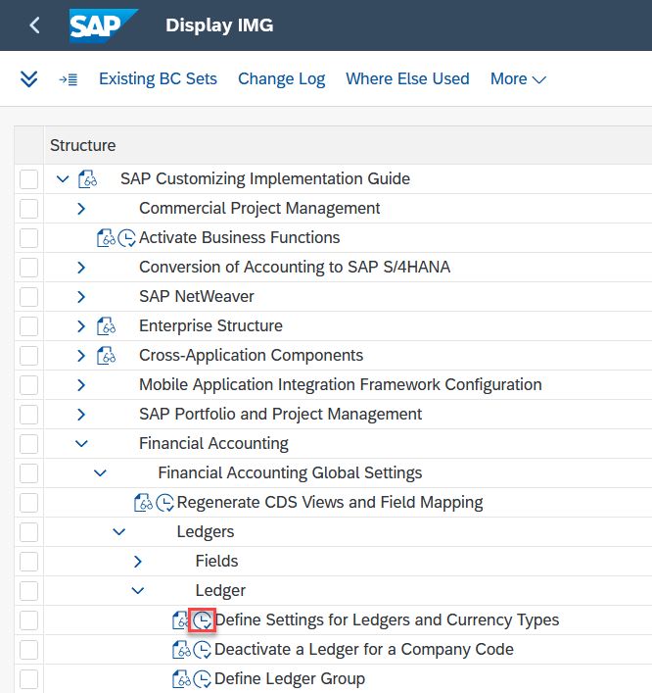
- If you receive a Consistency Check: Display messages pop-up, click  to proceed.
- In the Change View “Ledger” Overview screen, select the 0L Ledger and double-click Accounting Principles for Ledger and Company Code.
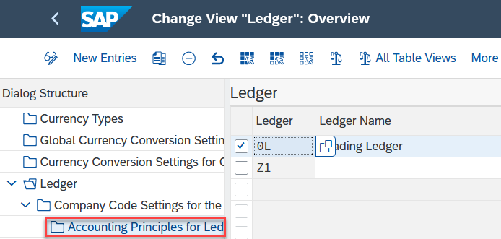
- In the Determine Work Area: Entry screen, enter your Company Code US##. |  | US##
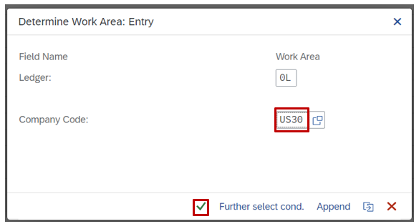
- Click to continue.
- Click on . You will get a message that says
- If you receive the Consistency Check: Display Messages pop-up message again, click on to proceed.
- Go back to the Ledger tab and select the ledger Z1. Then double-click on Company code settings for the ledger.
- enter the posting variant GL## for your company code. |  | GL##
- Click on . You will receive a message that says :
- If you receive the Consistency Check: Display Messages pop-up message again, click on to proceed.
- Click on to return to the SPRO menu.

 | I.1.12 Define Default Values for Postings in Controlling
Task Define Default Values for Postings in Controlling for US## Company Code. Time 5 min
Global Bike needs to define default values for use in CO business transactions whose user interfaces do not allow you to enter a document type or a ledger group during posting. |  | Motivation
- In the Display IMG screen, follow the menu path:  SAP Customizing Implementation Guide ► Financial Accounting ► Financial Accounting Global Settings ► Ledgers ► Integration of Controlling with Financial Accounting ► Check and Define Default Values for Postings in Controlling |  | Menu path
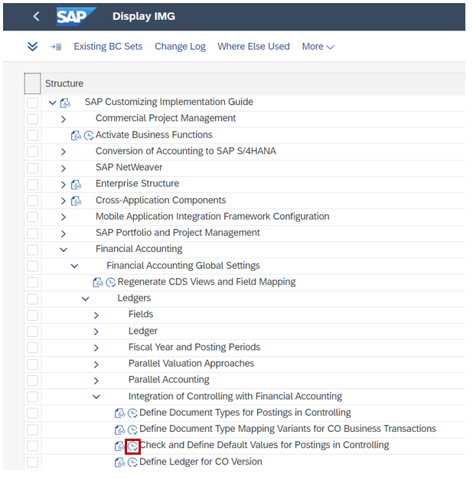
- In the Change View “Default Values for Postings in Controlling”: Overview select the US00 Company Code row.
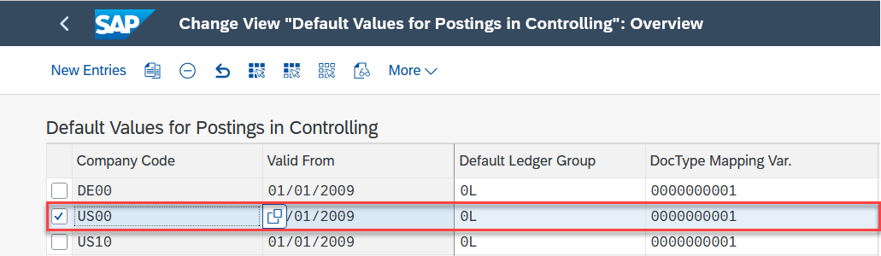
- Then click on  symbol.
- In the Company Code field, enter your Company Code US##. |  | US##
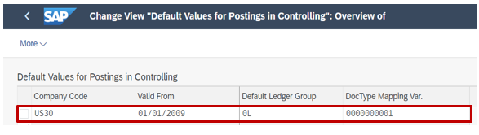 |  | a
- Click on. You will receive a message that says:.
- Click on . You will receive a message that says:.
- Click on to return to the SPRO menu.

 | I.1.13 Define Ledger for CO Version
Task Define Ledger for new Controlling Area (NA##) version. Time 5 min
Global Bike needs to define a ledger that contains all postings of actual data that is relevant to Controlling. |  | Motivation
- In the Display IMG screen, follow the menu path:  SAP Customizing Implementation Guide ► Financial Accounting ► Financial Accounting Global Settings ► Ledgers ► Integration of Controlling with Financial Accounting ► Define Ledger for CO Version |  | Menu path
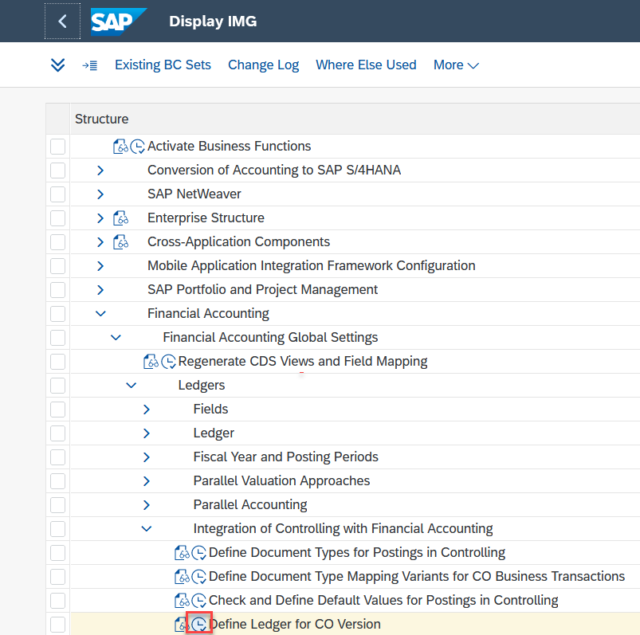
- In the Change View “Ledger from Which CO Reads Actual Data.” Overview select the NA00 CO Area row.
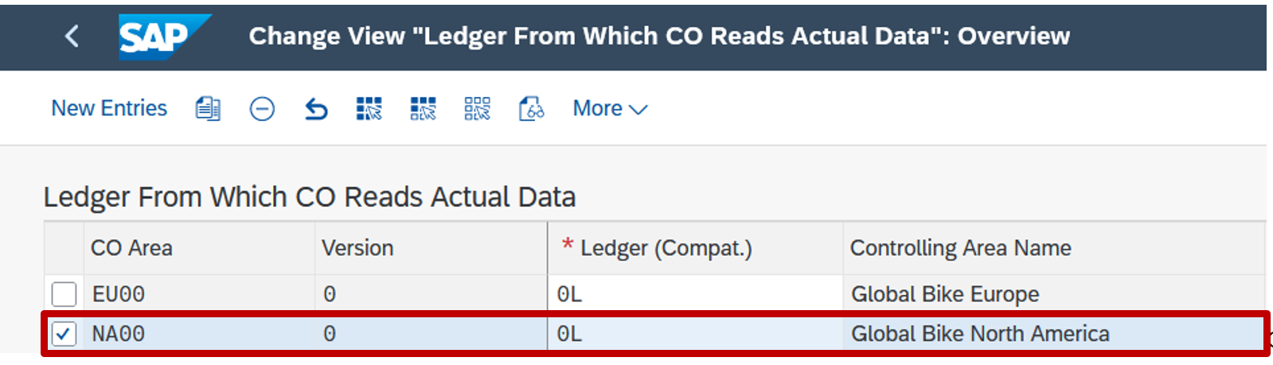
- Click on .
- In the CO Area field, enter your Controlling Area NA##. |  | NA##
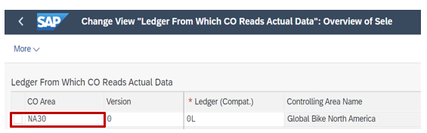
- Click on . You will receive a message that says:
- Click on . If you receive a Document lines: Display messages pop-up message, click on to proceed.
- You will receive a message that says
- Click on to return to the SPRO menu.

 | I.1.14 Enter Global Parameters for a Controlling Area
Task Enter controlling area parameters for North America. Time 5 min
In this step you are entering parameters for the North American controlling area. |  | Motivation
- In the Display IMG screen, follow the menu path:  SAP Customizing Implementation Guide ► Controlling ► General Controlling ► Organization ► Maintain Controlling Area |  | Menu path
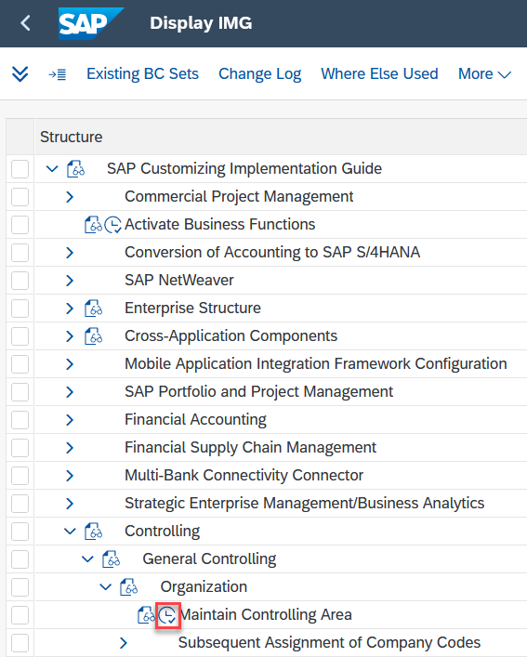
- In the Select Activity pop-up, double-click on Maintain Controlling Area.
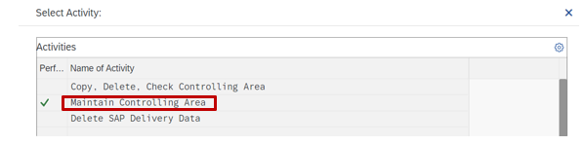
- In the Change View “Basic data”: Overview screen, highlight the NA## row.
- Click on  icon.
- In the Change View “Basic data”: Details screen, enter the following information:
 |  | NA##
  Attribute | Data value
  CCtr Std. Hierarchy | NA##
- Double-click on
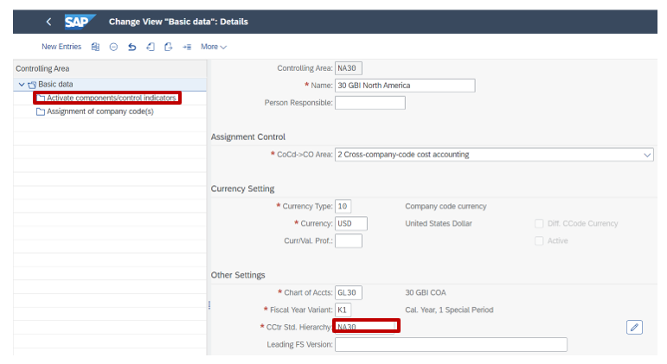
- In the Check standard hierarchy pop-up, click on the icon.
- Proceed by clicking on .
- In the Change View “Activate components/control indicators”: Overview screen, click on the icon.
- In the New Entries: Details of Added Entries screen, enter the data below:
 |  | Current Year  Component active  Component active  Component active
  Attribute | Data value
  Fiscal Year | Current Year
  Cost Centers | Component active
  Order Management | Component active
  Commit. Management | Component active
- Click on . If you receive a Document lines: Display messages pop-up, click to proceed. You will get a message that says .
- Click on and then on  to return to the SPRO menu.

 | I.1.15 Initialize the Posting Period
Task Initialize the posting period for the US company code. Time 5 min
In order to be able to post business transactions, the posting periods for the US company code need to be initialized (and set to the current month). |  | Motivation
- In the Display IMG screen, follow the menu path:  SAP Customizing Implementation Guide ► Logistics - General ► Material Master ► Basic Settings ► Maintain Company Codes for Materials Management |  | Menu path
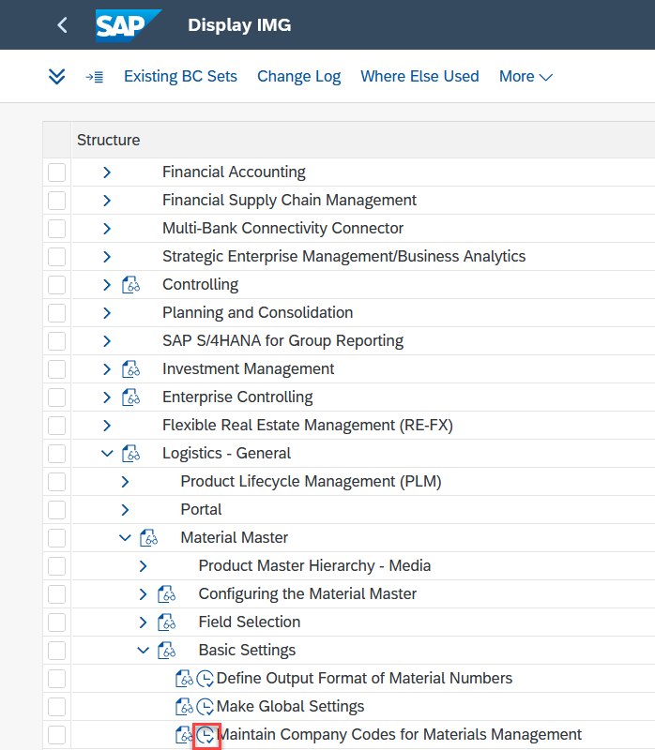
- In the Change View “Materials Management View on Company Codes” Overview screen, enter the following information:
 |  | US##  ## Global Bike Inc.  Current Year  Current Month  Selected
  Attribute | Data value
  Company Code (CoCd) | Your Global Bike Inc. (US##)
  Company Name | ## Global Bike Inc.
  Year | Current Year
  Current period (Pe) | Current Month
  Allow posting to previous per. (ABp) | Selected
- Click on . You will receive a message that says .
- Click on to return to the SPRO menu.

 | Phase I.2 – Process Configuration
Task Configure GBI’s core financial accounting processes. Time 45 min
Short Description Based on the results of the project preparation by both the GBI employees and the external consultants, now essential settings for the Financial Accounting department need to be made in the S/4HANA system.
Name (Position) Mona Falco (System Design and Development Manager)
Sarah Garcia (Business Analyst 2)
[external] (Senior SAP FI/CO consultant)
In the preparation phase, Mona Falco analyzed the business processes in GBI’s financial accounting department and identified issues which will be overcome by the ERP system. Together with her colleague Sarah Garcia and an FI/CO consultant of an external firm, she has studied the SAP system and found configuration settings that are needed now that the enterprise structure has been created in the previous phase. |  | Scenario setting  Mona Falco  [System Design and Development Manager]  Sarah Garcia  [Business Analyst 2]
Process  Execution  Master Data  Process Configuration  Enterprise Structure  Table of Contents  Phase I.2 - Process Configuration 40  I.2.1 Set Up Company Code for Payment Transactions 41  I.2.2 Define Account Groups 43  I.2.3 Create Document Number Ranges for Financial Accounting 45  I.2.4 Create Document Number Ranges for Controlling 47  I.2.5 Define Tolerance Groups for Employees 49 |  | Project structure

 | I.2.1 Set Up Company Code for Payment Transactions
Task Set up the US company code for GBI payment transactions. Time 5 min
In order for a company code to be referred to in payment transactions, it needs to be set up in this first essential process configuration task. |  | Motivation
- In the Display IMG screen, follow the menu path:  SAP Customizing Implementation Guide ► Financial Accounting ► Accounts Receivable and Accounts Payable ► Business Transactions ► Outgoing Payments ► Automatic Outgoing Payments ► Payment Method/Bank Selection for Payment Program ► Set Up All Company Codes for Payment Transactions |  | Menu path
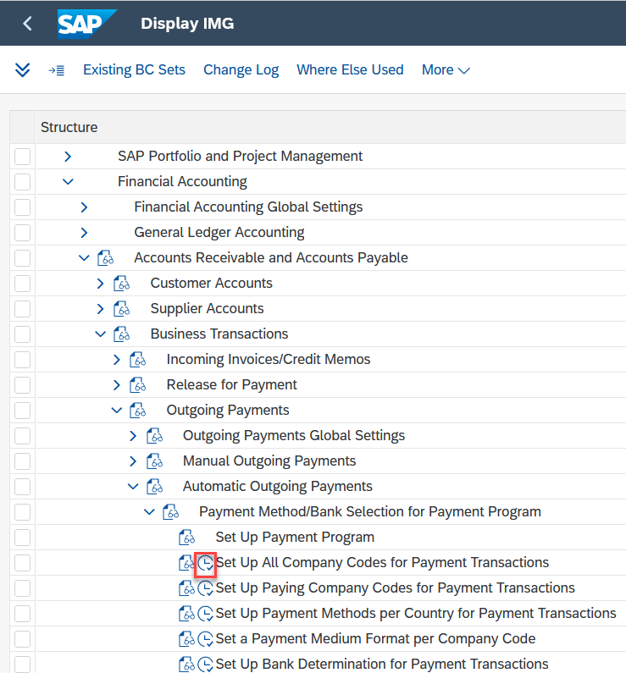
- In the Change View “Company Codes”: Overview screen, click on the icon
- In the New Entries: Details of Added Entries screen, enter the following information:
 |  | US##  US##  US##
  Attribute | Data value
  Company code | Your Global Bike Inc. (US##)
  Sending company code | Your Global Bike Inc. (US##)
  Paying company code | Your Global Bike Inc. (US##)
- Click on . You will receive a message that says .
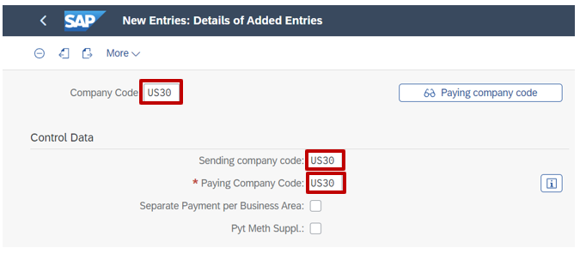
- Click on to return to the SPRO menu.

 | I.2.2 Define Account Groups
Task Define G/L account groups for Global Bike. Time 20 min
The next task is to define G/L account groups in order to group similar G/L accounts such as Liquid Assets or Material accounts. |  | Motivation
- In the Display IMG screen, follow the menu path:  SAP Customizing Implementation Guide ► Financial Accounting ► General Ledger Accounting ► Master Data ► G/L Accounts ► Preparations ► Define Account Group |  | Menu path
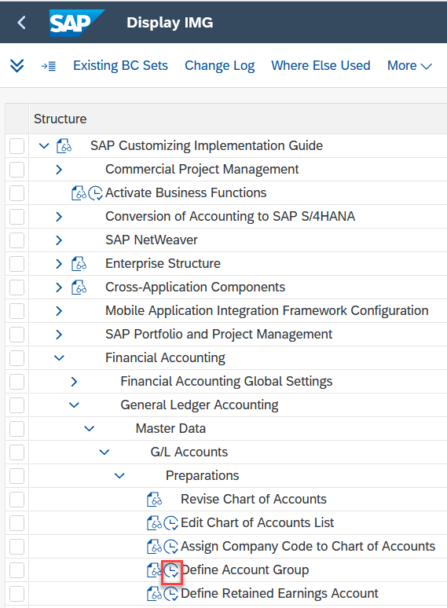
- In the Change View “G/L Account Groups”: Overview screen, click on the icon.
- In the New Entries: Overview of Added Entries screen, enter in the following information:
Chrt/  Accts | Acct  Group | Name | From Acct | To A00ccount
GL## | 00 | ## Capital Asset Accounts | 100000 | 999999
GL## | 01 | ## Current Asset Accounts | 1000000 | 1999999
GL## | 02 | ## Property Capital Accounts | 2000000 | 2999999
GL## | 03 | ## Outside Capital Accounts | 3000000 | 3999999
GL## | 04 | ## Revenues | 4000000 | 4999999
GL## | 56 | ## Operating Expenditure | 5000000 | 6999999
GL## | 07 | ## Other Revenue & Expenditure | 7000000 | 7999999
GL## | 08 | ## Secondary Costs | 8000000 | 8999999
GL## | 09 | ## Carry-Forw., Cap. & Statist | 9000000 | 9999999

- Click on . You will receive a message that says .
- Click on to return to the SPRO menu.

 | I.2.3 Create Document Number Ranges for Financial Accounting
Task Set up the number ranges for financial accounting documents. Time 5 min
For every business transaction with effect on Financial Accounting, at least one financial document needs to be created. In order for these documents to be uniquely identifiable, a number range has to be defined. |  | Motivation
- In the Display IMG screen, follow the menu path:  SAP Customizing Implementation Guide ► Financial Accounting ► Financial Accounting Global Settings ► Document ► Document Number Ranges ► Copy to Company Code |  | Menu path
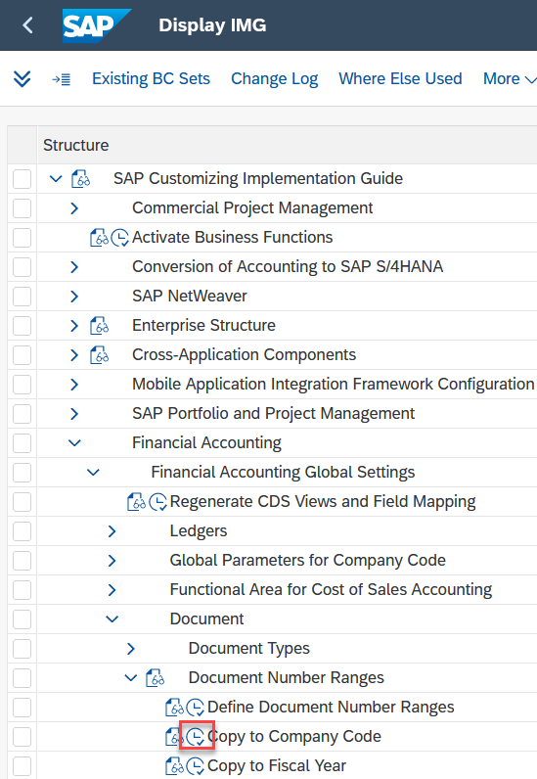
- In the Document Number Ranges: Copying to Company Code screen, enter the following information:
 |  | US00  US##
  Attribute | Data value
  [Source company code details] Company Code | US00
  [Target company code details] Company code | Your Global Bike Inc. (US##)
- Proceed by clicking on . In the Copy document number ranges pop-up, click on the 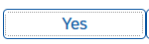 icon.
- Click on twice to return to the SPRO menu.

 | I.2.4 Create Document Number Ranges for Controlling
Task Set up the number ranges for managerial accounting documents. Time 5 min
For every business transaction with effect on Managerial Accounting, at least one controlling document needs to be created. In order for these documents to be uniquely identifiable, a number range has to be defined. |  | Motivation
- In the Display IMG screen, follow the menu path:  SAP Customizing Implementation Guide ► Controlling ► General Controlling ► Organization ► Maintain Number Ranges for Controlling Documents |  | Menu path
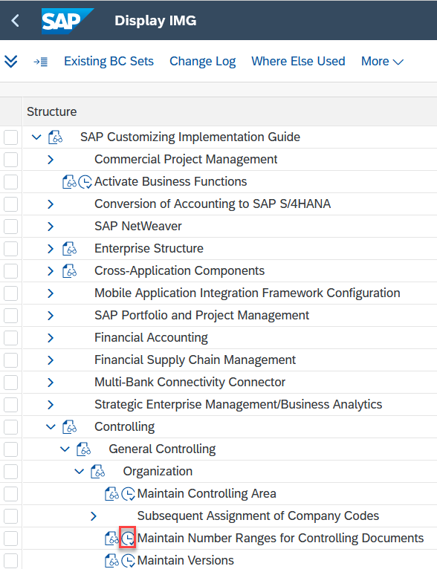
- In the Edit Intervals: CO Document, Object RK_BELEG screen, enter NA00 in the CO Area field and click Copy Subobject icon . |  | NA00
- In the Copy: CO Area pop-up, enter the following information:
 |  | NA00  NA##
  Attribute | Data value
  From… | NA00
  To… | Your GBI North America (NA##)
- Proceed by clicking on .
- In the Number Range Interval Transport pop-up, click on the icon. You will receive a message (“CO Area NA00 was copied to NA##”)
- Click on to return to the SPRO menu.

 | I.2.5 Define Tolerance Groups for Employees
Task Define tolerance groups for GBI accounting documents. Time 10 min
To solve the system issue identified before the start of the implementation project, tolerance groups need to be defined and monitored in the SAP ERP system. |  | Motivation
- In the Display IMG screen, follow the menu path:  SAP Customizing Implementation Guide ► Financial Accounting ► Financial Accounting Global Settings ► Document ► Tolerance Groups ► Define Tolerance Groups for Employees |  | Menu path
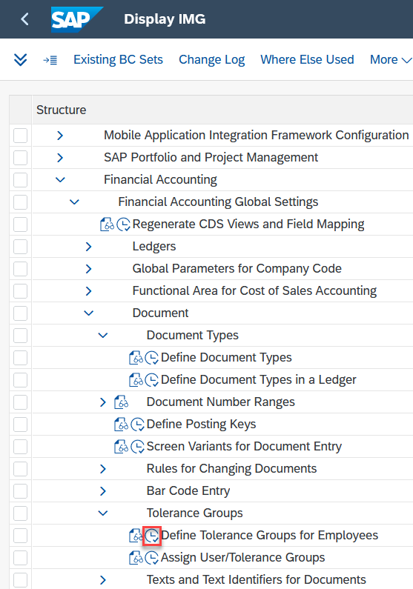
- In the Change View “FI Tolerance Groups for Users”: Overview screen, click on the icon.
- In the New Entries: Details of Added Entries screen, enter the following information:
 |  | US##  500000  100000  5  100  10  10  100  10  10
  Attribute | Data value
  Company code | Your Global Bike Inc. (US##)
  Amount per document | 500000
  Amount per open item account item | 100000
  Cash discount per line item | 5
  Revenue Amount | 100
  Revenue Percent | 10
  Revenue Cash discnt. adj. to | 10
  Expense Amount | 100
  Expense Percent | 10
  Expense Cash discnt adj. to | 10
- Click on . You will get a message that says
- Click on to return to the SPRO menu.

 | Phase I.3 – Master Data
Task Enter or load Global Bike master data. Time 90 min
Short Description Migrate Global Bike’s master data for Financial Accounting from the legacy system to the S/4HANA system.
Name (Position) Mona Falco (System Design and Development Manager)
Sarah Garcia (Business Analyst 2)
[external] (Junior SAP FI/CO consultant)
After the enterprise structure and the business processes for the Financial Accounting department were configured in the system, now the financial master data needs to be migrated from the old system(s). |  | Scenario setting
Master Data  Process  Execution  Process  Configuration  Enterprise Structure  Table of Contents  Phase I.3 - Master Data 51  I.3.1 Define Retained Earnings Account 52  I.3.2 Create Balance Sheet G/L Accounts 54  I.3.3 Create Standard Hierarchy 57  I.3.4 Create Cost Element Groups 61  I.3.5 Open Posting Periods 64  I.3.6 [OPTIONAL] Close Posting Period 66 |  | Project structure

 | I.3.1 Define Retained Earnings Account
Task Set the retained earnings account for Global Bike. Time 5 min
In this task, you define a retained earnings account in your new chart of accounts. A retained earnings account is the net income that is reinvested into the company. Your retained earnings account is assigned to each profit and loss account by specifying a profit and loss statement account type in the chart of accounts area of each profit and loss account. The balance is then carried forward at the end of the fiscal year from the profit and loss account to this account. |  | Motivation
- In the Display IMG screen, follow the menu path:  SAP Customizing Implementation Guide ► Financial Accounting ► General Ledger Accounting ► Master Data ► G/L Accounts ► Preparations ► Define Retained Earnings Account |  | Menu path
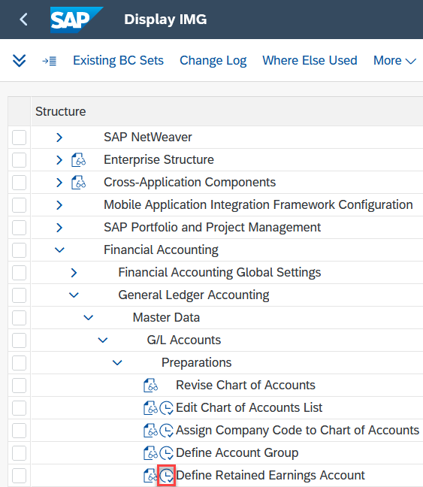
- When the system prompts you to enter your chart of accounts, please enter GL##. |  | GL##
- In the Configuration Accounting Maintain: Automatic Posts - Accounts screen, enter the following information:
 |  | RE  2970000
  Attribute | Data value
  P&L statmt acct type | RE
  G/L Account | 2970000
- Click on . You will get a message that says . Confirm this message with Enter.
- You will then receive the following message:
- Click on to return to the SPRO menu.

 | I.3.2 Create G/L Accounts
Task Create relevant Balance Sheet G/L accounts for GBI. Time 10 min
In this task, you will select general ledger accounts from the Balance Sheet account group that GBI needs in the US. The general ledger consists of all of the financial transactions in a business. The Balance Sheet account groups as previously defined (step I.2.2) include Fixed Assets, Liquid Assets and Material Accounts. |  | Motivation
- In the Display IMG screen, follow the menu path:  SAP Customizing Implementation Guide ► Financial Accounting ► General Ledger Accounting ► Master Data ► G/L Accounts ► G/L Account Creation and Processing ► Create G/L Accounts with Reference |  | Menu path
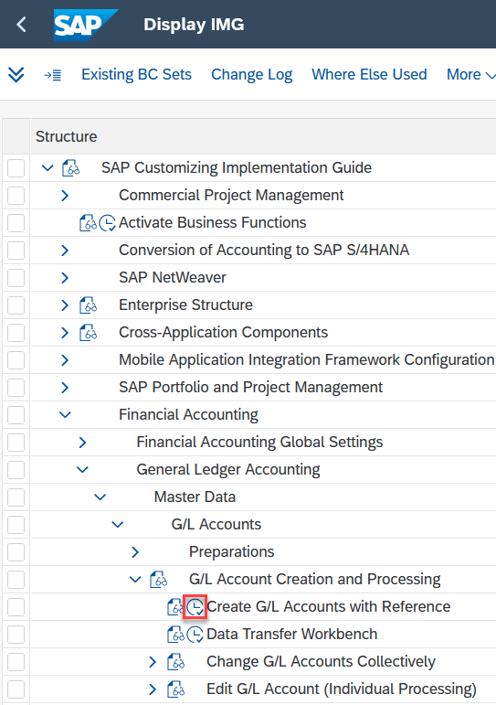
- When the system prompts you to enter your chart of accounts, please enter GL##. |  | GL##
- In the Create G/L Accounts with Reference - Overview screen, enter the following information:
 |  | US##  US00
  Attribute | Data value
  Company Code | Your Global Bike Inc. (US##)
  Reference company code | Global Bike Inc. (US00)
- Click on .
- In the Information pop-up with the message “Data saved”, click on the  icon.
- In the Create G/L accounts with Reference – Overview” screen, highlight the US## row, click on (Details).
- In the “Create G/L accounts with Reference – Accounts” screen, click on the 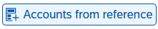 icon.
- In the “Using Reference Accounts in Table” pop-up, enter the following information:
 |  | 0000000  9999999
  Attribute | Data value
  From G/L acct | 0000000
  To | 9999999
- Click on .
Note: Be aware that within the new data model of S/4HANA primary and secondary cost elements share the same master data model as accounts. For this reason, the cost elements are created in this step.
- In the Create G/L accounts with Reference – Accounts screen, click on the 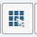 (Select All) icon.
- Click on 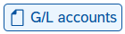. If this icon is not displayed on your application toolbar, click 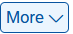 and select Create G/L Accounts.
Note: If you get a message, in the Table of the G/L accounts in the company code: Display messages pop-up, click on the icon.
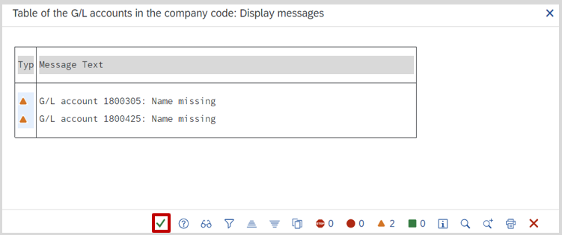
Then deselect all the G/L accounts concerned without short text and G/L Acct long text.
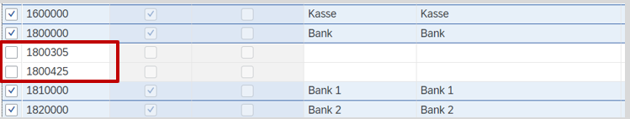
Depending on which case studies you have already performed in the system, the number of accounts that need to be deselected may vary.

- In the Create G/L accounts with Reference – Accounts screen, click on the icon.
- In the Information pop-up, click on the icon.
- Click on to return to the SPRO menu.

 | I.3.3 Create Standard Hierarchy
Task Create the standard (cost center) hierarchy for Global Bike. Time 20 min
As it was defined that the two regional Global Bike subsiduaries (US and Germany) control their companies separately, in this task the standard hierarchy for North America is created. |  | Motivation
- In the Display IMG screen, follow the menu path:  SAP Customizing Implementation Guide ► Controlling ► Cost Center Accounting ► Master Data ► Cost Centers ► Define Cost Center Groups |  | Menu path
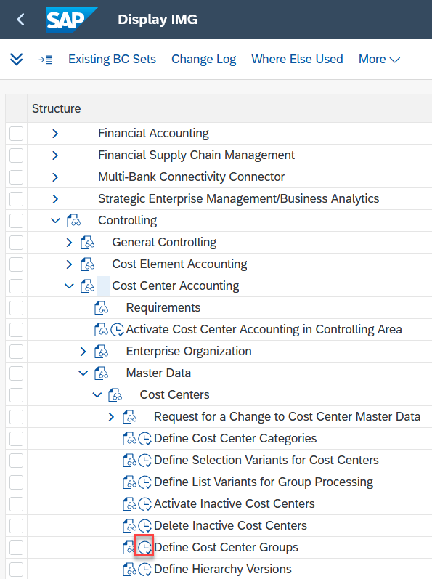
- In the Select Activity: screen double-click Change Cost Center Group.
- If requested by the system, enter Controlling Area NA## and Cost Center Group NA##. If you can not enter NA## as Controlling Area, please follow the path below to set the controlling area NA##:  More ►Extras ► Set Controlling Area |  | NA##
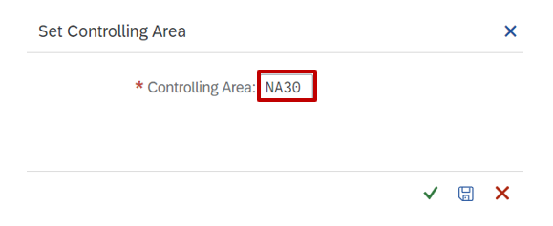
- In the Change Cost Center Group: Initial screen, enter NA## as the cost center group. |  | NA##
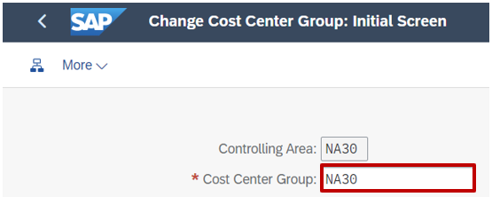
- Click on :
- In the Change Standard Hierarchy (Cost Centers Group): Structure screen, enter the following information:
 |  | ## GBI North America CCtr Std. Hierarchy
  Attribute | Data value
  Short Description of Group | ## GBI North America CCtr Std. Hierarchy
- Click . You will get a message that says 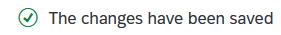.
- Click on 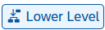.
If this icon is not displayed on your application toolbar, click 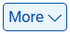 and select “Insert Cost Center Group on lower level”.
- Enter the following information.
 |  | N10##  ## Corporate
  Attribute | Data value
  Group Name | N10##
  Short Description of Group | ## Corporate
- In the hierarchy structure, click on the element you have just created (N10##) and .
- At the bottom of the screen, enter the following information:
 |  | N11##  ## Executive Board
  Attribute | Data value
  Group Name | N11##
  Description of Group | ## Executive Board
- Right-click on N11## and select Insert Cost Center from the drop-down menu.
- Enter the following information in the Create Cost Center (Group: N11##) screen.
 |  | NAEX10##  Current Date  12/31/9999
  Attribute | Data value
  Cost Center | NAEX10##
  Valid From | Current Date
  Valid To | 12/31/9999
- Then click on .
- In the Create Cost Center: Basic Screen, enter the following information in the Basic Data tab.
 |  | ## John Davis  ## NA Executive: John Davis  ## John Davis  W  BI##  USD
  Attribute | Data value
  Name | ## John Davis
  Description | ## NA Executive: John Davis
  Person Responsible | ## John Davis
  Cost Center Category | Administration (W)
  Business Area | Your Bikes (BI##)
  Currency | USD
- On the Control tab, enter the following information.
 |  | Deselected
  Attribute | Data value
  Commitment Update | Deselected
- Click on .
- Then click on  and you will get the message:
- Right-click on N11## again and click on Insert Cost Center in order to create a second cost center.
- Enter the following information in the Create Cost Center (Group: N11##) screen.
 |  | NAEX20##  Current Date  12/31/9999
  Attribute | Data value
  Cost Center | NAEX20##
  Valid From | Current Date
  Vadid To | 12/31/9999
- Click on.
- In the Create Cost Center: Basic Screen, enter the following information in the Basic Data tab.
 |  | ## Peter Schwarz  ## NA Executive: Peter Schwarz  ## Peter Schwarz  W  BI##  USD
  Attribute | Data value
  Name | ## Peter Schwarz
  Description | ## NA Executive: Peter Schwarz
  Person Responsible | ## Peter Schwarz
  Cost Center Category | Administration (W)
  Business Area | Your Bikes (BI##)
  Currency | USD
- In the Control tab, enter the following information.
 |  | Deselected
  Attribute | Data value
  Commitment Update | Deselected
- Click on . Save these changes by clicking on . You will get a message that says
- You can run the OKEON transaction from the SAP Easy Access menu to view all saved changes to the Standard hierarchy.
- Refer to Appendix A for the complete list of standard hierarchy elements that need to be created for Global Bike. From the overall structure, complete group N10## including  - sub-groups N11## and N12## as well as  - cost centers NAEX10##, NAEX20##, and NAIS10##. |  | Appendix A
Note: Now the first three cost centers, which were the task of Sarah Garcia, are created. Please now create all the other standard hierarchy elements from Appendix A. All cost centers that are necessary for the execution of the processes have been marked in color. These are the minimum cost centers that must be created to ensure all phases run smoothly.  Make sure that the attributes "Actual Revenues" and "Plan Revenues" are deselected for the cost centers NAPL10## and NAGS10##. |  | Appendix A

 | I.3.4 Create Cost Element Groups
Task Create cost element groups for Global Bike. Time 15 min
Cost element groups categorize cost elements and help manage them. |  | Motivation
Note: Since the introduction of SAP S/4HANA, the way in which cost elements are managed has changed. Cost elements are now managed directly in the chart of accounts as income and expense accounts and are no longer maintained separately in Controlling. The G/L accounts are therefore used for postings in Financial Accounting (FI) and Controlling (CO) at the same time.
- In the Display IMG screen, follow the menu path:  SAP Customizing Implementation Guide ► Controlling ► Cost Center Accounting ► Planning ► Group Maintenance ► Define Cost Element Groups |  | Menu path
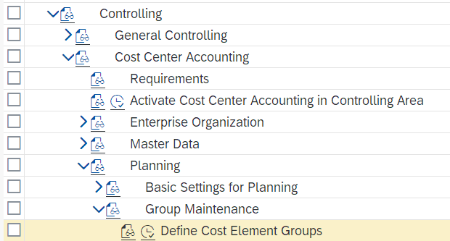
- In the Select Activity pop-up, double-click on Create Cost Element Group.
- If the Set Controlling Area pop-up is displayed, then enter the data below:
 |  | NA##
  Attribute | Data value
  Controlling Area | Your Controlling Area (NA##)
- Click on .
- In the Create Cost Element Group: Initial Screen screen, enter the following information:
 |  | NA10##
  Attribute | Data value
  Cost Element Group | NA10##
- Click on .
- In the Create Cost Element Group: Structure screen, enter the following information:
 |  | ## NA Cost Element Total
  Attribute | Data value
  Short description of a set | ## NA Cost Element Total
- Click on the (Insert Cost Element Group on lower level) icon.
- Enter the following information:
 |  | NASECO10##  ## NA Secondary Cost Element Total
  Attribute | Data value
  Set Name | NASECO10##
  Short description of a set | ## NA Secondary Cost Element Total
- Click on the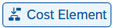 (Insert Cost Element) icon.
- Enter the following information:
 |  | 8000000  8999999
  Attribute | Data value
  From Value | 8000000
  To Value | 8999999
- Click on . You will get a message that says
- Click on NA10##. |  | NA10##
- Click on the icon (Insert Cost Element Group on lower level).
- Enter the following information:
 |  | NAPRIM10##  ## NA Primary Cost Element Total
  Attribute | Data value
  Set Name | NAPRIM10##
  Short description of a set | ## NA Primary Cost Element Total
- Click on the icon (Insert Cost Element).
- Enter the following information:
 |  | 5000000  6999999
  Attribute | Data value
  From Value | 5000000
  To Value | 6999999
- Click on . You will get a message that says:
- Click on to return to the SPRO menu.

 | I.3.5 Open Posting Periods
Task Open periods for G/L posting. Time 5 min
After you defined the fiscal year variant K1 for the controlling area (in task I.1.4) as well as for the company code (in task I.1.8) and after you set up the posting period variant for Global Bike (in task I.1.6), you can now open the posting periods. |  | Motivation
- In the Display IMG screen, follow the menu path:  SAP Customizing Implementation Guide ► Financial Accounting ► Financial Accounting Global Settings ► Ledgers ► Fiscal Year and Posting Periods ► Posting Periods ► Open and Close Posting Periods |  | Menu path
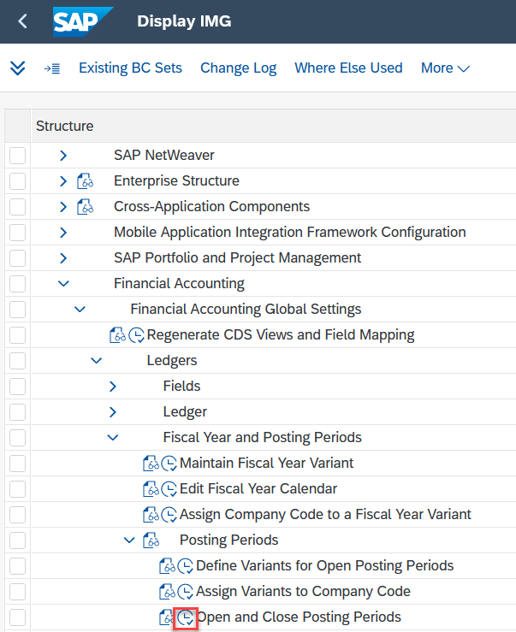
- If the Determine Work Area: Entry screen appears, enter your posting period variant (GL##) in the Pstng period variant field. |  | GL##
- Click .
- In the Change View “Posting Periods: Specify Time Intervals”: Overview screen, click on the icon.
- In the New Entries: Overview of Added Entries screen, enter the following information:
 |  | +  1  Current Year  12  9999  13  Current Year  13  9999
  Attribute | Data value
  A (Account Type) | Valid for all account types (+)
  From per. 1 | 1
  Year | Current Year
  To period | 12
  Year | 9999
  From per. 2 | 13
  Year | Current Year
  To period | 13
  Year | 9999
- Click on . You will get a message that says .
- To exit the Customizing menu, click on three times and go back to the SAP Easy Access menu.

 | I.3.6 [OPTIONAL] Close Posting Period
Task Close posting periods, if necessary. Time 5 min
As all other accredited accounting systems, S/4HANA uses periods (months for the most cases) to separate and close financial transactions over a given period of time. At the end of a month, this period needs to be closed in Financial Accounting. This task is called Period Closing. |  | Motivation
Note You only need to perform this task if the current month ends during your class or project. Without closing that period, you are not able to post financial statements in the new month.
- In the customizing area open the app Close Period for Material Master Records: |  | Menu path
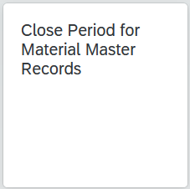
- In the Close Period for Material Master Records screen, enter the data below:
 |  | US##  US##  Current Month  Current Year
  Attribute | Data value
  From company code | Your Global Bike Inc. (US##)
  To company code | Your Global Bike Inc. (US##)
  Period | Current Month
  Fiscal Year | Current Year
  Close period only | Selected
- Click on .
- If successful, you will see on the Close Period for Material Master Records screen:
- Click twice on to return to Fiori Launchpad.

 | Phase I.4 – Process Execution
Task Process Financial Accounting transactions. Time 35 min
Short Description Test your system configuration by running some FI transactions.
Name (Position) Sarah Garcia (Business Analyst 2)
After organizational data (enterprise structure & process configuration) and master data have been implemented in S/4HANA, it is time to test the system by creating transactional data (process execution). |  | Scenario setting
Process  Execution  Process  Configuration  Master Data  Enterprise Structure  Table of Contents  Phase I.4 - Process Execution 67  I.4.1 Display General Ledger Accounts 68  I.4.2 Display Balance I 70  I.4.3 Enter General Ledger Account Posting 71  I.4.4 Display Balance II 74 |  | Project structure

 | I.4.1 Display General Ledger Accounts
Task Review some individual G/L accounts. Time 10 min
Check whether you can find and display the G/L accounts you created for your US company code in task I.3.2. |  | Motivation
To view G/L account balances, use the Manage G/L Account Master Data app in the Financial Accounting on the Accounts Payable page in the Head of Accounting role. |  | SAP Fiori
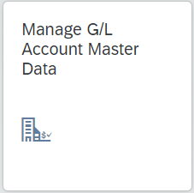
- In the Manage G/L Account Master Data screen, enter the data below:
 |  | GL##  1810000
  Attribute | Data value
  Chart of Accounts | GL##
  G/L Account | Your Bank Account (1810000)
- Click on 
- Review the account and verify that the information is correct with your configuration.
- Enter the following information:
 |  | GL##  6310000
  Attribute | Data value
  Chart of Accounts | GL##
  G/L Account | Rent (6310000)
- Click on .
- Review the account and verify that the information is correct with your configuration.
- Now click on  and you will return to the SAP Fiori menu.

 | I.4.2 Display Balance I
Task Display the balance for one of your G/L accounts. Time 5 min
Check the current balance of your bank account before we are going to enter a G/L posting. |  | Motivation
To view the current balance of your bank account, use the Display G/L Account Balances app in the Financial Accounting on the Accounts Payable page in the AP Accountant role. |  | SAP Fiori
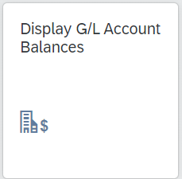
- In the G/L Account Balances screen, enter the data below:
 |  | 0L  US##  1810000  Current Year  NA##
  Attribute | Data value
  Ledger | 0L (Leading Ledger)
  Company Code | Your Company Code (US##)
  G/L Account | Your Bank Account (1810000)
  Ledger Fiscal Year | Current Year
  Controlling Area | NA##
- Click on .
- Now click on and you will return to the SAP Fiori menu.

 | I.4.3 Enter General Ledger Account Posting
Task Use your new G/L accounts in some postings. Time 15 min
In this task, you post various entries to your General Ledger to test settings in the system. |  | Motivation
To enter the G/L Account posting, use the Post General Journal Entries app in the Financial Accounting on the Accounts Payable page in the Head of Accounting role.  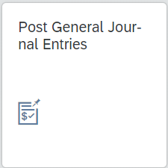 |  | SAP Fiori
- On the Post General Journal Entries screen, please enter the data below:
- in the header data:
 |  | Current Date  US##  Current period  USD  0L
  Attribute | Data value
  Journal Entry Date | Current Date
  Company Code | US##
  Period | Current period
  Transaction Currency | USD
  Ledger Group | 0L
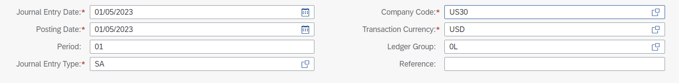
- in the Line Items:
 |  | US##  1810000  60000  US##  2000000  60000
  Attribute | Data value
  1 Company Code | US##
  G/L Account | Bank 1 (1810000)
  Debit | 60000
  2 Company Code | US##
  G/L Account | Fixed capital (2000000)
  Credit | 60000
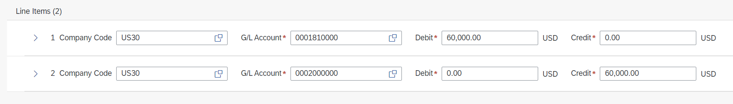
- Click on . You will receive a message that says:
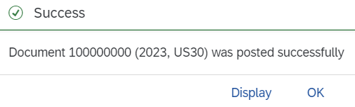
- On the Post General Journal Entries screen, please enter the data below:
- in the header data:
 |  | Current Date  Current period  0L
  Attribute | Data value
  Journal Entry Date | Current Date
  Period | Current period
  Ledger Group | 0L
- in the Line Items:
 |  | US##  6310000  500  NAAD10##  US##  1810000  60000
  Attribute | Data value
  1 Company Code | US##
  G/L Account | Rent (6310000)
  Debit | 500
  Cost Center | NAAD10##
  2 Company Code | US##
  G/L Account | Bank 1 (1810000)
  Credit | 500
- Click on to the left of 1 company code to enter the cost center (NAAD10##) in the Account Assignment.
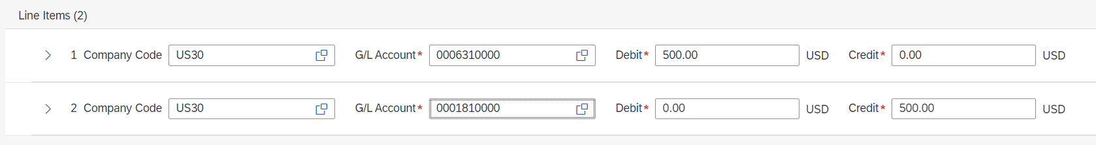
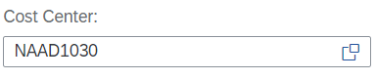
- Click on .
- You will receive a message that says:
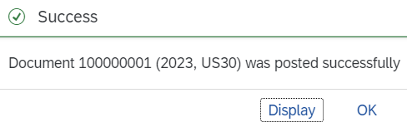
- Now click on and you will return to the SAP Fiori menu.

 | I.4.4 Display Balance II
Task Display the balance for one of your G/L accounts again. Time 5 min
Check the balance of your bank account after the G/L posting. |  | Motivation
To view the current balance of your bank account, use the Display G/L Account Balances app in the Financial Accounting on the Accounts Payable page in the AP Accountant role. |  | Fiori App
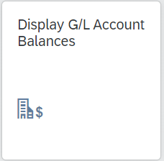
- In the G/L Account Balances screen, enter the data below:
 |  | 0L  US##  1810000  Current Year  NA##
  Attribute | Data value
  Ledger | 0L (Leading Ledger)
  Company Code | US##
  G/L Account | Bank 1 (1810000)
  Ledger Fiscal Year | Current Year
  Controlling Area | NA##
- Click on  . Review the account and check the Total Debit and the Total Credit balance.
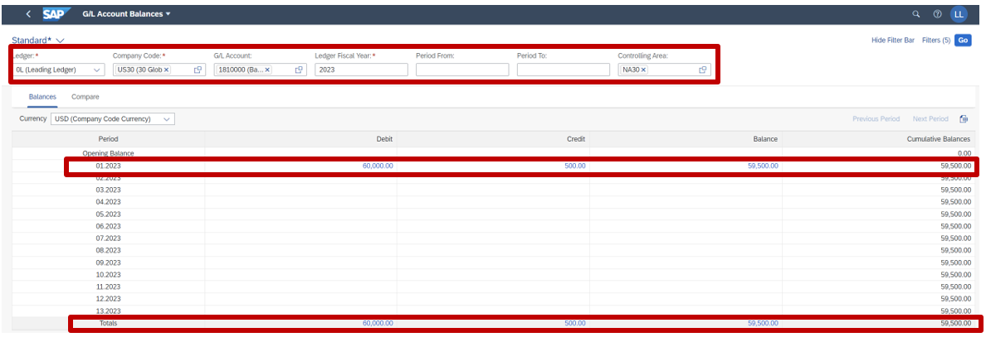
- Now click on and you will return to the SAP Fiori menu.

