

S/4HANA Configuration Case
Phase III – Scenario
In this third phase, a basic Fulfillment process is implemented in S/4HANA according to Global Bike specifications. Enterprise structures and business processes are set up in the S/4HANA system, master data is loaded and the end-to-end process is tested.

Product  S/4HANA 2023  Global Bike  Fiori 3.0  Level  Intermediate  Advanced  Focus  ERP Configuration  Sales and Distribution  Author  Simha Magal  Stefan Weidner  Version  4.3  Last Update  August 2025 | MOTIVATION  After Global Bike has approved and kicked of the implementation project with phases I and II (financial accounting and procurement), the next process is fulfillment within the Sales and Distribution module of S/4HANA.  Similar to phase II, conversations between Global Bike employees help you understand current issues in the organization and existing systems. |  | PREREQUISITES  It is highly recommended to have worked through phase 0 of the ERP Configuration Case. In order to relate the ERP implementation of Fulfillment to real tasks in Global Bike and their mapping to ERP processes. It is also recommended to complete the Introduction to ERP using GBI curriculum material for the SD module (chapter 4).  NOTES  This case study uses the Global Bike data set which has been created for SAP UA global curricula exclusively.  ACKNOWLEDGEMENT  This case study was prepared with the assistance of student interns at the Seidman ERP program at Grand Valley State University and research assistants at SAP UCC Magdeburg.



Step 1: Introduction to GBI Configuration Case
Learning Objective Understand objective and structure of ERP configuration Time 15 min case.
Overall Case Objective The ERP configuration case intends to develop a basic understanding of ERP implementation projects based on a comprehensive scenario in a fictitious mid-size company (Global Bike). Based on theoretical concepts taught in lectures the case provides real-life conversations within and across Global Bike departments for students to identify and analyze problems in business processes in order to derive possible solutions. After the best solution has been selected it is configured in the S/4HANA system.
Overall Case Structure As visualized in the graphic below, the introductory part (Phase 0) of the ERP Configuration Case is independent of any specific ERP solution and any functional module. It consists of a case study document and lecturer notes.
The subsequent phases focus on ERP configuration tasks for specific functional areas such as Financial Accounting, Procurement and Fulfillment. They are executed in a particular S/4HANA module like FI (Finance), MM (Materials Management) and SD (Sales and Distribution).
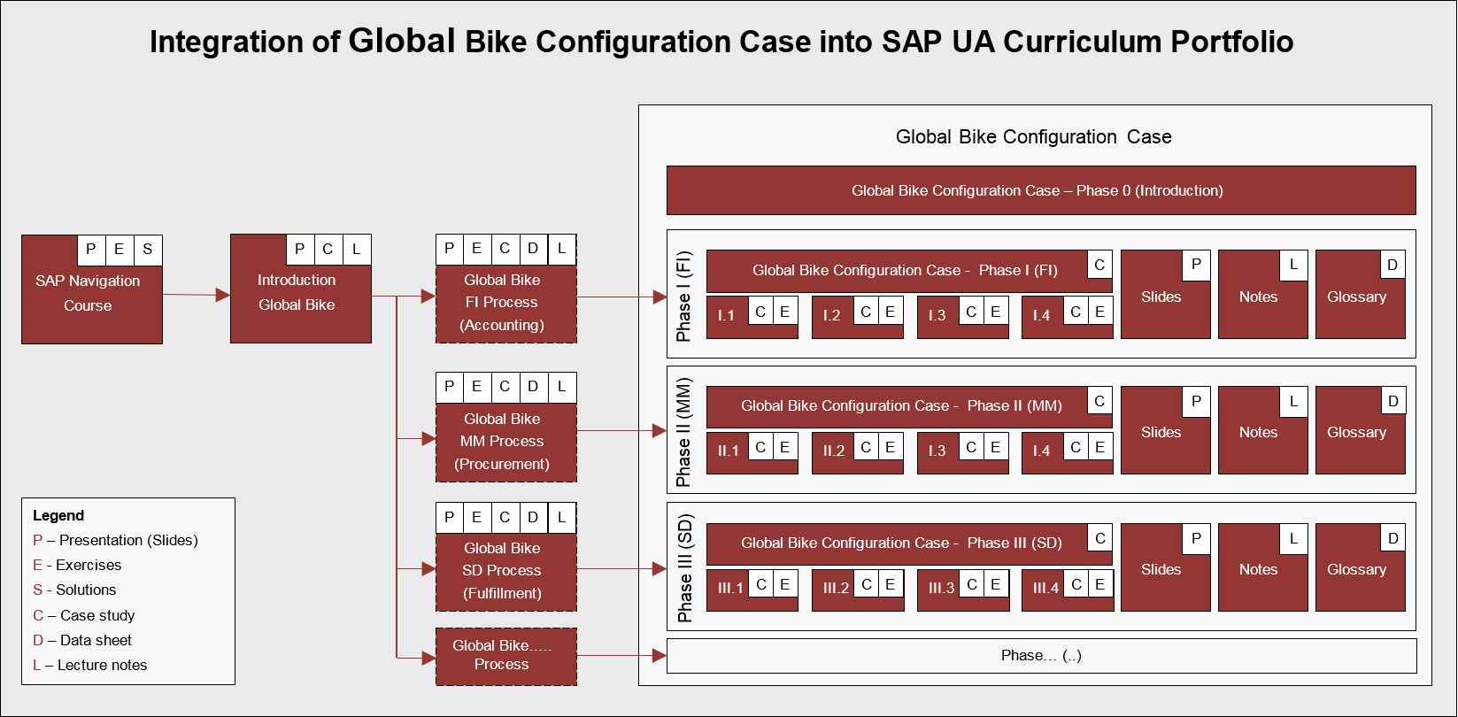
Other than Phase 0 for which no prerequisites are necessary before you start with the actual configuration phases, you should have had previous exposure to the S/4HANA system and ERP process execution (presentations, exercises and case studies), preferably using the Global Bike dataset.
All phases except the introduction follow the same structure (as shown in the detailed graphic below): phase-specific scenario (case study), handbook (exercises) and a glossary (data sheet) together with slides and lecturer notes.
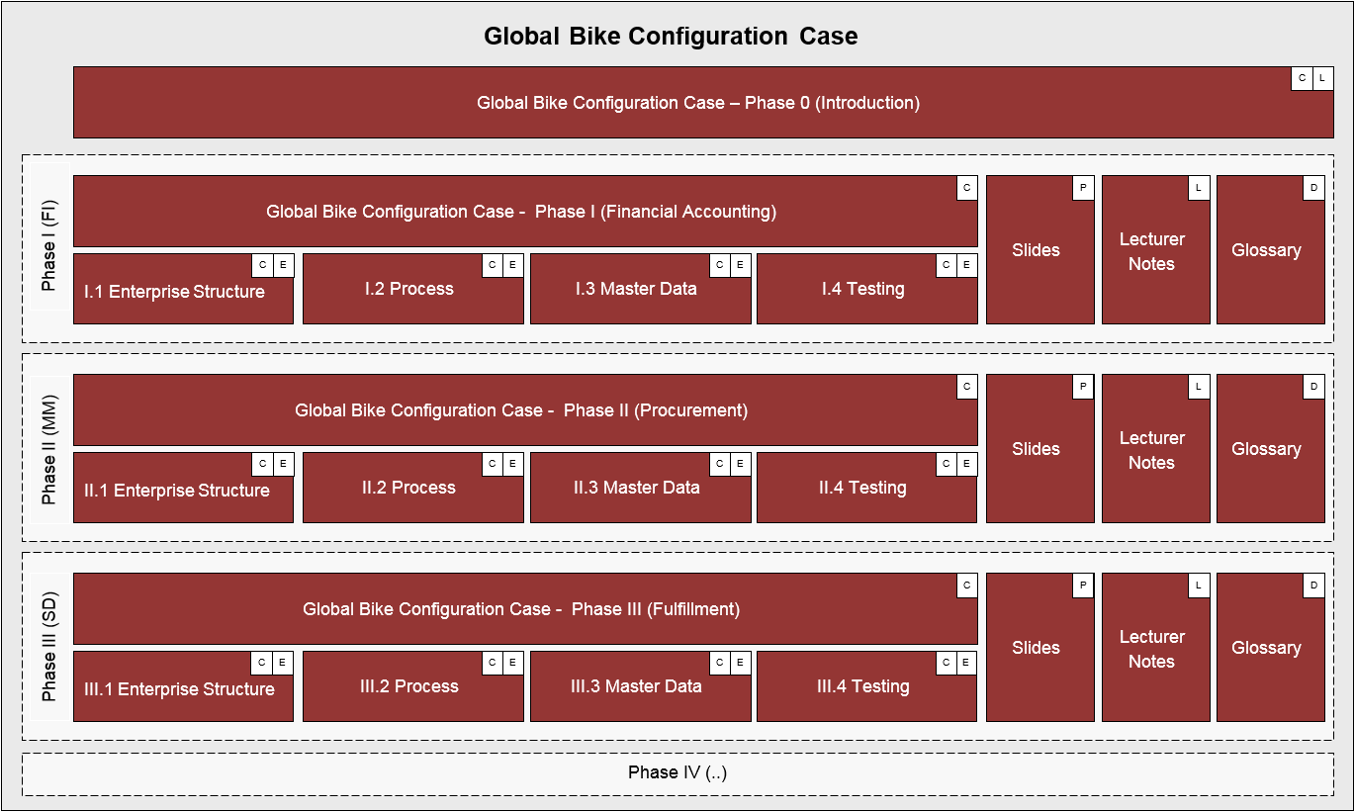
Case Study Objective Whether or not you already have previous ERP knowledge or practical experience, an introduction to the company’s organizational structures as well as its business processes is necessary. Thus, it is recommended, but not mandatory to go through the introductory case study (Phase 0) which helps develop scenario analysis, critical thinking and project planning skills in the ERP implementation domain.
This third implementation case study (Phase III) starts with the basic implementation of Fulfillment in an S/4HANA system in order for you to understand the implications of sales business activities. By doing so, you will acquire the following skills:
- ERP proficiency, e.g. What is the highest summation level for the sales function in an S/4HANA system?
- ERP configuration skills, e.g. How to create a new organizational unit in an S/4HANA system?
- Project-driven and scenario-based integration of tasks in complex environments, e.g. Why do
we need to assign a sales organization to a company code in S/4HANA?
Case Study Structure This case study is structured in 5 steps as visualized below. Similar to phases I and II, it presents a realistic scenario between different Global Bike departments for which all issues, problems and a reference solution need to be found (Steps 2 to 4).
Similar to phases I and II, this case study provides a detailed description of how to implement units and a fulfillment process in the S/4HANA system. In order to help you understand different aspects and degrees of detail throughout the case study, three separate documents were created.
The scenario (this case study document) guides you through the overall learning process along realistic project steps (here steps 2 to 4). It refers to two other documents; the handbook and the glossary. The handbook consists of a sequence of interdependent tasks to configure the S/4HANA system, to add master data and to test the business process, in this case Fulfillment. In order to keep the scenario document lean, all common or technical definitions were compiled into one glossary document which can be used as a reference guide.
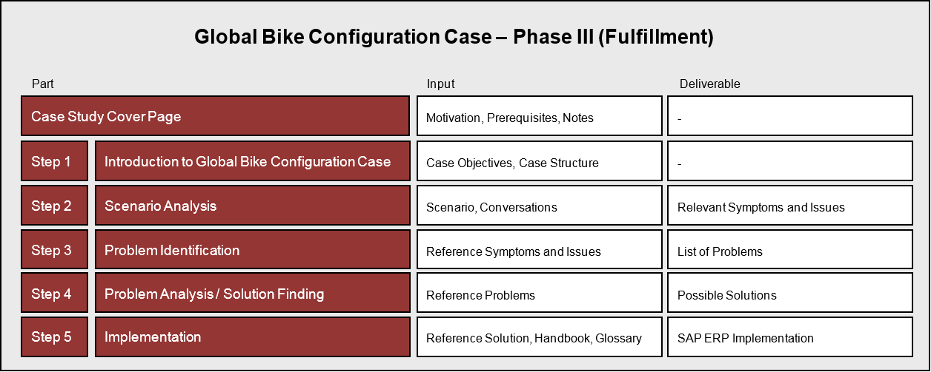

 | Step 2: Scenario Analysis
Task Read the scenario and highlight the most important and relevant Time 45 min information.
Short Description Read through the scenario and critically analyze the challenges employees are facing in this unit. Focus particularly on the core statements during the conversation.
Name (Position) Susanna Castro (Dallas WH Receiving Clerk)
David Lopez (US East Sales Representative)
Juriko Hamada (Dallas WH Shipping Clerk)
Ricardo Robles (Dallas WH Warehouse Supervisor)
Jun Lee (Production Supervisor)
Units involved Warehouse Dallas, Production, Sales US East
Before you start analyzing the Fulfillment scenario, you should be familiar with the overall company structure and know the gaps that exist in the organizational units prior to this implementation process. Thus, it is recommended to have read and understood the GBI story document (see Phase 0 Step 2). You may skip this step if you have already used other GBI curricula and feel that you are well informed about the company.  The projected heuristics ‘forecasting sales and demand’ are based on previous year demand. Occasionally, the company receives more requests to cover unusual events that were not planned for. In this case the Miami sales office saw, in the middle of the month, that they are running short on black touring bikes due to an unexpected high demand for them. |  | Global Bike Inc.
So, David Lopez (US East Sales Rep) contacted the Dallas plant to check whether they can produce and send 20 more in a week’s time. Susanna Castro (Dallas WH Receiving Clerk) processed the request and placed it on hold and was waiting for the order slip to confirm the order.
A problem arises when the truck driver arrives at the Dallas warehouse to pick up a shipment of 20 black touring bikes in order to deliver them to the Miami location. The driver presents the pickup order to Juriko Hamada (Dallas WH Shipping Clerk) and asks to start loading his truck. |  | Scenario setting I
DRIVER  “Hello, I am here to pick up the boxes for 20 finished black bikes for delivery to Miami.” |  | Driver
JURIKO  “Sure give me a second; I’ll look into it for you.” … “Hey Driver, are you sure you have a shipment scheduled to be picked up today?” |  | Juriko Hamada  [Shipping Clerk ]
DRIVER
“Yes, this is my sheet and I am scheduled for a pick up at your location. Here is a copy of my order.”

JURIKO
“Well, I don’t have any shipment ready for you. Let me check with Sue. Maybe she has more information that can help further locate the inventory.”
Juriko asks Susanna Castro (Receiving Clerk). After her checking the inventory using the computer system and doing a physical inventory count she cannot locate the demanded inventory. Finally, she decides to speak with Ricardo Robles (Warehouse Supervisor) to look into the problem. He in return calls Jun Lee (Production Supervisor) who also does not know about this order.
At the same time, the driver calls David Lopez (US East Sales Representative) to update him on the situation. As Miami is running out of stock, David decides to call Jun directly.
DAVID  “Hello Jun. this is David from the Miami sales office, How is it going?” |  | David Lopez  [US East Sales Rep]
JUN  “Same old same old, what’s up?” |  | Jun Lee  [Production Supervisor]
DAVID
“I got a call about the shipment of finished bikes that is not ready yet. The driver says you don’t show in your excel sheet any shipment to be ready for today. What happened? According to my excel list, I show that I should have 20 boxes of finished bikes two days ago. Why didn’t you have them ready?”
JUN
“Well, Ricardo already called me about what seems to be the same problem. I really don’t know what order you are referring to? Quite frankly, I don’t think we have any bikes, my log does not show any orders to have black touring bikes ready for delivery this week.”
DAVID
“Now we have a problem. I have my shipment plan here and according to that it shows bikes arriving at my store, so I need these boxes of bikes today. The Miami store is waiting on these bikes. All customers are waiting for their delivery.”

JUN
“Well according to my excel production plan I have no record of that order. How and when did you place the order?”
DAVID
“I called your place about four weeks ago. As you were away that day, I spoke with Sue. I placed the order directly with her.”

JUN
“Let me look into it and I’ll get right back to you.”
A few minutes later…
JUN
“Hi, I spoke with Sue and she does remember you calling and asking whether we can produce 20 more black bikes. According to Sue, she then ran your request against our preliminary production plan which we always create six weeks ahead of production. Sue says she told you that we are able to fulfill the order once we receive a fax copy of the order slip with your signature. Have you faxed the order?”
DAVID
“I thought I did. I was so busy that day that I may have forgotten to actually send it to you. Oh gosh. So, what now? We have backorders and customers will complain about the delay. Can you still help me?”
JUN
“I already checked our finished goods inventory and I have a buffer of 12 black bikes ready for shipment. I will start a rush production on the other 8 bikes and have them shipped to you by next week. That is the best I can do for you.”
DAVID
“If I don’t receive the 12 bikes by tomorrow then I cannot deliver them to the urgent customer this week which may lead to losing this particular customer. I only see two other options; either you send the bikes by FedEx Air or I need to give the client a huge discount to keep him/her happy. However, if you ask me, I would prefer the first option.
JUN
“Ok, I will start working on getting the production right away and put a rush shipment on and see if we can get it delivered to Miami by tomorrow forenoon.”
DAVID
“I appreciate that.”
JUN
“I will explain the situation to my manager and seek approval for the FedEx Air charges. I will keep you updated.”
DAVID
“Thanks a million. I owe you a drink next time you are in Florida.”
Eventually, production started right away and completed faster than usual. This happened at an expense of having extra personnel work overtime and place rush material orders to complete the production needed. Also, a rush delivery was scheduled to deliver the finished 12 black bikes to Miami overnight so that one customer received his/her bikes on time. |  | ]
The final delivery was completed sooner than promised but still came at a higher cost as those customers were compensated for the delay in receiving their bikes. Another 10 % discount was offered towards a future purchase.
RESULTS
- A shipment of 20 black touring bikes and deliver them to the Miami location
- Driver’s sheet shows pick up schedule
- Warehouse clerk does not show order on their log sheet
- Warehouse staff start checking inventory using computer system and perform a physical inventory count
- Order was called in 4 weeks ago
- Signed Order slip was not faxed by sales branch for confirmation
- The shipment will be sent out twice, first a bulk of 12 bikes inventory buffers
- Second shipment of 8 bikes will arrive a week later
- Added expenses of freight charges and personnel working overtime to complete the bikes on time.

 | Step 3: Problem Identification
Task Revisit the reference symptoms/issues and condense them into the problems Time 30 min
specific to this case.
Short Description You (in the role Mona Falco) need to come to a clear understanding of the most relevant symptoms in Fulfillment in order to identify the causes and underlying problems including the issue of delayed delivery to customer.
Name (Position) Bianca Cavarini (Chief Information Officer)
Mona Falco (System Design and Development Manager)
Following phase II, where Bianca Cavarini and Mona Falco helped implement procurement in S/4HANA, they have now moved on to the sales department. Bianca has given Mona the task to start analyzing the fulfillment processes in detail (project phase III).  Based on the reference highlights from the scenario in step 2 (listed below), identify together with your peers symptoms, causes and effects in Global Bike’s sales unit. |  | Scenario setting
Symptoms
- Miami sales office did not receive the 20 black bikes they requested from Dallas plant.
- Separate shipment’ of 20 bikes (12 bikes ready, 8 shipped a week later).
Particular effect
- Back order
- Delayed delivery to customer
- Higher shipping costs for two separate occasions
- Customer waiting time leading to customer dissatisfaction
- Cost of offering store credit to retain customer’s satisfaction
- Extra personnel working overtime
Underlying cause/problem
- Missing standardized computer system to simplify and collaborate the entries of different units
- Lack of communication
- Orders are taken manually by phone, fax and no system is in place to follow up on the orders either to confirm or cancel them

Corporate effect
- Re-occurring communication problems leading to lack of transparency of information and feedback.

 | Step 4: Problem Analysis / Solution Finding
Task Revisit the reference problems and identify possible solutions for Global Time 30 min Bike.
Short Description In the role of Mona Falco (System Design and Dev Manager) and Sarah Garcia (Business Analyst 2), analyze all relevant problems in Sales and Accounting and find possible solutions.
Name (Position) Mona Falco (System Design and Development Manager)
Sarah Garcia (Business Analyst 2)
Mona Falco and Sarah Garcia’s (Business Analyst) task is to revisit the problems and come up with a detailed structure for this project phase.  Based on the reference problems you identified in Step 3 (listed below), track, together with your peers, the connection between these symptoms across the sales unit, identify the source of each issue and its effects. |  | Scenario setting
Underlying cause/problem
- Missing standardized computer system to simplify and collaborate the entries of different units
- Lack of communication
- Orders are taken manually by phone, fax and no system is in place to follow up on the orders to confirm or cancel them
Corporate effect
- Re-occurring communication problems leading to lack of transparency of information and feedback accurate forecasting is possible

 | Step 5: Implementation Phase III
Task Revisit the reference solution and come up with a concrete implementation Time 10 min plan.
Short Description Mona Falco and Sarah Garcia are called upon to define the scope of implementing S/4HANA for Fulfillment at Global Bike. Therefore, in this phase they need to structure the project by defining steps and milestones.
Name (Position) Mona Falco (System Design and Development Manager)
Sarah Garcia (Business Analyst 2)
After the Global Bike executive board selected the S/4HANA solution and after Financial Accounting and Procurement have been implemented successfully in Phase I and II (respectively); the Fulfillment module was chosen as the next project. As for the first two projects, the US company is set up first (with Germany following later).  Based on the results of steps 2 to 4 and the reference solution (find below) this document presents the detailed project scenario. It offers links to the handbook with particular configuration steps in the S/4HANA system. Although optional, it is highly recommended to do these exercises to gain hands-on work experience in a live system. Please refer to the glossary for detailed definitions of terms that are frequently used in this case study. |  | Scenario setting  Handbook  for Glossary
Overall solution  The benefits of implementing an ERP system for Fulfillment are:  - Increase efficiency by streamlining and partially/fully automating business software processes for staff to focus on business operations and delays from correcting data.  - Increase accuracy of forecast sales and demand thus improving planning of sales and operational activities.  - Increase collaboration between different departments to avoid delays and to smooth the sales operations.  - Improve communication among employees hence optimize the accuracy of the forecast demand and the operation’s effectiveness. |  | Reference solution
According to best practices for ERP implementation projects, the S/4HANA system will be configured in the below order.  Process  Execution  Master Data  Process  Configuration  Enterprise Structure |  | Project structure

 | Phase 3.1 – Enterprise Structure
Task Define the Global Bike enterprise structure for Fulfillment and Time 30 min
prepare its configuration in the S/4HANA system.
Short Description Review Global Bike’s organizational structure and identify all relevant organizational units in Fulfillment. Then, map them to the organizational units available in S/4HANA.
Name (Position) Mona Falco (System Design and Development Manager)
Sarah Garcia (Business Analyst 2)
Global Bike operates (produces, procures, and sells) in two regions: the US and Germany. Global Bike Inc. in the US has three plants: one production facility in Dallas and two distribution centers in Miami and San Diego. Whereas Dallas stores raw materials, semi-finished goods, and finished goods, Miami and San Diego manage stocks for trading goods and finished goods. All three locations have additional storage space for miscellaneous materials. In Germany, Global Bike operates a manufacturing facility in Heidelberg and a distribution center in Hamburg with analogous storage spaces to the plant types in the States. |  | Scenario setting
Global Bike serves professional and “prosumer” cyclists for touring and off-road racing. Global Bike primarily assembles semi-finished goods into finished goods at its production facilities but also sells an accessories product line comprised of helmets, t-shirts and other riding accessories. Finished goods are either stored in the local warehouse or shipped to other regional distribution centers to fulfill customer orders.
During phase I the client, company code, business area and credit control area were set up. These elements form the foundation for the SAP logistical processes and more specifically the fulfillment function which is part of the Sales and Distribution module. |  | S/4HANA terminology
The first organizational unit specifically used in the fulfillment process is the sales organization which structures the company according to its sales requirements and is responsible for the sale of products and services.
A distribution channel is an organizational unit through which saleable materials or services reach the customer. One sales organization can have many distribution channels and a single distribution channel can be valid for several sales organizations.
A division organizes materials or services, for example to form product groups or lines and it establishes responsibility for profits from materials and services. Together, the sales organization, distribution channel and division form a sales area. This organizational unit is the bare minimum structure required to process a sales transaction in the sales and distribution module.
A shipping point is an organizational unit within which processing and monitoring of the deliveries as well as goods issue is carried out. Each delivery is processed by only one shipping point.
After Mona and Sarah analyzed and modeled Global Bike’s organizational structure and made themselves familiar with the SAP terminology, they are now in the process of linking both worlds in order to start the integration process. Again, for this part of the implementation project Mona and Sarah were asked to focus on the US region. |  | Linking Global Bike to SAP terminology
The client that was set up in phase I represents the Global Bike enterprise. Company code US00 links all business transactions (e.g. sales orders in this context) to financial accounting and is, for that reason, often mentioned in organizational charts for sales and distribution as well.
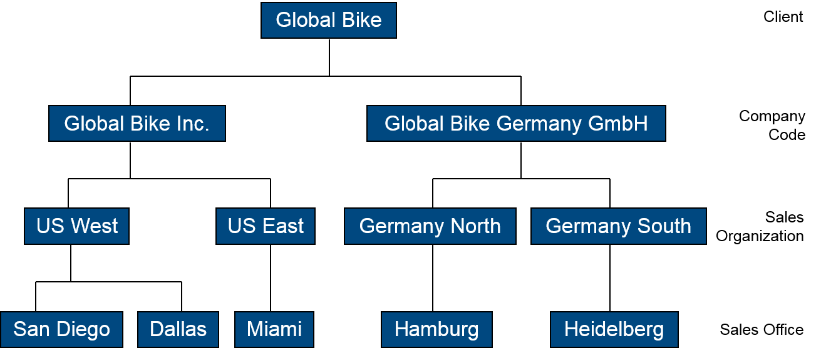 |  | GBI organizational chart  Sales and Distribution
Next, all organizational units identified above (including fulfillment specific organizational elements) are integrated in one model. In addition, each unit is given an alphanumerical ID.
As you can see all numbers for sales units in the SAP system (except for client, distribution channel and division) have four unique characters. The first two characters are always mnemonic and describe the unit, e.g. GL for global. The last two digits are used for numbering purposes (not in this document).
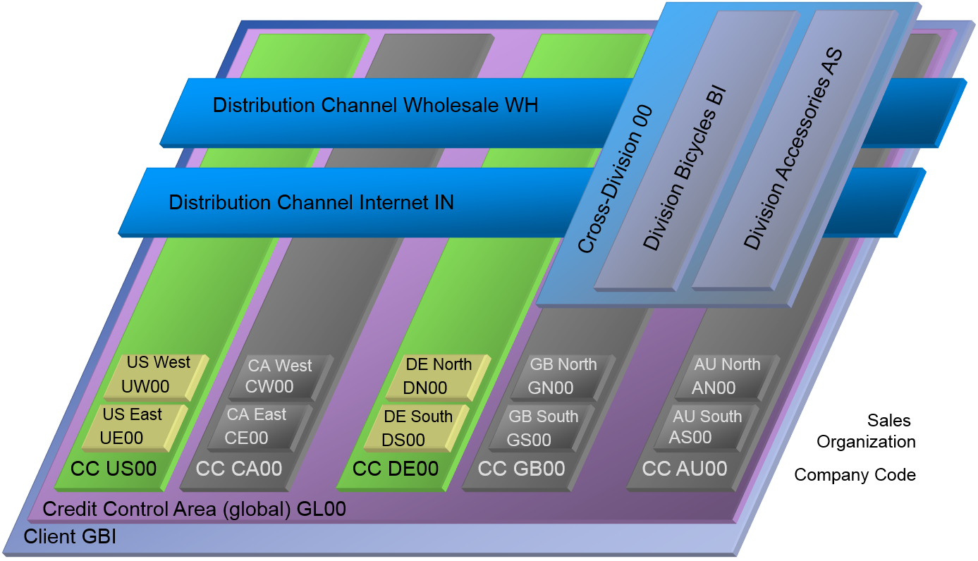 |  | Organizational chart  S/4HANA  Global Bike Sales and Distribution
GL00 Global DS00 Germany South
US00 North America DN00 Germany North
CA00 Canada GS00 Great Britain South
DE00 Germany GN00 Great Britain North
GB00 Great Britain AS00 Australia South
AU00 Australia AN00 Australia North
UE00 US East IN Internet
UW00 US West WH Wholesale
CE00 Canada East BI Bicycles
CW00 Canada West AS Accesories
As displayed in the graphic above the client forms the framework for all other Global Bike organizational units. Organizational units displayed in grey are not yet implemented, but are already planned in Global Bike. According to the Global Bike story and the results of the phase I sub-project (Financial Accounting), company codes are defined for financially independent units in the US and in Germany.
From the sales and distribution perspective, four sales organisations have been added i.e US East, US West, Germany North and Germany South. Global Bike customer can receive goods through two distribution channels i.e. Wholesale and Internet and only one division is relevant for this Global Bike scenario i.e. Bicycles (BI).
After Sarah Garcia has identified the organizational structure for Global Bike‘s sales department and mapped it to SAP terminology she presents the results in her next meeting with the external consulting team. The SAP logistics consultant approves the blueprint after verification. Now, the first configuration steps are agreed upon and can be executed in the S/4HANA system.
[Optional] If you have access to an S/4HANA system with the Global Bike dataset you may now ask your instructor for login details, open the handbook and go through the tasks listed below.  - Introduction Phase III – Fulfillment  - General Notes and Cautions  - Phase III.1 – Enterprise Structure  - Tasks III.1.1 to III.1.2 (Definition)  - Tasks III.1.3 to III.1.10 (Assignment) |  | Handbook  [Time: 95 min]

 | Phase 3.2 – Process Configuration
Task Configure business processes for Fulfillment in the S/4HANA system. Time 15 min
Short Description Familiarize yourself with basic S/4HANA process configuration settings for Fulfillment by defining GBI values and make changes in the system.
Name (Position) Mona Falco (System Design and Development Manager)
Sarah Garcia (Business Analyst 2)
[external] (Senior SAP Logistics consultant)
After defining the enterprise structure for fulfillment in the S/4HANA system, the project team is now revisiting the problems identified in the preparation phase and configuring the ERP system to avoid issues like lack of integration between fulfillment and accounting. |  | Scenario setting
The first step Sarah performs in the fulfillment process is to configure automatic postings. This task ensures that the ERP system automatically determines which account assignments in materials management make postings in financial accounting and that rules for postings made into financial accounting are determined. |  | Automatic posting
Automatic account assignment for revenue elements is then maintained. Default and automatic account assignments for cost elements that always post to a particular cost center are maintained in this step. |  | Automatic Acct. Asgmt. Of Revenue Elements
Thereafter, Sarah assigns shipping points to the desired combinations of shipping conditions and loading groups for each plant. Loading groups identify which equipment is required to load goods for examples cranes, fork-lifts. |  | Loading groups
The next step involves assigning G/L accounts for sales revenue. In this task Sarah determines exactly which G/L accounts the system automatically posts revenues to when you creating a billing document for goods in the sales order. |  | G/L Revenue accounts
Sarah then defines pricing procedure determination. The pricing procedure defines a group of condition types in a particular sequence. During pricing, the system automatically determines which pricing procedure is valid for a business transaction and it takes the condition types contained in it into account one after another. |  | Pricing procedures
Lastly, Sarah defines for each sales area the rules according to which business area account assignment should be carried out. |  | Sales Area rules
[Optional] Log back on to the S/4HANA system, open the handbook and go through the tasks listed below.  - Tasks III.2.1 to III.2.6 |  | Handbook  [Time: 60 min]

 | Phase 3.3 – Master Data
Task Create fulfillment-related master data into the S/4HANA system. Time 15 min
Short Description Identify and migrate all legacy master data for the fulfillment process in Global Bike to the new ERP system.
Name (Position) Mona Falco (System Design and Development Manager)
Sarah Garcia (Business Analyst 2)
[external] (Junior SAP SD consultant)
Sarah Garcia together with her colleague Mona Falco and an external expert for sales and distribution master records analyze and prepare all Global Bike fulfillment master data in legacy system(s). In this phase, they are testing the creation of customer and pricing condition master records in the new system as well as extending sales views for trading goods that were previously created for the procurement process (phase II).
A trading good is a material type that is always procured externally and then sold to customers. It needs purchasing and sales data. For this test, Sarah extends the sales views of the master records for trading goods that she previously created for the procurement process. |  | Trading good
Sarah creates a customer record for DC Bikes in Washington DC in the new system. A customer master record describes a business partner that purchases goods or provides services from a company. In this case DC Bikes will be purchasing trading goods from GBI. |  | Customer
Sarah also creates pricing condition master records to assign selling prices to all the trading goods extended into the new system. |  | Pricing conditions
[Optional] Log back on to the S/4HANA system, open the handbook and go through the tasks listed below.  - Tasks III.3.1 to III.3.3 |  | Handbook  [Time: 60 min]

 | Phase 3.4 – Process Execution
Task Test business processes in the S/4HANA system. Time 15 min
Short Description Use Global Bike’s pre-defined sales test cases to verify that the basic Fulfillment configuration was successful.
Name (Position) Sarah Garcia (Business Analyst 2)
After essential G/L posting cases were tested in phase I, Sarah can now test the integration of fulfillment and financial accounting using the given test case for Global Bike’s sales core process.
Firstly, Sarah needs to create a sales quotation as the starting point of the fulfillment process in the new system. In this test, she creates a quotation for trading goods that were extended in the previous task. |  | Sales quotation
She then creates a sales order referencing the sales quotation from the first step. The system copies the relevant data from the sales quotation into the sales order. The sales order specifies DC Bikes as the customer.  An outbound delivery document is then created to ship the goods listed in the sales order. Only goods that are due for shipment are included in the delivery.  Sarah thereafter posts a goods issue for the shipment of the goods to the customer created in the previous step.  This is followed by the creation of a customer invoice which contains information about the transaction between GBI and DC Bikes e.g. price and date of purchase.  The last step is for Sarah to post a customer payment for the full amount of the goods shipping to DC Bikes. |  | Sales order  Outbound delivery  Goods issue  Customer invoice  Customer payment
[Optional] Log back on to the S/4HANA system, open the handbook and go through the tasks listed below.  - Tasks III.4.1 to III.4.6 |  | Handbook  [Time: 50 min]

