Navigation in SAP S/4HANA
Introduction to navigation in SAP solutions, here using SAP S/4HANA as an example.

Product  SAP S/4HANA 2023  Global Bike  Fiori 3.0  Level  Beginner  Focus  Navigation in SAP  S/4HANA Fiori  Authors  Babett Ruß  Stefan Weidner  Version  4.3.1  Last Change  October 2025 | MOTIVATION  This material explains the navigation in the SAP S/4HANA system with the SAP Fiori apps. It is aimed primarily at students from universities, colleges, vocational schools, and other educational institutions with no prior knowledge of SAP Fiori. It can be used for both frontal teaching and as a self-learning unit.  After completing the course, students will be able to navigate SAP Fiori user interfaces to handle processes or exercises independently.  This course can also be used as a reference for occasional users. |  | LEARNING METHOD  To process this case study, a user account for SAP S/4HANA is required.  The delivery method used is guided learning. Since SAP navigation on the one hand is basic knowledge and skills, but on the other hand it is also very extensive, this learning method is suitable.  The advantage of the learning method is not only the rapid transfer of expertise, but also the ability to act. Graphical formatting is used to explain a process or procedure to the learner in detail, similar to a case study.  Exercises are used to practically apply learned knowledge and consolidate it sustainably.  


Table of Contents
Step 1: Log on to SAP S/4HANA 3
Step 2: Organization and Structure of the Launchpad 5
Step 3: Three Types of Fiori Apps on the Launchpad 10
Step 4: Make Settings 16
Step 5: Export Data to Excel 19
Step 6: Sending Emails 20
Step 7: Logoff from SAP S/4HANA 22

 | Step 1: Log on to SAP S/4HANA
Task Learn how to log on to the SAP S/4HANA Fiori launchpad. |  | Time 10 min
Open a web browser and use the link provided by your instructor to log on to your SAP S/4HANA.
On the logon screen, select your user name, your password, the client, and the language English. Then click Sign In. |  | Username  Password  Client  English
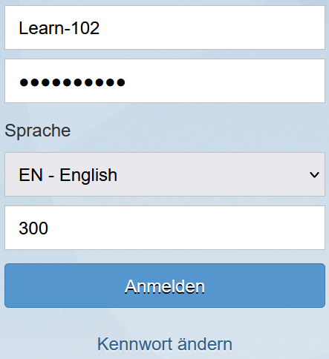
After logging in for the first time, you will be asked to change the password. Select a password of your choice, confirm it, and then click Change Password. |  | Password of your choice
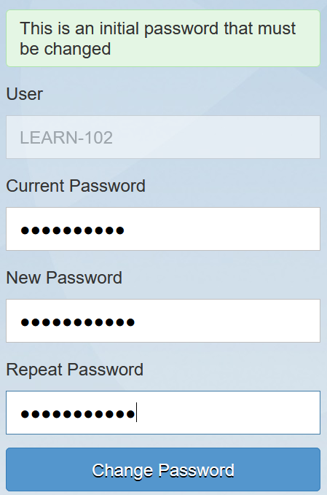
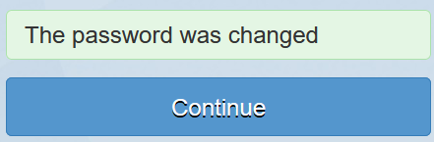
Click Continue to confirm the password change. This takes you to the SAP S/4HANA home page, which is called the SAP Fiori launchpad. The launchpad shows all available SAP Fiori apps and is the starting point for all actions. The SAP Fiori apps are displayed as square tiles and are grouped into the business processes of a company. In addition, the launchpad has a search function for general search queries or to find other SAP Fiori apps. |  | Continue
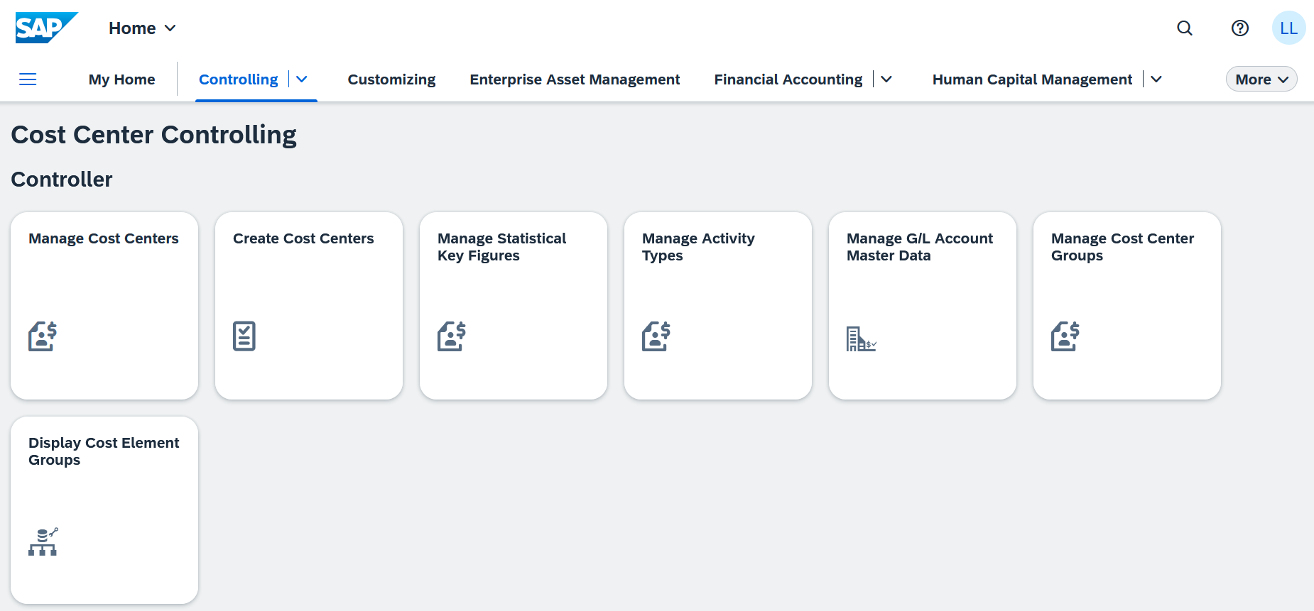

 | Step 2: Organization and Structure of the Launchpad
Task Familiarize yourself with the individual spaces and elements of the launchpad. |  | Time 10min
On the SAP Fiori launchpad, there is a search function  at the top, as well as the profile button . |  | Local Layout
The search function allows you to find specific SAP Fiori apps. As a result of this function, transaction codes are no longer required in SAP S/4HANA.
In the search window, enter Order* and choose Enter. The * is a wildcard (a placeholder for other characters). |  | Order*
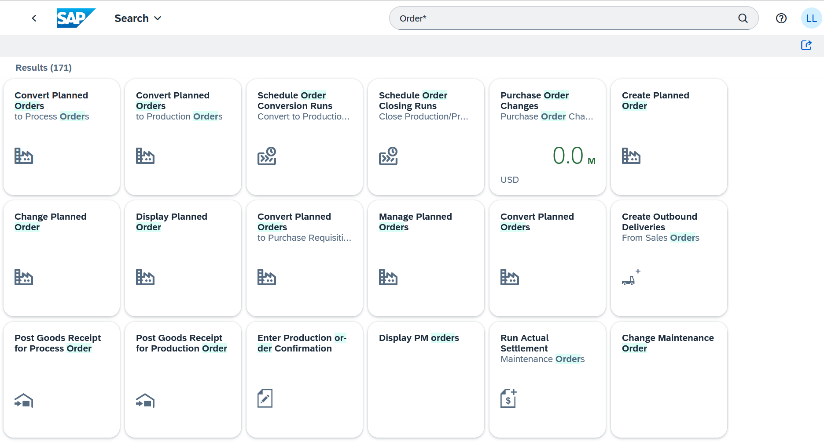
Click the Home button  to return to the SAP Launchpad. |  | Home button
All SAP Fiori apps are arranged in square tiles. Some of these tiles have a display function that, without having to open the app first, displays a preview of the content of the business process.
All SAP Fiori apps are organized in spaces. The spaces are divided into pages and each page has one or more roles below which the apps are shown. To see an overview of all spaces, you can click in the upper right area. In your view, there are only as many spaces as you need to complete the exercises and case studies. The number of spaces, pages, and roles available to you may therefore differ from this example.
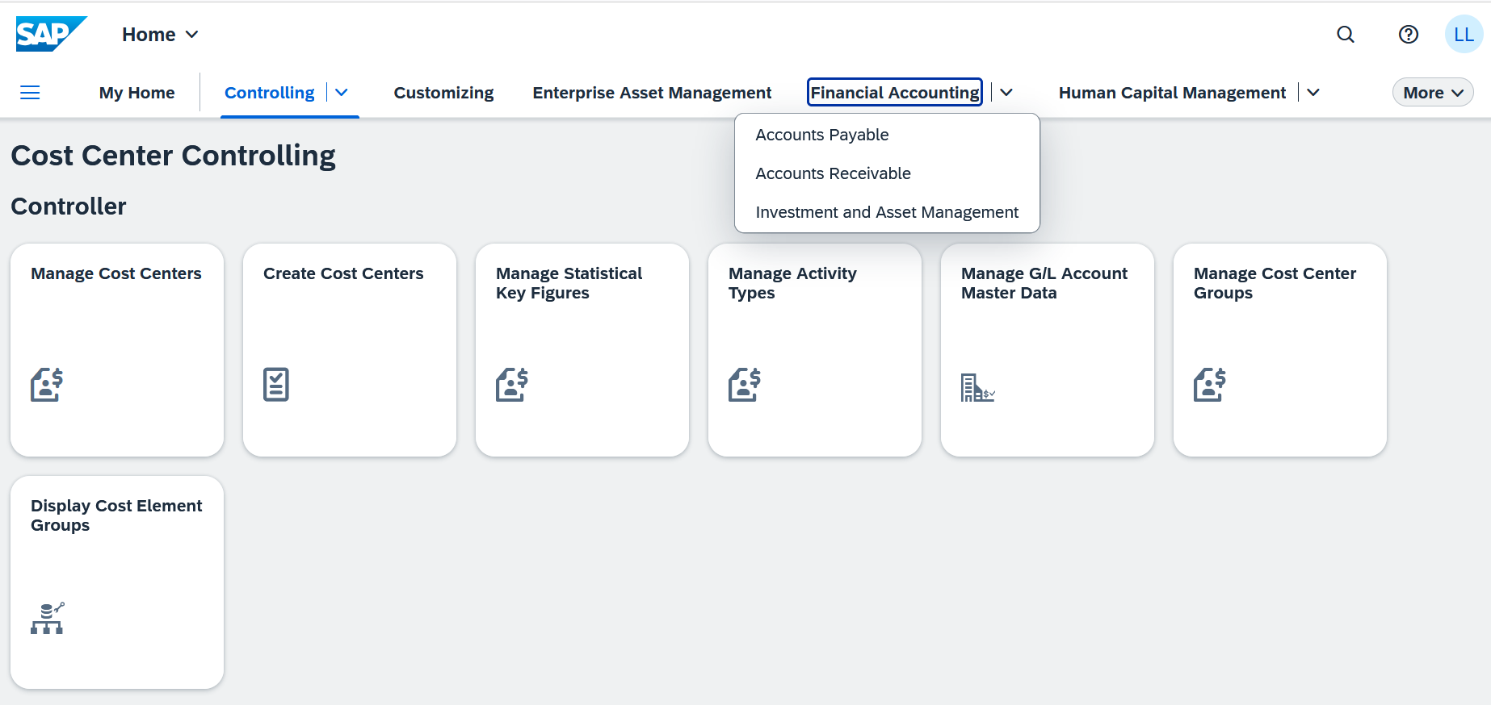
One space of Fiori apps is the Financial Accounting space. There you can, for example, Manage Journal Entries or Display Supplier Balances. |  | Financial Accounting
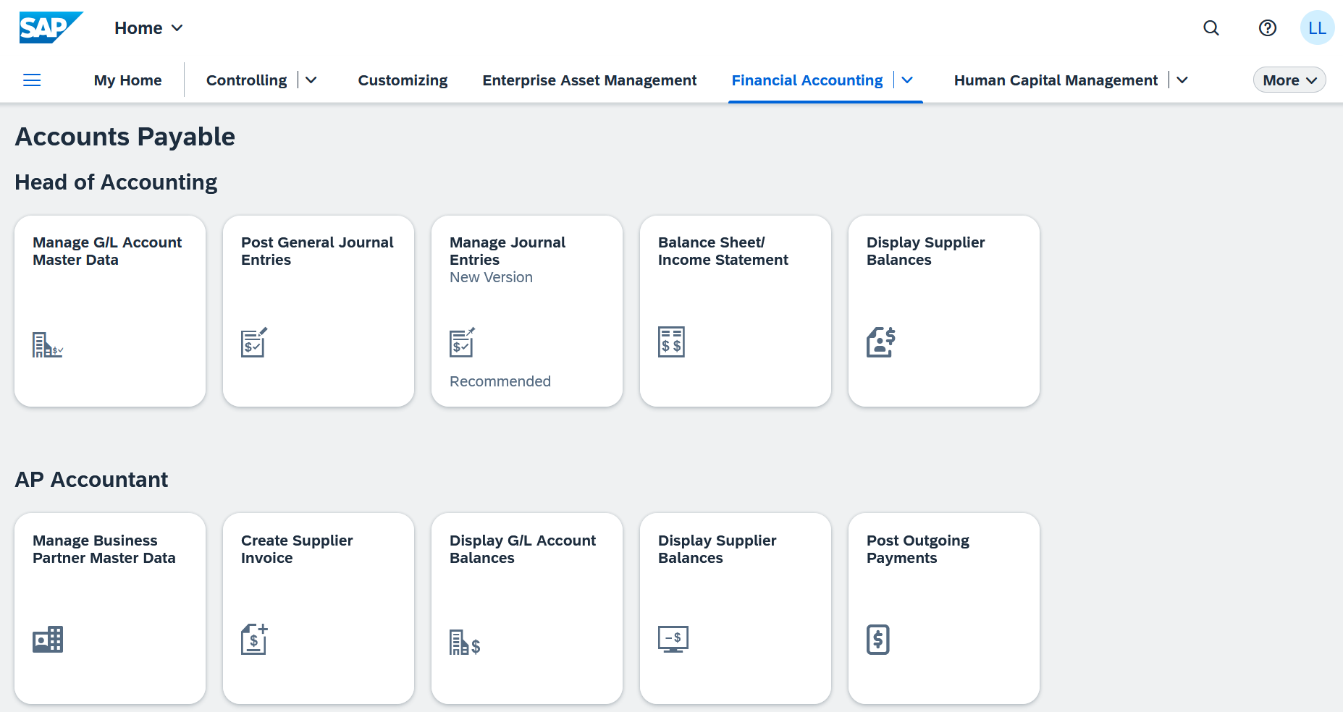
Another way to navigate is the dropdown menu at the top of the launchpad
Click at 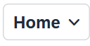 the top of your launchpad. |  | Home
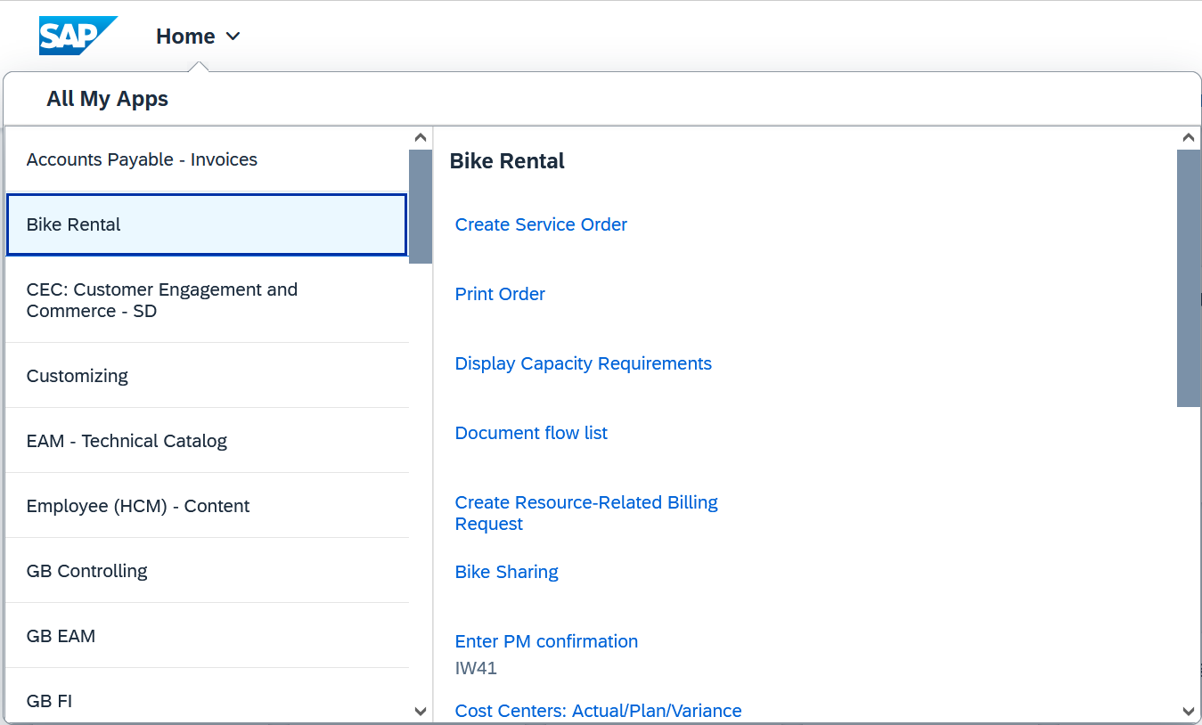
On the left, you see all spaces of your launchpad. On the right are all apps of the selected space.
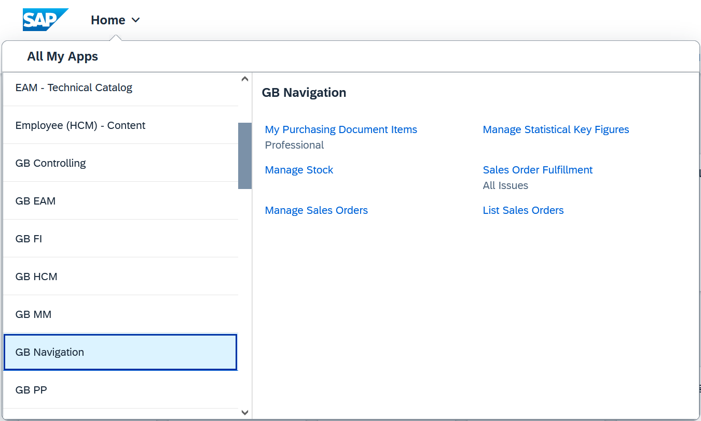
To close the dialog box again, click either on the start page or outside the dialog box.
Fiori apps allow you to navigate from the app to another app. Choose the app Stock – Multiple Materials within Sales and Distribution space. |  | Stock – Multiple Materials
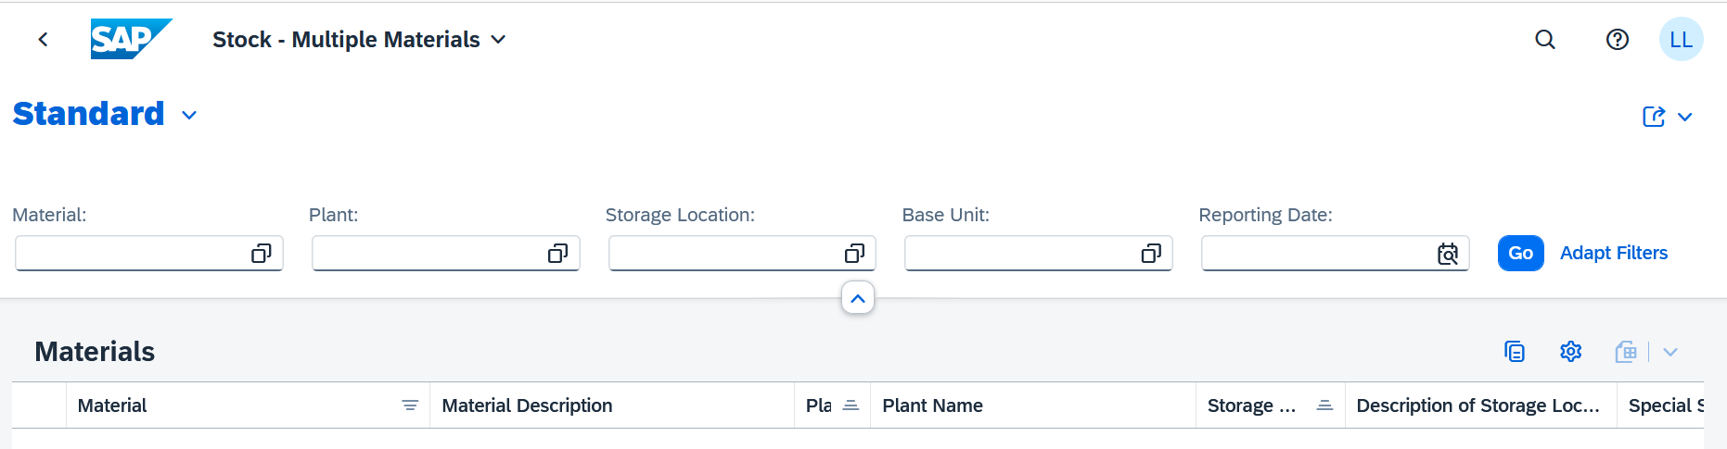
Enter *### as the material number (replace ### with the last three digits of your user), DL00 as the plant, and FG00 as the storage location. Then press . Now click on the material number of the first entry. |  | *###  DL00  FG00  Go  First Material No.
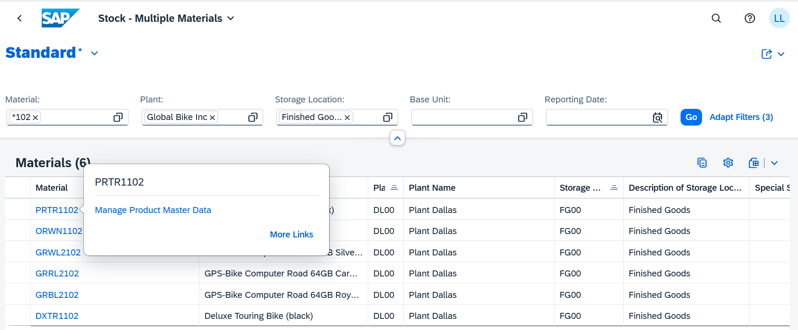
In the window that appears, click 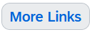 . |  | More Links
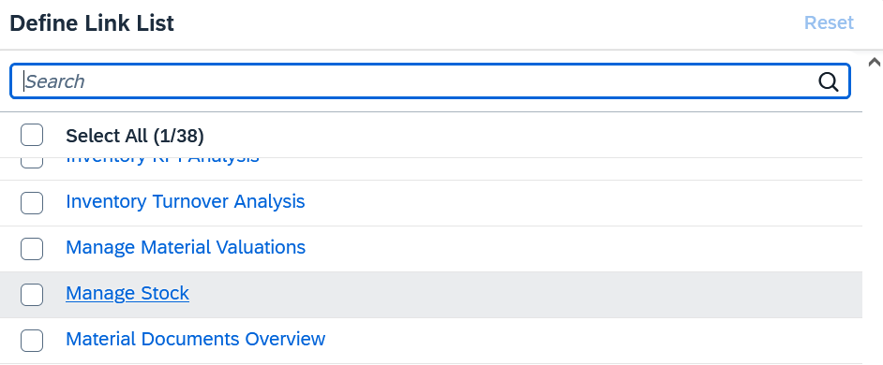
In the link list, click on the entry Manage Stock to go to the related app. |  | Manage Stock
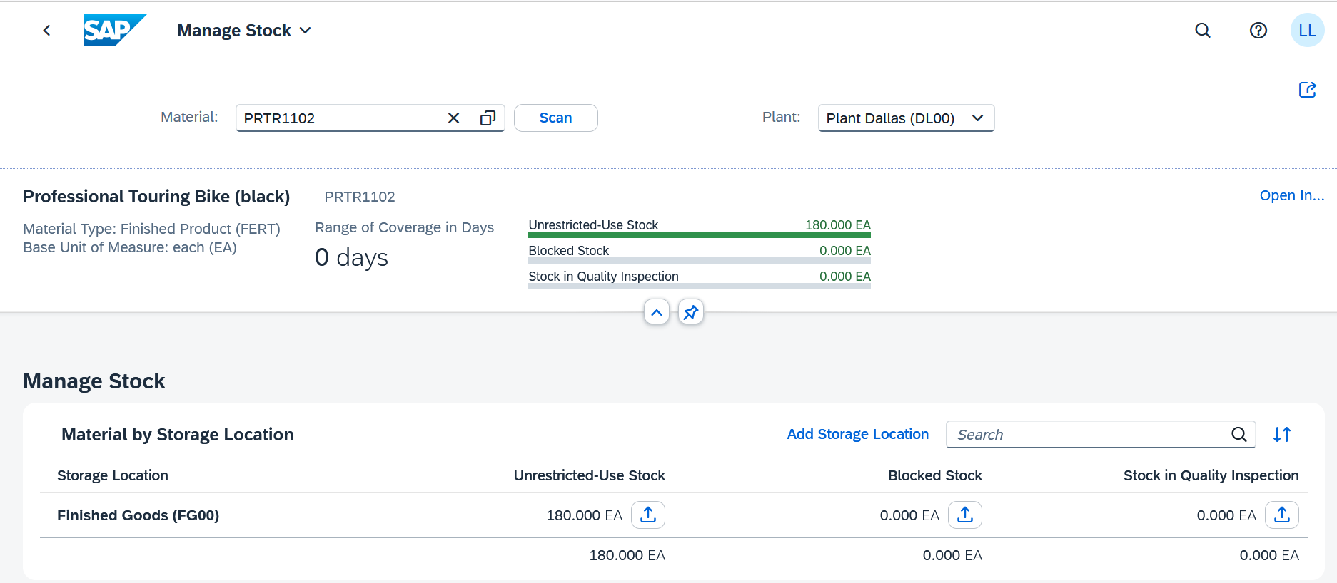
Choose the Home button to return to the SAP Fiori launchpad. |  | Home button
Click to open your profile. |  | Profile
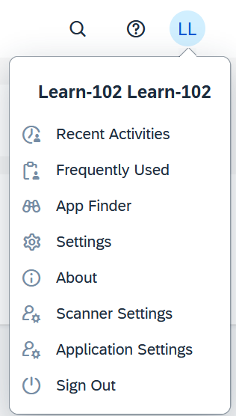
Under the entry Recent Activities, you can see the apps that you accessed most recently. Click the Recent Activities and Frequently Used tab. You will see the dialog shown below, but the listed apps may differ. |  | Recent Activities  Frequently Used
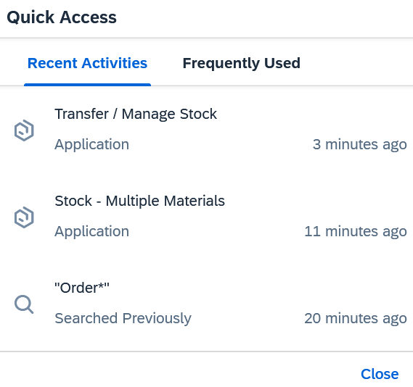
Click 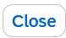 to return to the Fiori Launchpad. |  | Close
Stay in the SAP Fiori launchpad for the next task.

 | Step 3: Three Types of Fiori Apps on the Launchpad
Task Familiarize yourself with the different SAP Fiori apps. |  | Time 15 min
With the SAP S/4HANA Fiori Launchpad, you have the option to access data web-based. Access can be provided by mobile devices, such as tablets or smartphones, as well as by a fixed PC. The SAP Fiori apps provide personalized and faster access to the company’s business processes.
The SAP Fiori app system consists of three different types: transaction apps, analytical apps, and fact sheet apps. In addition, some transactions are displayed in WebGUIs.
The three types are presented below using examples. You can find the respective apps in one of the spaces or by using the search function .
Transactional apps:
This includes all apps that can be used to execute transactions of a company or manage entire business processes. These include transactions between managing directors and employees, such as vacation approvals and new hires, as well as order confirmations. With transactional apps, you can also handle simple SAP transactions on a mobile device.
An example of a transactional app is My Purchasing Document Items - Professional in the space of Materials Management. |  | My Purchasing Document Items
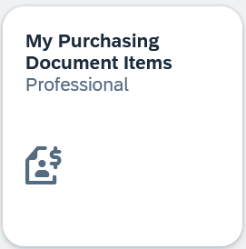
With this app, you can quickly search within a large amount of data that is in your area of responsibility. When searching, the app allows you to set various filters to simplify or narrow down the search.
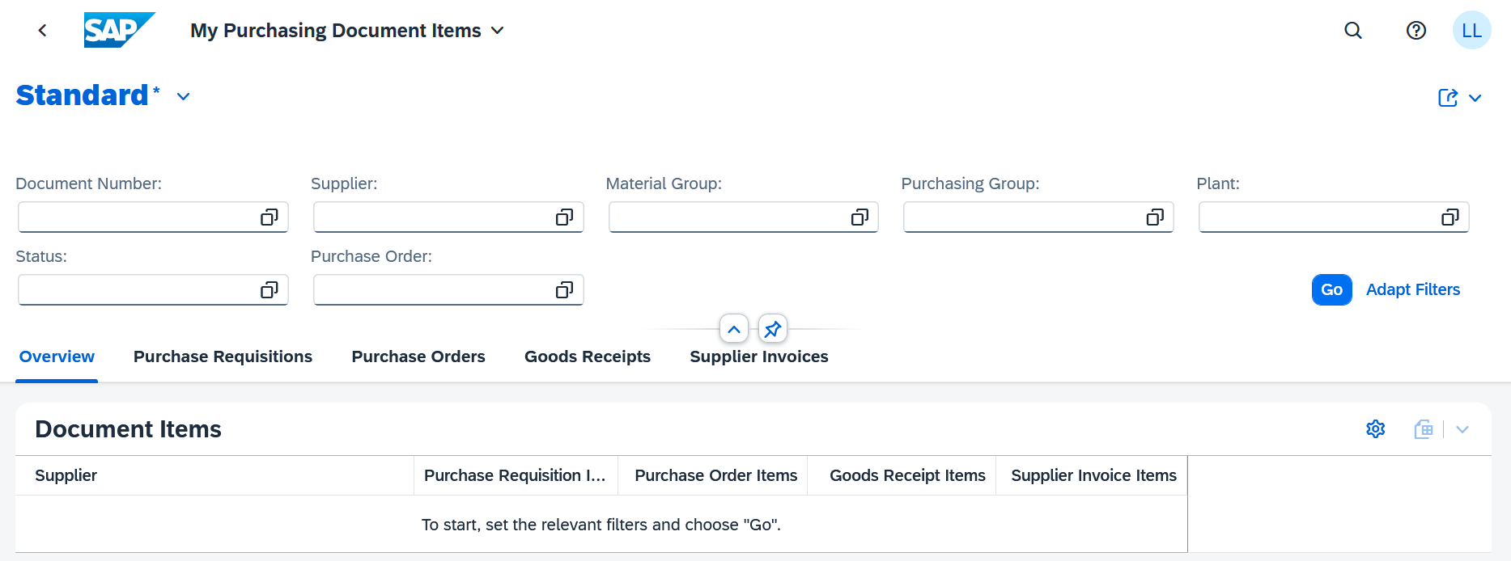
Choose the Home button to return to the SAP Fiori launchpad. |  | Home button
Analytical apps:
Analytical apps are used for real-time data analysis of business processes and their clear presentation. Visual overviews and data can be evaluated. In addition, complex calculations and a quick response to changes in the market are possible. Analytical apps combine the capabilities of SAP HANA and the SAP Business Suite and are divided into two types: SMART Business and Virtual Data Models. SAP Fiori SMART business apps represent the key performance indicators (KPIs) in real time and adapt flexibly to changes in the market. You can use the drilldown and filter functions to analyze data from your existing Business Suite system in real time. The SAP Smart Business framework allows you to build apps and helps you manage your business in real time with KPIs. The SAP Smart Business content serves as a template to help you create and consume industry-proven KPIs. Virtual data models prepare the large mass of data without the need for additional software. SAP provides several standard models that can be enhanced.
An example of an analytical app is the Sales Order Fulfillment. |  | Sales Order Fulfillment
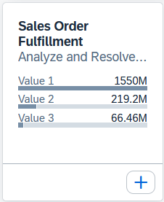
Click on your profile icon 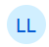 in the top right corner, then select the App Finder. Please wait until the application has fully loaded.
In the left-hand menu, navigate to the section “Sales – Sales order Monitoring and Tracking”. There, select the app Sales Order Fulfillment.
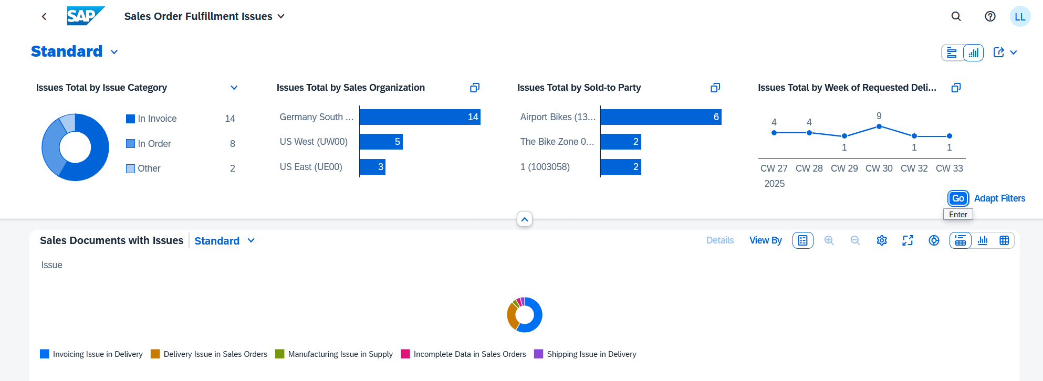
The orders are presented in a visual format and can be analyzed based on various criteria. By interacting with the charts, you can access detailed information on individual orders and their respective statuses.
Note that you may see more sales orders. This depends on whether other case studies have already been processed.
Choose the Home button in the upper left corner to return to the SAP Fiori launchpad. |  | Home button
Another example of analytical apps in the space of Materials Management in the role Goods Receipt Clerk is the Manage Stock app. |  | Manage Stock
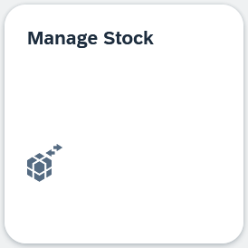
For material, enter DXTR1### (replace ### with the last three digits of your user, for example 102) and ensure that it is selected for plant Dallas DL00. |  | DXTR1###  DL00
Click  on the lower part of the screen. |  | Stock - Single Material
To view the stock history, click the lines 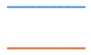 below. |  | Stock History
Note If you do not see this column, click on the  icon and then on the columns icon . Next, look for the Stock Development column and check the box next to it. Finally, click .
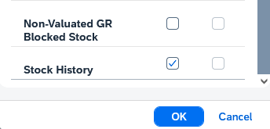
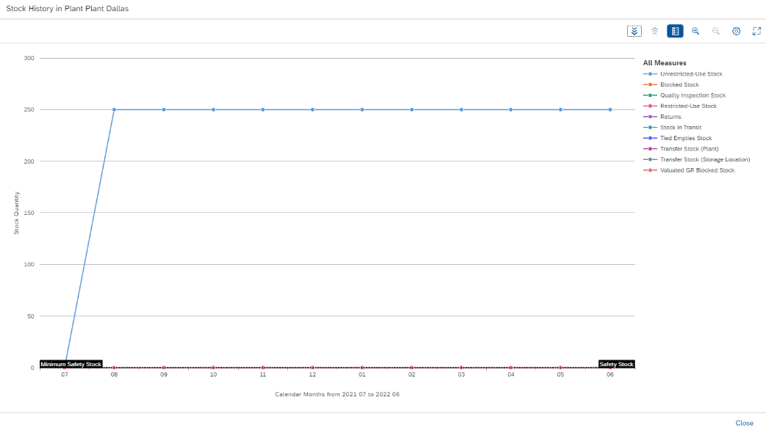
Close the view with the corresponding button (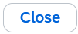). |  | Close
Click the Home button to return to the SAP Fiori launchpad. |  | Home button
Fact sheet apps:
Fact sheet apps provide key information and facts about key business objectives. In doing so, they make it possible to call up specific company processes in detail and obtain key information. You can also connect to other fact sheet apps and also switch to transaction apps.
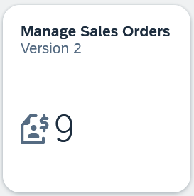
Click on the Manage Sales Orders – Version 2 app in the space of Sales and Distribution. In the Manage Sales Orders window, choose . |  | Manage Sales Orders  Go
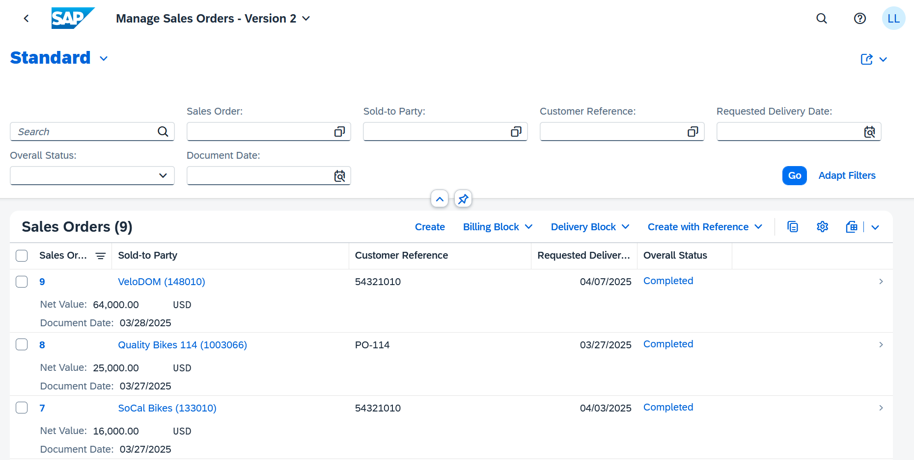
Click on the Buyer 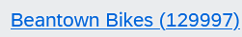. |  | Beantown Bikes
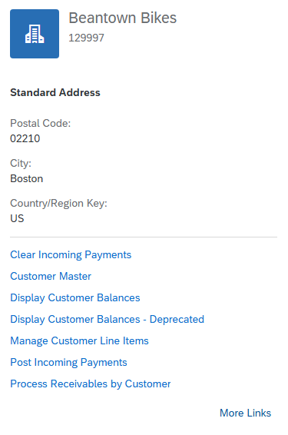
You can see information about the customer and navigate to other apps. For example, you can use to open the app Customer – 360° View. This is a real fact sheet with only one specific data object. |  | Customer – 360° View
Click the Home button to return to the SAP Fiori launchpad. |  | Home button
The three apps listed above are divided into dynamic and static apps.
Dynamic Apps
In the space of Sales and Distribution, the Manage Sales Orders – Version 2 app is a dynamic app. Currently, Global Bike has 9 different sales orders. When you create a new sales order, the number increases to 10. You might see a higher number than 9, depending on whether you or other students have already created sales orders. |  | Manage Sales Orders – Version 2
Choose the Home button to return to the SAP Fiori launchpad. |  | Home button
Static Apps
The List Sales Orders app is a static app. You can use this app to display all sales orders. However, after the search in the launchpad, you do not see in the tile how many sales orders there are currently at Global Bike. |  | List Sales Orders
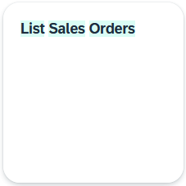
Choose the Home button to return to the SAP Fiori launchpad. |  | Home button

 | Step 4: Make Settings
Task Learn how to change the settings. |  | Time 5 min
Alternative way to perform the Steps 4 to 6 with SAP EnableNow
You can complete the following steps directly in the system without using this case study guide (in document form).
SAP EnableNow is – as the name suggests – an enablement solution that offers functions for creating and using digital learning and training content. The “Guided Tour” is one of these functions and offers interactive in-app (or in-solution) guidance – in other words, instructions integrated in the Fiori Launchpad. |  | SAP EnableNow  Guided Tours
The guided tours are included in the help section. Pay attention to the two icons at the top right of the screen.
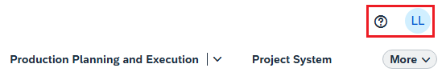
Click on the 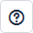 button to open the EnableNow context menu. There are three symbols shown on the right side of the EnableNow menu. Select the  symbol to get an overview of the available Guided Tours.
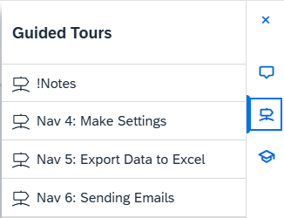
Click on the entry to start the respective tour. If you do not wish to use the guided tours, continue with this case study.
Note The exercises for all modules can also be completed using SAP EnableNow. For more information, you can have a look at the “!Notes” tour.
Click to show the settings. The following view appears. |  | Profile
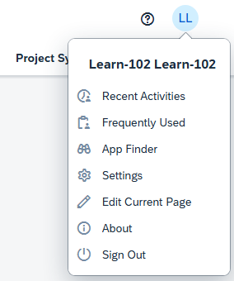
Click on 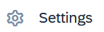. The following view appears. Here you can change settings such as language, date format, and default values. |  | Settings
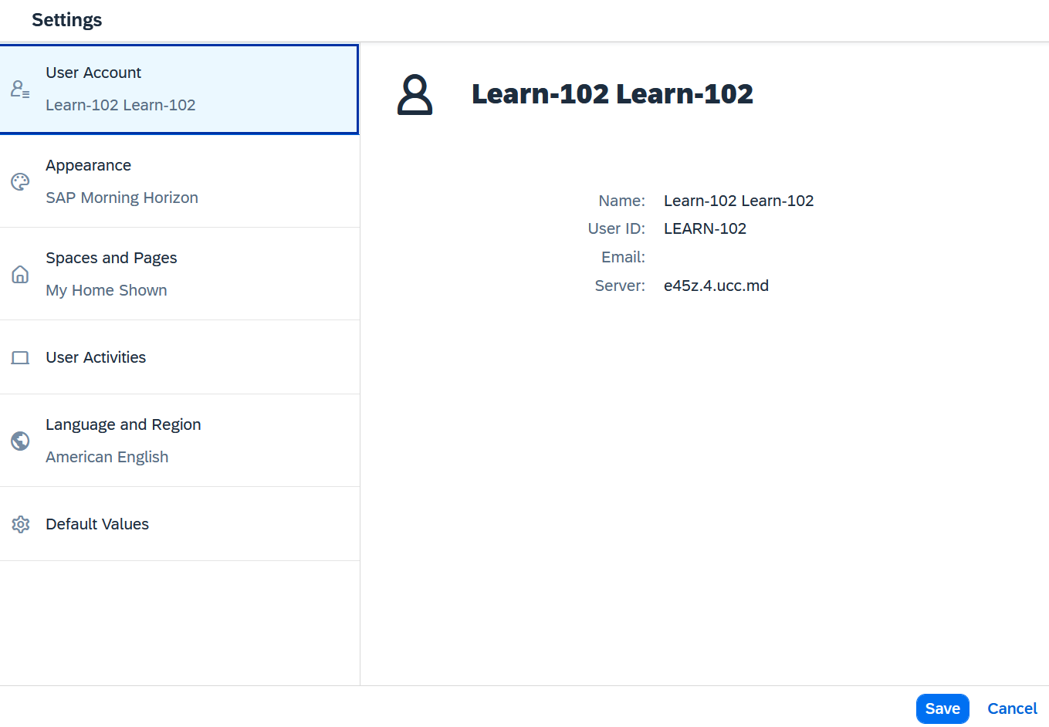
Click on the entry 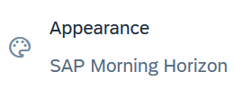 to see the different designs of the SAP Fiori interface. As you can see, the default theme is SAP Quartz Light. |  | Appearance
Click on . You can change the appearance of your interface on the Theme tab page. |  | SAP Belize Deep
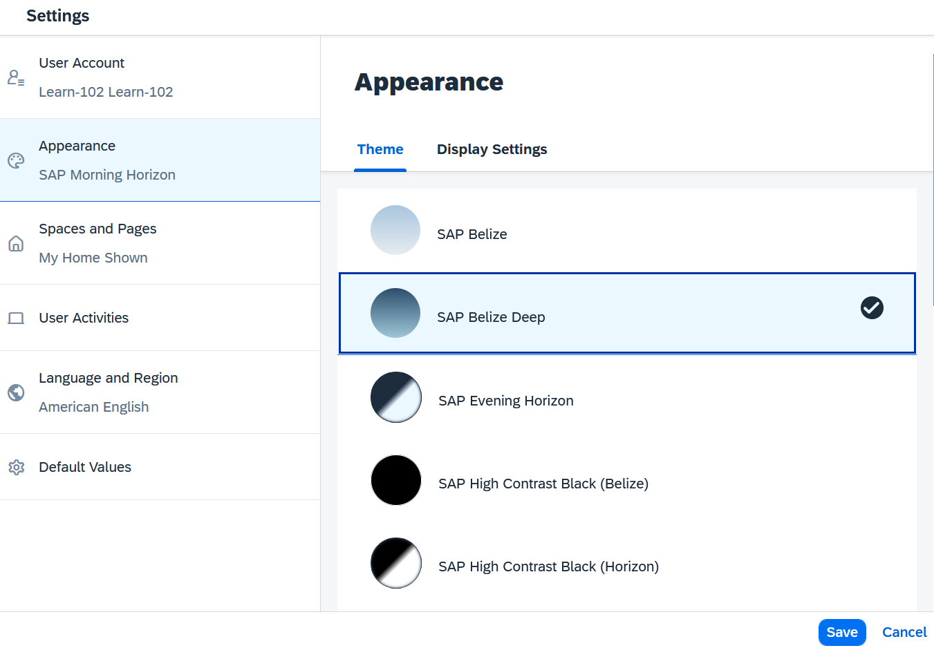
Select a new theme and click . Your Fiori launchpad should have changed. The following screenshot shows the SAP Belize Deep theme. |  | Save
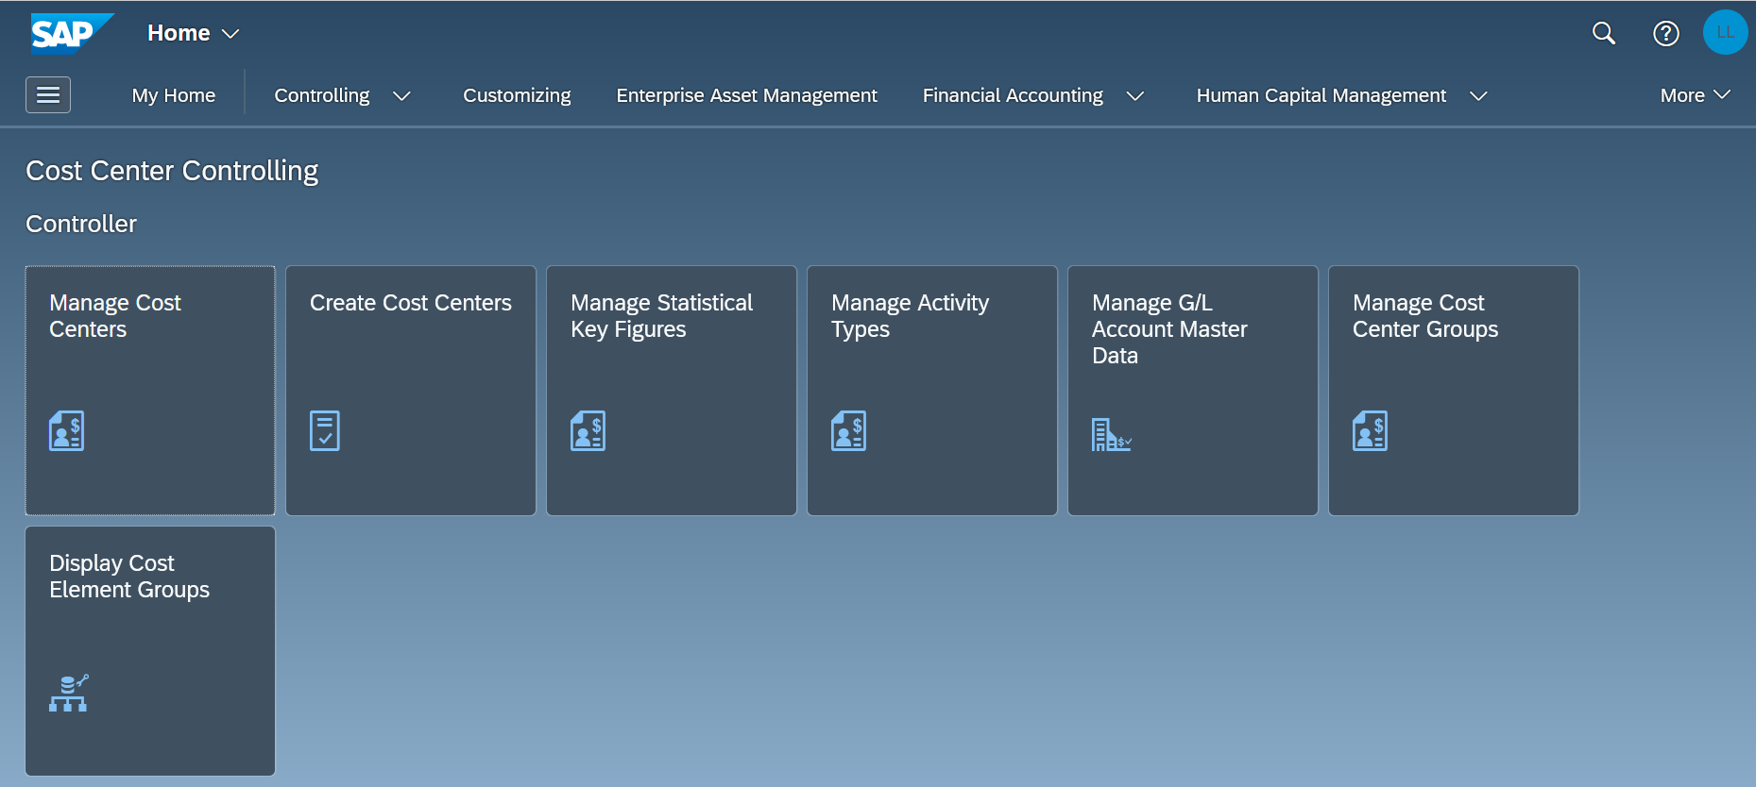
Now change the setting back to the default theme SAP Horizon. Afterwards, stay on the SAP Fiori launchpad for the next task.

 | Step 5: Export Data to Excel
Task Export data from SAP S/4HANA to an Excel program. |  | Time 5 min
You have the option to export data to external applications. Most SAP Fiori apps allow the information to be exported to Microsoft Excel.
To do so, open the Manage Sales Orders – Version 2 app in the Sales and Distribution space. |  | Manage Sales Orders – Version 2
Click to display the sales orders. |  | Go
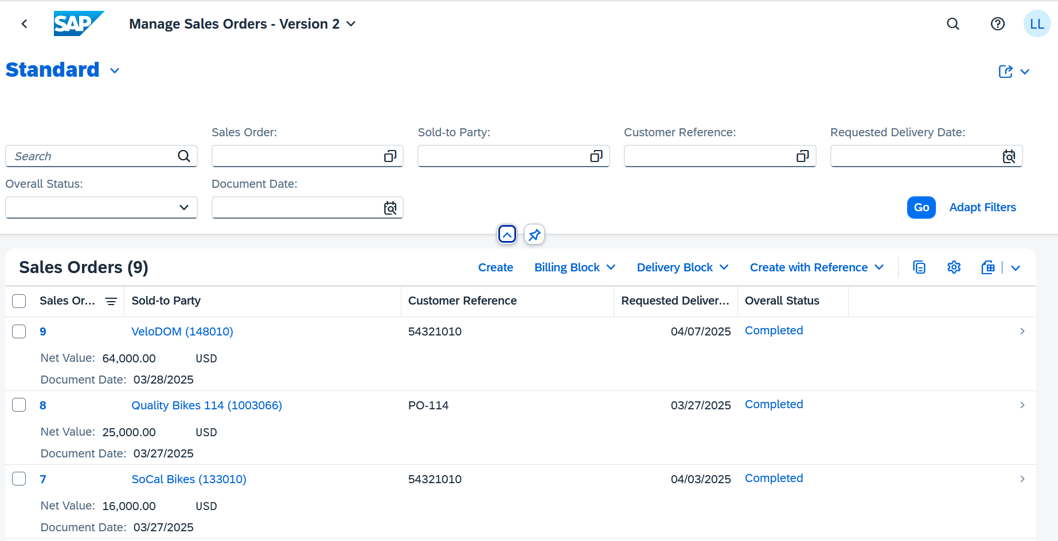
Now download the data using the (Export to Spreadsheet) button .
The system automatically creates and downloads an Excel table. The Excel is displayed either in your download folder or directly in the browser.
Close the Excel and click the Home button to return to the SAP Fiori launchpad. |  | Home button

 | Step 6: Sending Emails
Task Learn how to send data by e-mail with SAP S/4HANA. |  | Time 5 min
In the Sales and Distribution space, open the Manage Sales Orders – Version 2 app. |  | Manage Sales Orders – Version 2
Choose without entering any values. |  | Go
Click the button  in the upper right corner.
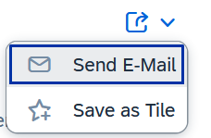
Click . If you have installed an e-mail program, a new window opens automatically. The most important information and the link are stored there. |  | Send E-Mail
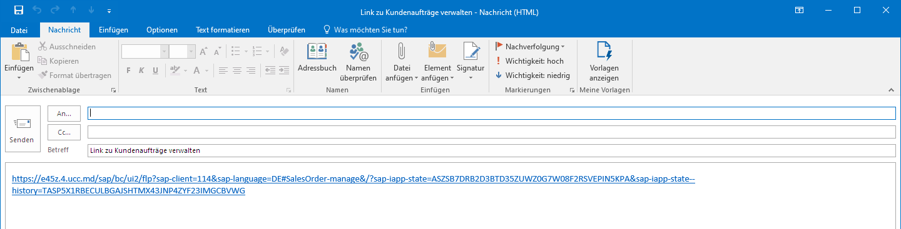
Close your email program.
Click the Home button to return to the SAP Fiori launchpad. |  | Home button

 | Step 7: Logoff from SAP S/4HANA
Task Log off from SAP S/4HANA successfully. |  | Time 5 min
To successfully log off from SAP S/4HANA, you need to click  in the upper right corner. |  | Profile  Logout
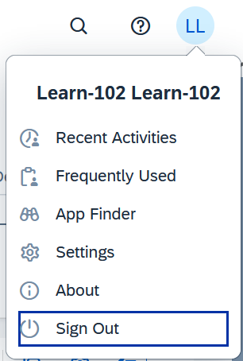
Then choose Sign Out. |  | Sign out
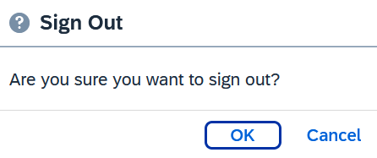
Confirm the subsequent warning with OK. Once you have logged off, you see the logon screen for SAP S/4HANA again. |  | OK
