
 | EM 1: Display a Location
Exercise Use the Fiori Launchpad to display locations in Global Bike.  Task Use the Manage Locations app to display the current location structure and a specific location (Plant Dallas DL00).  Name (Position) Alberto Conti, Technical Office Assistant, DC Miami |  | Time 10 min
Please go to the Environment Management space. In the Locations section, start the Manage Locations app. |  | Start
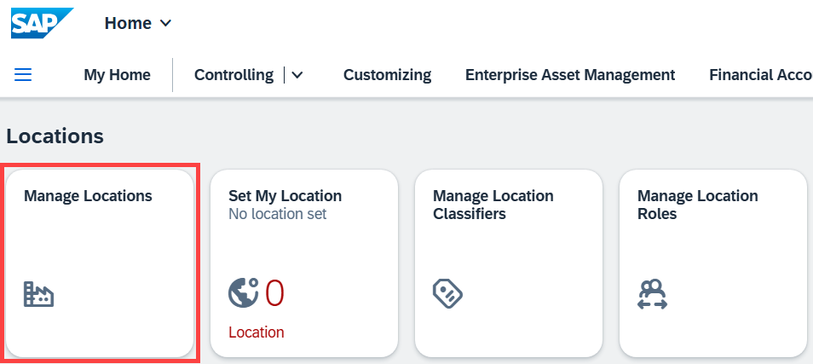
A location is used to represent an identified real place, virtual space, or object in the system. The location is a central master data object that can be organized in a structure to represent where a location exists spatially or functionally in a company. Examples of a location are a plant, a piece of equipment, or a work center.
On the next screen, locations you have recently worked with are displayed. The first time you use this app the list is empty. In order to display the entire location structure of Global Bike, click Structure View.
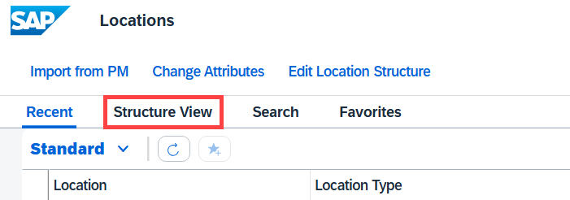
Now expand the location hierarchy by clicking in front of hierarchy elements of interest and take a closer look at Global Bike’s location structure.
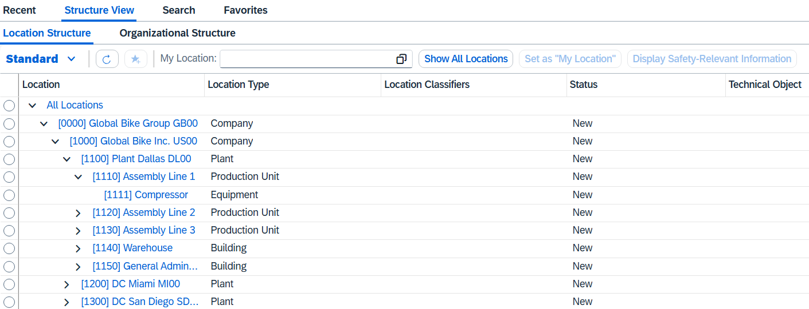
You see that every hierarchy element has its own unique ID in square brackets. These four-digit IDs represent the hierarchy level of their element. [0000] is the root element for the entire Global Bike group. [1000] represents the US subsidiary Global Bike Inc. [1111], for example, defines a compressor located at the plant in Dallas on assembly line 1.
To get more information on a certain location you may click on it. Please choose location [1100] Plant Dallas DL00. |  | [1100] Plant Dallas DL00
Note If you are prompted with the error message shown below, another user is accessing this location master record at the same time. Remember that all users in this SAP S/4HANA client are sharing the same business environment. Please acknowledge or ignore this message. The system will display the location master data without editing rights. |  | Parallel access
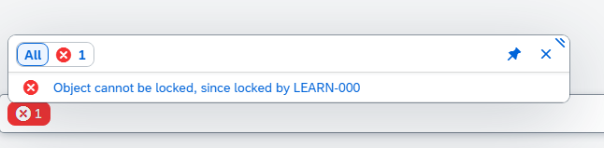
Now the system displays basic information of that location such as its type, status, revision start date or organizational information.
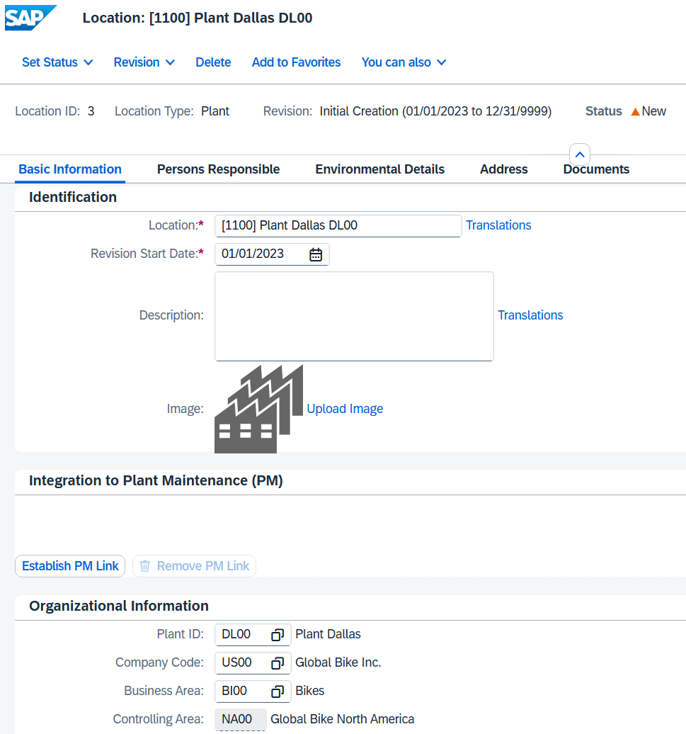
Now please click on the Address tab. Here you see that country, region and time zone are specified for the Global Bike plant in Dallas.
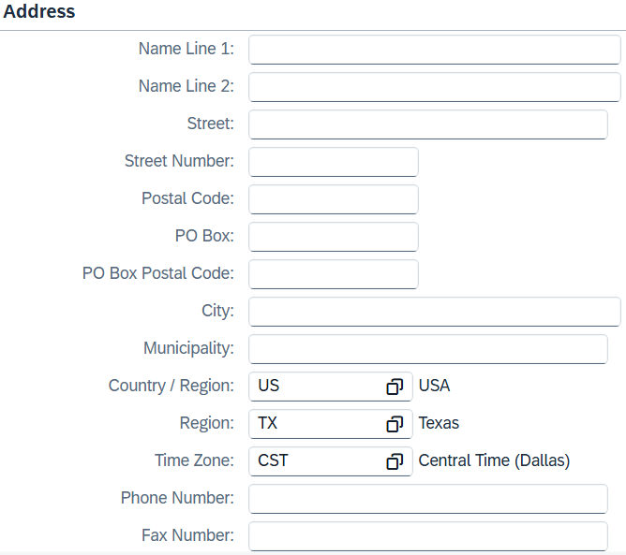
Browse trough the other tabs and fields to find out which addition information could have been recorded for this location.
Click  to return to the SAP Fiori Launchpad.

 | EM 2: Set Your Location
Exercise Use the SAP Fiori Launchpad to set your standard location.  Task A user may have access to multiple location hierarchy elements. In this exercise, you are setting your standard location in the SAP S/4HANA system.  Name (Position) Hiro Abe, Plant manager, Plant Dallas |  | Time 5 min
To set your default location use the Set My Location app in the Environment Management space in the Locations section. |  | Start
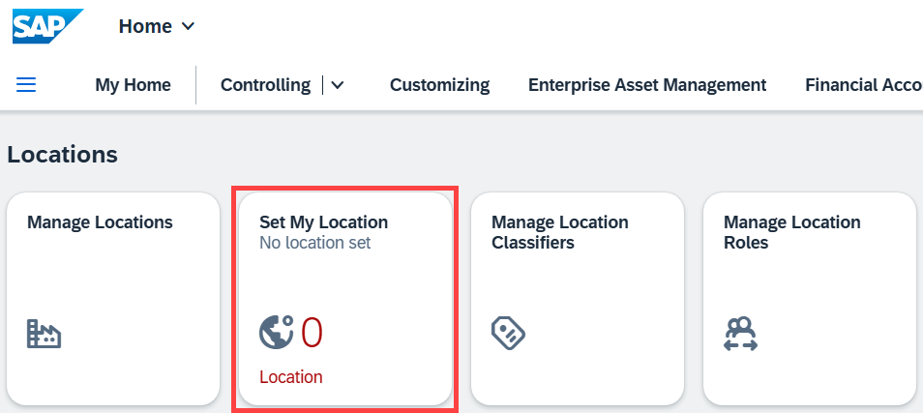
In the following screen, select the root location hierarchy [0000] Global Bike Group GB00 and choose Set as “My Location”. |  | [0000] Global Bike Group GB00  Set as “My Location”
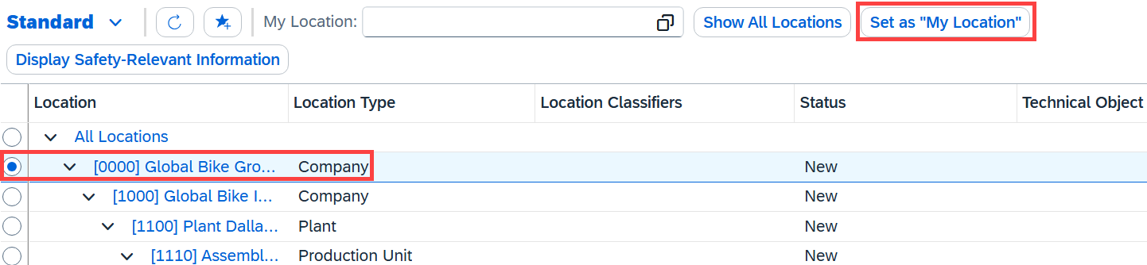 |  | [0000] Global Bike Group GB00  Set as “My Location”
Ignore the warning message on the bottom.
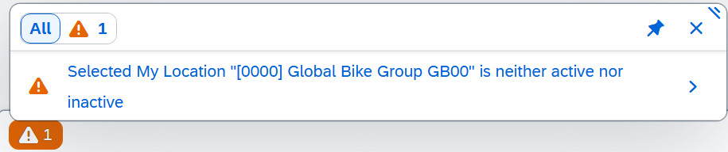
Now this location is displayed in the My Location field.
Click to return to the SAP Fiori Launchpad. Confirm any browser warning messages for unsaved data with 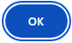.
The next time you choose the Environment Management space, you see the number of locations within the standard location hierarchy you selected in this exercise. If not, please refresh the browser page.
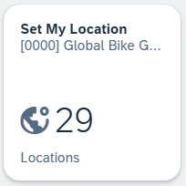

 | EM 3: Display Compliance Requirements
Exercise Use the Fiori Launchpad to display current compliance requirements for Global Bike.  Task Before creating compliance scenarios you need to know or define compliance requirements that Global Bike needs to fulfill. Get familiar with the current compliance requirements and their details.  Name (Position) Hiro Abe, Plant manager, Plant Dallas |  | Time 5 min
To view the current compliance requirements for Global Bike use the Manage Compliance Requirements app in the Environment Management space in the Compliance Requirements section. |  | Start
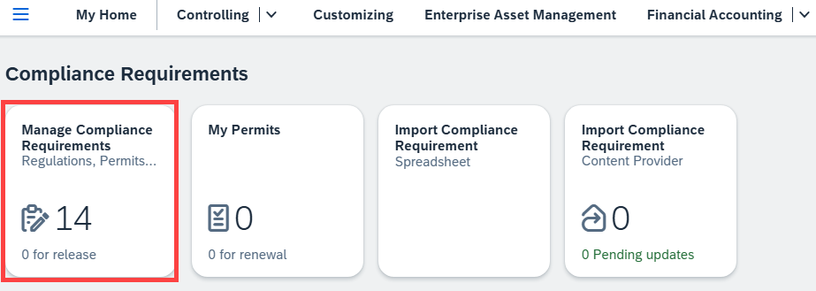
On the following screen, you see all available requirements for Global Bike. Remember that these requirements are all preset. You can also create your own compliance requirement.
Please choose the EN: COMMISSION DECISION: 2014/955/EU regulation to get more information.
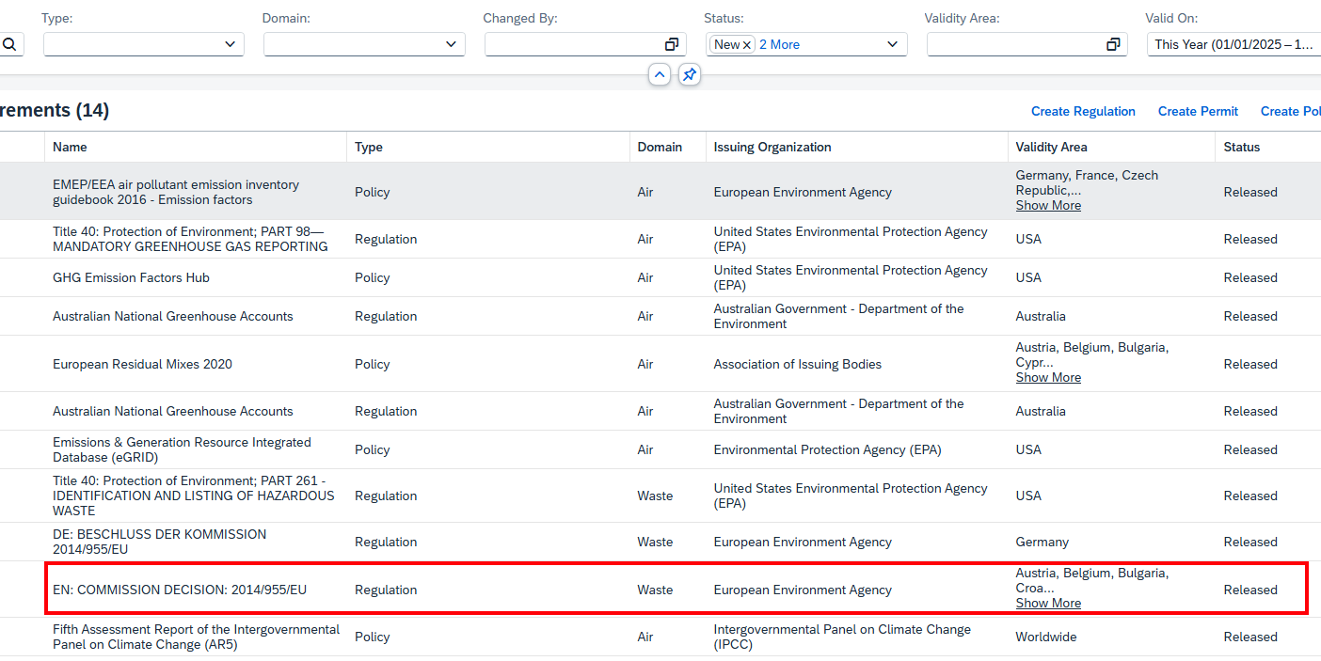
You can now dive into various information of existing compliance requirements such as requirement details, contents, tasks or documents in order to learn what this requirement regulates and which specifics Global Bike needs to fulfill.
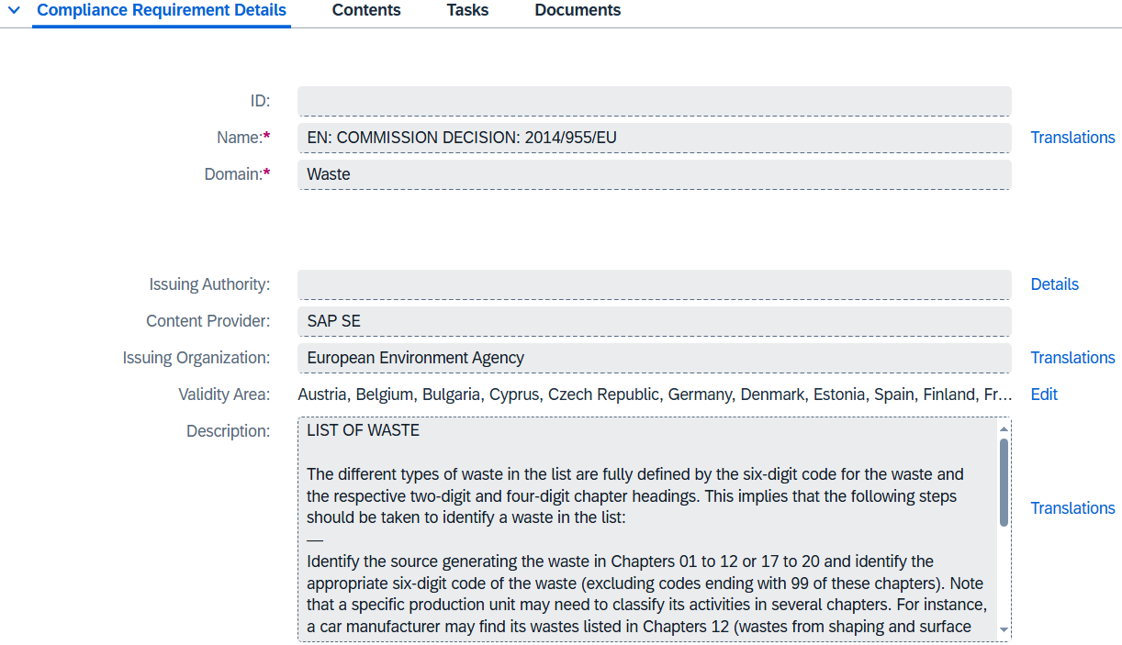
Note If you receive the error message below again, please acknowledge or ignore it.
On the Tasks tab, particular tasks can be defined that compliance scenarios introduced in the next exercise could be linked to.
Click to return to the SAP Fiori Launchpad. Confirm any browser warning messages for unsaved data with .

 | EM 4: Display Compliance Scenarios
Exercise Display the current compliance scenarios for Global Bike and view selected data.  Task Use the Manage Compliance Scenario app to gain an overview of all scenarios and their activities. Also, look at data points to measure the electricity consumption in the Dallas plant assembly lines.  Name (Position) Jun Lee, Production planner, Plant Dallas |  | Time 20 min
To get an overview of all existing compliance scenarios, use the Manage Compliance Scenario app in the Environmental Management space in the Compliance Scenario section. |  | Start
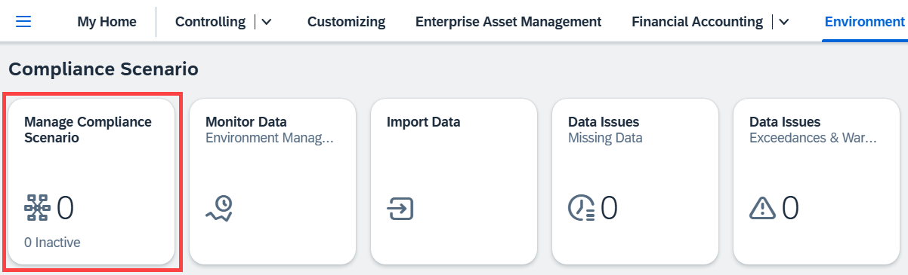
Choose Search to find and select compliance scenarios available to you. Keep all default setting and click Go. Then, click the first entry in the list [1100] DL00 Energy Consumption. |  | Go  [1100] DL00 Energy Consumption
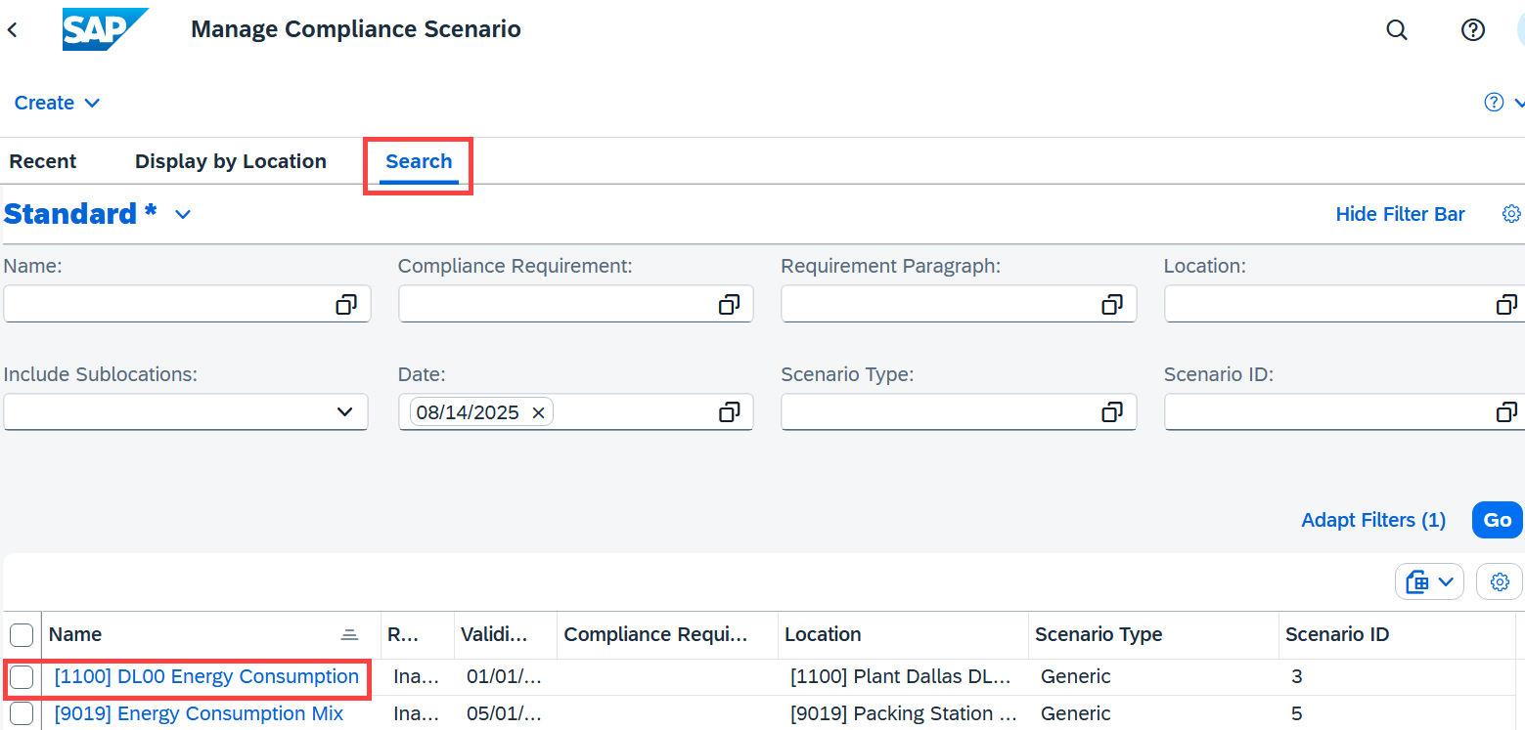
Note If you receive the error message below again, please acknowledge or ignore it.
You are now able to see all information regarding this compliance scenario such as basic information, the associated location, the responsible manager and more. Take some time to browse through these details. Then, click [1120] Electric Meter Assembly 2 . In the data collection definition, click Monitor Collected Data to view the electricity output of this meter. |  | [1120] Electric Meter Assembly 2
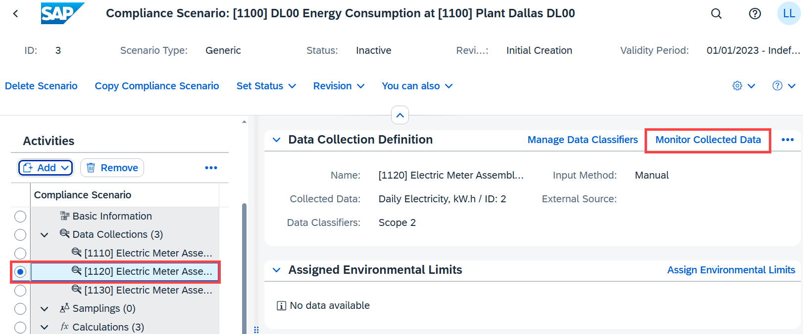
Now, in the From field choose 01-Jan-2023 and in the To field choose 30-Jun-2024. Your screen will automatically refresh to display the electricity consumption of the 18-month period you selected. It will look like the screenshot shown below. According to the status options in the legend, all data points have already been approved. |  | 01-Jan-2023  30-Jun-2024
Use the horizontal scroll bar on the bottom to examine the consumption data. For example, find and review the data points at the turn of the year 2023/2024.
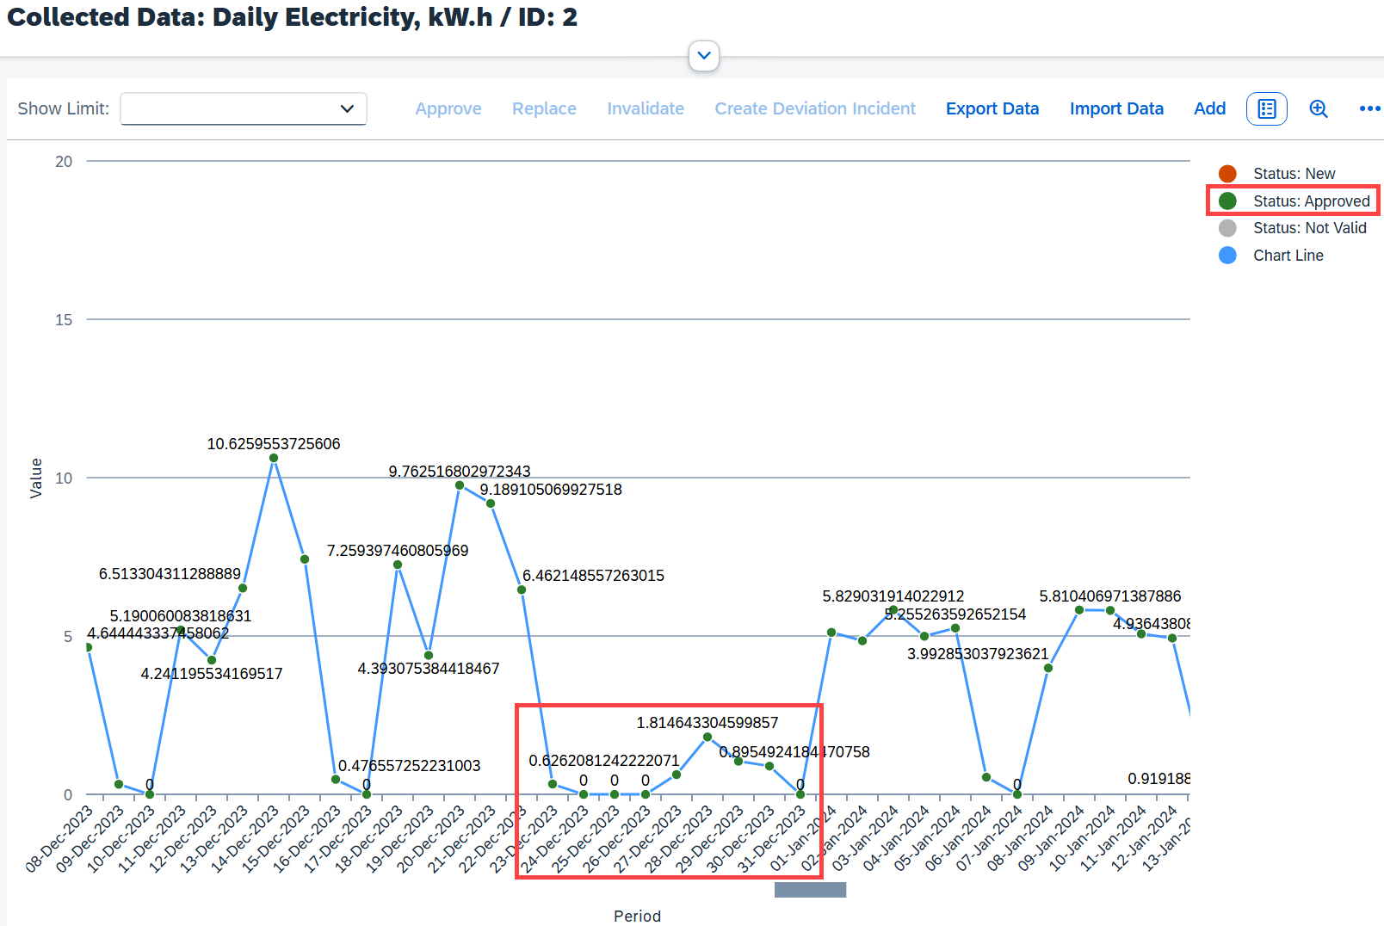
You may use the button to open and the button to close the full screen. Click on to switch to the table view.
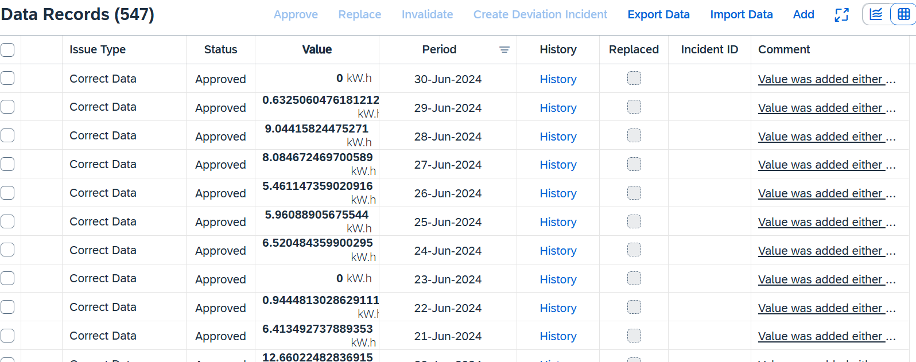
Close your current web browser tab Monitor Data and go back to your Compliance Scenario tab.
Back in the compliance scenario for [1100] Plant Dallas DL00, you see that a total of three data collections – all for electric meters – have already been put in the system. This function is used to establish, schedule, and ensure the collection of environmentally-related data at a given location. Feel free to display and compare the energy consumption of the other two meters.
You see that so far no sampling was conducted within this scenario. You can also see that three calculations were entered into the system for this compliance scenario. They contain all the necessary information that is needed to carry out calculations of environmentally-related data. Choose calculation [1110] Electric Meter Assembly 1 - monthly. |  | [1110] Electric Meter Assembly 1 - monthly
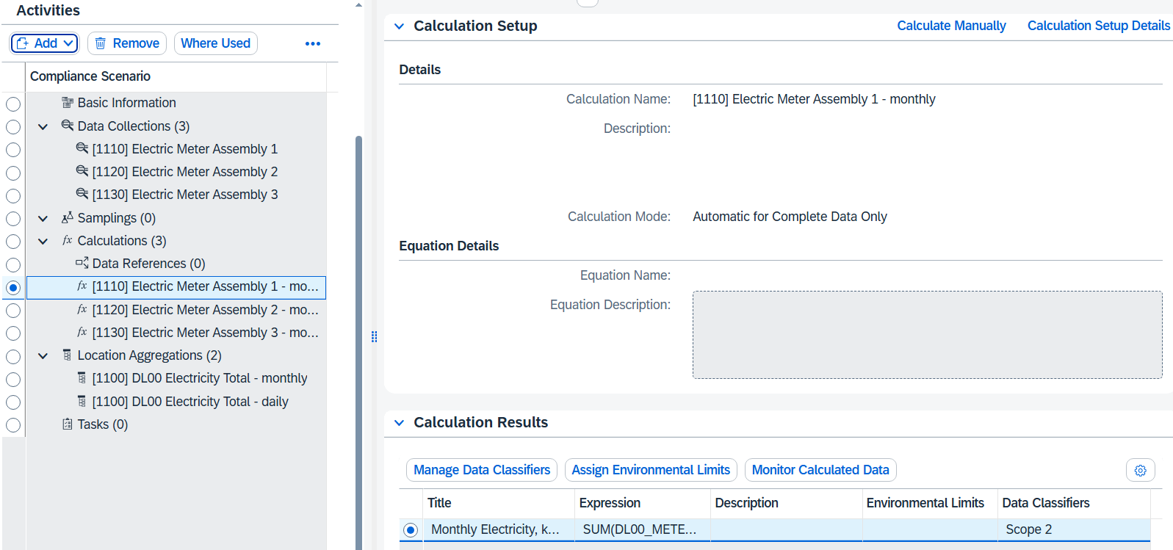

On the top right, choose Calculation Setup Details. | Calculation Setup Details
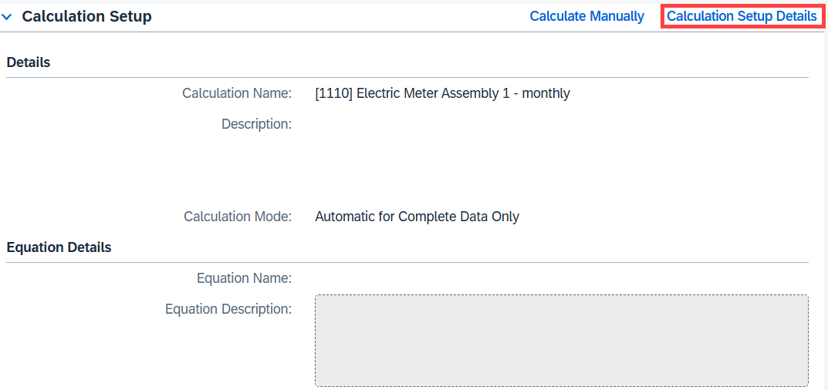
Note If you receive the error message below again, please acknowledge or ignore it.
Here you can see the selected calculation method, the calculation expression, the data classifier (scope 1 vs. scope 2 vs. scope 3) and the defined variable DL00_METER1.
On the bottom right, choose Back to Compliance Scenario. | Back to Compliance Scenario
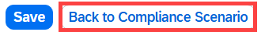
In the menu on the left, you see that two location aggregations were created. This activity is used to acquire aggregated values for your environmental data for the purposes of environmental assessments and reporting to authorities. You can perform location-based aggregations manually or schedule them to run automatically. Select [1100] DL00 Electricity Total - monthly. On the top right, click Monitor Aggregated Data. | [1100] Electricity Total – monthly  Monitor Aggregated Data
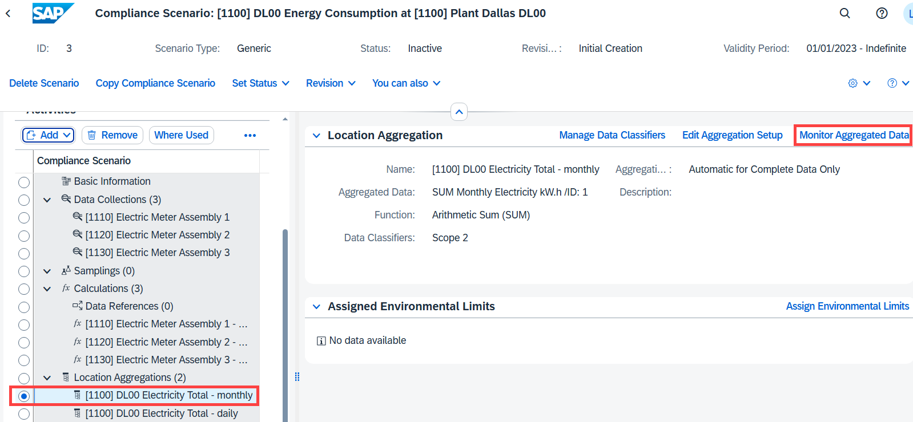
In the From field, select Jan, 2023, in the To field, select Jun, 2024. Your screen will automatically refresh to display the aggregated electricity consumption for all electric meters. It will look like the screenshot shown below. | Jan, 2023  Jun, 2024
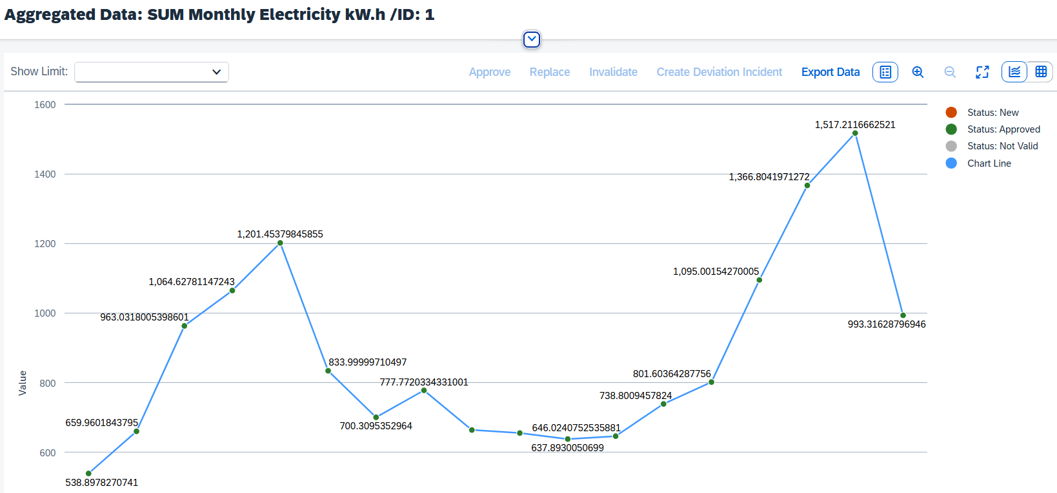
Close your current web browser tab Monitor Data and go back to your Compliance Scenario tab.
In the menu on the left, you see that no compliance tasks have been selected. Remember that this is where tasks defined in the Manage Compliance Requirements app could be linked to regulations that need to be fulfilled by Global Bike.
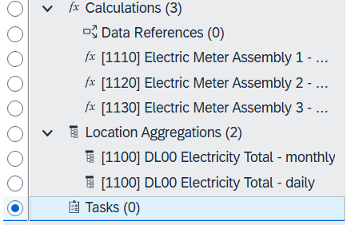
Click to return to the SAP Fiori Launchpad.

 | EM 5: Analyze Environmental Data
Exercise Analyze Global Bike’s environmental data.  Task Use the Environmental Data Explorer app to analyze all environmental data collected and calculated for Global Bike.  Name (Position) Jun Lee, Production planner, Plant Dallas |  | Time 10 min
To analyze environmental data, use the Environmental Data Explorer app in the Environmental Management space in the Analysis section. |  | Start
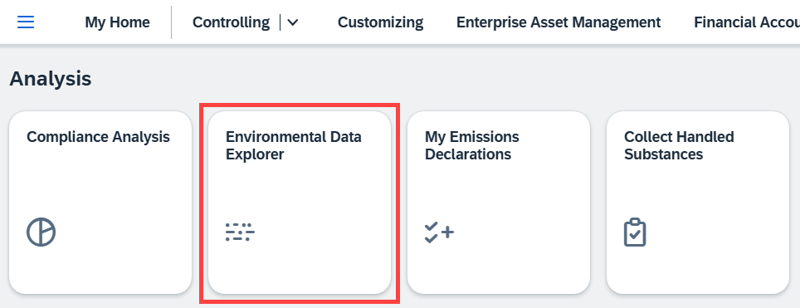
Note: You must first click on the name [1000] Global Bike Inc. US00 before the tree can be opened. Only then can the tree be opened or expanded.
In the menu Location Structure on the left, select [1100] Plant Dallas DL00. From the Attributes list, select Year, Data Type and Activity Name by clicking the Attribute. From the Data Type value list, select Collected Data. From the Activity Type value list, select [1110] Electric Meter Assembly 1. Finally, select Year 2023. The 365 resulting data records (one for each day of calendar year 2023) are shown below. |  | [1100] Plant Dallas …  Year  Data Type  Activity Name  Collected Data  [1110] Electric …  2023
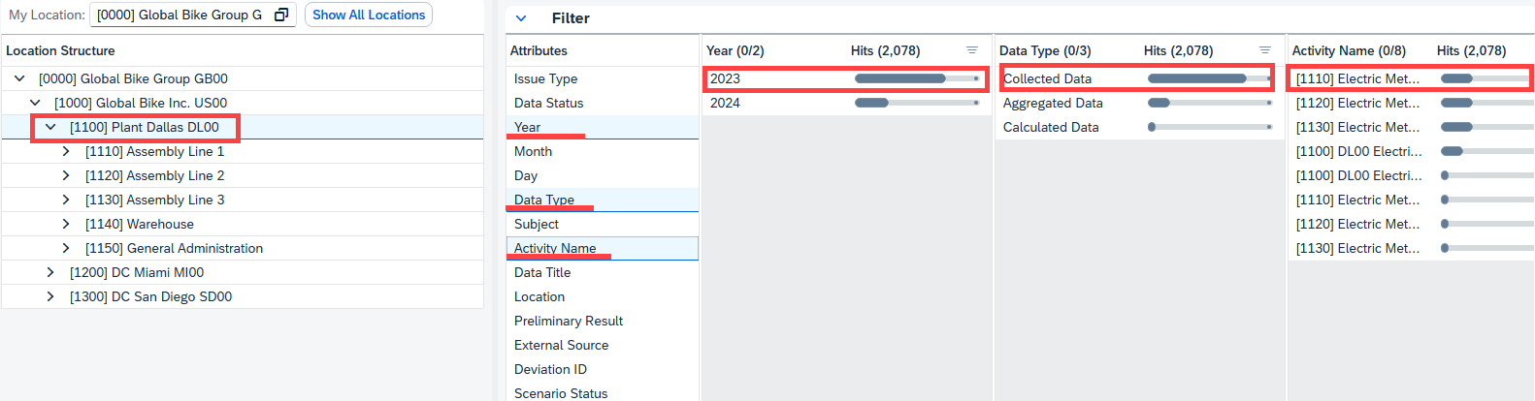
You can export the search result to a spreadsheet.
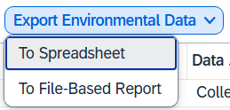
These files could then be imported and further processed in MS Excel or SAP Analytics Cloud (SAC).
Note SAP UCC Magdeburg developed an extensive SAC Sustainability case study loading travel data to a Global Bike event in New York City and calculating the partial carbon footprint using UN-approved conversion factors for various means of transportation. |  | SAC Sustainability  case study
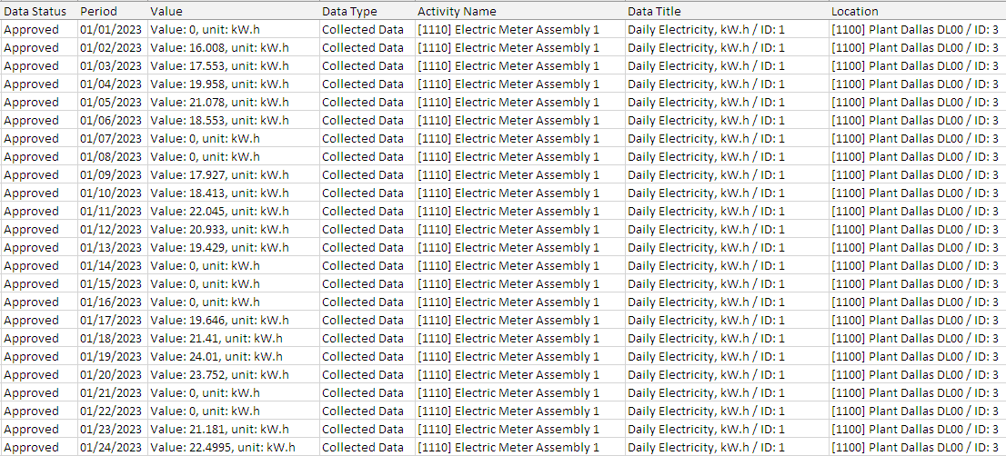
Click to return to the SAP Fiori Launchpad.

