Logistics (LO)
In this case study, logistical processes and the integration of sales, production planning, and materials management processes in the SAP S/4HANA system are shown using the example of the model company Global Bikes.

Product  S/4HANA 2023  Global Bike  Fiori 3.0  Level  Beginners / Advanced  Focus  MM, SD, PP  Authors  Tobias Bellger  Version  4.3.1  Last Change  November 2025 | MOTIVATION  In this case study, logistical processes and the integration of sales, production planning, and materials management processes in the SAP S/4HANA system are shown using the example of the model company Global Bikes. We look at the complete process from the customer inquiry, through manufacturing to settlement, including the procurement of production components.  The processing of the case study promotes the understanding of the individual process steps and the underlying SAP functions. |  | PREREQUISITES  To successfully carry out this case study, it is not necessary to have processed the individual modules “SD”, “MM” and “PP”. However, it is recommended.  NOTE  This case study uses the model company Global Bike.  

Process Overview
Objective Understand and execute a comprehensive logistical process.
Scenario
With their reputation for excellent quality, the bikes from Global Bikes have aroused the interest of the new customer Elbe Cycle ###. A special request for customized mountain bikes brings a new challenge: The wheels should also be maintainable on the go, and should therefore be equipped with an Air Pump and Repair Kit. In addition, the wheels are to be equipped with an innovative GPS bicycle computer, which is inconspicuously integrated in the area of the handlebar – a practical solution designed to simplify navigation while driving. In addition, Global Bikes is to design three versions to serve different customer segments: an inexpensive variant, a higher-priced variant and a carbon fiber wheel variant.
Global Bikes meets this request with the introduction of a new “Sport & Commute” product line that meets the needs of commuting as well as those of sporting use. Global Bikes then plans the "Sport & Commute" series with three models – a basic, premium and carbon fiber wheel variant – with only the first two to go into regular production. The carbon fiber wheel version is exclusively made to order. Based on the existing mountain bike design, the first two variants are further developed and produced for three months to test market acceptance.
For the required Integrated GPS Bike Computer, vendor inquiries are initiated to obtain suitable quotations - also MagdePedal Tech ###, as a new company on the market, signals interest in creating a quotation. After the procurement of the components and the successful payment of the supplier, the production takes its course.
Once the new mountain bikes have been produced, they will be shipped to Elbe Cycle ###. The final step is the posting of the incoming payment for the delivered wheels.
To carry out a complete logistics process, you assume various roles within the Global Bike company. You are active in the areas of Sales and Distribution (SD), Materials Management (MM), and Production (PP).
Employees Involved
Sales:
- David Lopez (Sales Representative US East)
- Matthias Dosch (Sales Person 2 US East)
- Sergey Petrov (Warehouse Employee)
- Stephanie Bernard (AR Accountant)
Production:
- Jun Lee (Production Manager)
- Hiro Abe (Plant Manager)
- Lars Iseler (Shop Floor Worker 2)
- Susanne Castro (Goods Receipt Clerk)
- Michael Brauer (Shop Floor Worker 4)
- Jamie Shamblin (Controller)
Procurement:
- Joyce Hausman (Contract Manager)
- Sandeep Das (Warehouse Supervisor)
- Sergey Petrov (Warehouse Employee)
- Aura Maxwell (Purchasing Agent 2)
- Alberto Conti (Inventory Assistant)
- Wilton Saban (Inventory Supervisor)
- Tatiana Karsova (Goods Receipt Clerk)
- Shuyuan Chen (Head of Accounting)
- Silvia Cassano (AP Accountant)
Table of Contents
Process Overview 2
Step 1: Create New Business Partners (Customer) 6
Step 2: Create Material from Template (Bike) 13
Step 3: Maintain Condition Types 18
Step 4: Create material from template (Integrated GPS Bike Computer) 20
Step 5: Create Sales Inquiry 25
Step 6: Create Quotation 30
Step 7: Create sales order with reference to quotation 34
Step 8: Create Routing (from Template) 38
Step 9: Create Product Group 46
Step 10: Create Planned Independent Requirements 48
Step 11: Display Planned Independent Requirements 51
Step 12: Supplement Production Version in Material Master Record 53
Step 13: Perform Material Requirements Planning 55
Step 14: Display Stock/Requirements List 61
Step 15: Convert Planned Orders to Purchase Requisition 65
Step 16: Create Vendor 68
Step 17: Create RFQ 72
Step 18: Create Quotation from Supplier 75
Step 19: Price-Based Bid Evaluation 78
Step 20: Create purchase order with reference to RFQ 82
Step 21: Display Purchase Order 86
Step 22: Post Goods Receipt for Purchase Order 88
Step 23: Check received goods 92
Step 24: Check physical goods receipt 95
Step 25: Create and Post Supplier Invoice 97
Step 26: Display Purchase Order History 100
Step 27: Display Document Flow 103
Step 28: Post Outgoing Payment 106
Step 29: Display Vendor Balance 109
Step 30: Display Purchase Order History 111
Step 31: Display Balance List and Line Item List 114
Step 32: Create Routing GCBK3### (from template) 116
Step 33: Create Production Version 122
Step 34: Display Material 124
Step 35: Planned Order in Production Order 127
Step 36: Display Production Order 136
Step 37: Confirm Partial Production Completion 141
Step 38: Check Production Order 144
Step 39: Confirm Complete Production Completion 146
Step 40: Check Production Order 148
Step 41: Goods Receipt for Production Order 151
Step 42: Analyze Production Costs 153
Step 43: Execute Variance Calculation 156
Step 44: Settle production order 159
Step 45: Display Stock 163
Step 46: Track Sales Order 165
Step 47: Create Outbound Delivery 171
Step 48: Track Sales Order 173
Step 49: Pick and Goods Issue 175
Step 50: Display stock 178
Step 51: Create Customer Invoice 180
Step 52: Post Customer Invoice 183
Step 53: Post Incoming Payment 185
Step 54: Display Document Flow 188

 | Step 1: Create New Business Partners (Customer)
Task Create a new business partner (customer).  Description Use the SAP Fiori launchpad to create a new customer. Since you want to win Elbe Cycle ### as a new customer as part of this case study (which is therefore not yet stored in the system), you will create the customer master record for it. You enter two types of customer data – sales and financial data. In general, customer data is created in three groups or views – General, Financial Accounting, and Sales.  Customers can be created centrally, which means that all views are created by a single employee in one step. However, responsibility can also be distributed so that different employees of the finance and sales departments are responsible for creating and maintaining the data in their respective views.  In this activity, you will use central maintenance to enter all necessary data for the new customer at once.  Name (Job) Matthias Dosch (Sales Person 2 US East) |  | Time 15 min
To create a new customer, click the Manage Business Partner Master Data app in the section Sales & Distribution in the Sales Person role. |  | Initial Screen
Note If the app is not displayed, search for it using the search bar .
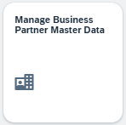
In the Manage Business Parttner Master view, choose the 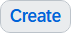 button. As the new customer Elbe Cycle ### is a company, click Organization in the submenu that opens. |  | Organization
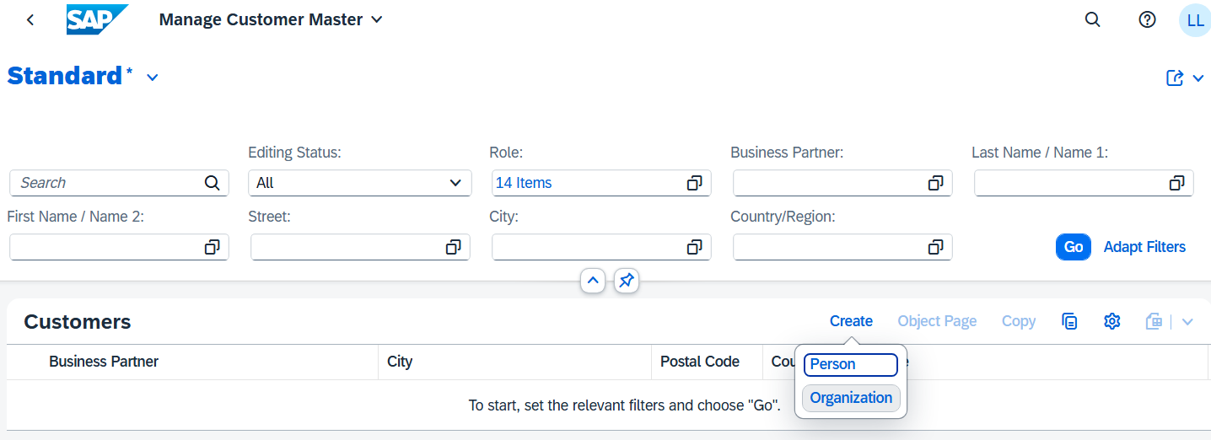
Note Business partners are created at a higher level (or cross-department). They can be categorized as a person or organization. An organization represents entities such as a company (for example, a legal person), parts of a legal person (such as a department), or an association. “Organization” is an umbrella term used to map any situation that can occur during daily business activities.
Roles are assigned to the business partners, for example: Customer, Supplier. The different roles are defined for specific organizational levels (company code, sales area).
In the following, you will learn about and use the two standard roles for customers. While you store data for financial accounting in the role FLCU00 | Customer, specific roles such as Customer or Supplier are assigned in the role FLCU01 | Customer Sales Data. These roles are relevant for specific organizational levels (for example: Company Code, Sales Area). Standard roles for customers.
In the Create Organization view, click the value help icon in the BP Role field. In the dialog box, search for Business Partner FI Customer and then choose the entry FLCU00 | Customer. |  | Business Partner Customer  FLCU00 | Customer
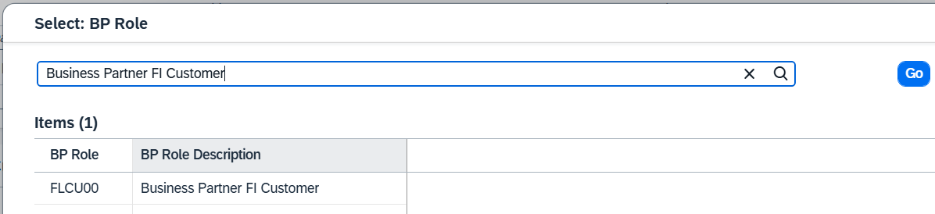
Choose Company as the form of address, enter 1 Elbe Cycle ### as the name. Then, in the Street field, enter Main Street, House Number 7, and as City, enter Magdeburg. In addition, add the postal code 39106, the country/region DE, the region 15 | Saxony-Anhalt, and the language DE. |  | Elbe Cycle ###  Main Street  7  Magdeburg  39106  EN  15 | Saxony-Anhalt  EN
The sales organization is DS00, the distribution channel is WH, and the corresponding division is BI. The currency is set to Euro (EUR). The responsible company code is DE00, to which reconciliation account 12000000 is assigned. |  | DS00  VH  BI  Euro (EUR)  DE00  12000000
Note Remember that you use your three-digit number for ###, for example, if your number is 003, enter 003. The number makes a clear distinction between individual data records in this teaching setup.
Since the new customer is based in Magdeburg, you will assign it to the company code DE00 (Global Bike Germany GmbH) in Germany.
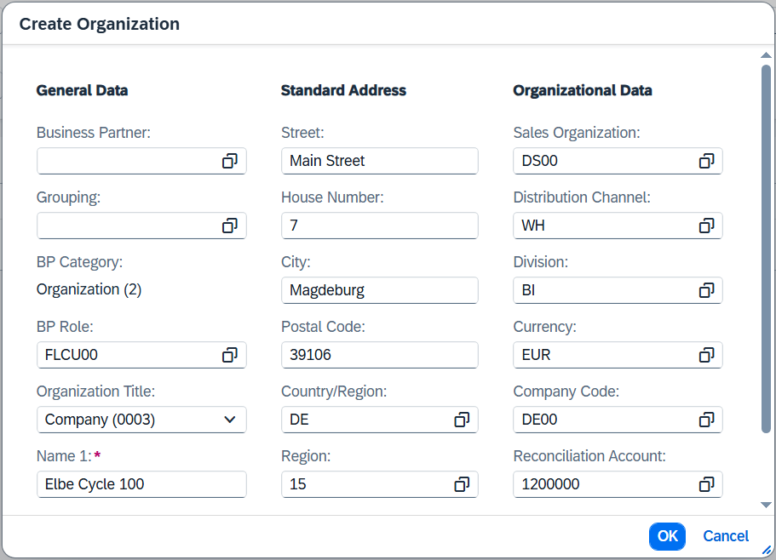
Compare your data with the screenshot above and confirm your entries with . As a result, a new summary is generated. Make sure that you have selected the Basic Data tab page. In the General Information area, add your three-digit number ### as search term 1. |  | ###
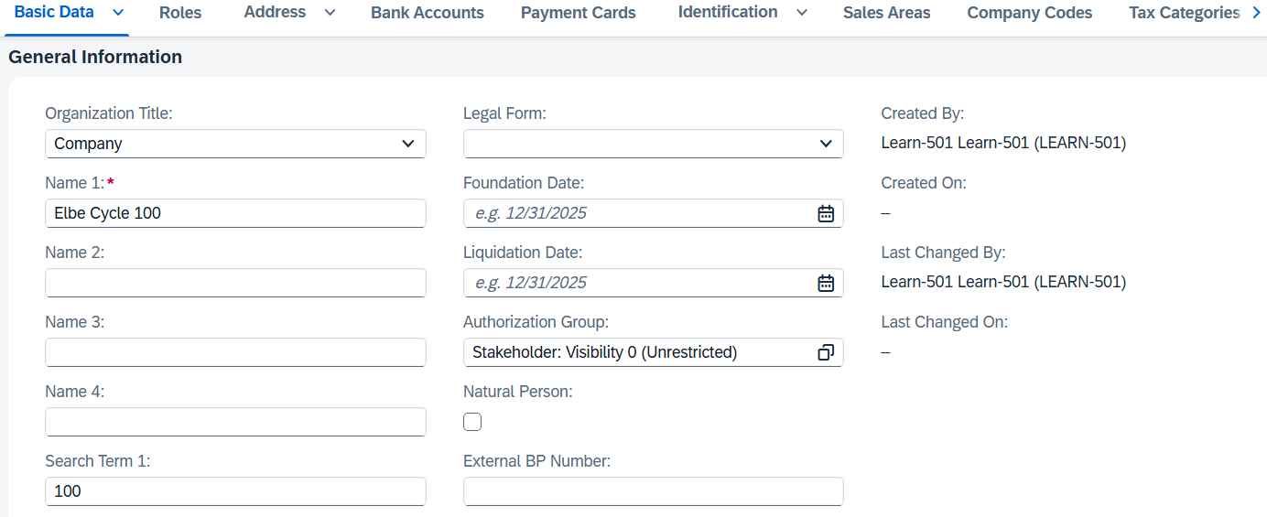
Note In the general/higher-level role of the business partner, the name and address of the business partner are documented. The general data is relevant for both Sales and Distribution and Accounting. To avoid data redundancy, they are stored client-specifically. They are valid for all organizational units of a business partner.
Choose the Address Address Details tab. You see a row with the country details and the validity dates. Click to maintain more details.
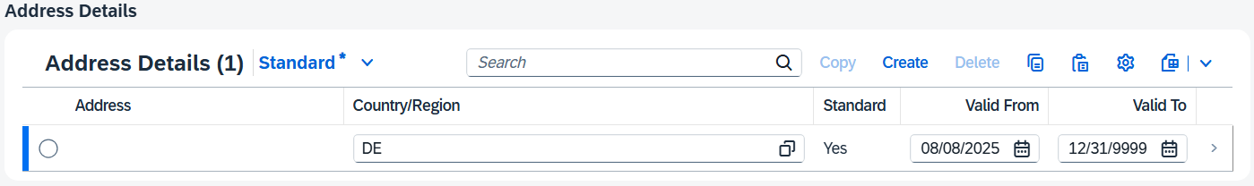
In the Address area, you can use the button 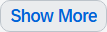 to show all fields. There, you want to define the transportation zone to simplify route determination in the future. Locate the Transport Zone field and click the value help icon . The following dialog box opens.
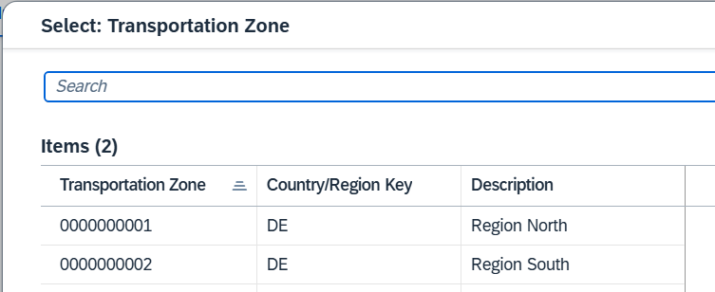
Germany is often divided into the zones North and South. Due to the geographical location of Magdeburg, you choose the area North. By simply clicking on the entry, the transport zone is inserted into the address details. |  | Area North
Finally, use the button to save your draft and return to the general overview.
Then choose the Roles tab page. You get to the correct position via auto scroll. You see a line with the details of the business partner role and the validity dates.
Note At the beginning of the Manage Business Partner Master Data app, you have already created the role FLCU00 (Customer) for your business partner and have already created it with sales-specific and company-code-specific organizational data. For this reason, the "Sales Area" tab page and the "Company Codes" tab page are already displayed.
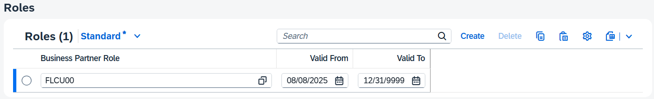
Choose the Company Codes tab page. The company codes to which the customer is assigned or in which accounting-relevant data is stored are displayed there.
Click at the end of the row to maintain further accounting-relevant data.
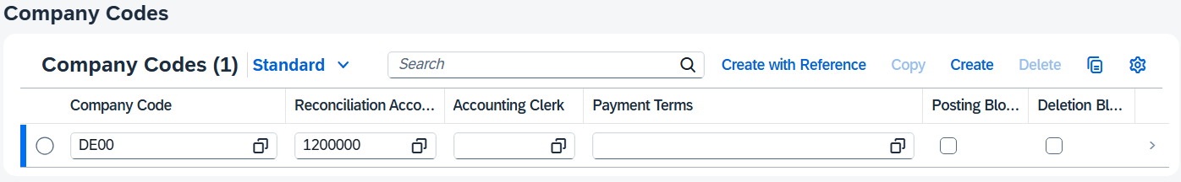
Check that DE00 is defined as the company code and that reconciliation account 12000000 (Trade Receivables) is used. |  | DE00  12000000
Enter 001 (posting date) as the sort key. In addition, add 0001 (payable immediately due net) as the payment term. |  | 001  0001
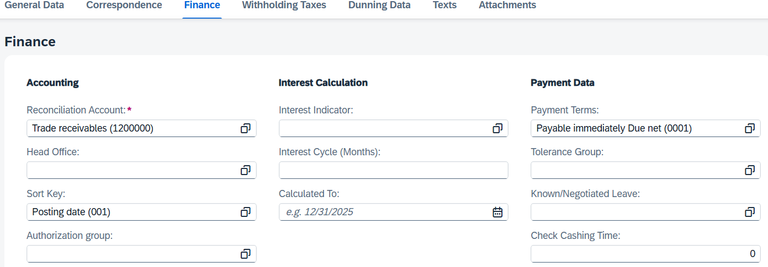
Choose to save the entry as a draft.
You return to the general overview again and navigate to the Roles area.
To be able to now also maintain data for the sales department, you must create a new business partner role. When you click the button, a new row is created in the Business Partner Role area.
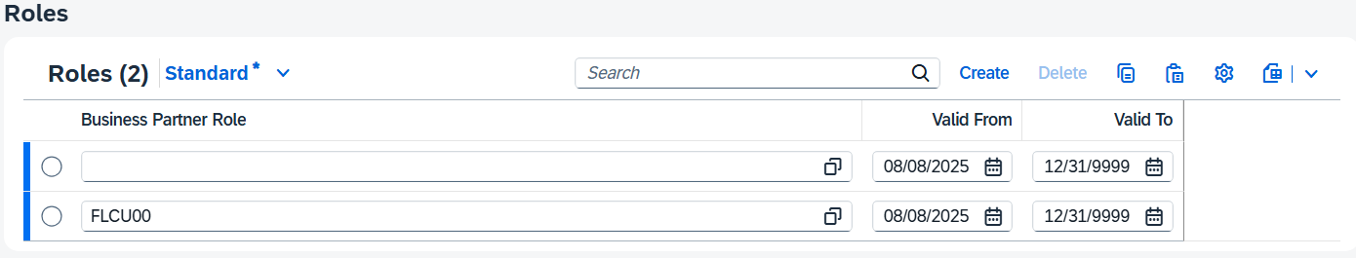
In the empty Business Partner Role field, click the value help icon . In the dialog box, search for Customer and then choose the entry FLCU01 | Business Partner Customer. |  | Customer  FLCU01- Business Partner Customer
Switch to the Sales Areas tab page for maintaining the sales area data of your customer.
Since you have already maintained individual sales area data at the start, an entry has already been made here. Click at the end of the new line to maintain more details.
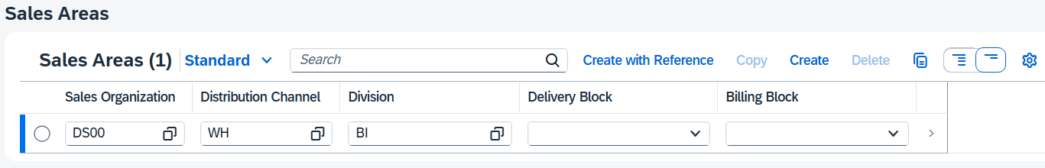
Then choose the Sales Area Details tab page. In the Sales Orders area, enter DE0001 as the sales district and make sure that EUR is specified as the currency. |  | DE0001  USD
In the Billing area, you enter FOB (Free on Board) as the Incoterms and Magdeburg as Incoterms Location 1. This information is relevant for quotation creation at the latest. In addition, add 0001 (payable immediately due net) as payment terms. |  | FOB  Magdeburg  0001
Note Incoterms (abbreviation for International Commercial Terms) are internationally recognized delivery terms published by the International Chamber of Commerce (ICC) for international commercial law. |  | Terms
In the Shipping area, select Normal item as the delivery priority from the dropdown list and Standard as the shipping conditions. Add HD00 (Heidelberg) as the delivering plant. |  | Normal  Default  HD00
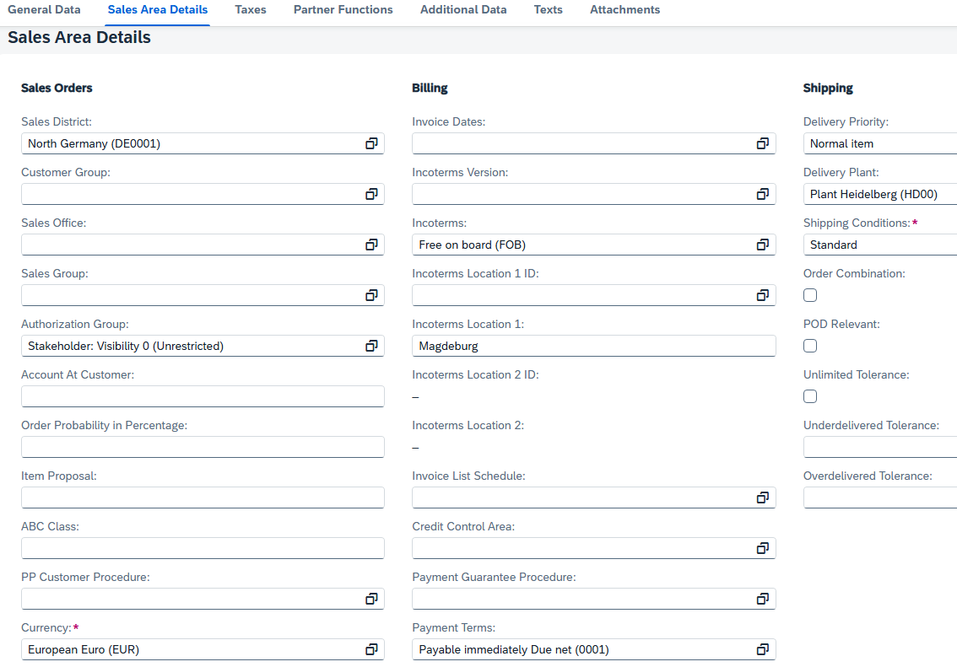
In the Accounting area, select Domestic Revenue as the account assignment group. In the following Partial Deliveries area, use the dropdown list in the Partial Delivery per Item field and select Partial Delivery Allowed. In the last area of this entry screen, select Pricing and Statistics as the price group using the Bulk Buyer dropdown list and enter 1 (Standard) as the customer pricing procedure. Compare your entries with the following screenshots and confirm your entries with Enter. |  | Revenue Domestic  Partial Delivery Allowed  Bulk Buyer  1 (default)
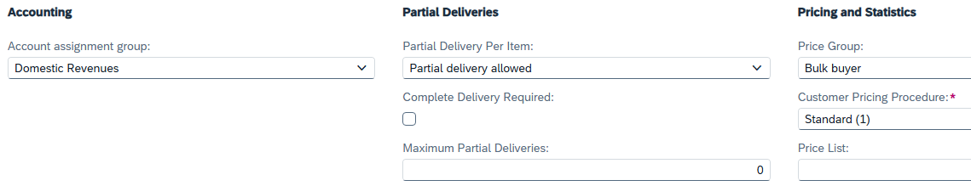
Then choose the Taxes tab page. The tax categories should be added automatically by the system. If there is no entry option yet, press Enter or switch to the Sales Organization field again. The system should have generated a tax line. For the tax category MWST, enter the tax classification 1 (taxable). |  | 1
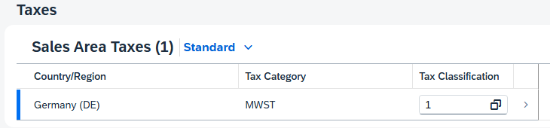
Choose to save your adaptations as a draft. Then press  to save the final business partner.
Note When you receive a message that the language is a mandatory field, navigate to the Standard Communication area and enter EN in the Language field. |  | EN
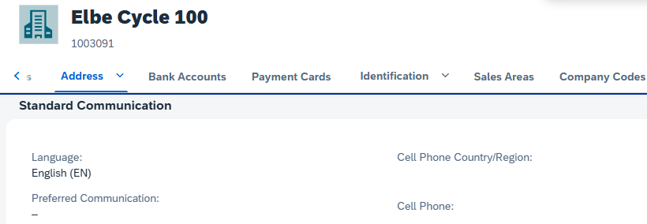
The SAP system creates the master data record for the new BP and assigns a unique business partner number. Make a note of the BP number that you can find in the header area.
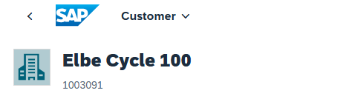
Click  to return to the SAP Fiori launchpad.

 | Step 2: Create Material from Template (Bike)
Task Create the material master record for GCBK1###, GCBK2###, GCBK3###.  Description Use the SAP Fiori launchpad to create your new products. Since these should be a modification of the previous bikes, use the Deluxe Touring bikes DXTR1### and DXTR2### already stored in the system as a template.  For the carbon fiber wheel GCBK3###, the newly created GCBK2### can be used as a template. All new components of the bicycles will be completed later in the case study.  Name (Job) Sandeep Das (Warehouse Supervisor) |  | Time 10 min
To create new products, use the Manage Product Master Data app in the Materials Management area in the Warehouse Supervisor role. |  | Initial Screen
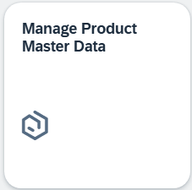
Use the Product field to find your mountain bike DXTR1###. |  | DXTR1###
Select the line with your Deluxe Touring Bike and click 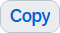.
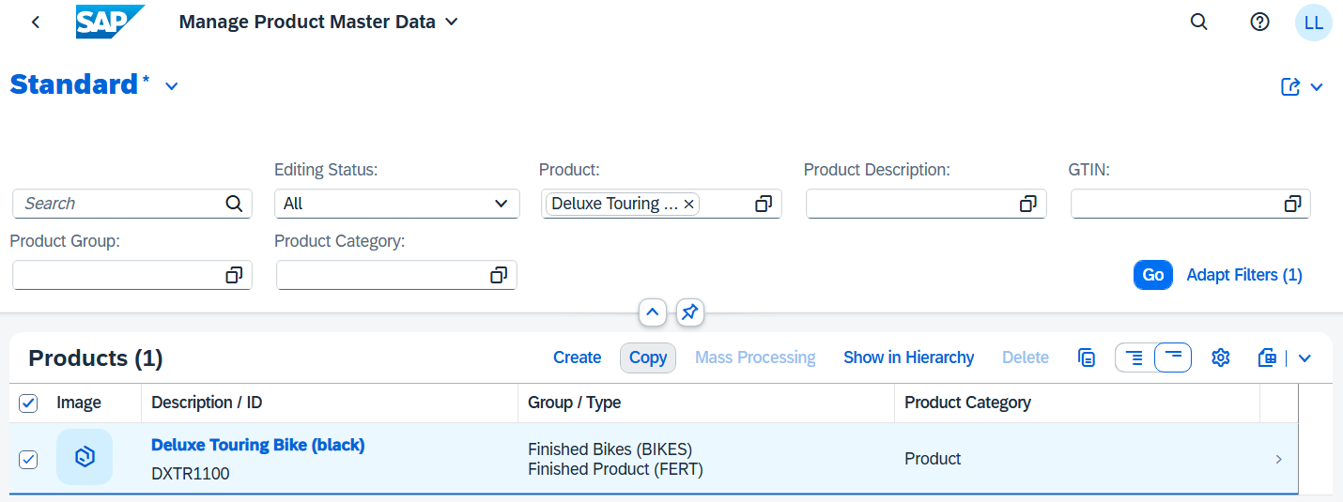
In the Select Organizational Data to Copy popup, click on the Plants row.
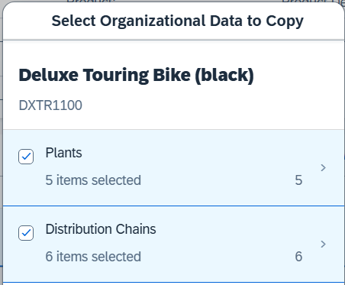
Deselect all plants except your plant in Heidelberg (HD00). Click . |  | HD00
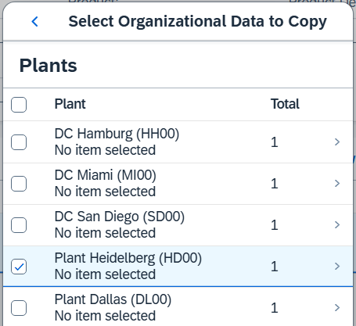
Now click on the line of the distribution chains and select only all lines with the sales organization DS00. Click |  | DS00
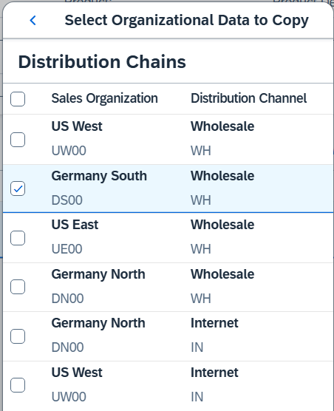
Confirm your adjustments with .
In the Create Master Data Record dialog box, enter GCBK1### as the product number and Global Basic Sport & Commute Bike as the description. Click . |  | GCBK1###  Global Basic Sport & Commute Bike
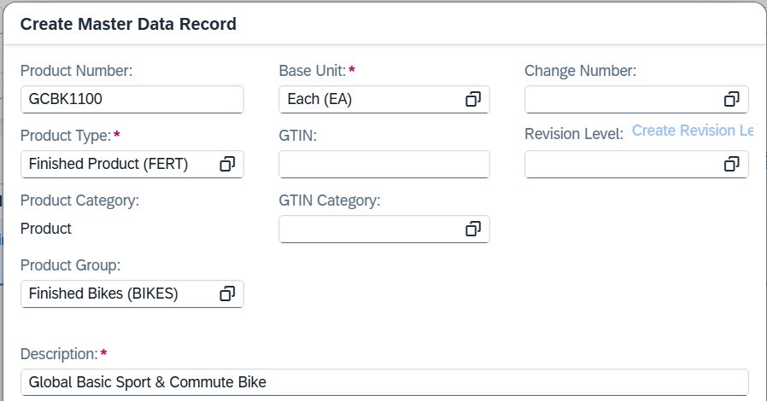
Navigate to the "Valuation Areas" tab page and click on the line of the valuation area HD00. |  | HD00
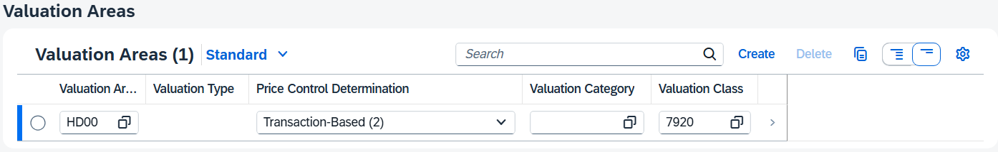
Increase the inventory cost by EUR 200 (to EUR 1058). |  | 1058 EUR
Note Since the original mountain bike is equipped with new components (additional Integrated GPS Bike Computer, Repair Kit and Air Pump), we are already raising the value of the material by EUR 200 at this point.
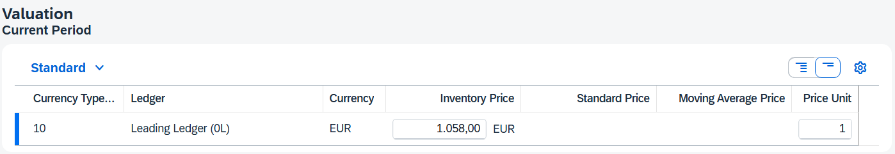
Click .
Now navigate to the "Plants" tab page. Click on the line of plant HD00. |  | HD00
Now go to the MRP Data tab page and enter strategy group 40 (Planning with final assembly). |  | 40 (Planning with final assembly)
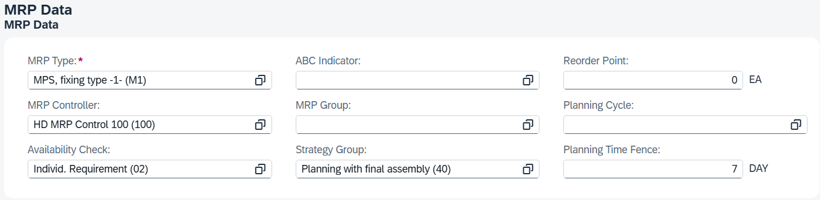
Note The strategy group 40 is used in demand management to preproduce semi-finished products and have them finally assembled only after receipt of a specific sales order, which enables rapid responsiveness to market demands.
Strategy group 20 is used to convert make-to-order production and generates an assigned planned order for each sales order in order-related MRP. This ensures production according to requirements.
Click .
Click .
Repeat these steps for your second bike. Use the bike DXTR2### as a template. Use the following values: |  | DXTR2### as template
- Product Number: GCBK2###  - Description: Global Endurance Sport & Commute Bike  - Plant: HD00  - Distribution Chain: DS00  - Inventory price: EUR 2133  - Strategy Group: 40 |  | GCBK2###  Global Endurance Sport & Commute Bike  HD00  DS00  2133 EUR  40
Repeat these steps for your third bike. Use the bike GCBK2### as a template. Use the following values: |  | GCBK2### as template
- Product Number: GCBK3###  - Description: Carbon Global Sport & Commute Bike  - Plant: HD00  - Distribution Chain: DS00  - Inventory price: EUR 2633  - Strategy Group: 20 |  | GCBK3###  Carbon Global Sport & Commute Bike  HD00  DS00  2633 EUR  20
Note The third variant GCBK3### of Global Bikes is intended as an exclusive custom-made product for a sales order and is therefore not integrated into standard production planning – here we use strategy group 20. The other two models, on the other hand, flow into regular production planning in order to establish them in the market even outside of the special order.
Click to return to the SAP Fiori launchpad.

 | Step 3: Maintain Condition Types
Task Create a new price condition.  Description In order to be able to offer our new customers an offer for our latest bicycles in the range, it is necessary to set pricing conditions for the new materials.  Name (Job) Matthias Dosch (Sales Person 2 US East) |  | Time 5 min
To create a new price condition, use the search bar to find and execute the app Condition Maintenance: Create.
Open the menu entry Prices and double-click Material Price.
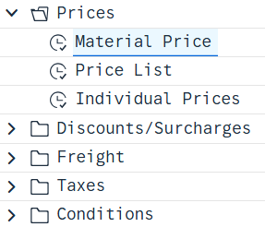
Now choose (Material with release status) on the right side of the screen.
Enter sales organization DS00 and distribution channel WH. Choose Enter to confirm your entry. |  | DS00  VH
In the Material with Release Status table, enter PR00 (price) as the condition type for the first three lines and enter an amount of EUR 1500 for material GCBK1###, EUR 3500 for material GCBK2###, and EUR 4000 for material GCBK3###. |  | PR00  GCBK1###  1500 EUR  GCBK2###  3500 EUR  GCBK3###  4000 EUR
Choose Enter to confirm your entries. Compare your entries with the screenshot.
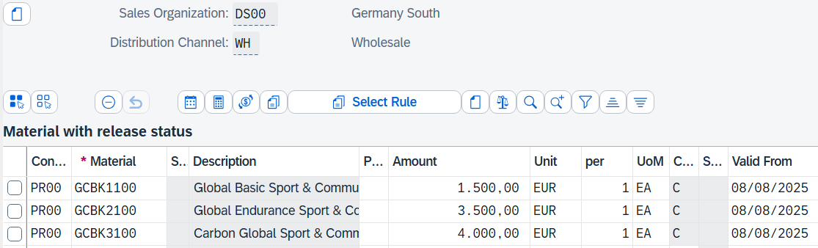
Click .
Click to return to the SAP Fiori launchpad.

 | Step 4: Create material from template (Integrated GPS Bike Computer)
Task Create the material master record for the Integrated GPS Bike Computer IDGC2###.  Description The new Integrated GPS Bike Computer is similar to existing materials in the system, but differs in its integration into the handlebars during the production phase. Please use the SAP Fiori launchpad to create this new Integrated GPS Bike Computer in the system. As a reference, you can use the Deluxe Bike Computer with the name DGRB2### as a template.  Name (Job) Sandeep Das (Warehouse Supervisor) |  | Time 10 min
To create new Integrated GPS Bike Computers, use the Manage Product Master Data app in the Materials Management area in the Warehouse Supervisor role. |  | Initial Screen
Use the Product field to find the Ironing Lock DGRB2###. Click . |  | DGRB2###
Select the row with the ironing lock and click .
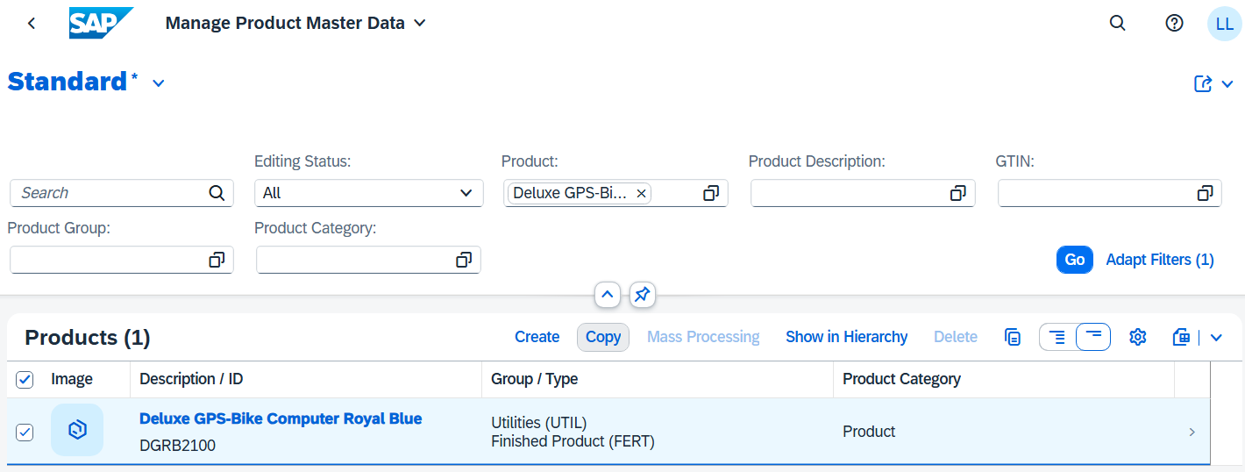
In the Select Organizational Data to Copy popup, click on the Plants row.
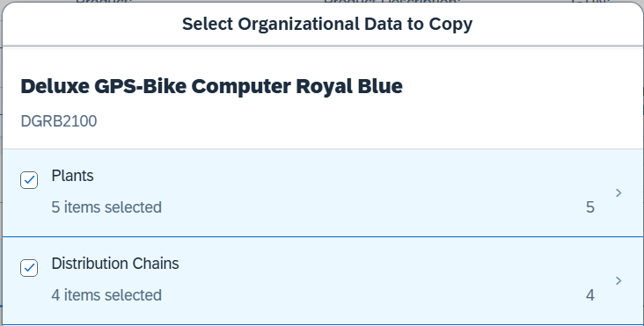
Deselect all plants except for the plant in Heidelberg (HD00). Click . |  | HD00
Now click on the line of the distribution chains and select only the line with the sales organization DS00. Click . |  | DS00
Confirm your adjustments with .
In the Create Master Data Record dialog box, enter IDGC1### as the product number, Raw Material (Raw) as the product type, Raw Materials (RAW) as the product group, and Integrated GPS Bike Computer ### as the description. Click . |  | IDGC1###  Raw Material (Raw) Raw Materials (RAW)  Integrated GPS Bike Computer ###
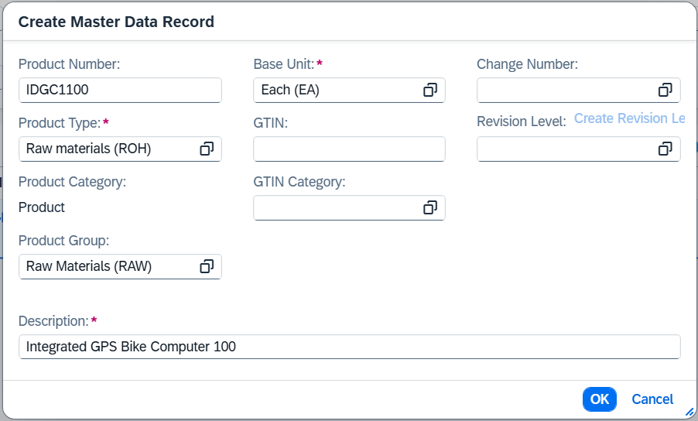
In the General Information section, click 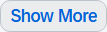. Then enter General item category group 0001 (Make-to-order production). |  | 0001 (Make-to-order production)
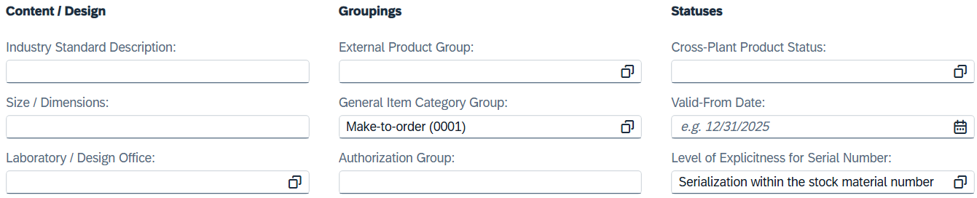
In the Descriptions section, also enter the product name Integrated GPS-Bike Computer ### for language DE (german). |  | EN  Integrated GPS Bike Computer ###
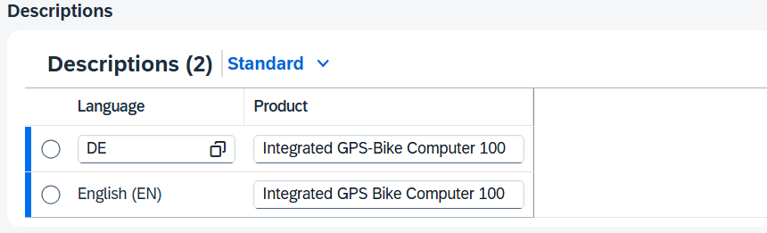
Now switch to the Purchasing area and enter Not Active as the status of the variable order unit. |  | Not Active
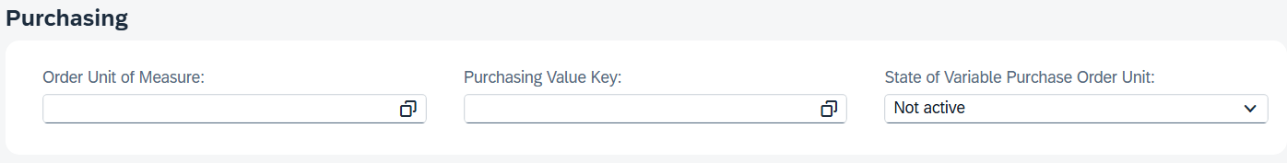
Scroll down to the Plants section. And click on the line of plant HD00.
On the Plant screen, under General Information, verify that HD00 is entered for Plant. |  | HD00
Now go to the Purchasing area and enter Purchasing Group E00 (Europe Purchasing). |  | E00 (Europe Purchasing)
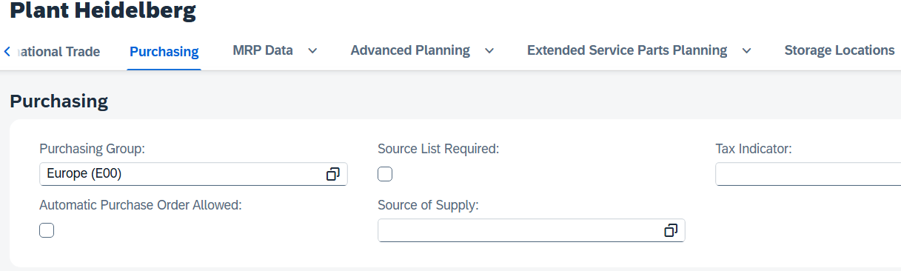
Now go to the MRP Data area and check that for MRP type PD (material requirements planning), as MRP controller 000 (HD MRP controller), and as availability check 02 is entered. |  | PD (Material Requirements Planning)  000  (HD MRP Controller) 02
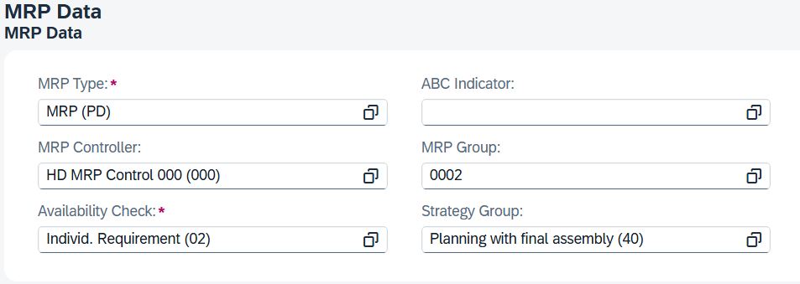
In the Lot-Size Data section, enter EX (Lot-for-Lot Sizing) as the lot-sizing procedure. |  | EX
Note that some values in this view have three decimal places. A minimum lot size of 10 is therefore displayed as 10,000.
In the Procurement section, enter External Procurement as the procurement type and 1 (days) as the planned delivery time and RM00 as the product storage location. |  | External Procurement  1  RM00
In the Repetitive Manufacturing for JIT Prod. Conf. section, select Profile Consider from Component Group Material. |  | Consider Component Group Material
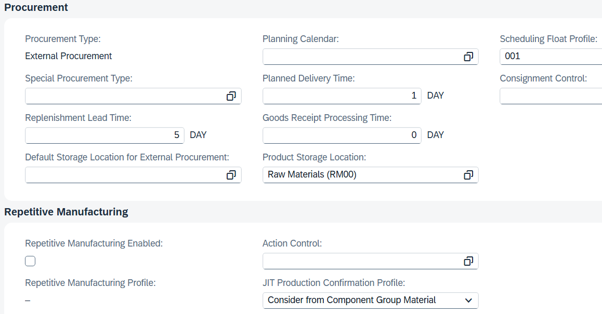
Go to the Storage Locations section and change the entry in the Storage Location field from TRAD to RM00 (Raw materials). |  | RM00
In the Costing area, enter the costing lot size 1 PC. |  | 1 PC
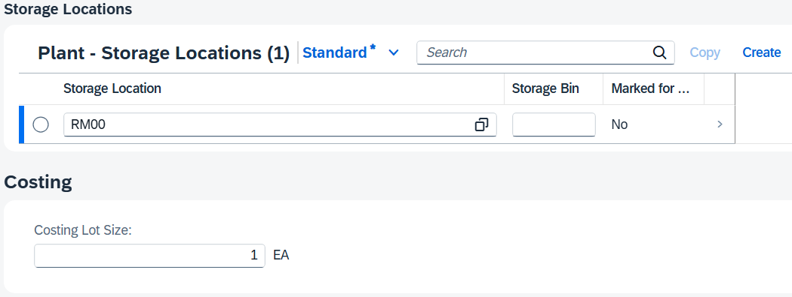
Click .
Back on the Product screen, navigate to the Valuation Areas area.
For valuation area HD00, change the valuation class to 3000 (Raw materials 1). |  | HD00  3000
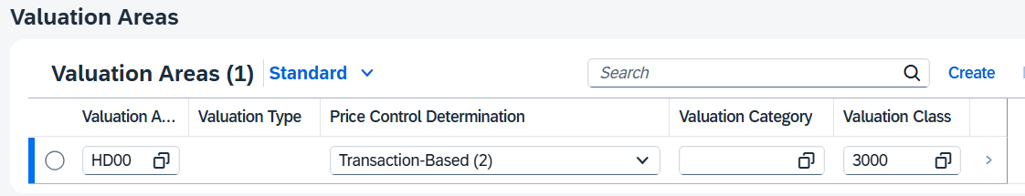
Click on the line of valuation area HD00. |  | HD00
Switch to the Valuation area and enter EUR 40 as the inventory price and make sure that Moving Average Price/Periodic Unit Price (V) is selected for Price Control. |  | 40  Moving  Average price/periodic unit price (V)
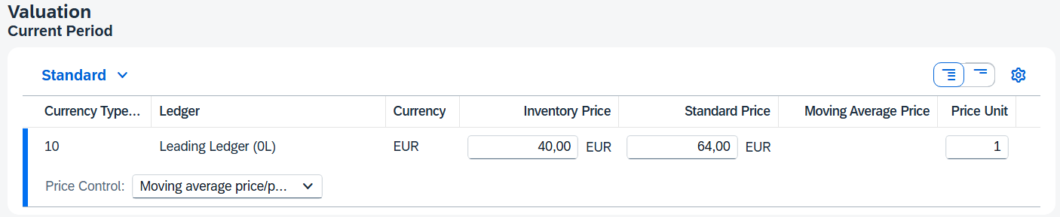
Click and then click .
Click to return to the SAP Fiori launchpad.

 | Step 5: Create Sales Inquiry
Task Create a sales inquiry.  Description Now you will create the request from your new customer (Elbe Cycle ###) in the system. An inquiry is a request from a customer for specific sales information or a non-binding quotation. An inquiry can relate to materials or services, conditions and, if necessary, delivery dates.  Name (Job) Matthias Dosch (Sales Person 2 US East) |  | Time 10 min
To create an inquiry, use the Manage Sales Inquiries app in the Sales and Distribution area in the Sales Person role. |  | Initial Screen
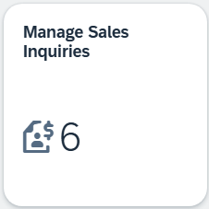
Note This app is dynamic and displays a 6 in this case. This means that Global Bikes currently has 6 different customer inquiries. The number you see depends on the requests that you and the other participants created previously. You will also encounter this functionality with other apps.
If you want to display all existing sales inquiries, choose . A list of all requests is output. If, on the other hand, you want to create a new customer inquiry, click 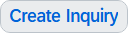.
Enter AF (Inquiry) as the RFQ type and DS00 (North Germany) as the sales organization. In addition, add WH (wholesale) in the Distribution Channel field and BI (bicycles) as the division. |  | AF  DS00  VH  BI
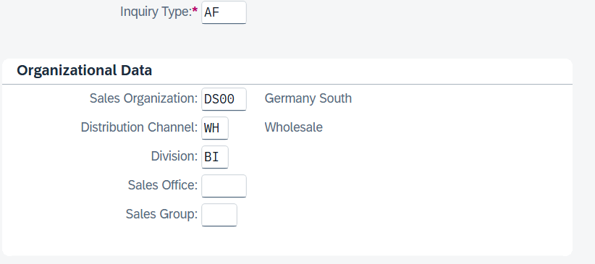
Compare your entries with the screenshot above. Then choose 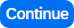 at the bottom of the screen to be able to enter further data for the request. The following screen is now displayed.
In the Sold-to party and Ship-to party field, enter the business partner number of your customer Elbe Cycle ###. |  | Business Partner Number  Elbe Cycle ###
Note Alternatively, you can search for your BP number by selecting the value help icon in the Sold-To Party field. Enter ### as the search term and Heidelberg as the city. Confirm your entry with Enter to start the search. Double-click the row with Elbe Cycle to transfer the BP to the request.
Enter ### as the customer reference and enter today's date in the Cust. Ref. Date and Valid From fields (F4, then Enter). For the Valid To and Requested Delivery Date fields, you specify a month from today. |  | Today's date  One month from today
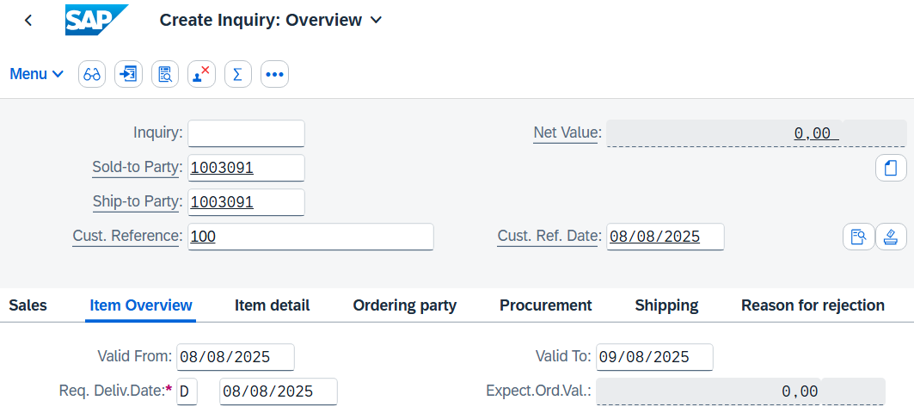
Elbe Cycle ### wants an offer for three products: the Global Basic Sport & Commute Bike, the Global Endurance Sport & Commute Bike and the Carbon Global Sport & Commute Bike. |  | Global Basic  Sport & Commute Bike Global Endurance Sport & Commute Bike  Carbon Global Sport & Commute Bike
To find these products, use the search function. Click in the Material field and then click the value help icon .
On the Material for Description tab page, enter *Global* as the material short text and *### as the material (for example, *003 if your number is 003). |  | *Global*
Then click to start the search process. The system displays results whose material short text contains "Global" and whose material key ends with "###".
Double-click the Global Basic Sport & Commute Bike to add it to the item list. |  | Global Basic Sport & Commute Bike
On the following screen, enter an order quantity of 15. |  | 15
Repeat the process for the second and third items, first searching for the Global Endurance Sport & Commute Bike as the material and entering an order quantity of 5, then searching for the material Carbon Global Sport & Commute Bike and entering an order quantity of 10. |  | Global Endurance Sport & Commute Bike  5  Carbon Global Sport & Commute Bike  10
Choose Enter to determine the price for this request. Confirm the information that appears.
Note Note that if no net price or no price is displayed for this request, enter today's date in the Pricing Date field.
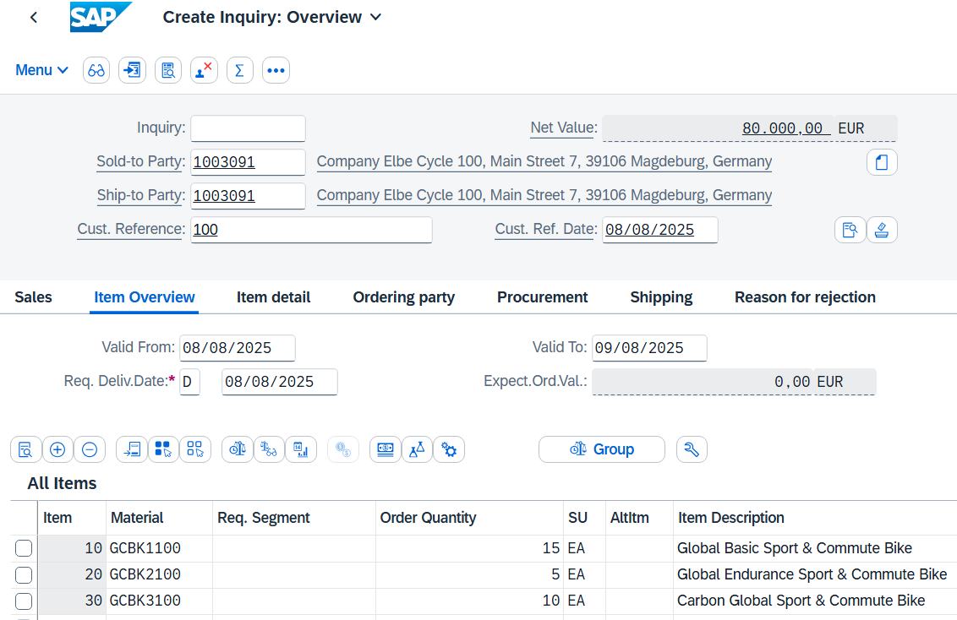
The total price for the requested 30 bicycles is EUR 80,000 (net value). The expected order value is a calculated value that multiplies the net value of the order quantity by the probability that an inquiry from this customer will result in an actual order. Select all items and click . |  | EUR 80,000
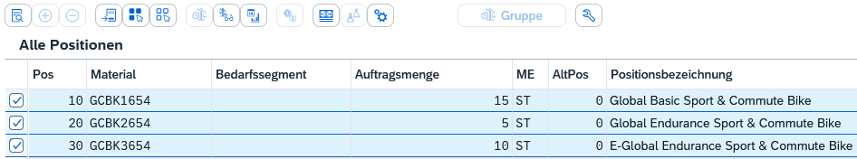
In the lower area of the General Sales Data, you will find the Order Probability field. This expresses the percentage probability that an inquiry or quotation item will flow into a sales order. If this order probability were 40%, the expected order value would be 0.40 x 80,000.00 EUR = 32,000.00 EUR.
Changing the order probability might make sense because different requests from customers have different probabilities. Change the order probability for material GCBK1### to 80 (%). |  | GCBK1###  80 (%)
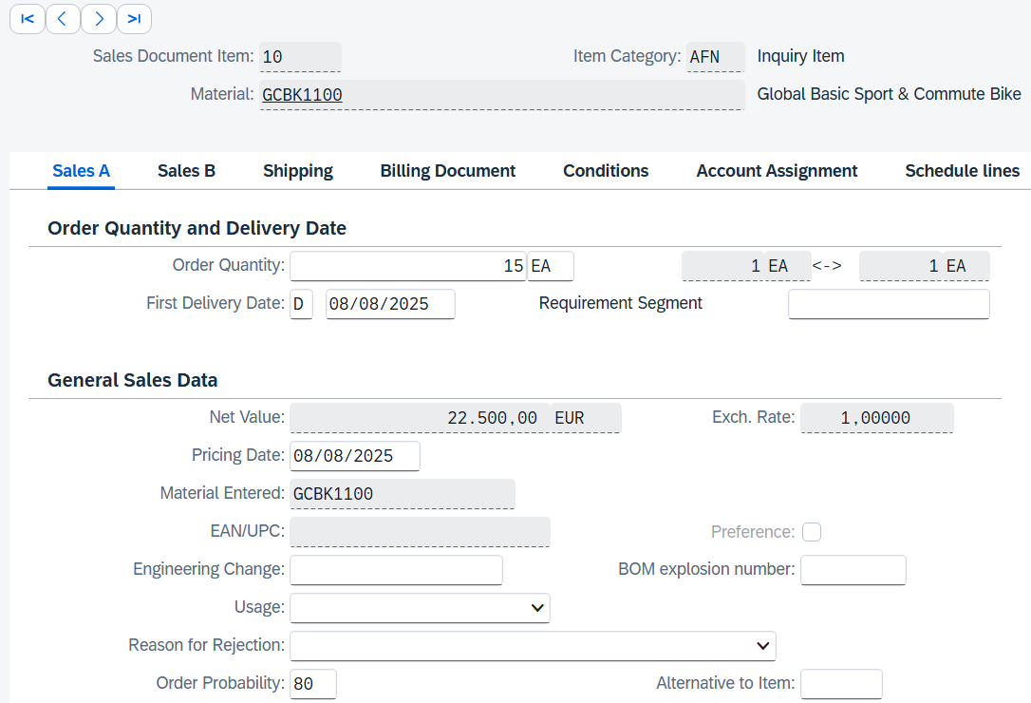
Then click on (Next Item) in the upper area to go to the material GCBK2###. Enter an order probability of 80 (%). |  | GCBK2###  80 (%)
Repeat this step for bike GCBK3###. |  | GCBK3###.
Confirm your change by choosing Enter. Click 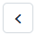 (Back) to update the request and note the new expected order value of 64,000.00 EUR. |  | 64,000.00 EUR
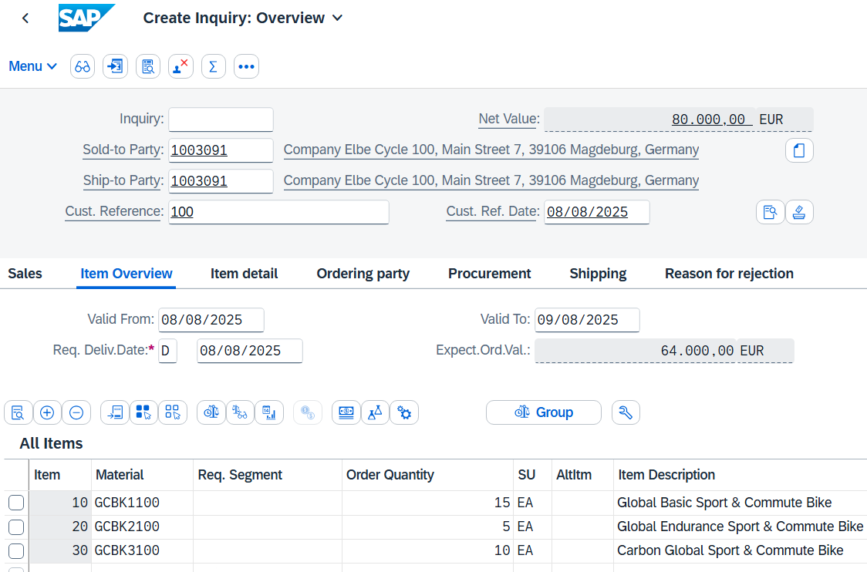
Click to save the request. The SAP system will assign a unique number to the request. Make a note of them.
Click to return to the SAP Fiori launchpad.

 | Step 6: Create Quotation
Task Create a sales quotation.  Description Elbe Cycle ### wants a quotation for the articles created earlier in the RFQ. Using the Create with Reference function, you can simply transfer the data from the RFQ to the quotation and send it to Elbe Cycle ###.  Name (Job) David Lopez (Sales Representative US East) |  | Time 10 min
To create a sales quotation, use the search bar to find and execute the app Manage Sales Quotations - Version 1. |  | Initial Screen
Note In an inquiry, a customer wants to know the conditions (price, scheduling agreement) for a specific product or service. The only difference to an offer is that it is a legally binding offer for the delivery of the desired goods.
If you want to display all existing quotations, press . A list of all quotations is output. However, if you want to respond to the request you just entered, click 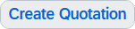.
In the Offer Type field, enter the abbreviation QT (Quotation) and click 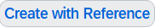 in the lower part of the screen. In the following dialog box, you can search for your inquiry and thus copy the data to the quotation. To do so, make sure that the Request tab is selected. In the Inquiry field, enter your inquiry number. |  | SP  Inquiry Number
Note If you have forgotten your inquiry number, alternatively click in the Inquiry field and then click the value help icon . On the Sales document according to customer PO number tab page, enter your number (###) as the customer reference.
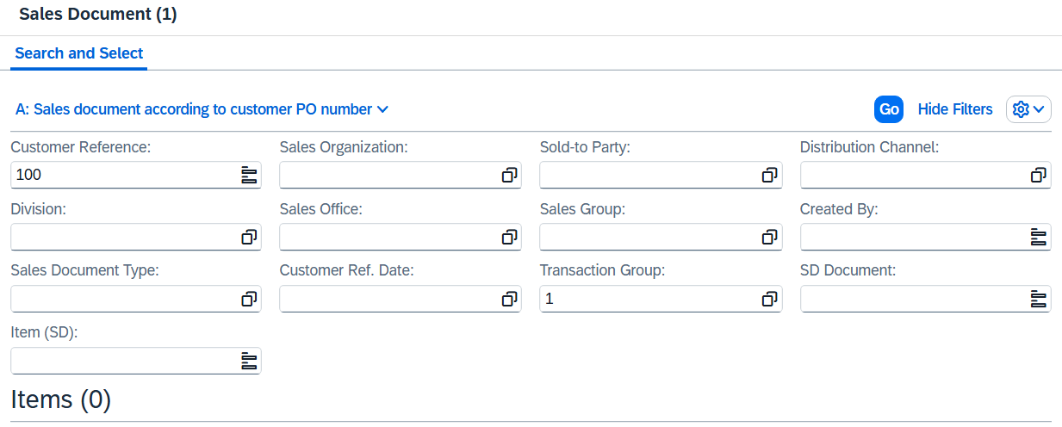
Then click and double-click your purchase order. Your inquiry number is added accordingly.
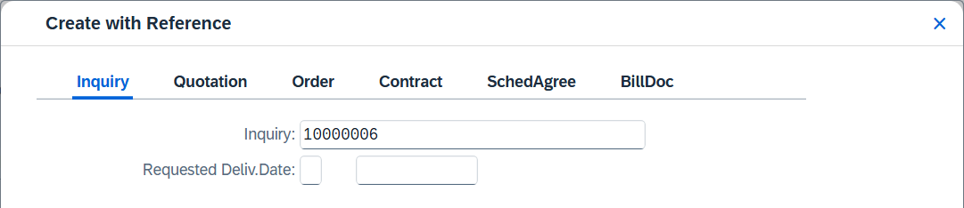
Click 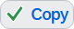 to copy the information from the Inquiry to the Quotation.
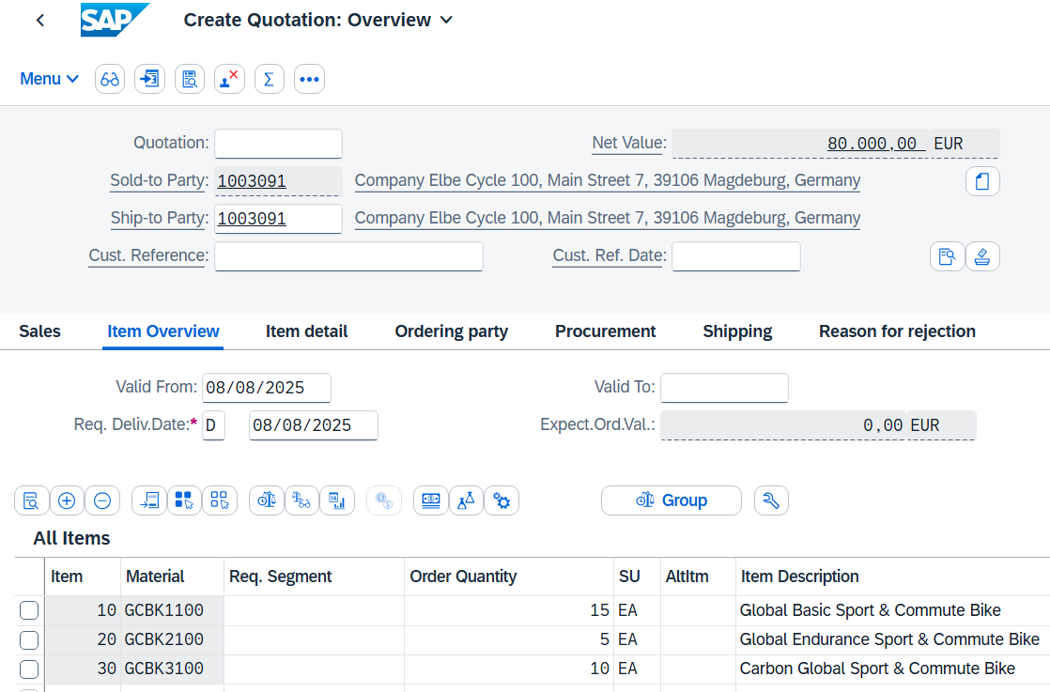
Enter the customer reference ### and the current date as the customer reference date. In addition, in the Valid To field, add the date from today in one month. The requested delivery date has already been copied from the RFQ. |  | ###  Today's  Current Date  One month from today
To ensure that Elbe Cycle ### becomes a loyal customer, you are entitled to give a discount of EUR 50.00 on each Global Basic Sport & Commute Bike as well as a discount of 5% on the entire order. |  | 50.00  Global Basic Sport &  Commute Bike  5%
To give the 50.00 EUR discount, select the line with the Global Basic Sport & Commute Bike and then click 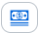 (Conditions). You get a screen showing the conditions of the Basic Mountain Bikes.
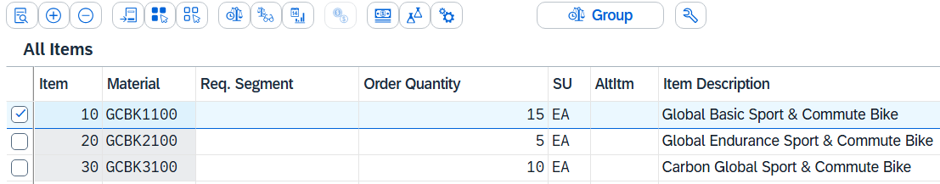
Note The condition master data includes prices, surcharges and discounts, as well as freight costs and taxes. You can define condition records so that they depend on different data. For example, you can specify a customer-specific material price. In the SAP system, pricing is carried out using conditions. A so-called pricing procedure determines which condition types are used to calculate the final price. Condition type PR00 determines, for example, the gross price.
To add a discount, enter condition type K004 (Material Discount) with an amount of 50 in the pricing procedure. |  | K004  50
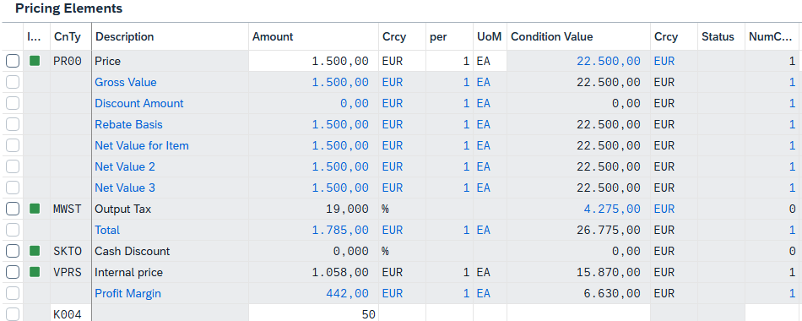
After clicking Enter, a new price will be calculated for the 10 Global Basic Sport & Commute Bikes.
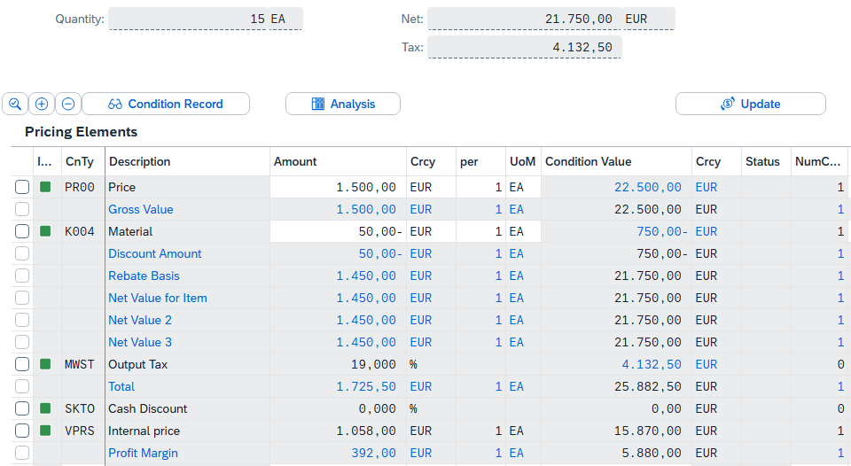
Note that the discount has now been included in the total order. Choose 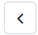 to return to the quotation screen. To apply the 5% discount to the complete order, follow the pull-down menu path:
Menu ► Goto ► Header ► Conditions
To apply the discount of 5%, in the CTyp (Condition Type) field, enter RA00 (Perc. Avail.) and an amount of 5, and choose Enter. Note that the discount is not yet included in the price. |  | RA00  5
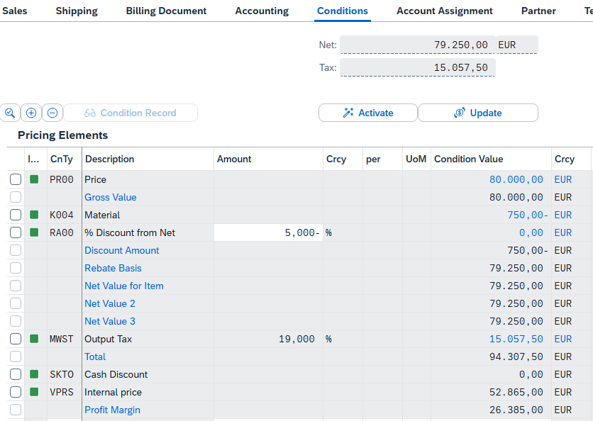
To activate the 5% discount, click . The 5% discount is now applied. Note that the 5% discount is calculated after the 50 EUR discount per Global Basic Sport & Commute Bike.
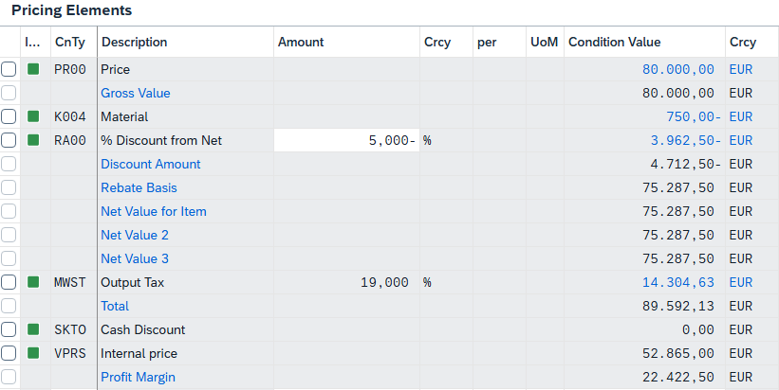
Click to save the new quote. The following success message appears. Make a note of the quotation number.
Click to return to the SAP Fiori launchpad.

 | Step 7: Create sales order with reference to quotation
Task Create a sales order with reference to a quotation.  Description Elbe Cycle ### has agreed to the terms and conditions of the offer and now wants to order the bikes. Since you have already maintained the quotation in the system as an example, you can create the order with reference to the quotation and save time again by transferring the data.  Name (Job) David Lopez (Sales Representative US East) |  | Time 10 min
To create a sales order, use the search bar to find and execute the app Manage Sales Orders - Version 1. |  | Initial Screen
If you want to display all existing sales orders, choose 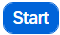. A list of all sales orders is output. If, on the other hand, you want to create a sales order for the accepted quotation, click 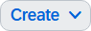 and then 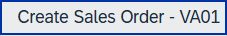.
In the Create Sales Documents view, in the Order Type field, enter OR (Standard Order). Click 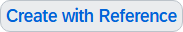 to find your quote from the previous step. Therefore, in the following dialog box, make sure that the "Offer" tab page is selected. Enter your quotation number in the Quotation field. |  | OR1  Quotation Number
Note If you have forgotten your quotation number, alternatively click in the Quotation field and then click the value help icon . On the Sales Document by Customer PO Number tab, enter your number (###) for Customer Reference. |  | ###
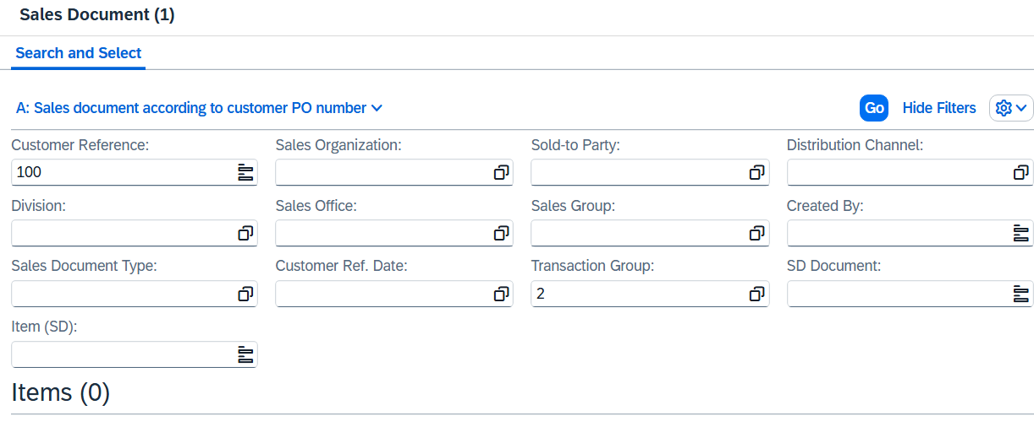
Then click and double-click your purchase order. Your quotation number is supplemented accordingly.
The system displays a list with the inquiry created previously and the quotation.
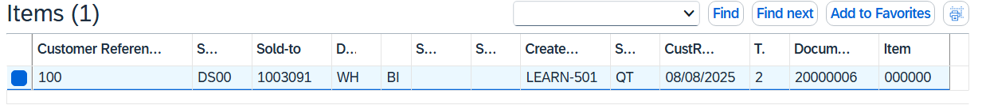
Double-click the document with the sales document type QT (quotation).
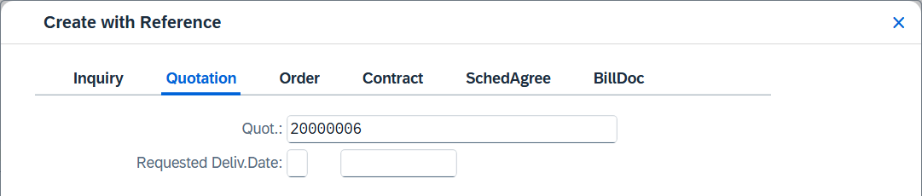
Click to copy the information from the quotation to the standard order.
Note If the System shows up the Availability Screen, press three times 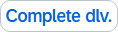.
Note that the net value has decreased due to the discounts granted in the quotation.
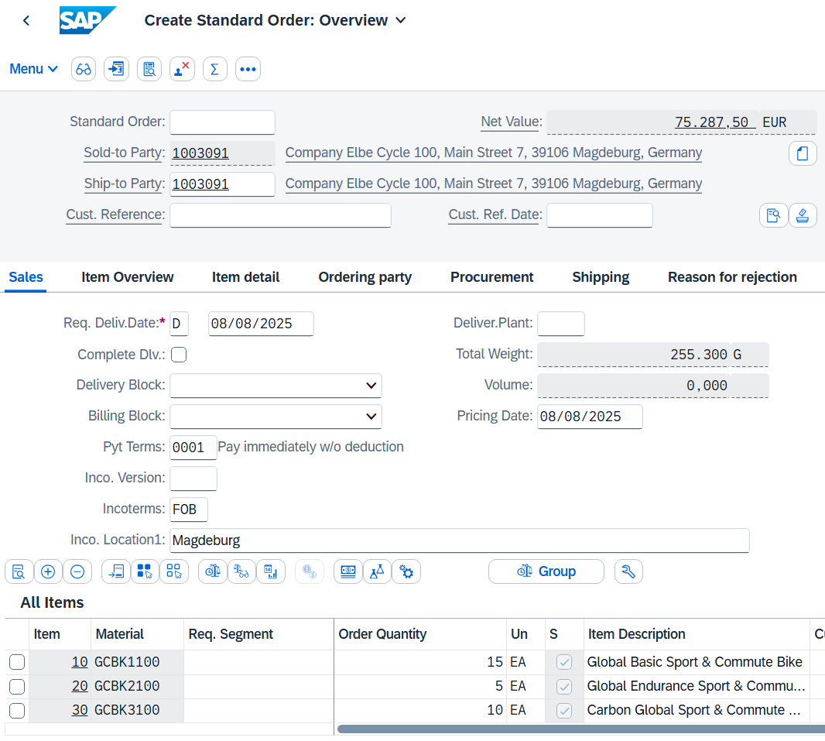
Enter the Customer Reference ### and the Customer Reference Date as today's date. Enter HD00 as the delivering plant, a corresponding warning can be confirmed. |  | ###  Today's date  HD00
Note that the requested delivery date has been copied from the quotation.
Also select material GCBK1### and then click 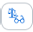 (Display Availability). Confirm any warnings with Enter. |  | GCBK1###
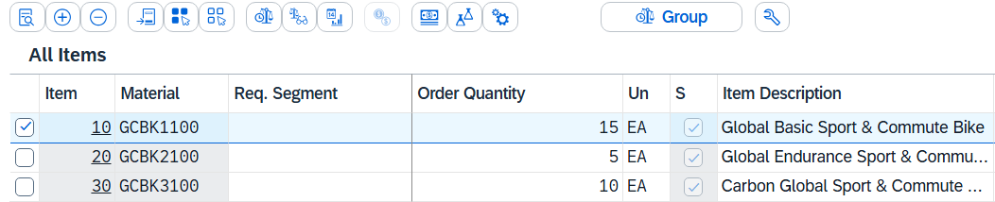
The availability overview opens.
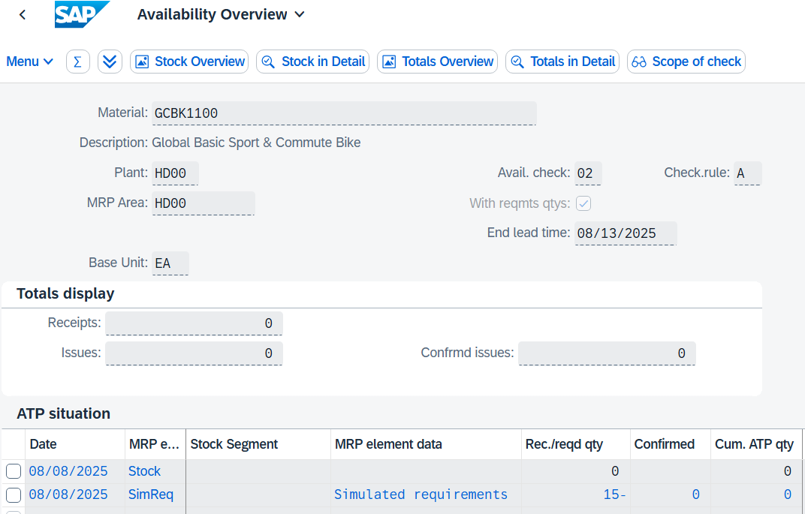
The first line shows you the current plant stock of your material (0) and the second line shows you the simulated requirement of the material to fulfill the sales order.
Click 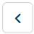.
Now display the availability check for your material GCBK3###. |  | GCBK3###
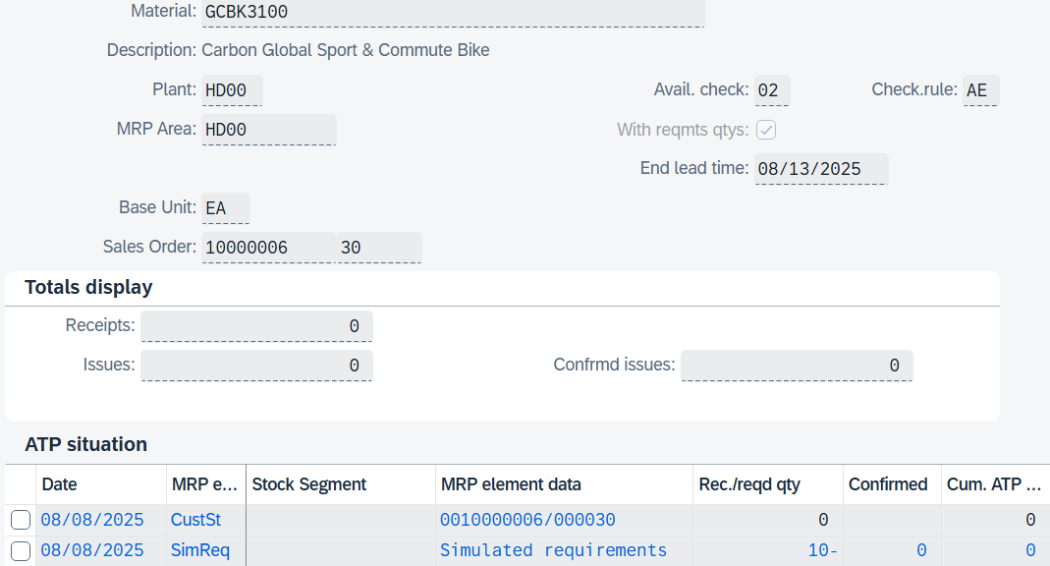
You will notice that this time you see the sales order stock (0) (quantity of a material that is in stock to execute a sales order) and in the second line you can see the simulated requirement of the material to fulfill the sales order.
Note In SAP, the MRP strategy is reflected in Supply and Demand Management. Strategy group 40 is set for GCBK1### and GCBK2###, which means plan-based production for warehouse stocks; these articles are therefore produced on stock and served from this (stock level). GCBK3### follows strategy group 20 for make-to-order production; plant stocks are reserved exclusively for a sales order. The "sales order stock" shows the reserved quantity, while the "simulated requirement" reflects the material requirement required to fulfill the order.
Click . Click on and note your order number. |  | Order Number  ………………….....
Note After the availability check, you can see that there is no warehouse stock of our new materials. You have the option of either procuring these materials externally or producing them separately. Global Bikes has opted for in-house production to offer a new product line. In the next step of the case study, we therefore focus on the transition to the production phase.
Click to return to the SAP Fiori launchpad.
Process Progress
Since the materials ordered by customer Elbe Cycle ### are new products, they must first be produced. At this point, the sales process therefore pauses and the production of the new materials is initiated.

Process Progress
To fulfill the requirement of the sales order, the new materials must first be produced. This is where the production planning and production process starts.
 | Step 8: Create Routing (from Template)
Task Use the SAP Fiori launchpad to create a routing (from a template).  Description After the planning parameters and data have been maintained, the components of the bicycles must now be assigned to the individual work steps. This is usually a dependent process in which each operation is based on the results (products) of the preceding transaction.  Since the bicycles of the new "Sport & Commute" series are derived from the Deluxe Touring Bike series, these are similar. Therefore, please use the routing of the Deluxe Touring Bike series as a template and adjust it accordingly.  Name (Job) Jun Lee (Production Manager) |  | Time 15 min
To create a Routing, click the Create Routing app in the Production Planning and Execution area in the Production Manager role. |  | Initial Screen
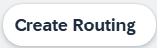
On the Create Routing: Initial Screen, enter material GCBK1### and plant HD00. |  | GCBK1###  HD00
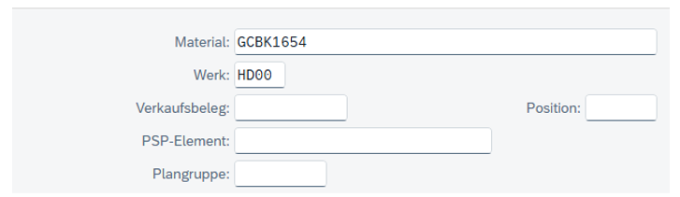
Choose 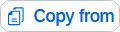.
In the dialog box that appears, select Routing and choose . |  | Routing
In the Template Selection dialog box, enter DXTR1### as the material and enter HD00 as the plant. |  | DXTR1###  HD00
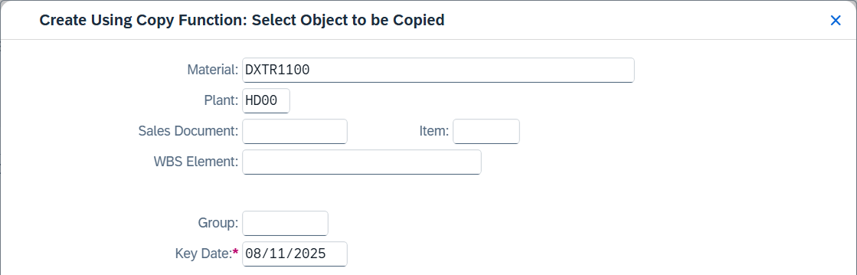
Click .
On the Create Routing: Header Data Check screen, use the F4 help for the Overall Status field and select 4 (Released (General)). |  | 4 (Released (general))
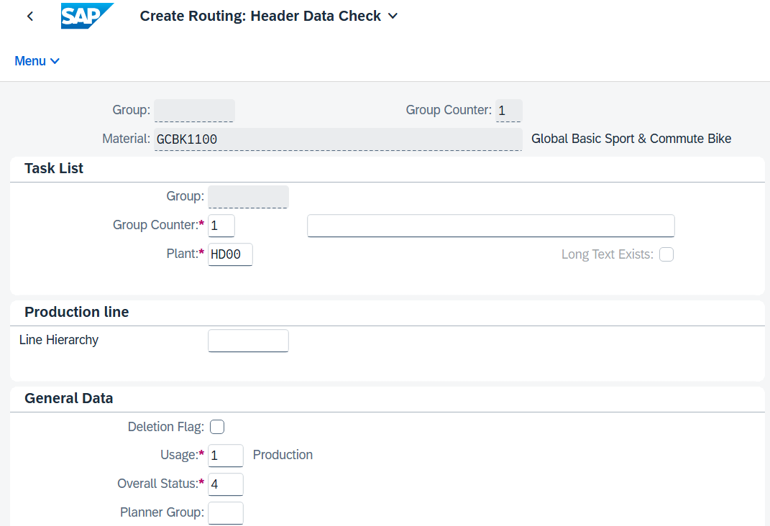
Press Enter.
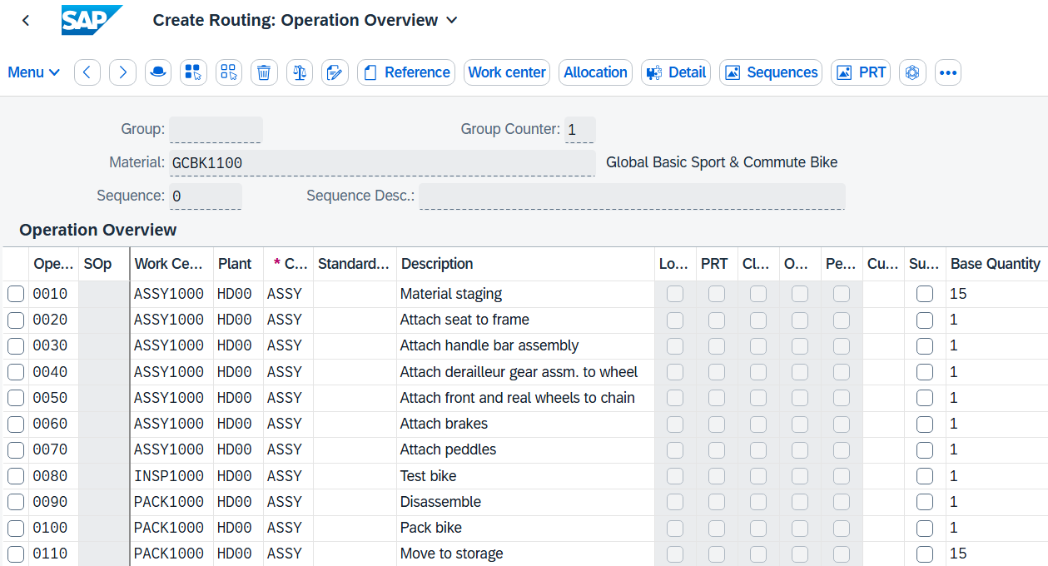
Note A routing is defined using the task list group and the group counter. The routing also contains references to the material whose production is described by the task list.
In addition to the standard sequence, it can also have parallel or alternative sequences. In addition to the standard values, the routing also contains the time elements that are relevant for scheduling the operations. The operations in the routing can each contain their own base quantity to which the time elements refer.
Choose 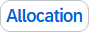 to display a list of all components. If the button is not displayed directly in the top bar, you can find the entry in the pull-down menu under More Allocation.
Since no BOM exists for your material, the system now asks you whether you want to create it. Confirm the message Material component assignment with Yes. |  | Yes
In the Usage field, enter 1 (Production). |  | 1 (Production)
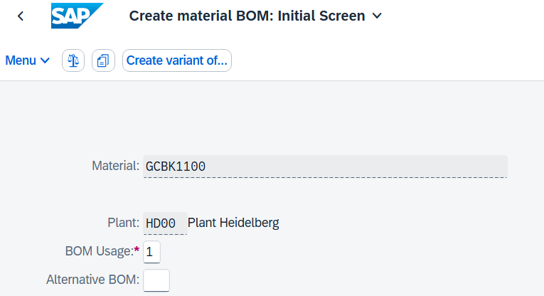
Again, use the BOM of material DXTR1### as a template. Click (Copy From).
In the Copy from dialog box, enter material DXTR1###. And click |  | DXTR1###
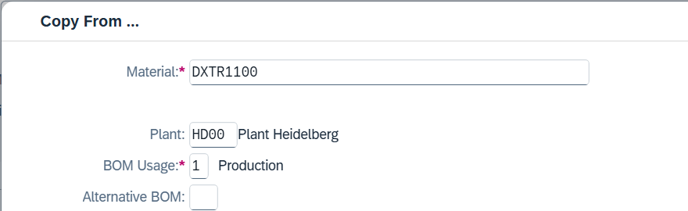
Select all BOM items using the button  and then choose (Copy).
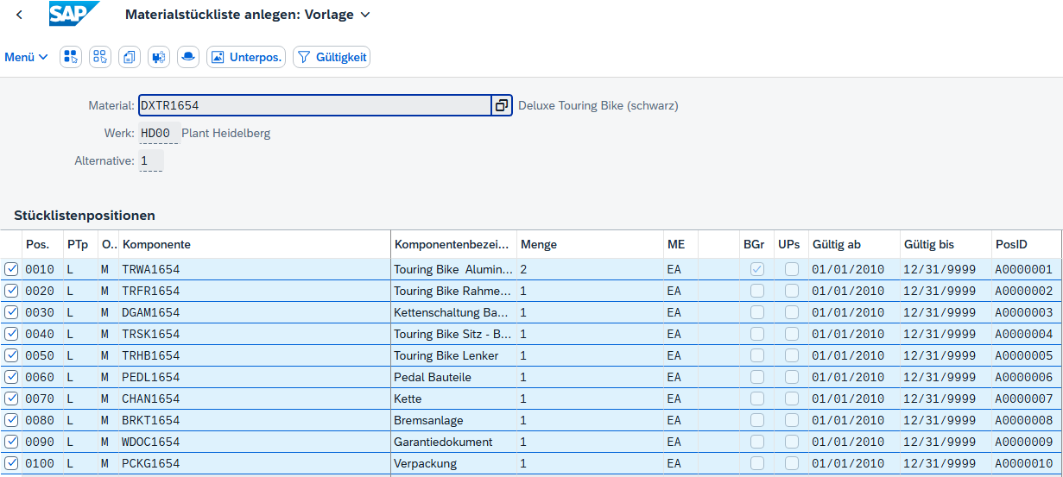
The components of DXTR1### have now been added to the BOM of GCBK1###. Now add the Repair Kit, Air Pump and Integrated GPS Bike Computer according to the requirements of customer Elbe Cycle ###.
Make the following enhancements in the table:
Item | ICt | Component | Quantity
00110 | L | PUMP1### | 1
00120 | L | RKIT1### | 1
00130 | L | IDGC1### | 1

Choose Enter to confirm your entries.
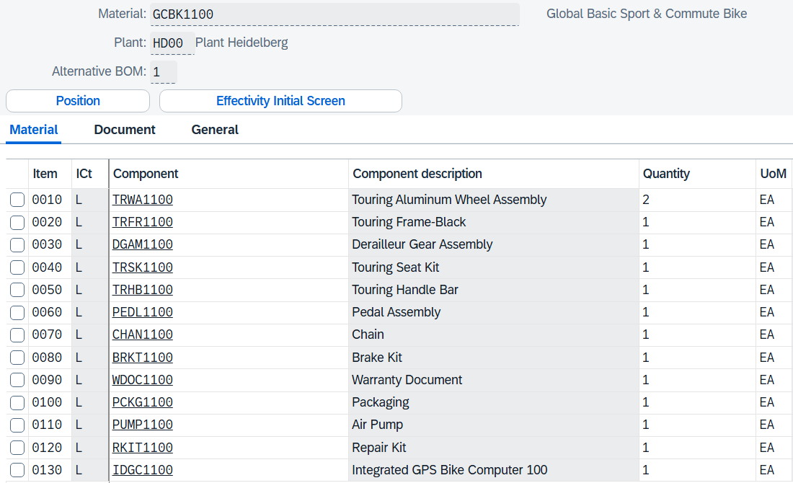
Click 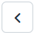.
You get an overview of all used components, but they are not currently assigned to a specific activity.
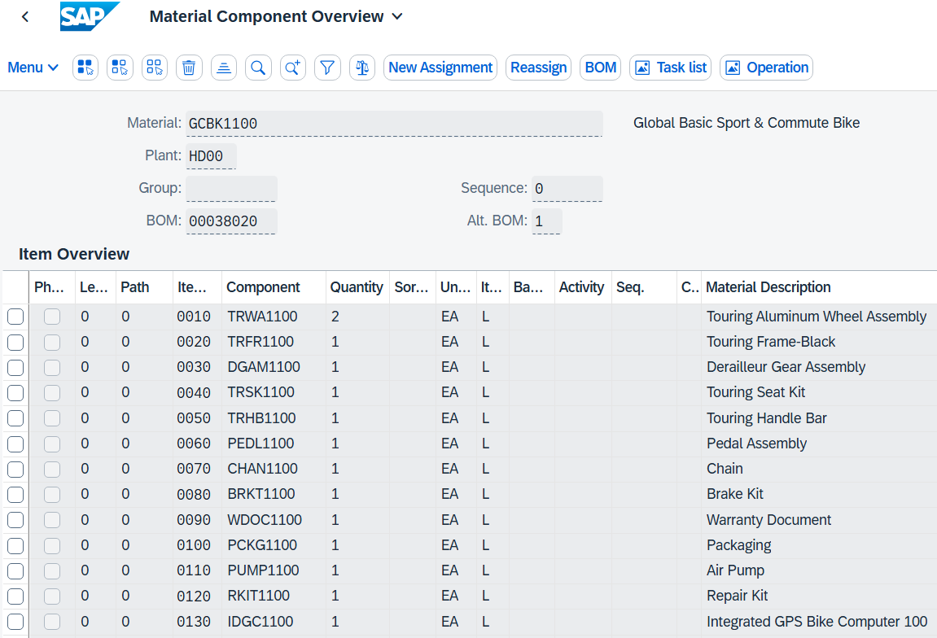
Select the line of component TRWA1### (Touring Bike Aluminum Wheel Parts) and press 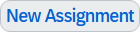. Alternatively, you can find the entry in the pull-down menu under More New Assignment.
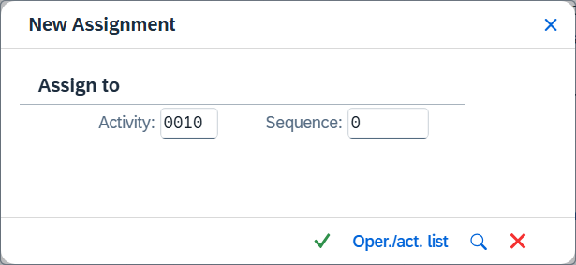
In the New Assignment dialog box that now appears, you can use 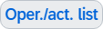 to get a quick overview of the transactions or transactions that have already been created. Receive routing work steps without having to leave the screen.
Choose the first entry (activity 0010) to assign the touring bike aluminum wheel components to this operation. Confirm with . |  | 0010
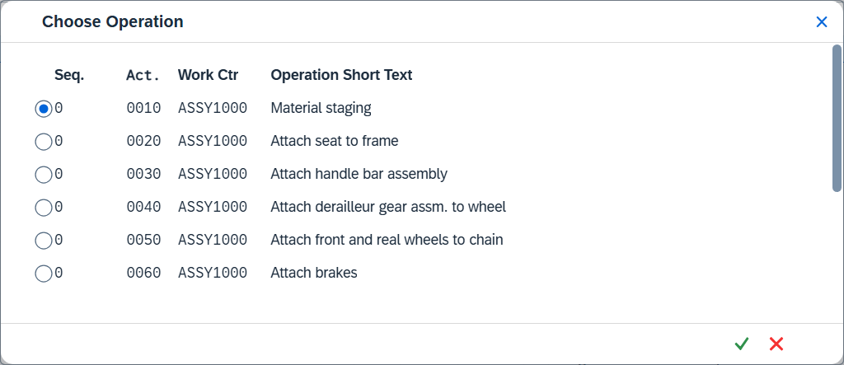
You can now see that the component has been assigned to operation 0010.
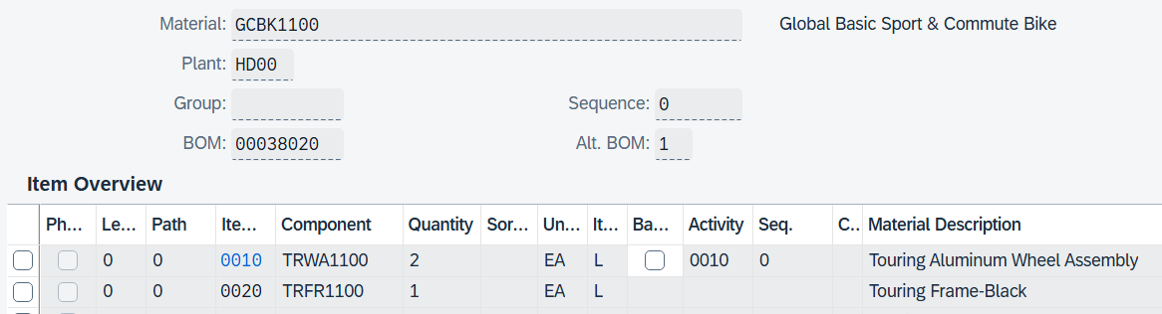
Repeat this process for all other components and assign them to the activities specified below.
Here, the affected components can also be selected together and assigned to an activity together.
Activity | Component
0010 | TRWA1###
0020 | TRFR1###
0040 | DGAM1###
0020 | TRSK1###
0030 | TRHB1###
0070 | PEDL1###
0050 | CHAN1###
0060 | BRKT1###
0100 | WDOC1###
0100 | PCKG1###
0100 | RKIT1###
0100 | PUMP1###
0030 | IDGC1###

Finally, each component is assigned to an activity.
Now set the checkmark for a backflush for all components.
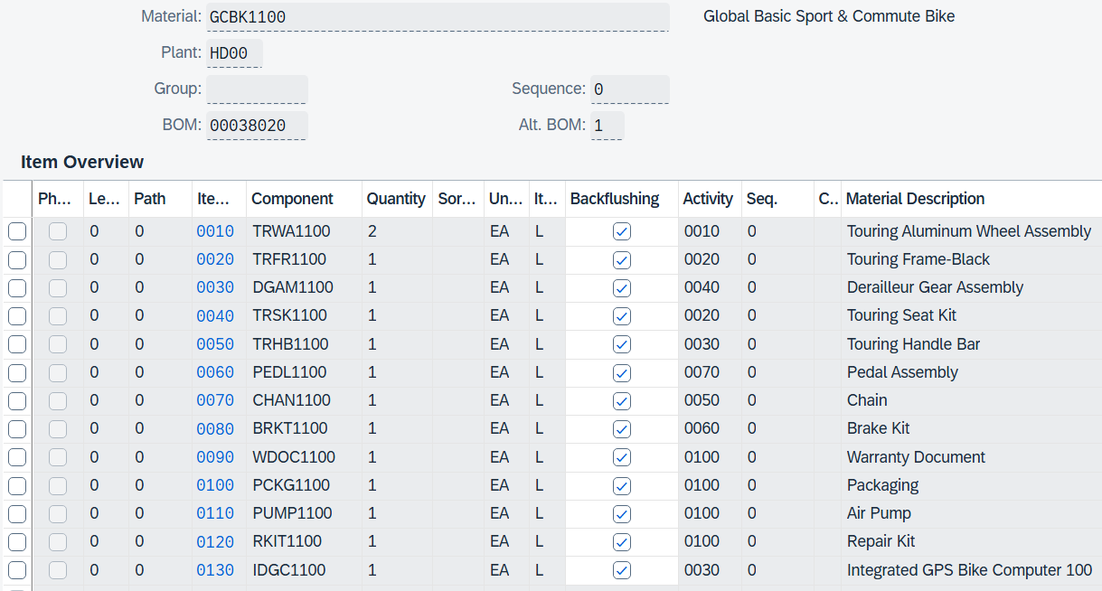
Note Backflushing in the routing enables the automatic posting of material consumption directly after completion of a work step (activity), which leads to accurate warehouse inventory management.
Without backflushing, a production order would also have to post and update material consumption and warehouse stocks manually, which is error-prone and time-consuming.
Use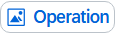 or operation to navigate back to the operation overview.
Note Since their new bike series “Sport & Commute” has more components than the original Deluxe Touring Bike series, this is also more elaborate to assemble. Therefore, increase the personnel time for the assembly of the individual parts (additional Air Pump, additional Integrated GPS Bike Computer and Repair Kit) to 8 minutes per bike.
In your operation overview, scroll to the right until you see the Labor Time column. From operation 0030, increase the labor time from 2 to 5 minutes and also from operation 0100 the labor time from 5 to 10 minutes. |  | 10
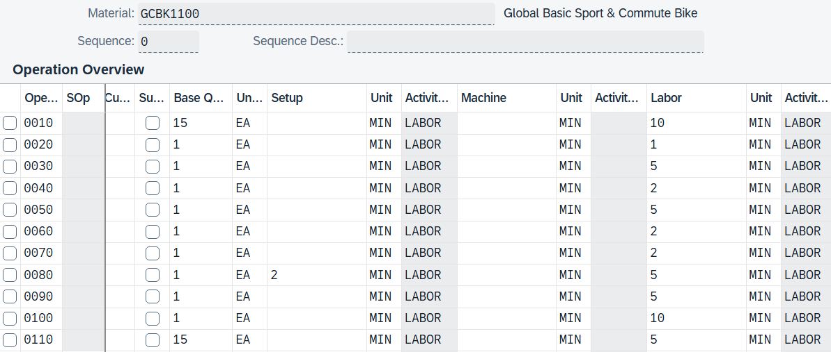
Apply your changes with . The system displays a message that the routing has been saved.
Repeat this procedure for material GCBK2###. Use material GCBK1### as a template for both the routing and the BOM.  However, the addition of the components as well as the assignment of the components to the respective operations and the setting of the backflush remain unchanged. Similarly, the increase in labor time for operation 0030 and 0100 should be the same as for GCBK1###. |  | Repeat GCBK2###
Note To facilitate and accelerate the process of the case study, we deliberately do not develop a routing and a BOM for the model GCBK3### at this point (this will be done later). This approach simplifies the production process for this particular bike because during a later material requirements planning (MRP) run, only the immediate requirements – that is, the planned independent requirements – are taken into account, whereas possible derived requirements (dependent requirements) that would normally result from the BOM are not included in planning.
Click to return to the SAP Fiori launchpad.

 | Step 9: Create Product Group
Task Create a product group.  Description The creation of product groups is used to structure the product portfolio and supports later material requirements planning (MRP) through aggregated planning and forecasting.  Group the two bicycles GCBK1### and GCBK2### into one product group.  Name (Job) Jun Lee (Production Manager) |  | Time 5 min
To create a product group, click the Display Product Group app in the Production Planning and Execution area in the Production Manager role. |  | Initial Screen
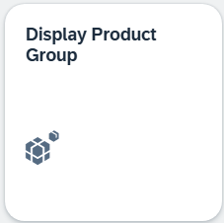
On the Display Product Group: Initial Screen, choose Menu Product Groups Create
On the Create Product Group: Initial Screen, enter PG-GC### as the product group and Product Group Sport & Commute ### as the description directly below. Enter HD00 as the plant and EA as the base unit of measure. |  | PG-GC###  Product group Sport & Commute ###  HD00  EA
Make sure that materials are selected for members. |  | Materials
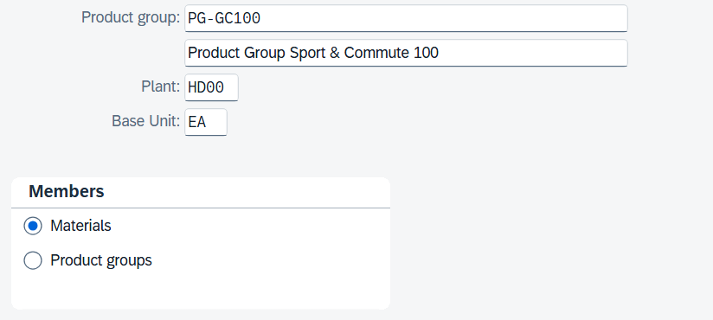
Press Enter.
In the Create Product Group: Maintain Members (Materials) view, enter your material numbers GCBK1### and GCBK2### as membership numbers with plant HD00. |  | GCBK1###  GCBK2###  HD00
In the Share (%) column, you can define shares for the two different bicycles for your product group. Propose a share of 75% for bike GCBK1### and a share of 25% for GCBK2###. Then press Enter. Confirm any upcoming messages. |  | 75%  25%
Note Each material has a proportion factor that represents the percentage share of the associated product group. The sum of the proportional factors on a planning level is usually 100.
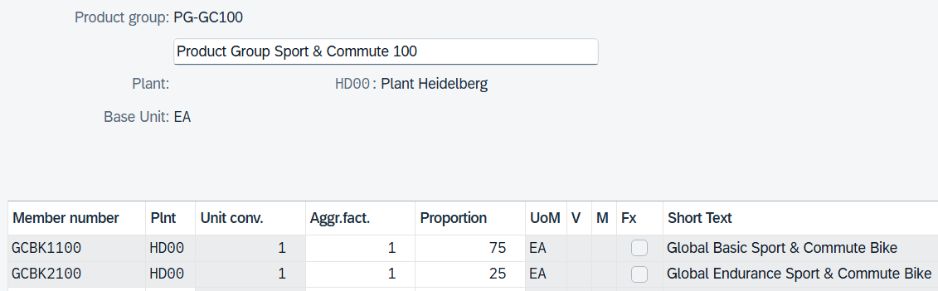
Click .
Click to return to the SAP Fiori launchpad.

 | Step 10: Create Planned Independent Requirements
Task Create a planned independent requirement for your product group.  Description Create a 3-month planned independent requirement for your PG-GC### Bike product group.  Name (Job) Jun Lee (Production Manager) |  |  |  | Time 15 min
A planned independent requirement is a planned requirement note for a material that has not yet been covered by sales orders. It is used in planning as the basis for requirements planning and consists of a planned quantity at a certain point in time or distributed over several periods.
In the area of Production Planning and Execution, in the role Production Manager, use the Maintain PIRs app. |  |  |  | Initial Screen
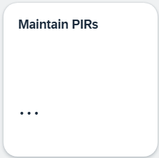
When you first open the app, you receive a welcome message informing you that you should select an area of responsibility. If you confirm this with 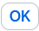, another My Area of Responsibility app appears.
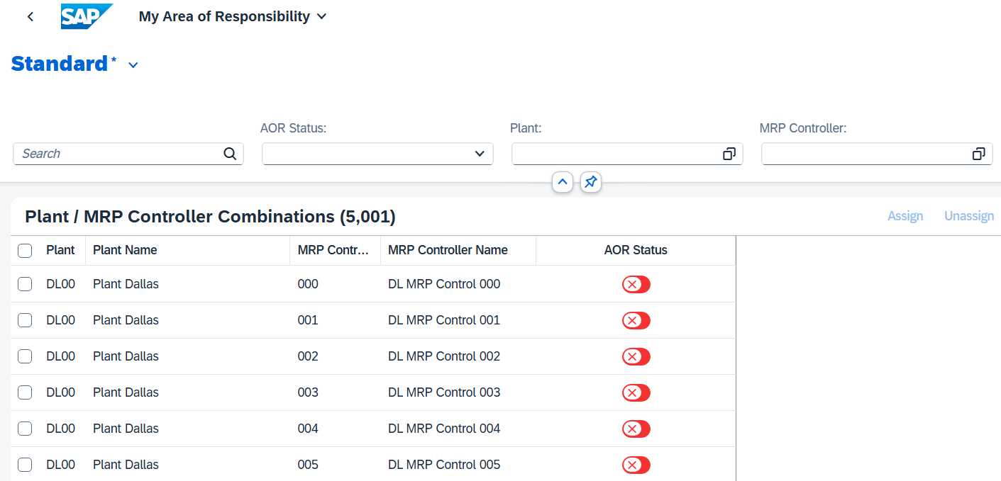
No plant is currently assigned to you. Select the plant in Heidelberg by entering HD00 as the plant and your three-digit number ### as the MRP controller and clicking . |  |  |  | HD00  ###
Then set the status to green. |  |  |  | Green
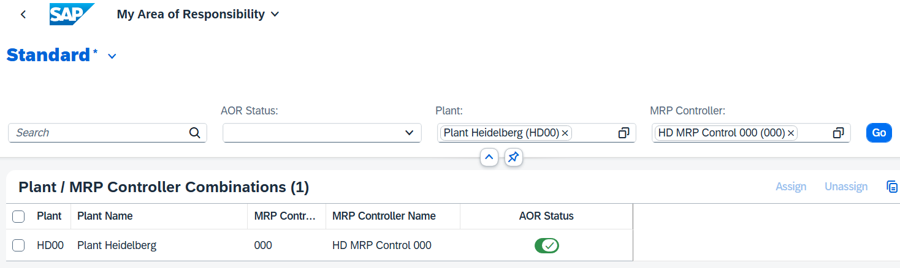
The values are saved automatically here. Go to the SAP Fiori launchpad  and open the Maintain PIRs app again.
In the search, enter both GCBK1### and GCBK2### as the material and HD00 as the plant. Make sure that Version Active is N/A. Click . |  |  |  | GCBK1###  GCBK2###  HD00
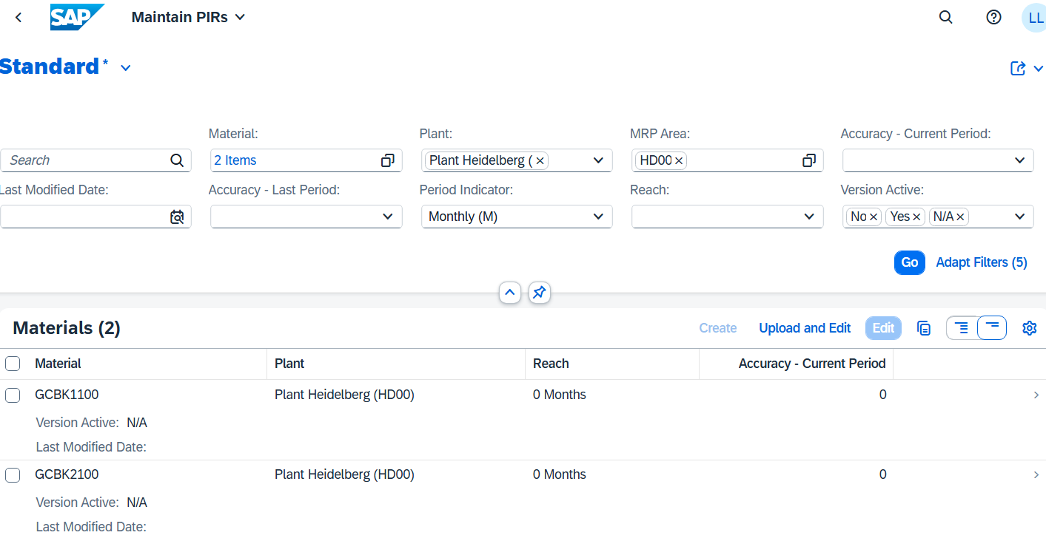
Select all two materials and click 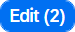.
The screen displayed deals with the maintenance of planned independent requirements for your materials (GCBK1###, GCBK2###) in plant HD00. The demand values are entered in the table for each period (12 months). Currently, all values are set to "0".
Click 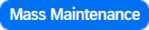. Then select the first three planning periods and enter a Proposed Quantity of 30. |  |  |  | three periods  30
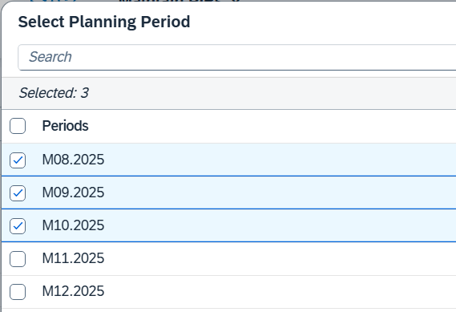 |  |  | 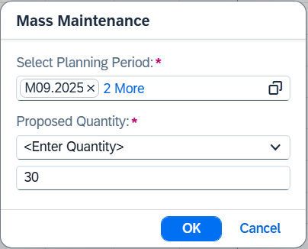
Note
Creation options in mass maintenance: In the Mass Maintenance function in SAP Fiori, you can maintain planned independent requirements in three ways:
- Copy from reference material:
Copies the planned independent requirements of another material as a template.
- Enter quantities:
You manually enter a fixed quantity that is adopted for the selected periods.
- Forecast Quantity:
Uses automatically calculated forecast values from MRP, if available.
In this case, you use fixed values for all periods for the sake of simplicity. However, you can also vary the values if necessary.
By confirming with , this value is taken over for all selected periods. In each row, choose the switch button (in the "Version Active" column) to use the active version for all materials. |  |  |  | Active - Yes
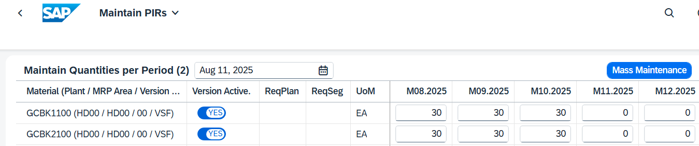
Click .
Click to return to the SAP Fiori launchpad.

 | Step 11: Display Planned Independent Requirements
Task Display the planned independent requirements.  Description Check the requirements for the product group to ensure that there are production requirements for the respective components.  Name (Job) Hiro Abe (Plant Manager) |  | Time 5 min
To display demand management, use the Display PIRs app in the Plant Manager role in the Production Planning and Execution area. |  | Initial Screen
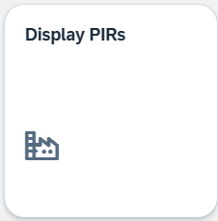
In the Planned Independent Requirements area, select Product Group and add your product group PG-GC###. Then specify the plant HD00. |  | PG-GC###  HD00
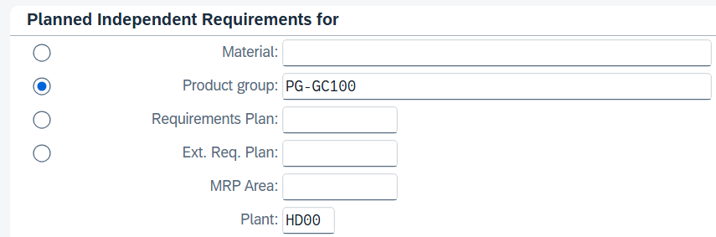
Click . The system displays an overview of the independent requirements for the individual products in the product group.
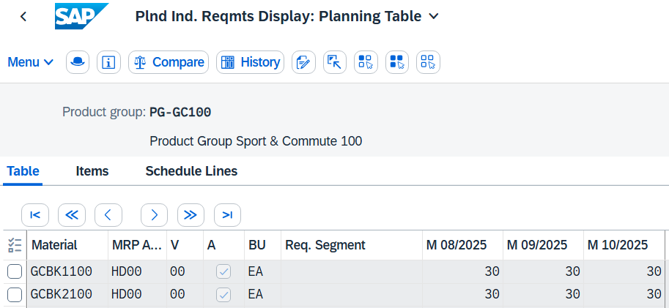
You see the previously created planned independent requirements for your product group.
Use the navigation buttons and to also display values in the hidden view area.
Click to return to the SAP Fiori launchpad.

 | Step 12: Supplement Production Version in Material Master Record
Task Enter the production version in the material master record.  Description Since material requirements planning is to be carried out in the following step, it is necessary for the determination of the dependent requirements that all materials are equipped with a production version. As of SAP S/4HANA 2020, a production version is mandatory for the BOM explosion. However, it is not possible to create a production version for each material using the Manage Product Master Data app.  Name (Job) Jun Lee (Production Manager) |  | Time 5 min
To set up a background process for creating the required function versions, use the search bar to find and execute the Schedule Mass Creation of Production Version. |  | Initial Screen
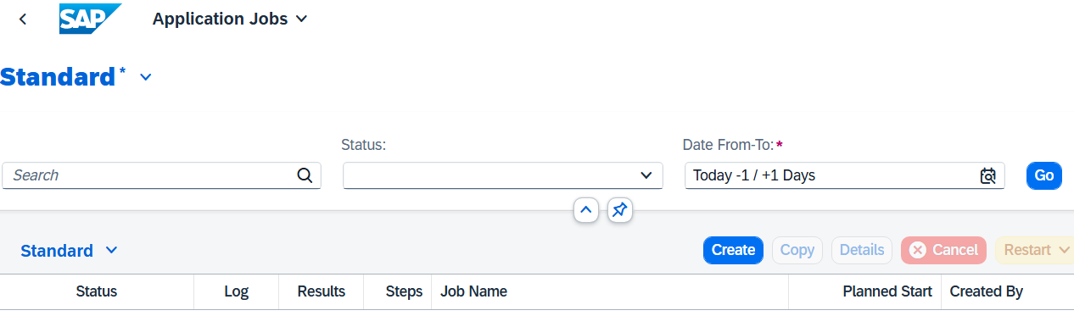
On the Application Jobs screen, click .
On the New Job: Mass Creation of Production Versions screen, click 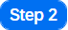.
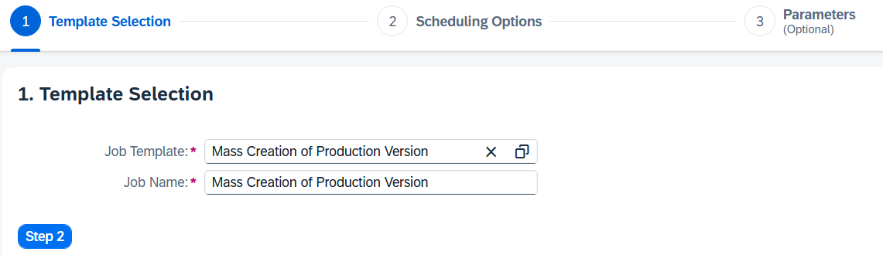
Make sure that Start Immediately is selected for Scheduling Options. Click 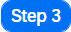.
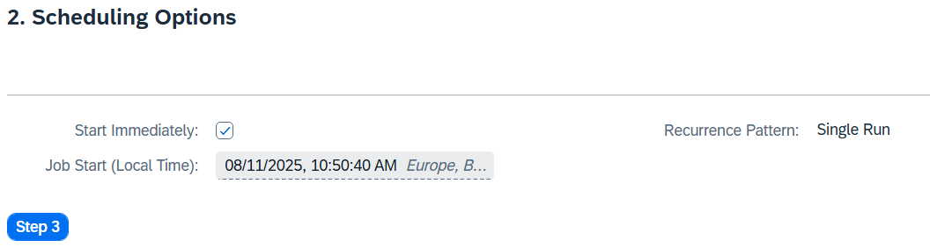
Enter material GCBK1### and plant HD00 as parameters for the material restriction. |  | GCBK1###  HD00
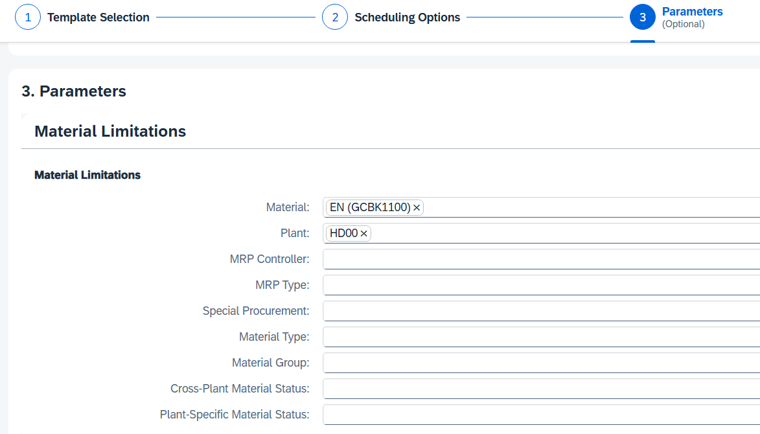
Click .
Back on the Application Jobs screen, you can see that your job is now in progress.
Refresh the view. You will notice that your job is now finished.
Repeat these steps for material GCBK2###. |  | GCBK2###
Click to return to the SAP Fiori launchpad.

 | Step 13: Perform Material Requirements Planning
Task Perform the Material Requirements Planning.  Description Start material requirements planning (MRP) to generate planned orders that meet the requirements of sales and operations planning and demand management. If necessary, MRP also creates planned orders for dependent requirements that are determined by the BOM explosion.  Name (Job) Jun Lee (Production Manager) |  | Time 15 min
To perform material requirements planning, use the app Schedule MRP Run - Run MPS with MRP in the Production Planning and Execution area in the role Production Manager. |  | Initial Screen
Note If the app is not displayed, search for it using the search bar .
Enter PG-GC### as the material and HD00 as the plant. Select Product Group. |  | PG-GC###  HD00  Product Group
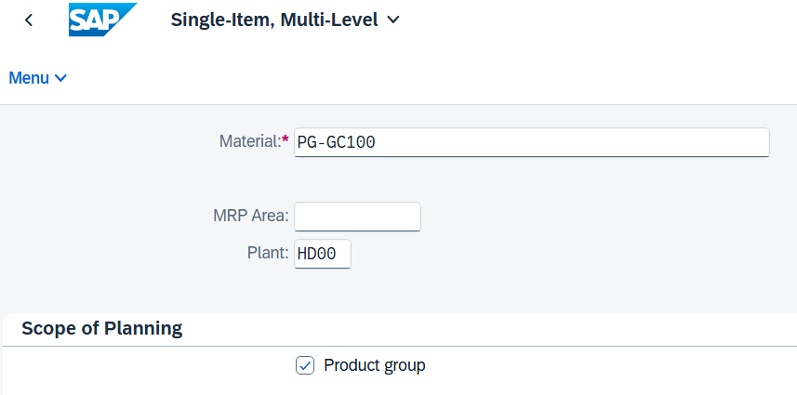
The MRP control parameters can be adopted and should be filled by the system as follows:  - Processing key: NETCH (net change in total horizon)  - Create purchase requisition: 2 (purchase requisition in opening period)  - Scheduling agreement schedule line: 3 (Basically scheduling agreement delivery schedule lines)  - Create MRP list: 1 (basic MRP list)  - Planning Mode: 1 (Adapt Planning Data (Normal Mode))  - Scheduling: 1 (Determination of basic dates for planned orders) |  | NETCH  2  3  1  1  1
In addition, in the Control Parameters for Process area, select Display Material List. |  | Display Material List
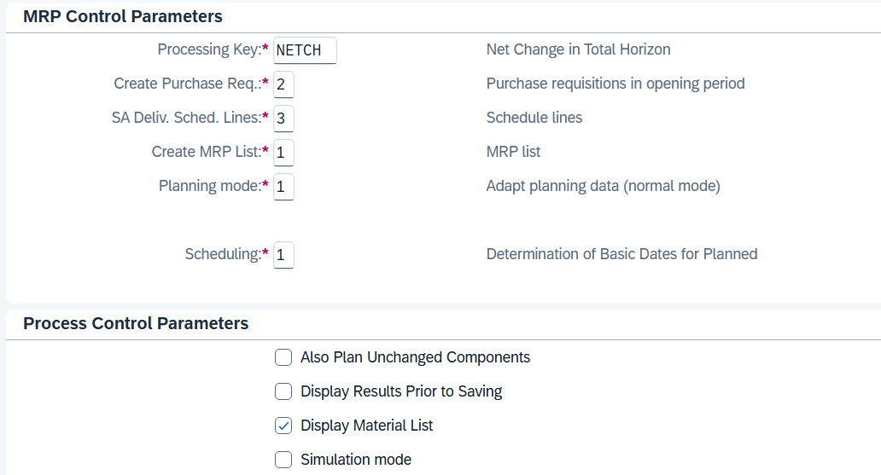
Press Enter. The following warning message informs you to check the input parameters. Press Enter again to confirm the check and continue with MRP.
In material requirements planning, a net requirements calculation is carried out to determine whether a shortage situation exists for a material. In addition, the stock and the existing firmed receipts (for example, purchase orders, production orders, firmed purchase requisitions, and planned orders) are compared with the safety stock and requirements. This comparison results in the quantity available for planning.
If the quantity available for MRP is less than zero, there is a shortage. MRP reacts to the shortage by creating new procurement proposals (purchase requisitions and planned orders). The proposed procurement quantity results from the lot-sizing procedure that is set in the material master.
As soon as the planning run has been completed, a results overview is displayed. Review the planning details of the result overview.
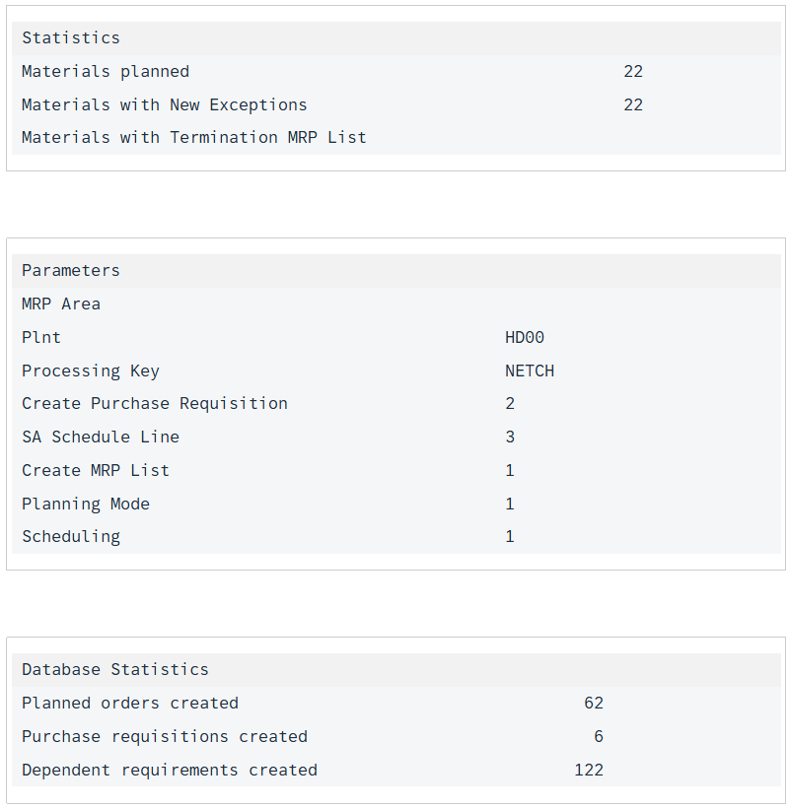
Scroll further down. There you can see a list of the considered product and its semi-finished products.
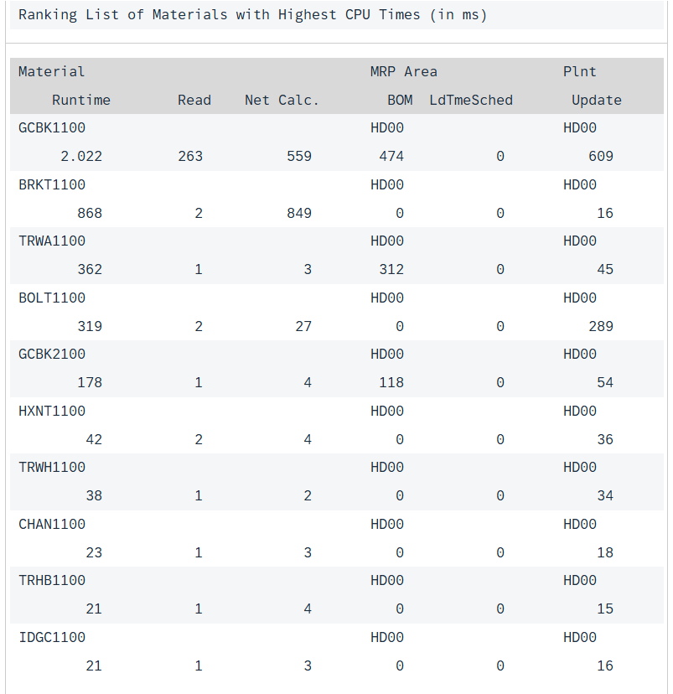
Click 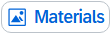 in the upper part of the screen to display a complete list of all planned materials.
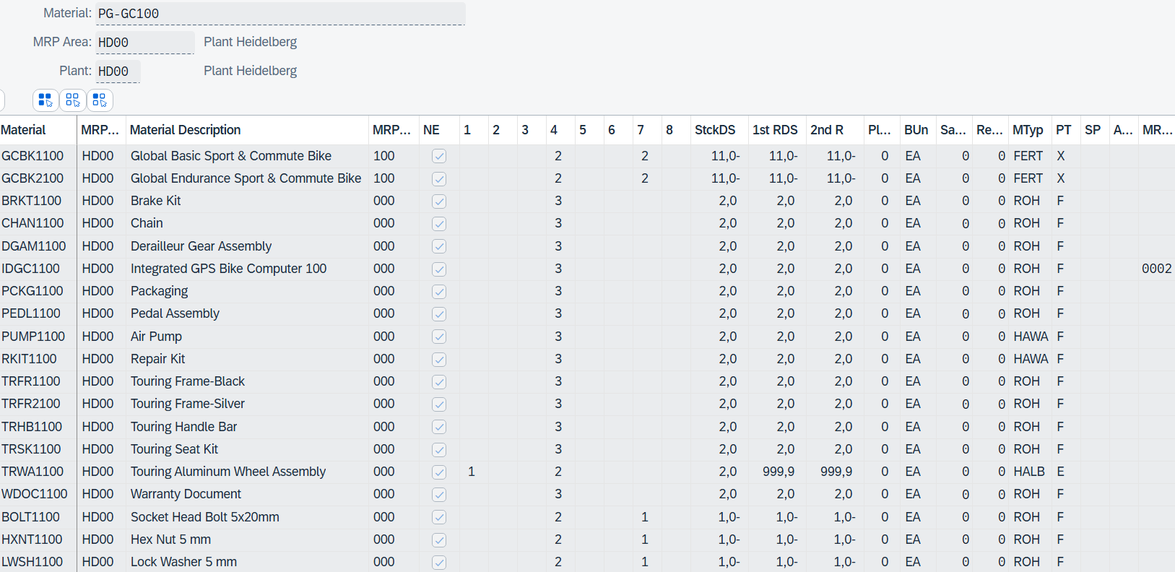
The screenshot now shows you all planned materials that could be determined by the multilevel BOM explosion.
Double-click the line of your bike GCBK1###.
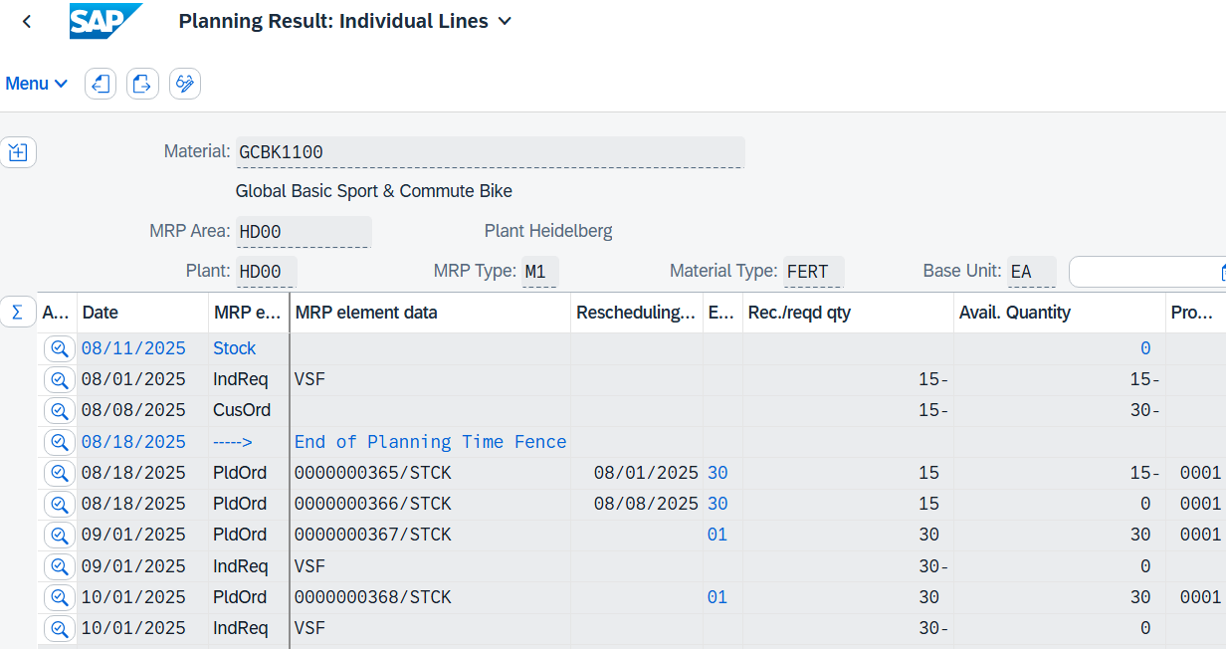
You will notice that 4 planned orders have been generated for your bike GCBK1### for each period that you planned before in and for the sales order of customer Elbe Cycle ###.
Production planning envisages the following requirements for the bike GCBK1###: 30 units in the first period, 30 units in the second period, and 30 units in the third period. In addition, there is a requirement of 15 units through the sales order of Elbe Cycle ###.
For each requirement, corresponding planned orders have been generated by the system. Depending on the current date, the first two planned orders can also be in the following month, since the procurement or Production time of bicycle GCBK1### are taken into account by the system during planning.
Click 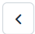 (Back).
Double-click the line of your Integrated GPS Bike Computer IDGC1###.
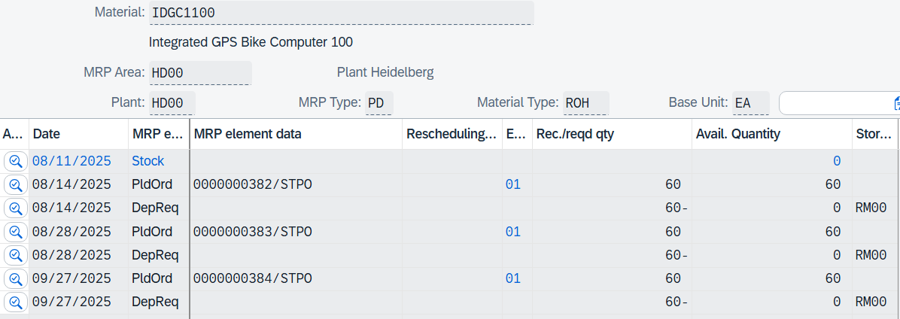
As you can see, 3 planned orders have also been created for your Integrated GPS Bike Computer, indicating that this is a dependent requirement for materials GCBK1### and GCBK2###.
Click (Back) three times until you are on the initial screen.
Repeat MRP for your bike GCBK3###. Deselect Product Group.
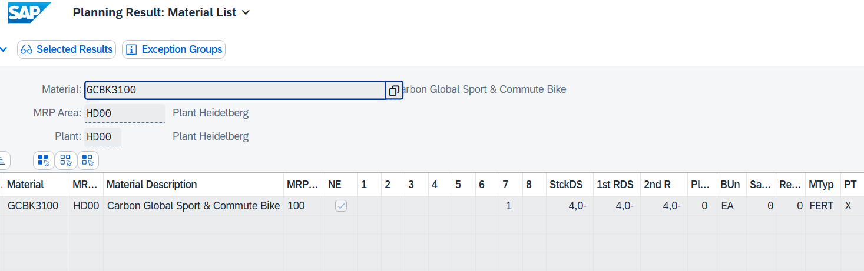
You will notice that no dependent requirements are planned during the material requirements planning of the bicycle GCBK3###. This is due to the missing routing, BOM, and production version that has not been maintained.
Click to return to the SAP Fiori launchpad.

 | Step 14: Display Stock/Requirements List
Task Display the stock/requirements list.  Description Display the stock/requirements list for your Sport & Commute.  Name (Job) Lars Iseler (Shop Floor Worker 2) |  | Time 10 min
The stock/requirements list is a dynamic list that displays the existing stock in the warehouses of a plant and incoming requirements of a material combined. |  | Scenario
To display the stock/requirements list, use the Monitor Stock/Requirements List app in the Production Planning and Execution area in the Shop Floor Worker role. |  | Initial Screen
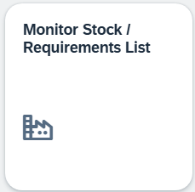
On the Individual access tab page, enter your material GCBK1### and plant HD00. |  | GCBK1###  HD00
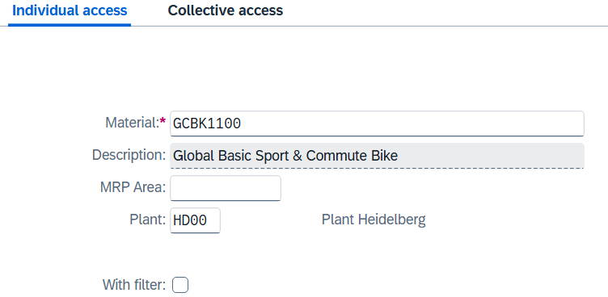
Choose to display the corresponding stock/requirements list.
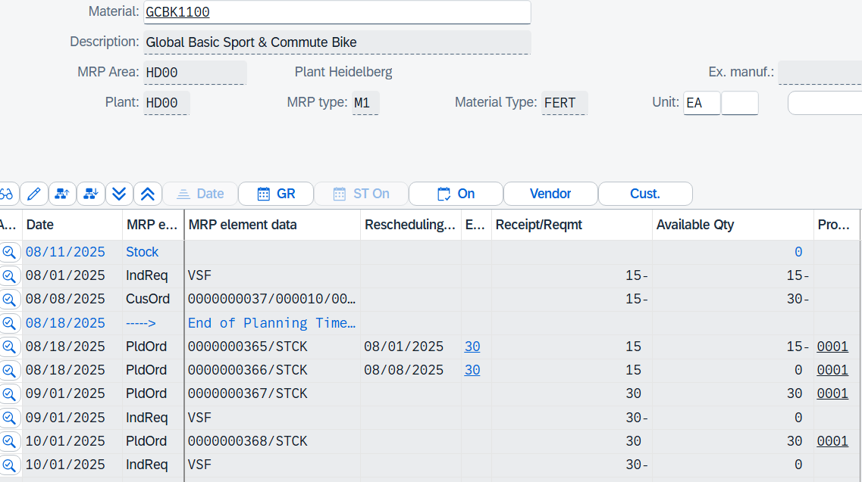
You can see the current available quantity in stock, as well as all requirements and planned orders determined by MRP to cover the requirements.
The system currently lists all entries as individual lines. Choose 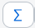 to group the entries into period totals. This enables you to see the planned independent requirements, planned receipts, and ATP quantities totaled by days, weeks, or months, depending on which tab is selected.
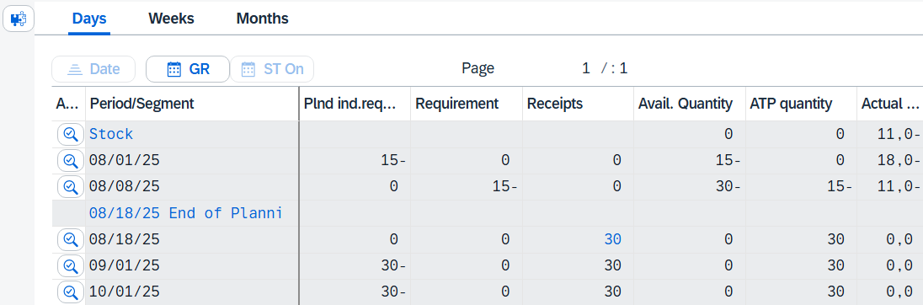
Choose 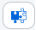 to return to the individual display.
To see the details of the first planned order (PldOrd), choose at the beginning of the row. A popup opens.
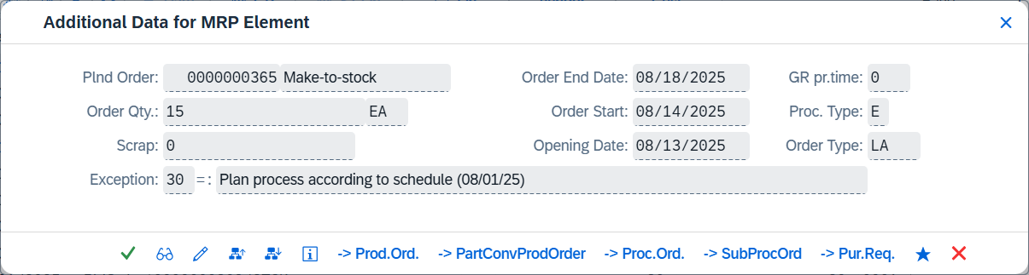
Choose to display the pegged requirement.
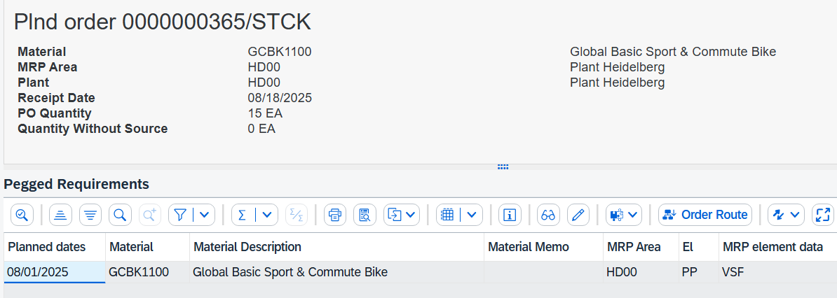
You can see that the pegged requirement is the product itself. For the components of the bicycle for which a requirement has also been determined, the product is also the pegged requirement.
Click 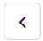 (back) and open the details of your first planned order again using . In the dialog box that opens again, select (order report).
In the subsequent view, you can see the determined dependent requirements for your bike GCBK1###. However, no planned orders have been created for them because they still have sufficient stock in stock. A planned order was only created for your Integrated GPS Bike Computer because this does not yet have any stock on hand.
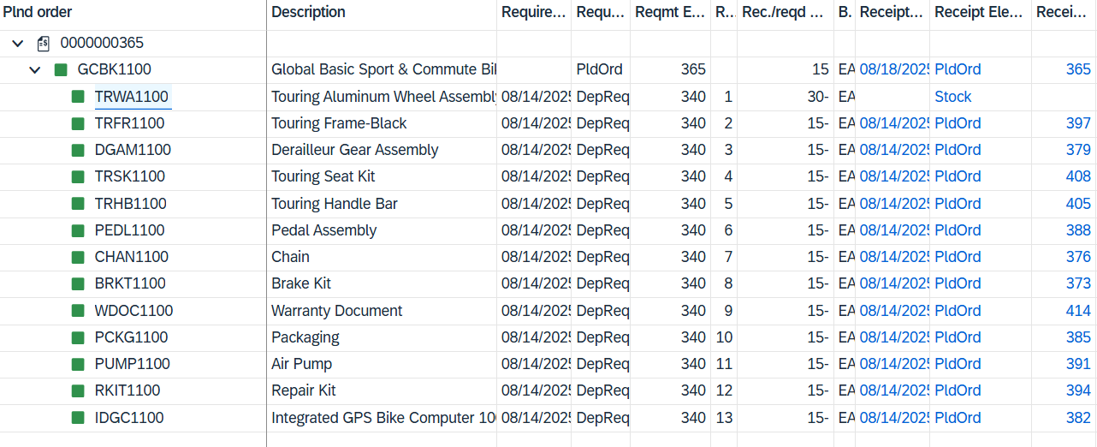
Repeat the steps for your Integrated GPS Bike Computer IDGC1###.
You will notice that both material GCBK1### and material GCBK2### are the pegged requirements for your Integrated GPS Bike Computer. The first planned order of the Integrated GPS Bike Computer contains both the planned independent requirements created for the first period and the requirements from the sales order.
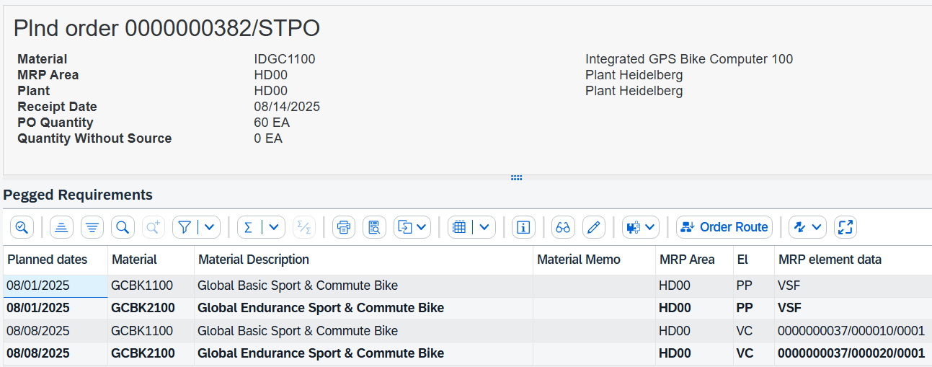
Click to return to the SAP Fiori launchpad.

 | Step 15: Convert Planned Orders to Purchase Requisition
Task Convert Planned Orders to Purchase Requisition.  Description To convert the dependent requirements resulting from the planned orders for components of the integrated GPS bicycle computer into purchase requisitions (PReqs) and transfer them to Materials Management, it is necessary to convert these planned orders.  The differently scheduled planned orders are converted to a uniform date to simplify the procurement process and to take advantage of potential benefits such as volume discounts or reduced shipping costs. Therefore, the date for all purchase requisitions should be set to one week from today.  Name (Job) Hiro Abe (Plant Manager) |  | Time 5 min
To convert the planned orders into purchase requisitions, use the search bar to find and execute the app Convert Planned Orders – to Purchase Requisitions. |  | Initial Screen
In the Collective Conversion of Planned Orders to Pur. Req.: Initial Screen view, enter HD00 as the plant and IDGC1### as the material. In addition, select the Material field. Click . |  | HD00  IDGC1###  Material
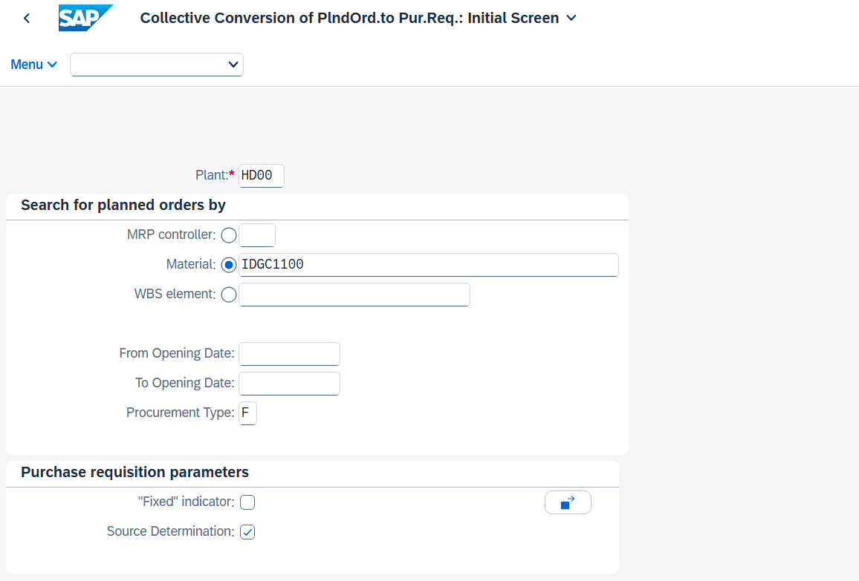
In the following view, all planned orders for your material are displayed. Select all of them using .
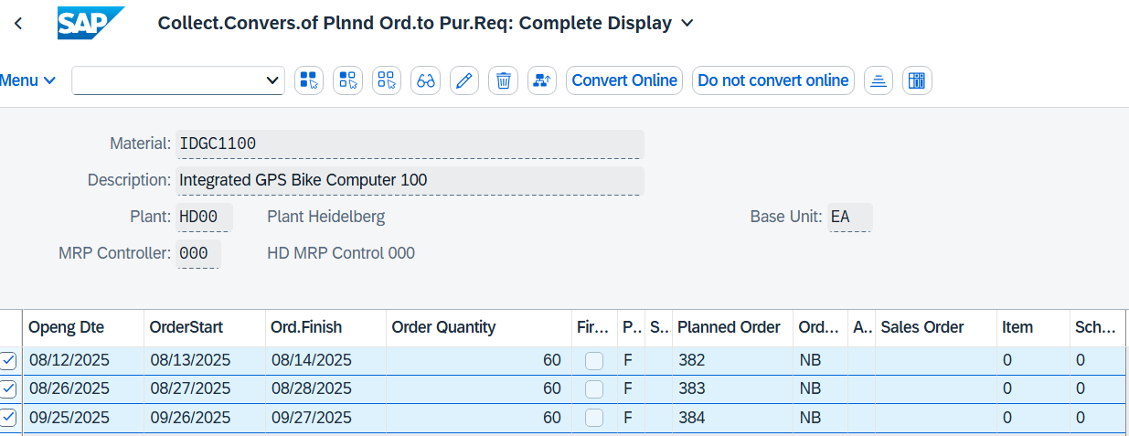
Then choose Convert Online. |  | Convert Online
In the following view, adjust the Delivery and Release Date to one week from today. |  | One week from today
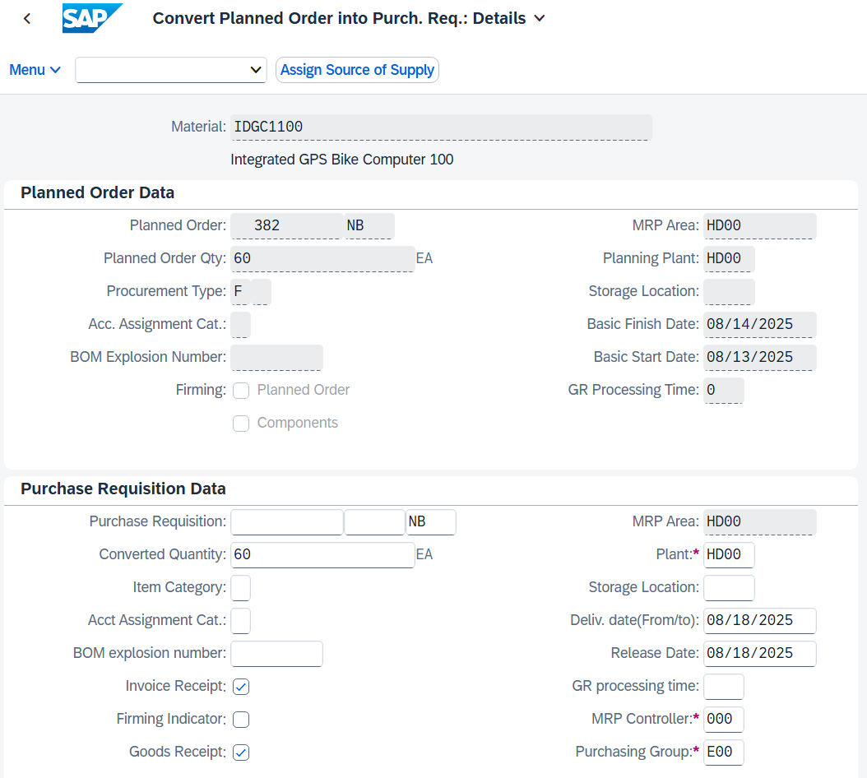
Click .
Your first planned order has been converted into a purchase requisition.
The second planned order is now displayed. Again, set the delivery date and the release date to one week from today. Click 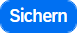. The next planned order has been converted into a purchase requisition.
Repeat this procedure for all other planned orders.
At the end, the system issues the following message:
Click to return to the SAP Fiori launchpad.
Process Progress
The production planning and production process must pause at this point because components that are required for the production of the bicycles must now be procured.

Process Progress
The production planning and production process has transferred purchase requisitions from dependent requirements to procurement. At this point, the PP process pauses and the procurement process is initiated. Suitable suppliers are now requested who can supply the missing integrated GPS bicycle computers.
 | Step 16: Create Vendor
Task Create a new vendor.  Description Use the SAP Fiori launchpad to create a new vendor.  Name (Job) Joyce Hausman (Contract Manager) |  | Time 15 min
To create a new vendor, use the Manage Business Partner Master Data app in the Materials Management area in the Contract Manager role. |  | Initial Screen
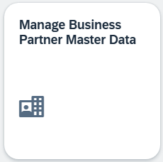
Vendors are used in both finance and procurement. The master record of a vendor contains 3 categories – General Data, Financial Accounting, and Procurement. Vendors can be created centrally or with shared responsibilities. During central creation, all views are generated in one step and by one person. With shared responsibility, finance and procurement create the views that are relevant for them. In this case study, the vendor is created centrally. This means that the vendor master record will contain all the information necessary to carry out business transactions.
On the Manage Business Partner screen, choose and then Organization. |  | Organization
In the Create Organization dialog box, leave the Business Partner field blank. The system will generate a unique number later. In the BP Role field, click 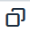, then in the Select: BP Role window, select FI Vendor (FLVN00). |  | FLVN00
For the Form of Address field, select Organization Company and enter 1 MagdePedal Tech ### as the Name. |  | Company  MagdePedal Tech ###
In the Address area, enter Breiterweg 2 in the Street field, 39112 for postal code, and Magdeburg as the city. Continue to select Germany (DE) as the country and 15 as the region. Under Standard Communication, choose English (EN) as the language. Compare your entries with the following screenshot. |  | Breiterweg 2  39112  Magdeburg  EN  15  EN
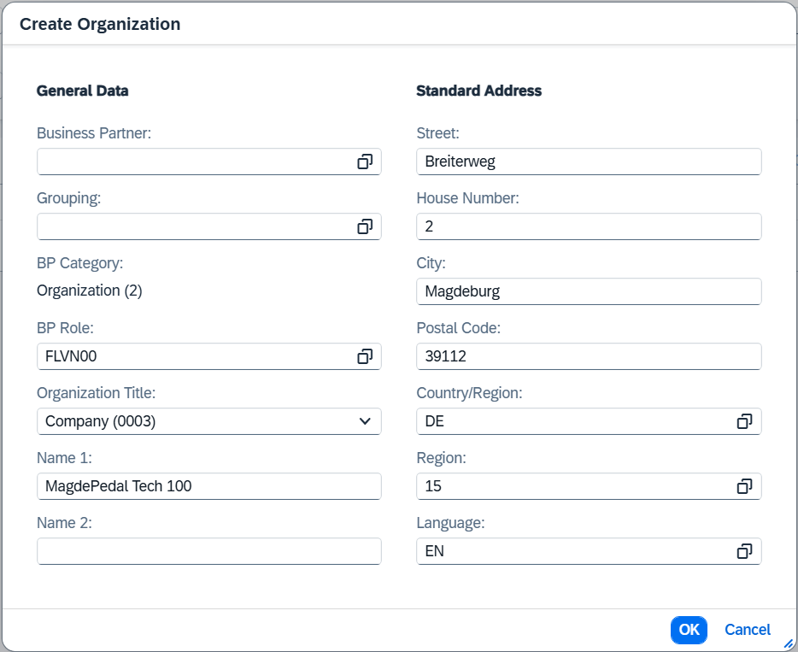
Click .
In the Business Partner view, in the Basic Data area, enter your three-digit number (###) as search term 1. |  | ###
Go to the Identification area and click in the Tax Numbers section. In the line that appears, enter DE0 as the tax category and DE123123### as the tax number, replacing ### with your number. |  | DE0  DE123123###
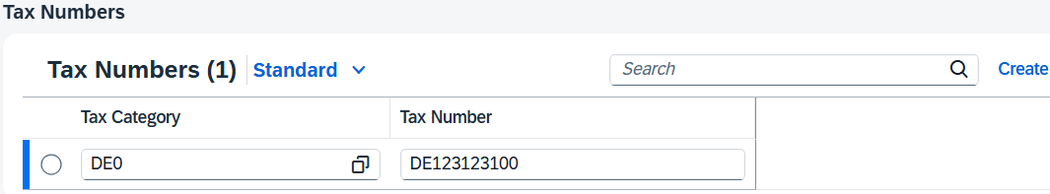
Now go back to the Roles area and click . Enter the Business Partner Role Vendor (FLVN01) by clicking on and then selecting Vendor (FLVN01). |  | FLVN01
Now click on in the line of the newly created business partner role.
Now you can maintain company code-specific data for your business partner in the role of vendor. Go to the Company Codes area and click .
On the Company Code screen, enter DE00 in the Company Code field. Select the value in the selection help that appears automatically. Confirm with Enter. |  | DE00
Go to the Finance area and enter 33000000 (Trade Payables) for Reconciliation Account. In the Payment Data section, enter 0001 as payment terms and select Check Double Invoice. Compare your entries with the screenshot below. |  | 33000000  0001  Check Duplicate Invoice
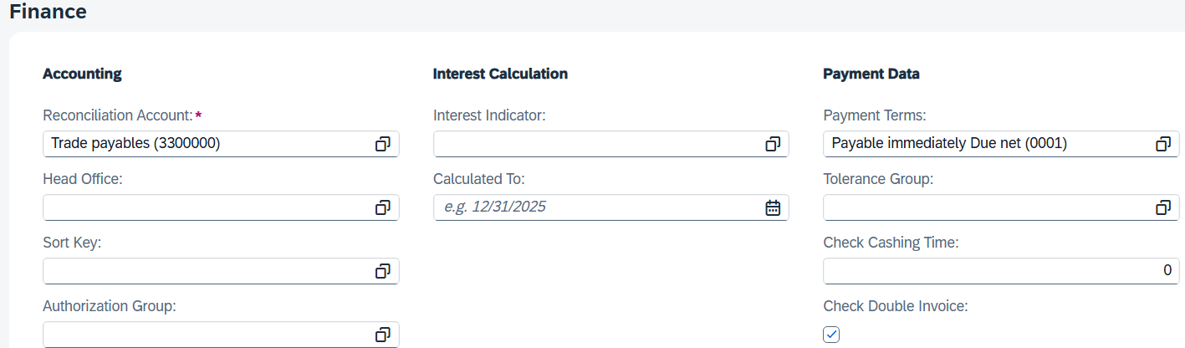
Now go to the Correspondence area. Enter your user (LEARN-###) as Clerk ID at Supplier. |  | your user
Now click .
Back on the Business Partner screen, go to the Purchasing Organizations area to enhance your business partner MagdePedal Tech ### with Purchasing-Specific Data.
Click .
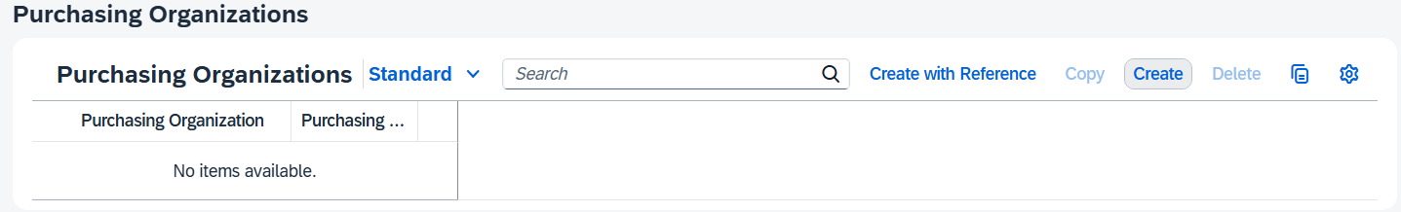
In the Purchasing Organization window, enter DE00 for the Purchasing Organization field. |  | DE00
In the Purchasing Organizations area, enter EUR as the order currency and use the F4 help to search for the payment term Payable immediately w/o deduction (0001). |  | USD  Pay immediately w/o deduction (0001)
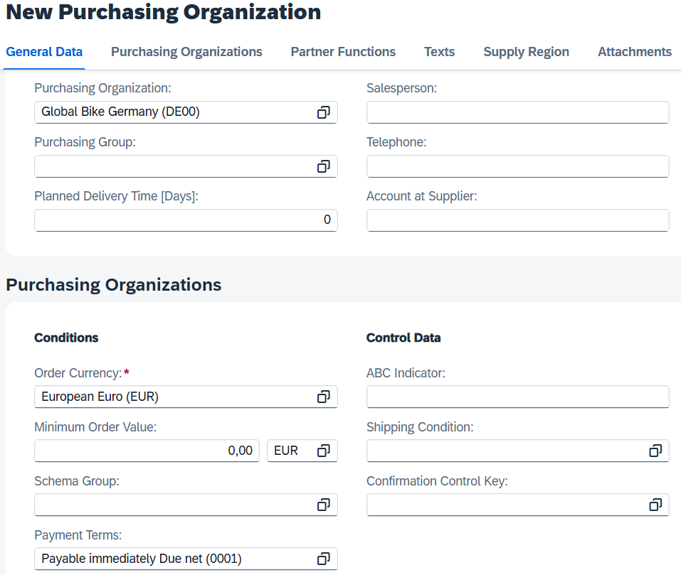
Click to copy your purchasing-specific data for your business partner. Click and then click .
Click  to return to the SAP Fiori launchpad.

 | Step 17: Create RFQ
Task Create a request for your purchase request.  Description Create a request for some suppliers. This is used to gather all the relevant information (such as pricing, delivery, and so on) needed to select the supplier that best meets your requirements.  Name (Job) Aura Maxwell (Purchasing Agent 2) |  | Time 10 min
To create a request for quotation (RFQ) for your purchase requisition, use the Process Purchase Requisition app in the Inventory Supervisor role in the area of Materials Management. |  | Initial Screen
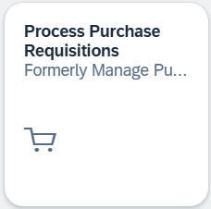
Click 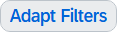. Add the value group Material and apply the filter with 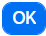. |  | Material
In the Material field, enter IDGC1### and click . |  | IDGC1###
Select all lines with your purchase requisition for material IDGC1### and then click 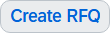.
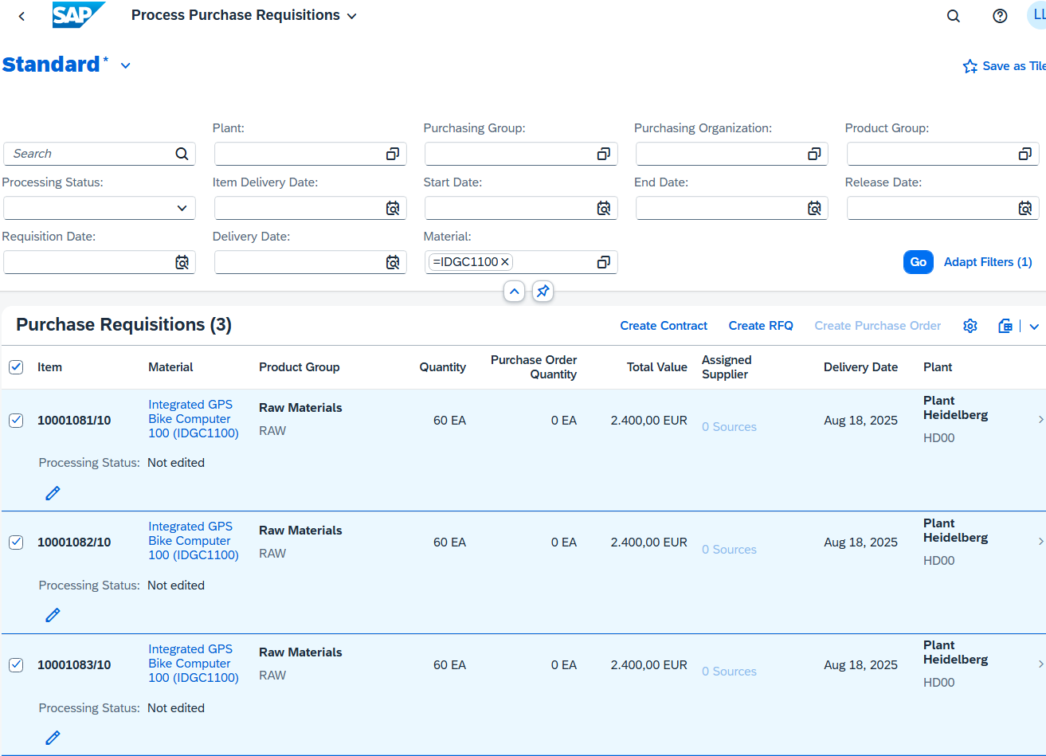
Note The number of existing lines is based on material planning. As explained above, the requirements may be split or combined. Accordingly, a different number of rows can also be displayed.
Under General Information, enter RFQ as the RFQ type, the submission deadline in three working days, the RFQ description IDGC-RFQ###, the purchasing organization, and the company code DE00. Compare your screen with the following screenshot. |  | RFQ  Purchase Quotation  in three working days  IDGC-RFQ###  DE00  DE00
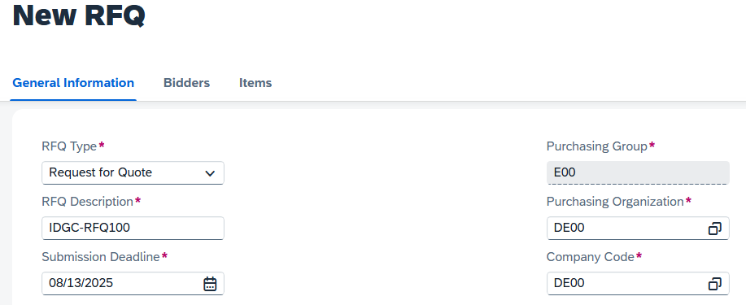
Go to the Bidders area. Click 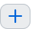 to add new bidders.
Search for your supplier MagdePedal Tech ### and add it as a bidder by clicking on . |  | MagdePedal Tech ###
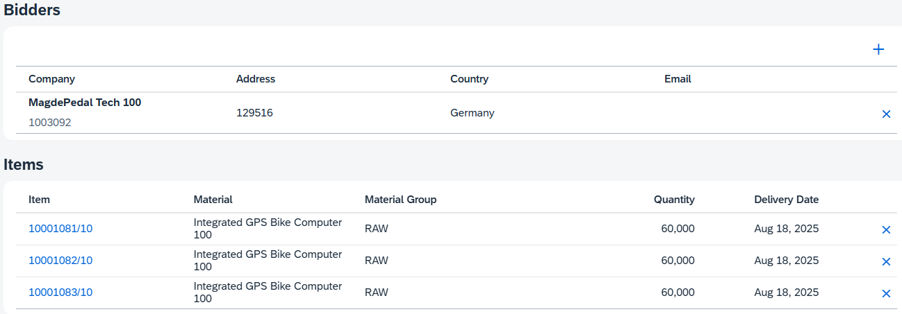
Repeat this procedure to add 121### (Shell Gear) as bidder. |  | 102### (Shell Gear)
You can identify your vendor by the last three digits of the vendor number. For example, vendor number 121### represents vendor Shell Gear and 113### represents supplier Burgmeister Accessories OHG for user LEARN-###.
Compare your screen with the following screenshot.
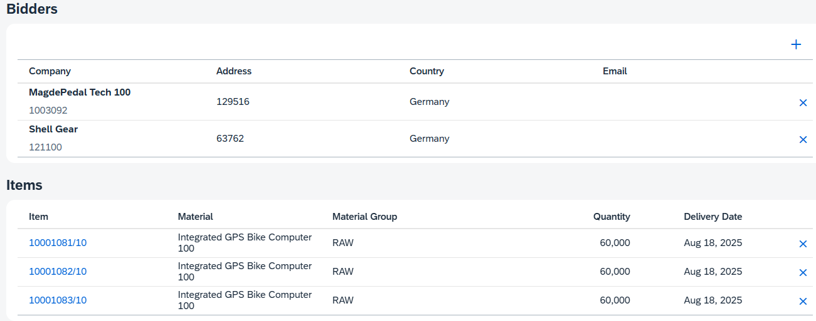
In the Item area, you can see that your items have already been transferred.
Now press . Click again.
You receive a success message with your request number.
Click  to return to the SAP Fiori launchpad.

 | Step 18: Create Quotation from Supplier
Task Maintain the quote from a vendor.  Description After we have received the supplier’s responses to our order inquiry, it is necessary to maintain the respective information in our procurement system in order to create comparability with which we can support the choice of supplier.  Name (Job) Alberto Conti (Inventory Assistant) |  | Time 10 min
To maintain the vendor quotations, use the Manage RFQs app in the Inventory Assistan role in the Materials Management area. |  | Initial Screen
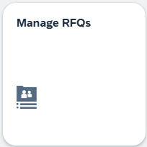
Click . Add the value group RFQ Description and apply the filter with . |  | RFQ Description
For the RFQ Description field, enter IDGC-RFQ###. Start the search by clicking on . |  | IDGC-RFQ###
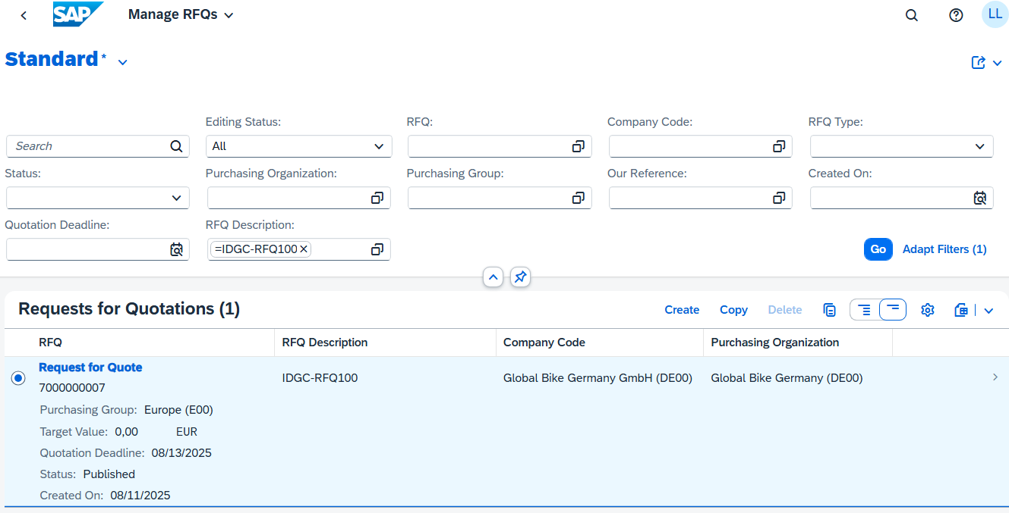
Click on your request for quotation.
Go to the Bidders area. Select the entry of your supplier MagdePedal Tech ### and click .
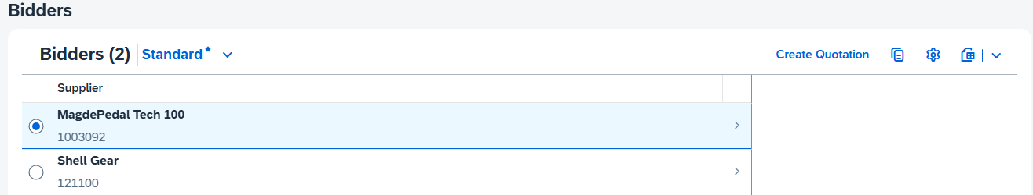
Enter quotation submission date today and follow-on document type NB (standard purchase order). |  | today  NB
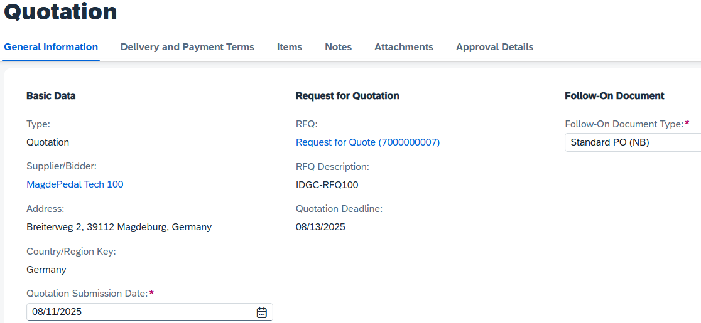
Note The quotation submission date must not be later than the quotation deadline. You can find the submission deadline under General Information in the RFQ area.
Go to the item. Enter a net order price of EUR 33 for the first item and EUR 34 for all other purchase order items. |  | 33  34
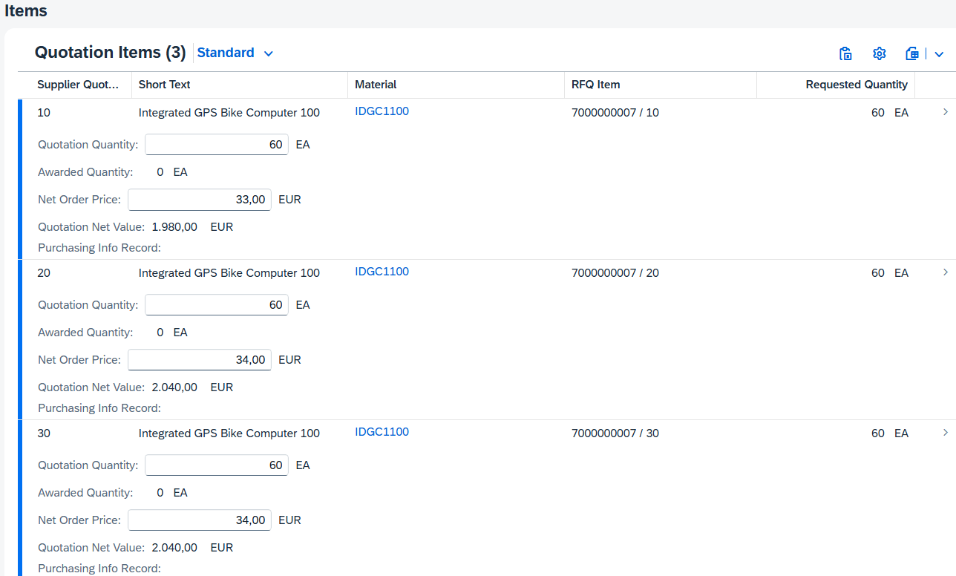
Note The number of items is based on the previously created RFQ. Accordingly, the number of items may differ from the screenshot.
Click and then click on the upper right to create the quotation of MagdePedal Tech ###. If you do not see the Submit button, enlarge your browser window.
Return 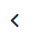 to your posting. In the Quotations area, you can now see your quotation from MagdePedal Tech ###.
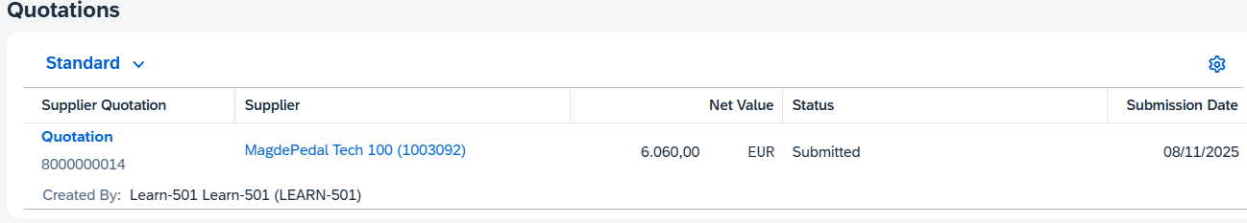
Repeat this process for the other request you created. Enter the following prices:  Shell Gear EUR 32 for the first items and EUR 36 for all other items  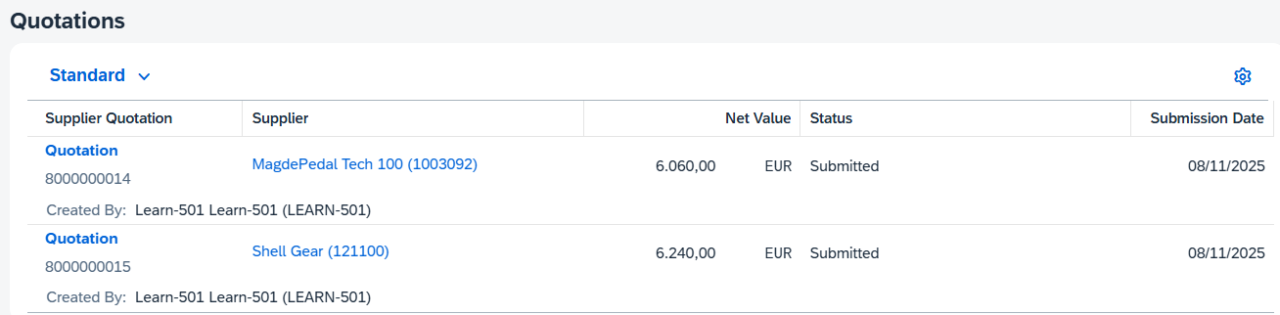 |  | 32  36
Click to return to the SAP Fiori launchpad.

 | Step 19: Price-Based Bid Evaluation
Task Evaluate the quotations based on the price.  Description Generate a quotation price comparison list from the quotations of the individual vendors. Offer price comparison list ranks offers from lowest to highest  The successful supplier (MagdePedal Tech ###) was selected using the criterion of the best bid. It is now necessary to inform the subordinate providers about the rejection of their offers. The system stipulates this in the process because it is defined for these providers that you need to be notified.  Name (Job) Wilton Saban (Inventory Supervisor) |  | Time 10 min
Generate a quotation price comparison list from the quotations of the individual vendors. Offer price comparison list ranks offers from lowest to highest.  The successful supplier (MagdePedal Tech ###) was selected using the criterion of the best bid. It is now necessary to inform the subordinate providers about the rejection of their offers. The system stipulates this in the process because it is defined for these providers that you need to be notified. |  | Scenario
To reject a quotation, use the Compare Supplier Quotations app in the Inventory Supervisor role in the area of Materials Management. |  | Initial Screen
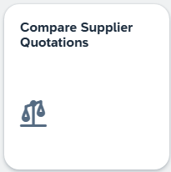
Use the F4 help to search for your RFQ. Enter IDGC-RFQ### as the RFQ Description and click . |  | IDGC-RFQ###
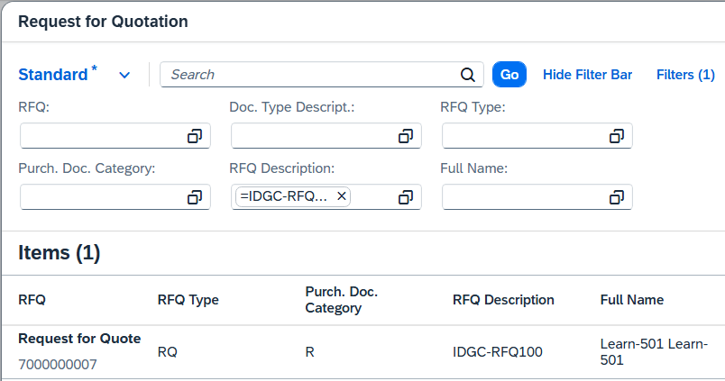
Select your posting.
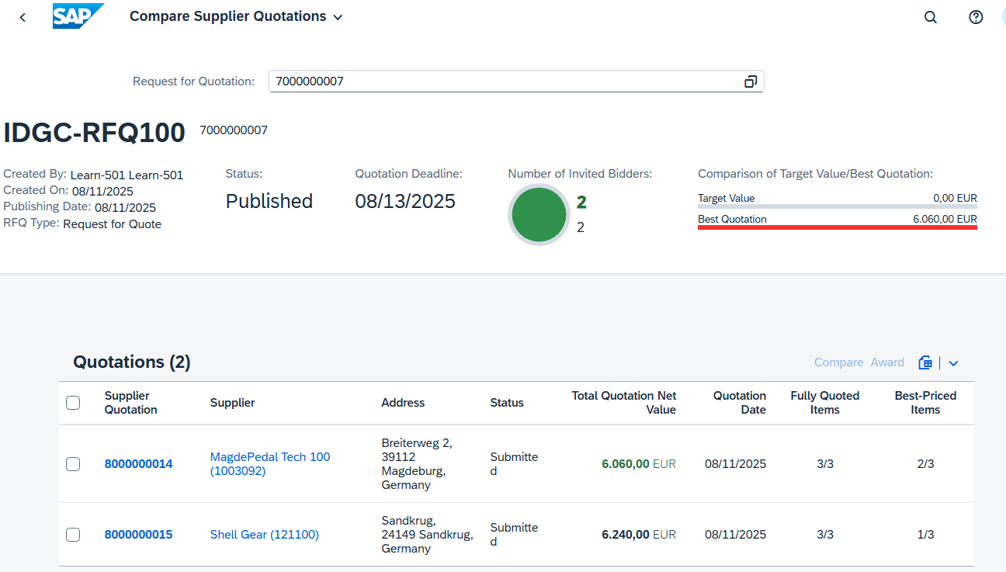
Compare the quotations. Select all two quotations and click Compare.
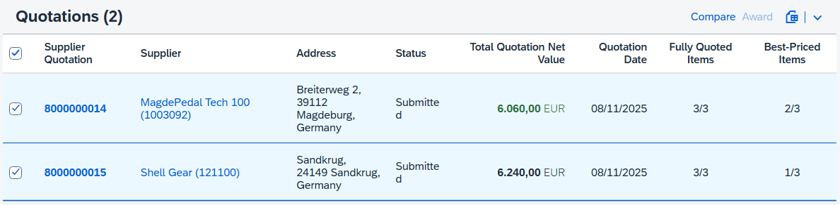
You now get a detailed breakdown of bids submitted per item.
As you can see, for item 00010, the Shell Gear quotation is highlighted in color, as this is best for the first item. For all other items, the supplier MagdePedal Tech ### has submitted the cheaper quotation.
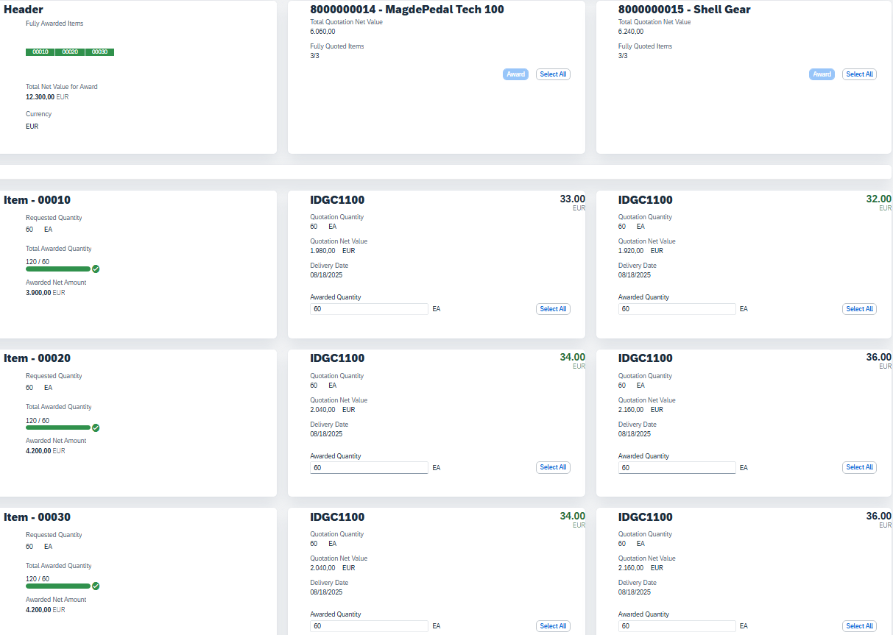
Click (Back).
Select the least expensive offer. Select only the offer from MagdePedal Tech ### and click to accept the quotation.
You can identify the best quotation by the total net value being highlighted in green.
Reject the other offers. Click on the quote number and click on the quote number again.
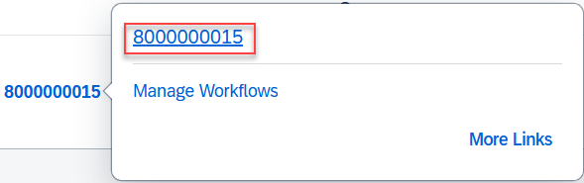
In the Supplier Bid screen, click (top right).
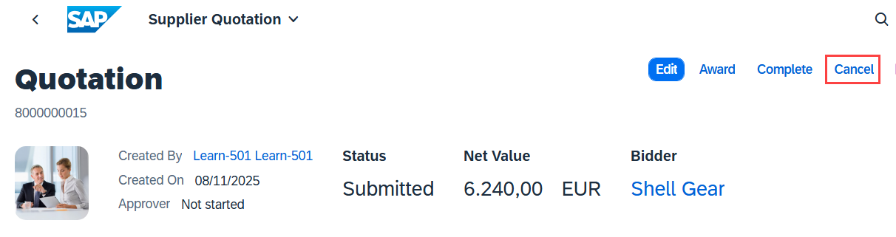
If your browser window is too small, you can find the Close button at 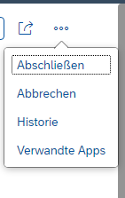.
Click (Back).
On the Compare Supplier Quotations screen, you can now see that one supplier quotation has been cancelled and the other has been awarded.
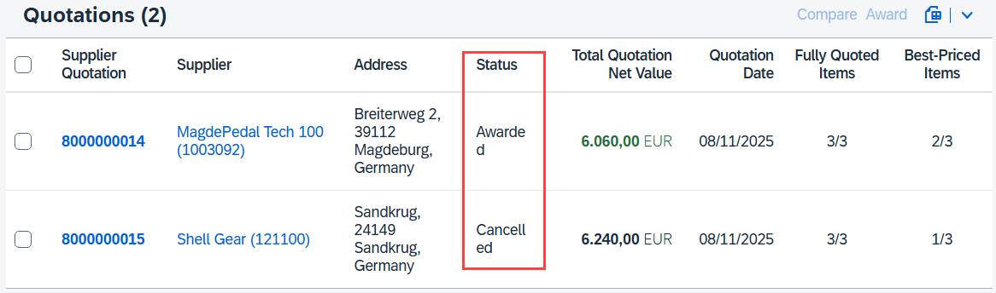
Click to return to the SAP Fiori launchpad.

 | Step 20: Create purchase order with reference to RFQ
Task Create a purchase order with reference to an inquiry.  Description Create a purchase order that refers to the quotation from the successful supplier. The details are then imported into the new purchase order.  Name (Job) Alberto Conti (Inventory Assistant) |  | Time 10 min
To create a purchase order, use the Manage RFQs app in the role Inventory Assistant in the area of Materials Management. |  | Initial Screen
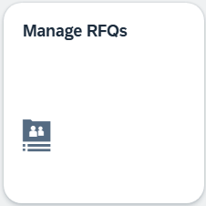
For the RFQ Description field, enter IDGC-RFQ###. Start the search by clicking on . |  | IDGC-RFQ###
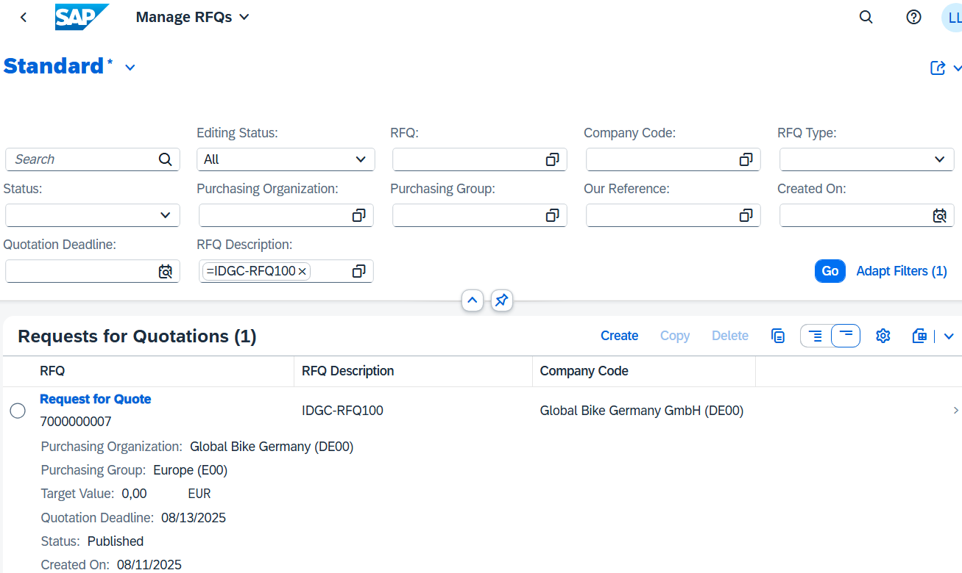
Click on your purchase quotation. Go to the Process Flow area.
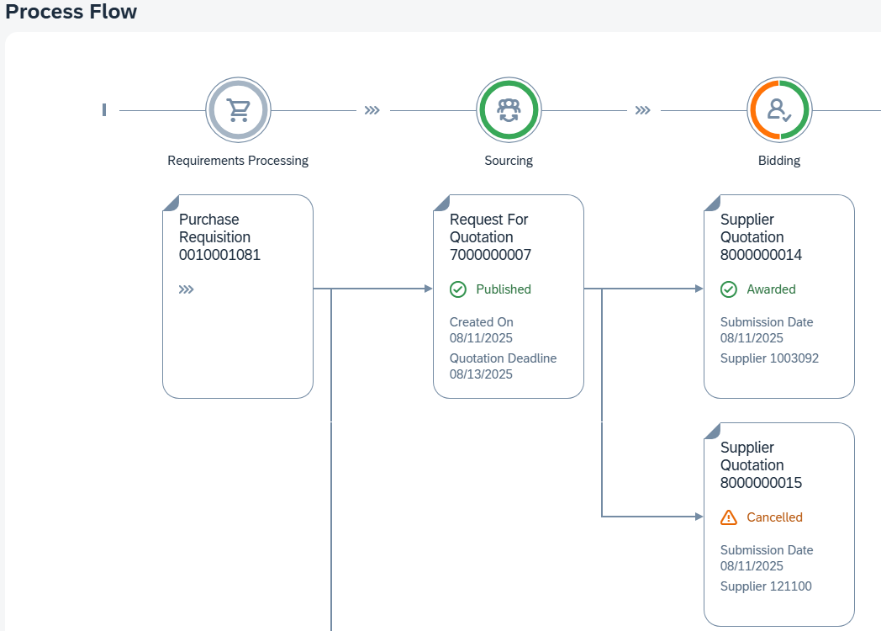
You see your purchase requisitions, which were bundled in the RFQ, followed by the two quotations. One of the two quotations has been rejected and you can see from the comment Cancelled.
Click on the supplier quotation with remark and then click on the quotation number.
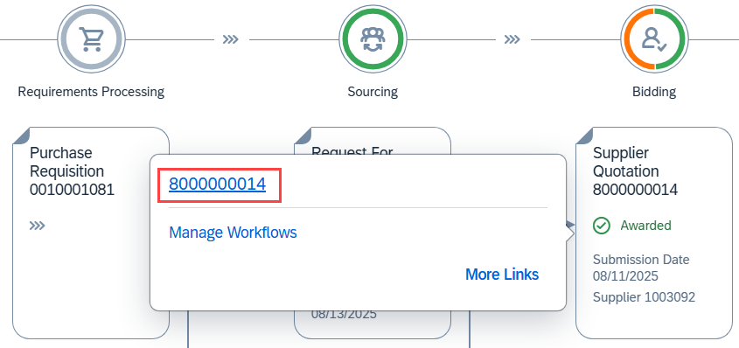
Create a purchase order from this quotation by clicking and then Create Purchase Order.
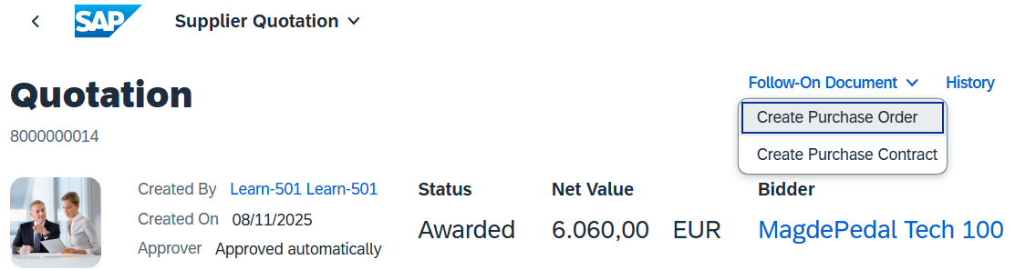
On the purchase order screen, switch to the Items area. Check your order of 180 Integrated GPS Bike Computers there.
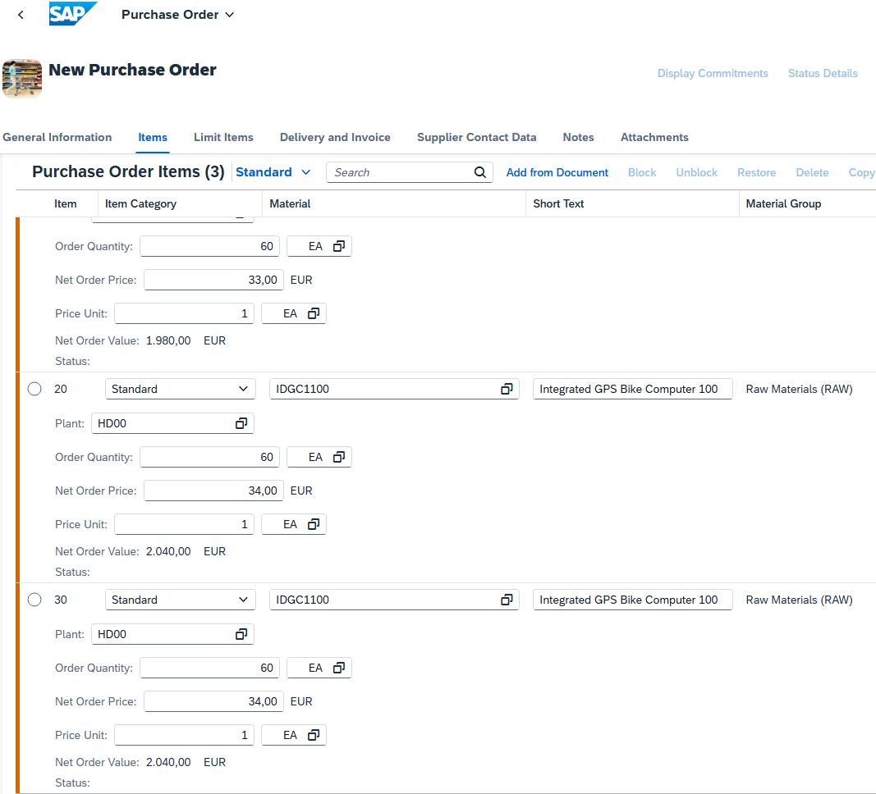
Now click to create your order.
Note A purchase order is a formal request to a vendor to deliver goods or services in accordance with the purchase order conditions. Several objects can trigger a purchase order.
Goods receipt and invoice verification are usually based on the purchase order.
Click 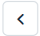 until you return to your posting. Have a look at your process flow again. The accepted quotation is now followed by a purchase order.
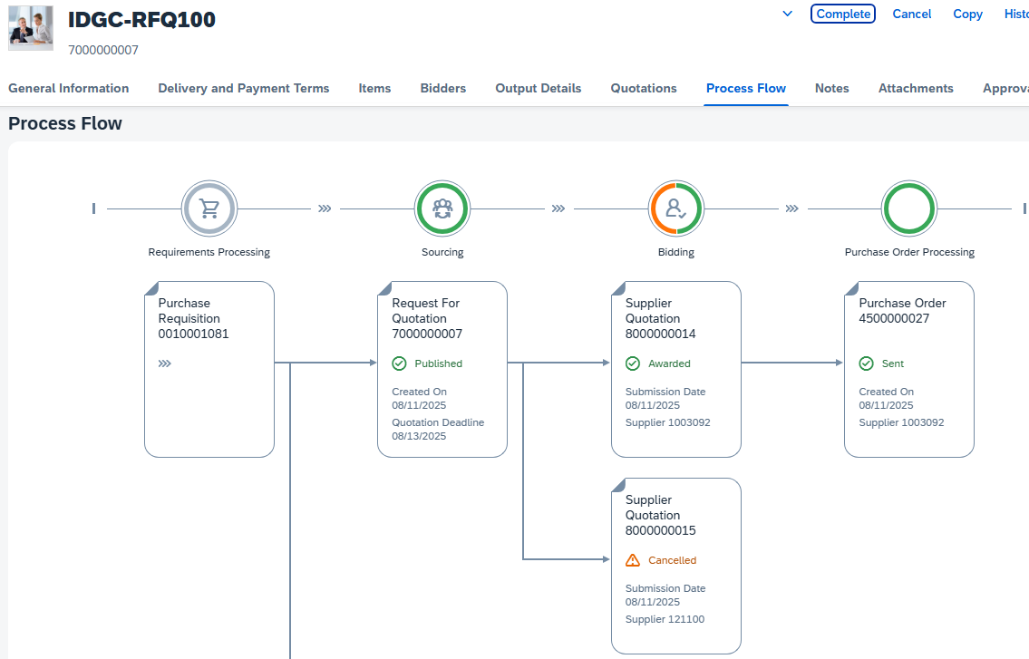
Click to return to the SAP Fiori launchpad.

 | Step 21: Display Purchase Order
Task Display your purchase order.  Description You now want to look at what you have sent to the supplier in the system.  Name (Job) Aura Maxwell (Purchasing Agent 2) |  | Time 5 min
To display the purchase order, in the Materials Management area, in the Inventory Supervisor role, use the My Purchasing Document Items - Professional app. |  | Initial Screen
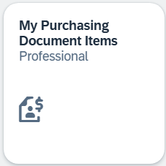
The app enables you to get an overview of all purchase requisitions, purchase orders, goods receipts, and supplier invoices.
In the Supplier field, enter or search for your supplier MagdePedal Tech ### using the input help and choose . |  | MagdePedal Tech ###
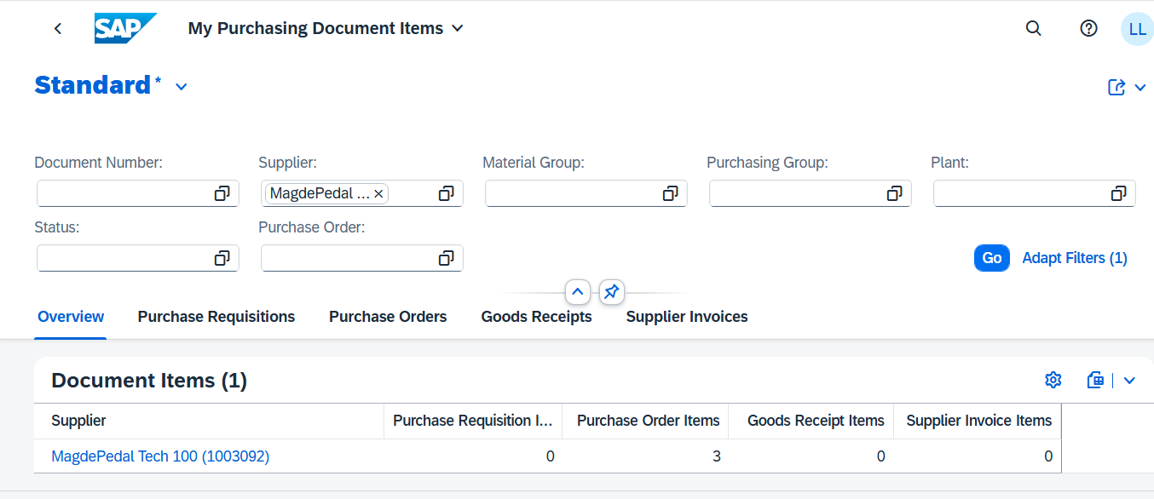
Click .
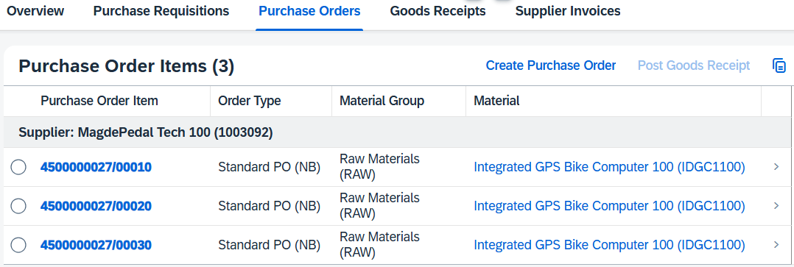
You can see that the Next Delivery Quantity is 180 pcs Integrated GPS Bike Computers.
Click to return to the SAP Fiori launchpad.

 | Step 22: Post Goods Receipt for Purchase Order
Task Create a goods receipt posting for the purchase order.  Description You receive the goods that you ordered from MagdePedal Tech ### in your stock in the previous step. A goods receipt posting is created that refers to your purchase order. The stock is increased and a financial document is created that correctly posts the value of the goods.  Name (Job) Tatiana Karsova (Goods Receipt Clerk) |  | Time 10 min
To post the goods receipt, use the Post Goods Receipt for Purchasing Document app in the area Materials Management in the role Goods Receipt Clerk. |  | Initial Screen
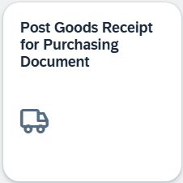
Enter your purchasing document number in the Purchasing Document field. |  | Purchasing Document Number
If you want to search for your purchasing document number, use the F4 help. In the search field, enter IDGC1### and then click  . |  | IDGC1###
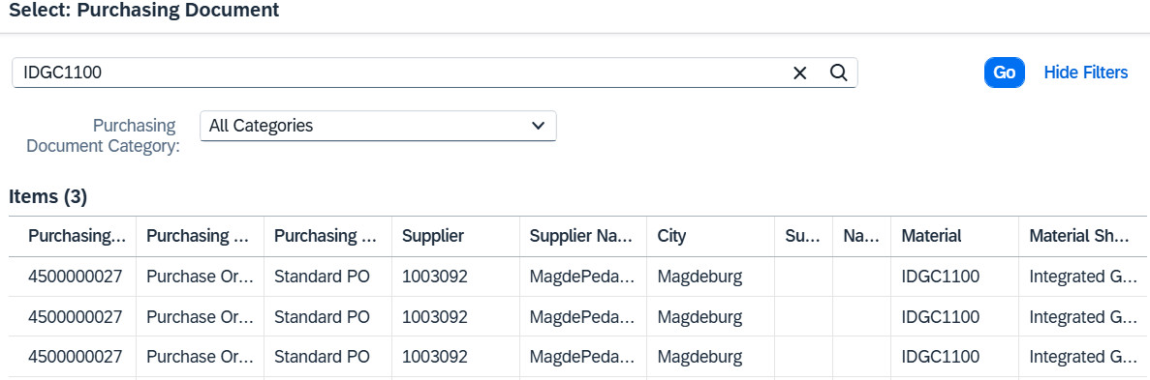
Then select the first of your purchase orders by double-clicking them. |  | First of your orders
You now see your purchase order.
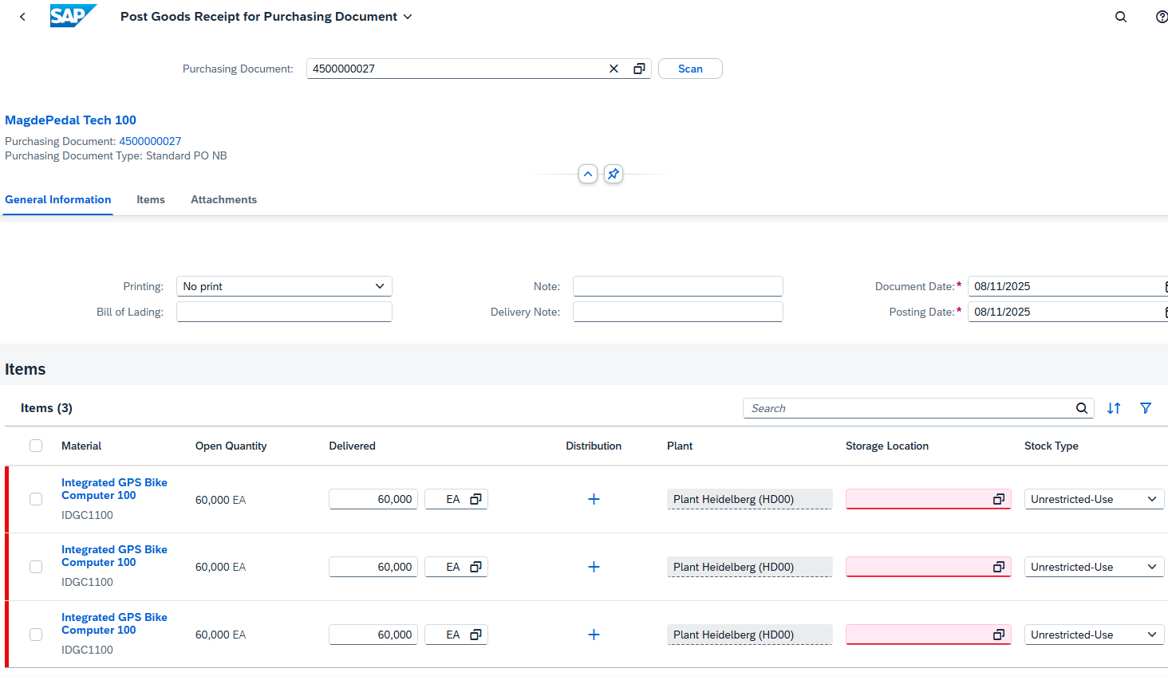
When goods are delivered for a purchase order, you document a goods receipt with reference to the purchase order. The system checks the purchase order and copies only the open purchase order items to the goods receipt transaction.
During goods receipt with reference to a purchase order, the system checks the following:
- Whether the right material was delivered.
- Whether the correct quantity was delivered. (If this is not the case, an over- or Underdelivery)
- Whether perishable goods are within their minimum shelf life. (In this case, the shelf life expiration date check must be activated.)
For Printing, select Individual Slip. |  | Individual Slip
If not filled automatically, select RM00 (RAW Materials) in each item for storage location. |  | RM00 (RAW Materials)
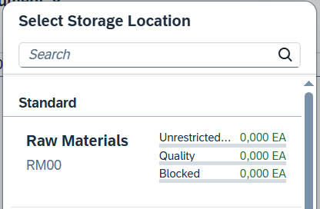
Now click on your item line to check all entries.
Select the checkbox for Delivery Completed. |  | Delivery Completed
Check that RAW materials are entered as the storage location and change the stock type to Quality Inspection. |  | RAW Materials  Quality Inspection
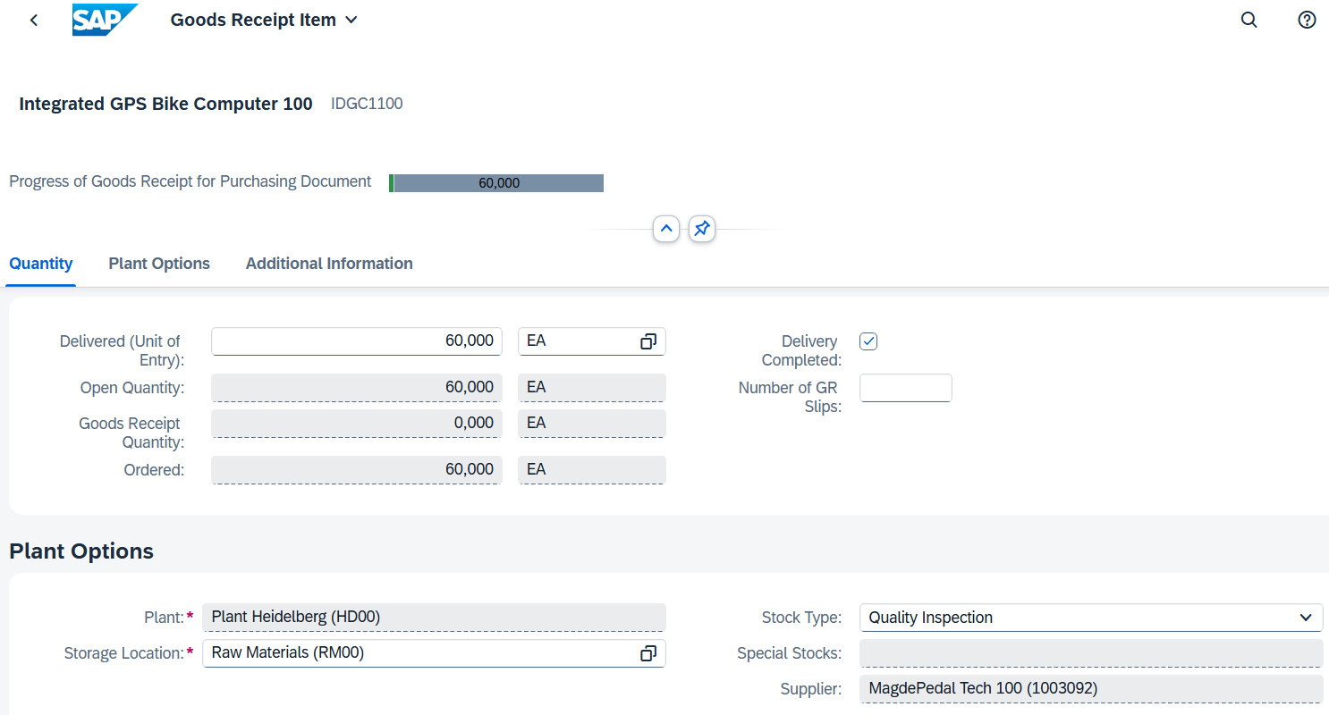
Now click .
Repeat this procedure for all other purchase order items.
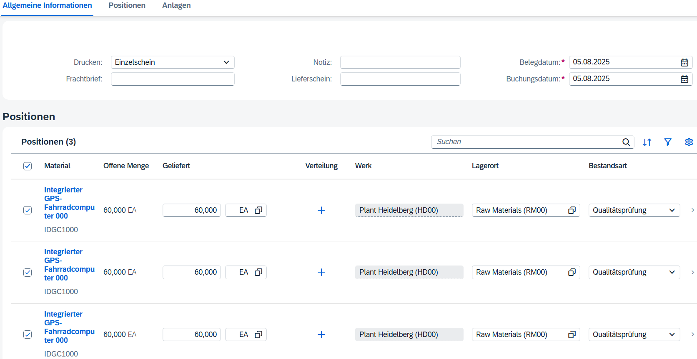
Inventory Management recognizes various stock types that indicate the usability of the material:
- unrestricted-use stock
- Stock in Quality Inspection
- Blocked stock
For goods receipts, you decide to which stock type a quantity is posted. The stock type is relevant for determining the available stock in MRP (material requirements planning) and for withdrawals in Inventory Management (see also Availability Check).
You can only post withdrawals for consumption from unrestricted-use stock. From quality inspection stock and blocked stock, you can only withdraw a sample, scrap a quantity, or post an inventory difference.
Leave the lines selected. Click  to post the goods receipt of your material. You receive a success message with your material document number.
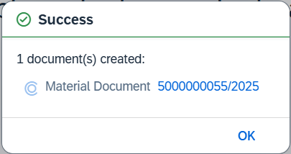
Note When you post a goods receipt in one of the warehouses, the system generates a material document. This document contains information about the delivered material and the corresponding quantity. The plant storage location is documented for stock items.
Click to return to the SAP Fiori launchpad.

 | Step 23: Check received goods
Task Check the quality of the goods.  Description You must ensure that the goods have been delivered in the desired quality. The goods are transferred to unrestricted-use stock.  Name (Job) Sandeep Das (Warehouse Supervisor) |  | Time 10 min
To display the stock, use the Stock - Single Material app in the area Materials Management in the role Warehouse Supervisor. |  | Initial Screen
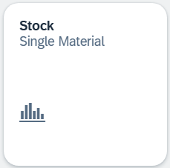
If it is not already selected, enter your material IDGC1###. A list is displayed. Click on your material IDGC1###. |  | IDGC1###.
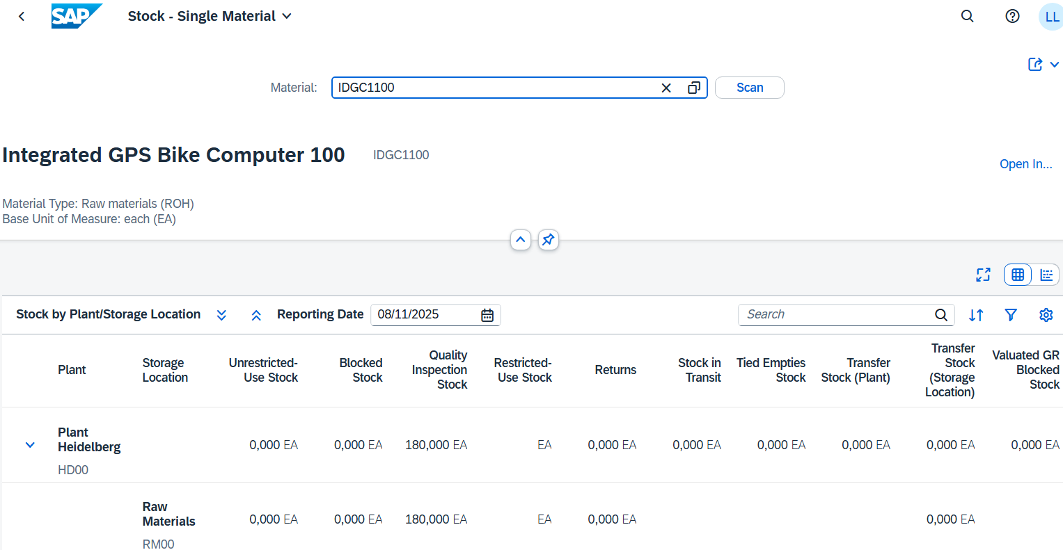
In the previous step, you posted the received goods for quality inspection. Here you can see the 180 units in the quality inspection stock.
You can only take goods from unrestricted-use stock for consumption. Therefore, you must transfer the goods.
Note In reality, you would check whether the correct goods and quantity were delivered before you post them to unrestricted-use stock.
Select the line of the storage location Raw Materials in the plant Heidelberg and click .
In the Stock in Quality Inspection column, click 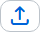 next to the 180 units. The icon under Unrestricted-Use Stock is now clickable. Click 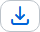.
In the Transfer Stock – In-Plant window, increase the quantity to 180. |  | 180
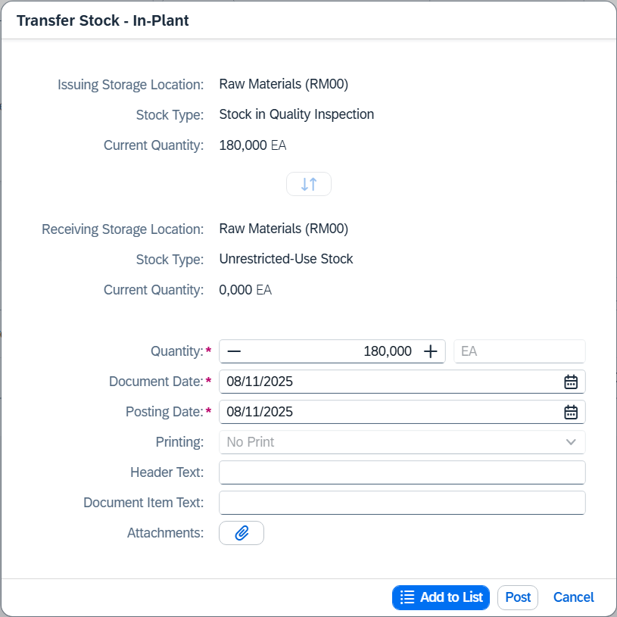
Click 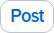. You receive a success message.
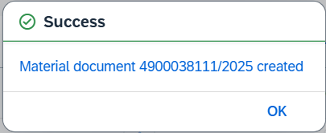
The material has been transferred. Close the window.
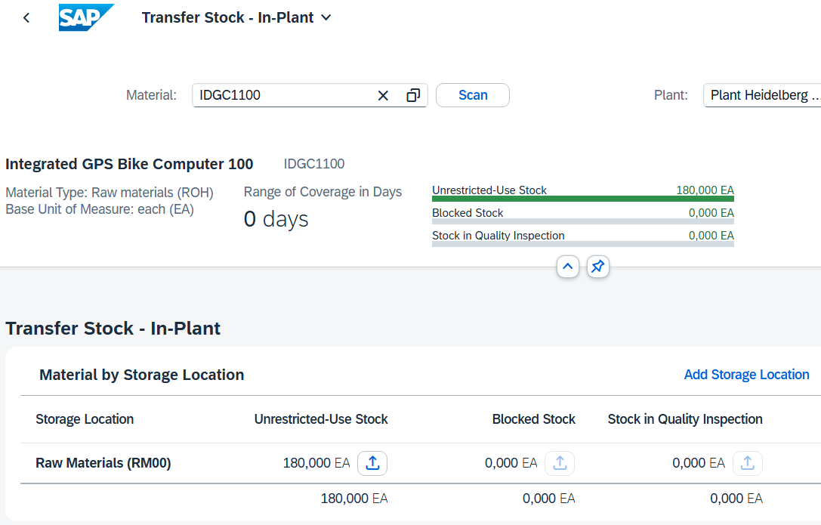
Click to return to the SAP Fiori launchpad.

 | Step 24: Check physical goods receipt
Task Confirm the physical receipt of the goods.  Description Revisit the stock of Integrated GPS Bike Computers. The stock overview gives you an overview of the stocks of a material across all organizational levels.  Name (Job) Tatiana Karsova (Goods Receipt Clerk) |  | Time 5 min
To check the warehouse stock of a material in the sales order, use in the area Materials Management in the role Goods Receipt Clerk, the Manage Stock app. |  | Initial Screen
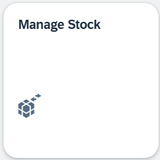
In the dropdown menu, select the plant in Plant Heidelberg (HD00). To find the material number from your Integrated GPS Bike Computers, click in the Material field and then click the value help icon . |  | HD00
In the Search field, enter *### (for example, if your number is 002, enter *002).
Click to view the list of materials. Extend the Material Description field.
Scoll down until you find your material IDGC1###. |  | IDGC1###
Double click on it. The report shows you the storage level for the plant in Heidelberg.
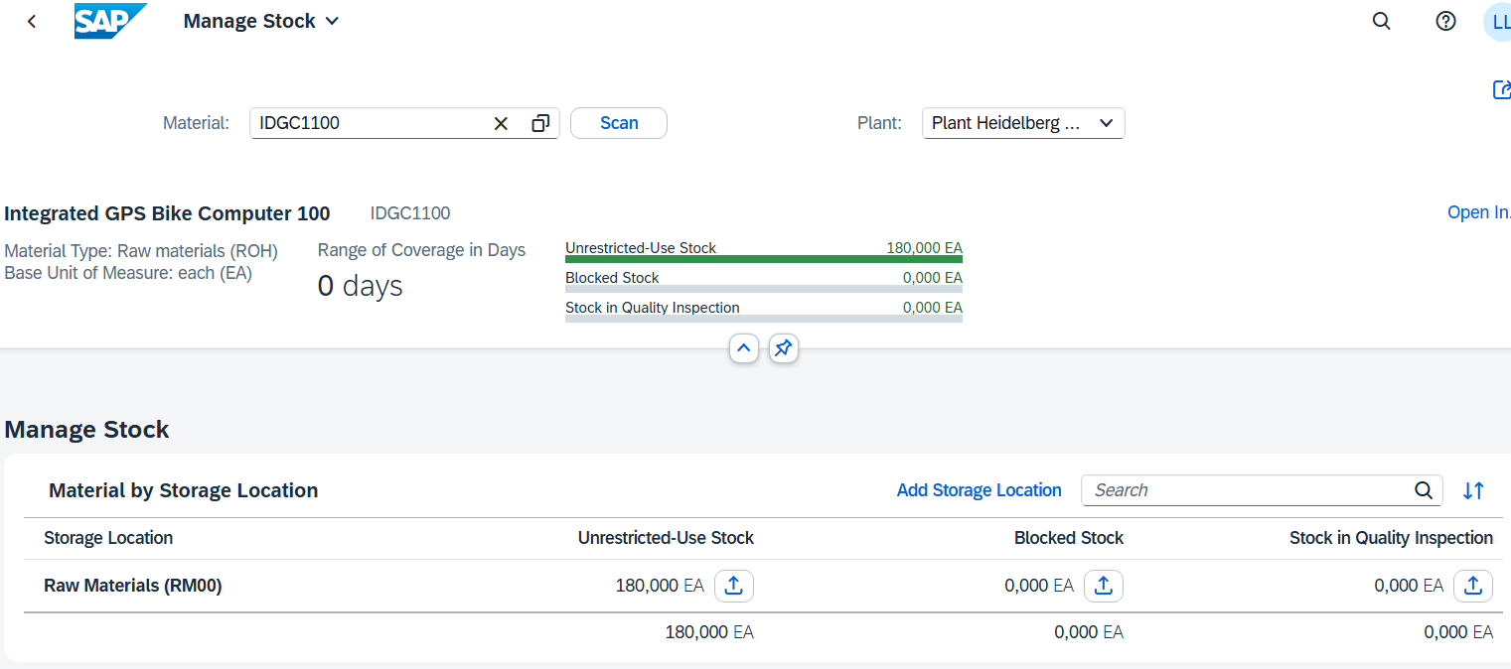
You can find out more details about the stock of the Integrated GPS Bike Computer. To do so, click . This will give you detailed information about the stock of the bicycle computer in the various plants.
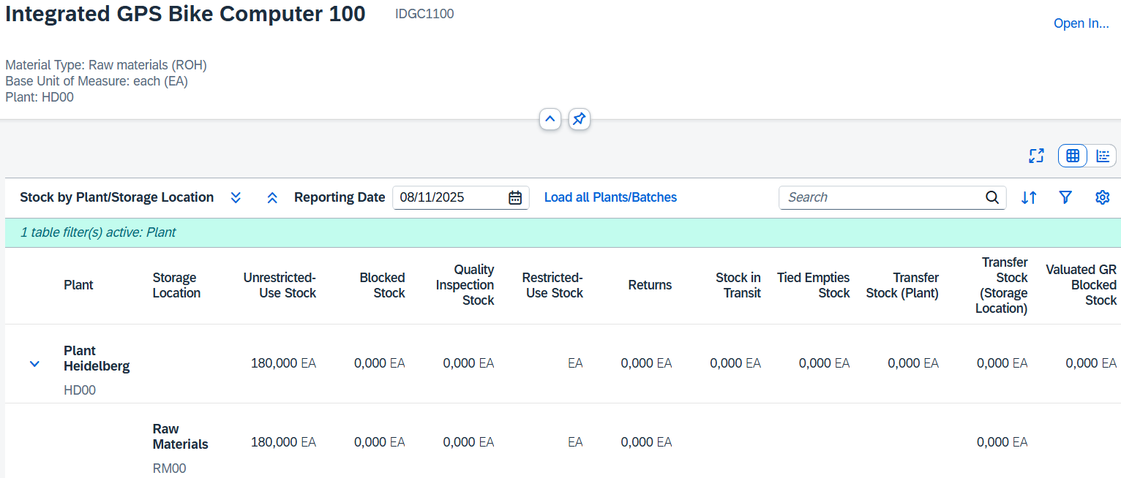
Click on the following icon 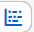 to see detailed information about the stock of the GPS bicycle computer in Heidelberg.
On the following screen, you can see a graphical overview.
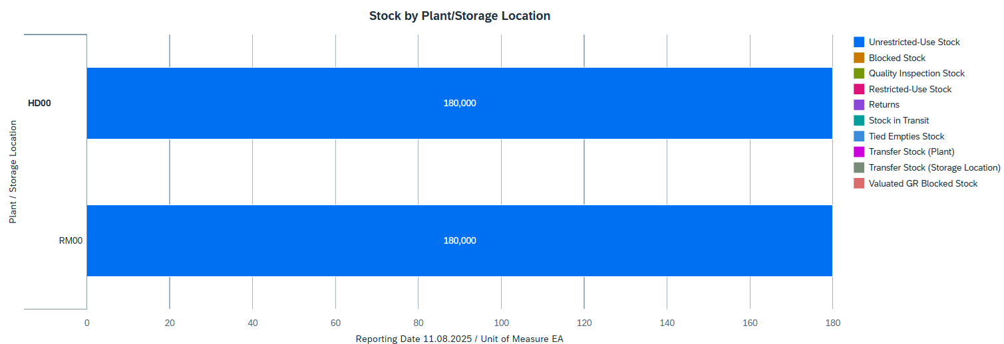
Click to return to the SAP Fiori launchpad.

 | Step 25: Create and Post Supplier Invoice
Task Create a supplier invoice.  Description Create a supplier invoice from MagdePedal Tech ### for the current purchase order and the received goods. This invoice is assigned to an existing expense account in the general ledger of your chart of accounts and saved as a payable to MagdePedal Tech ###.  Name (Job) Silvia Cassano (AP Accountant) |  | Time 10 min
To create a supplier invoice, use the Create Supplier Invoice app in the Materials Management area in the Accounts Payable Accountant role. |  | Initial Screen
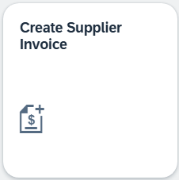
On the Create Supplier Invoice screen, enter today’s date as the invoice date by pressing F4 and then Enter. Enter your company code DE00. Now enter INVOICE.IDGC1### as the reference. |  | Today's date  DE00 INVOIC.IDGC1###
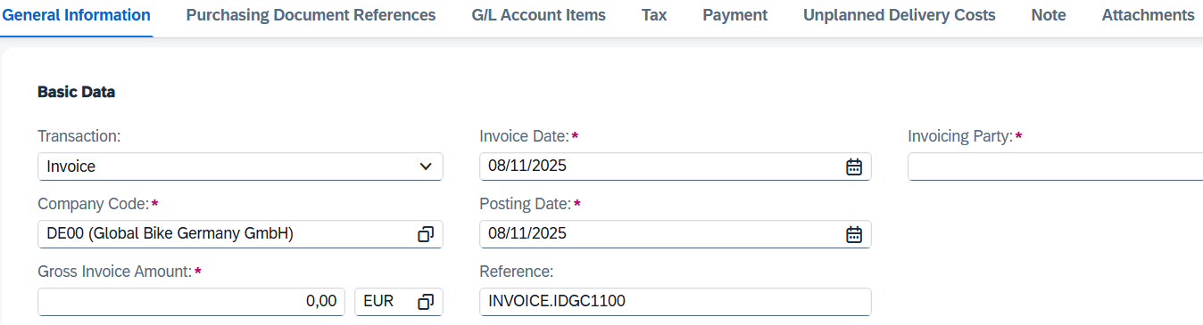
Choose the Purchasing Document References section.
Now enter (or search for) your purchase order number in the Purchase Order/Scheduling Agreement field. Then press Enter. |  | Your purchase order number
Make sure that V1 is entered as the tax code. |  | V1
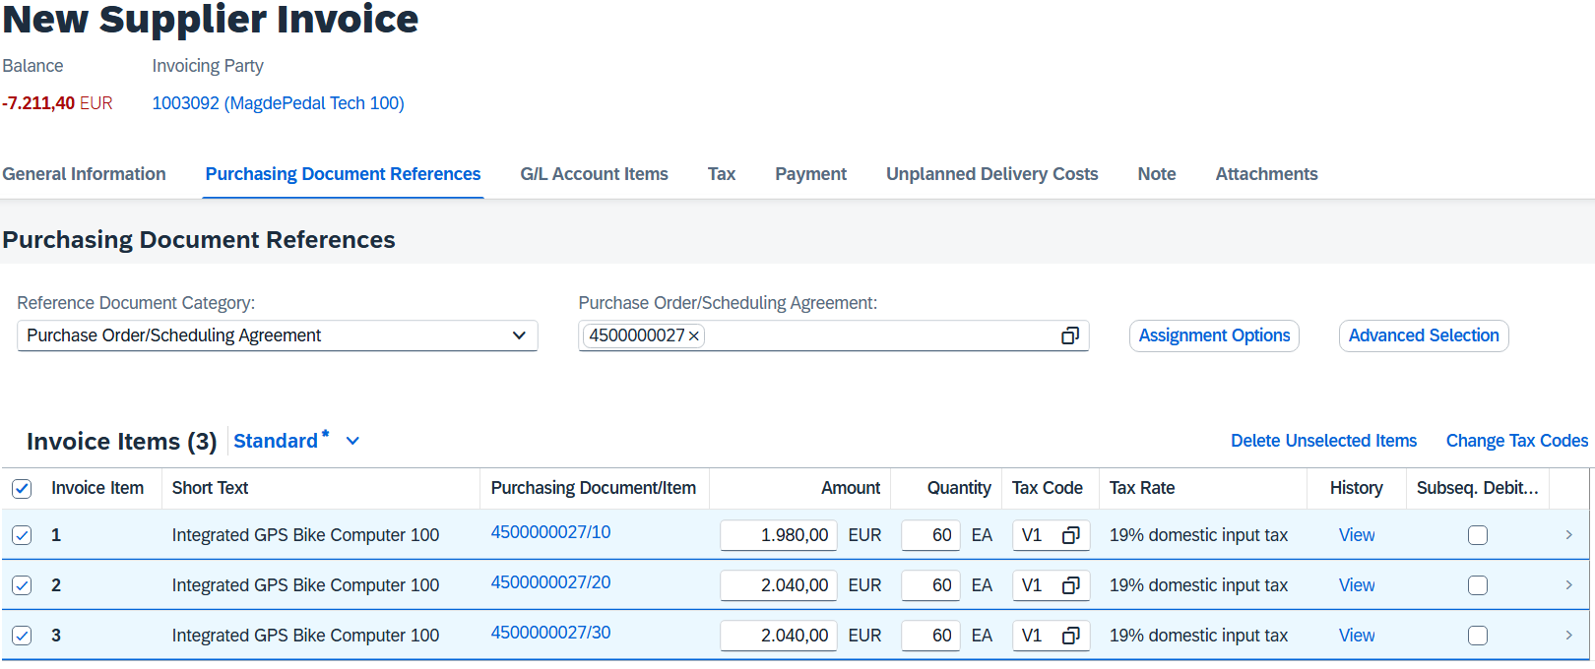
Your invoicing party and the balance have updated with the invoice items.
Enter the amount of the invoice EUR 7,211.40 (EUR 6,060.00 plus Taxes) in the Gross Amount field
Click .
Scroll back to the top of the page. As you can see, the balance is now EUR 0.00.
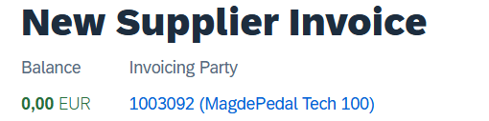
Then press to verify that your postings are correct.
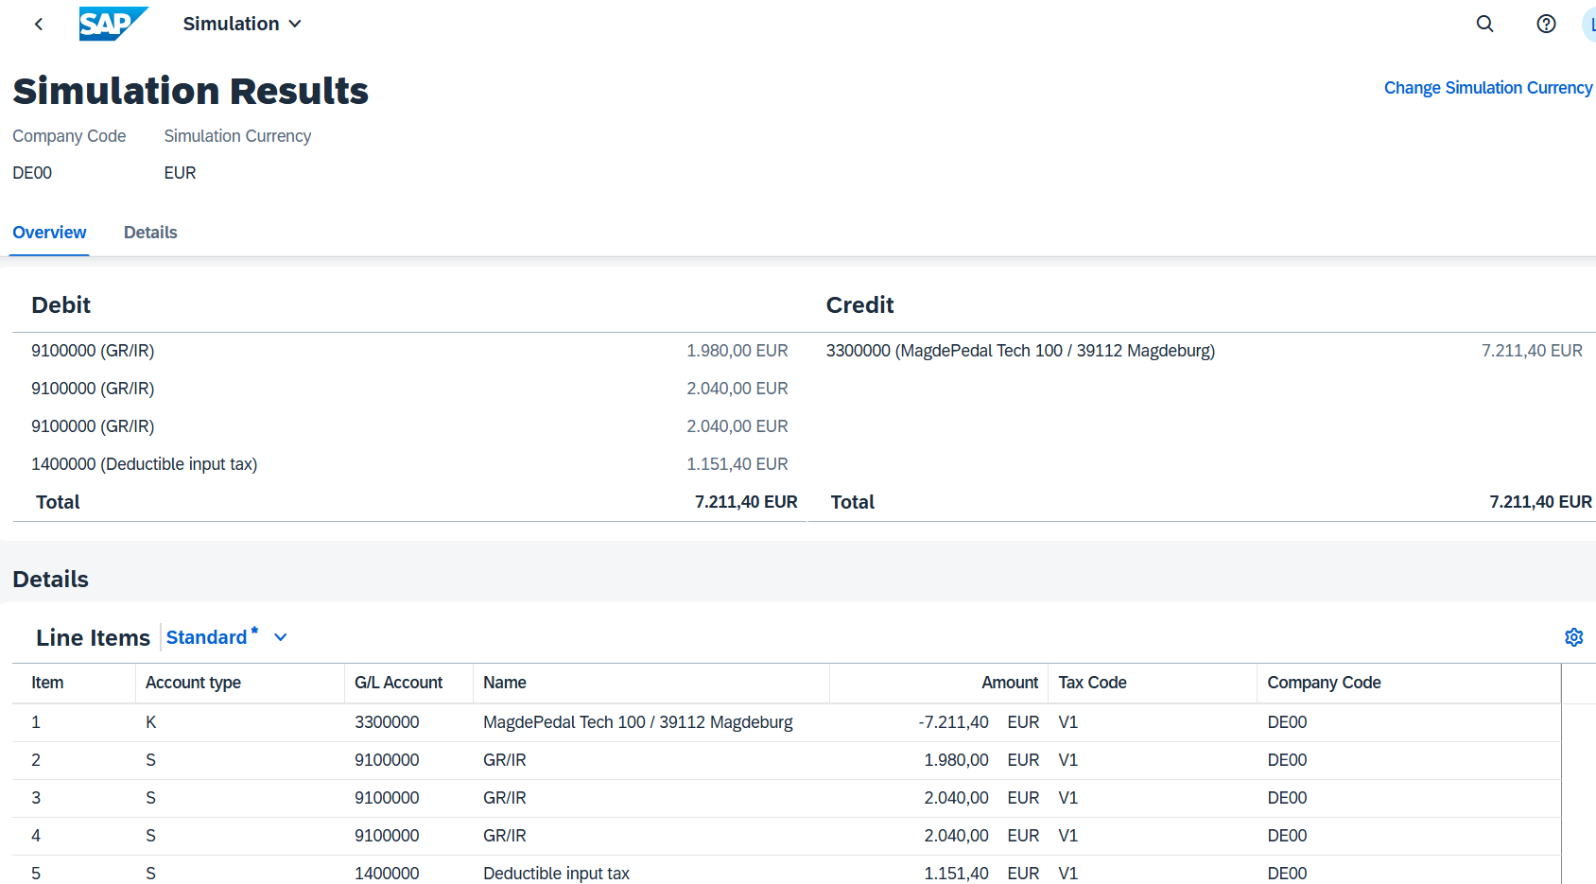
Finally, press . The system will generate a unique supplier invoice number.
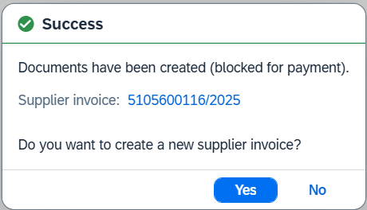
Click No to go back to the SAP Fiori launchpad.

 | Step 26: Display Purchase Order History
Task Display the purchase order history.  Description Revisit the status of your order of the bike computers. As a result of the first operation that was carried out for your purchase order number, the Purchase Order Processing tab page is now available in the purchase order.  Name (Job) Wilton Saban (Inventory Supervisor) |  | Time 10 min
To display the purchase order history, in the Materials Management area, in the Inventory Supervisor role, use the My Purchasing Document Items - Professional app. |  | Initial Screen
The app provides you with an overview of all purchase requisitions, purchase orders, goods receipts, and supplier invoices.
In the Supplier field, enter the number of your supplier MagdePedal Tech ###. Choose . |  | MagdePedal Tech ###
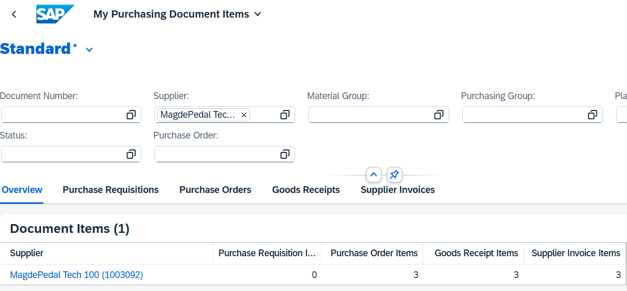
Then click the tab.
In the Purchase Order Items area, choose  and select the Delivered Amount column in the Display Settings dialog box.
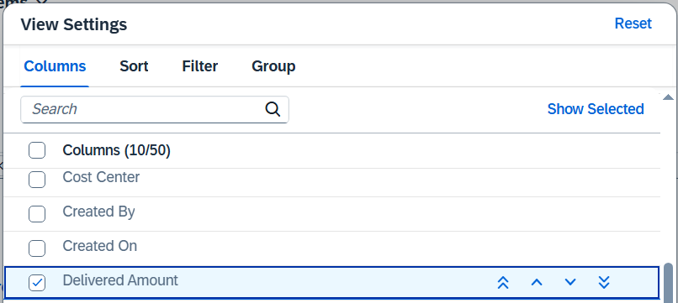
Click .
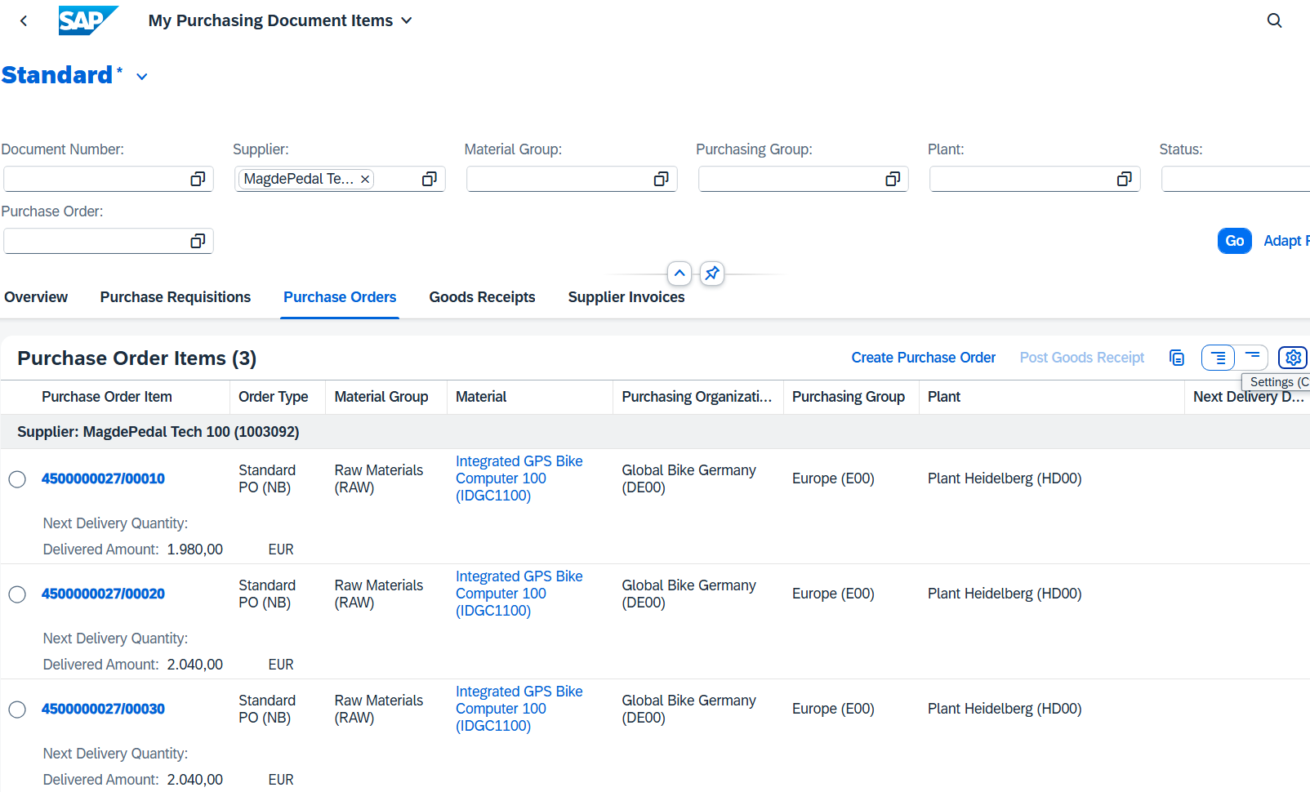
As you can see, the purchase order was delivered with several items in the amount of a delivery value of 6,060 EUR.
Now click on the tab. You can see the supplied bike computers there. You see the material document with multiple items created in the system when you confirmed the goods receipt.
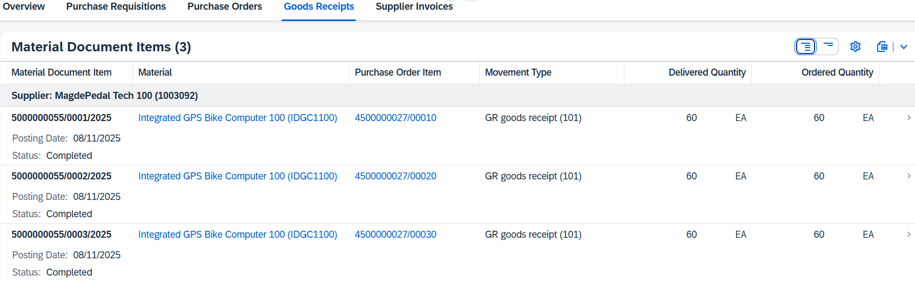
On the Supplier Invoice tab page, you can see further activities that were carried out with reference to your purchase order. Click 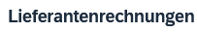.
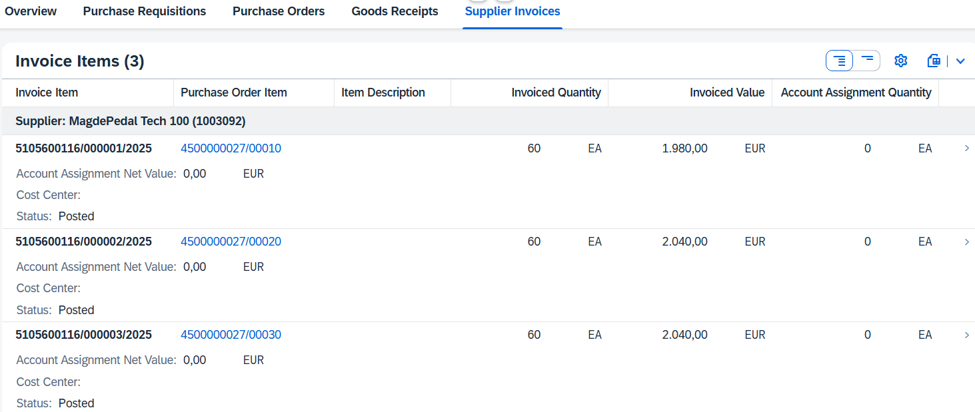
The invoice has been created. Click on one of the billing lines of your Integrated GPS Bike Computer. This takes you to the financial document that was created when you created the supplier invoice.
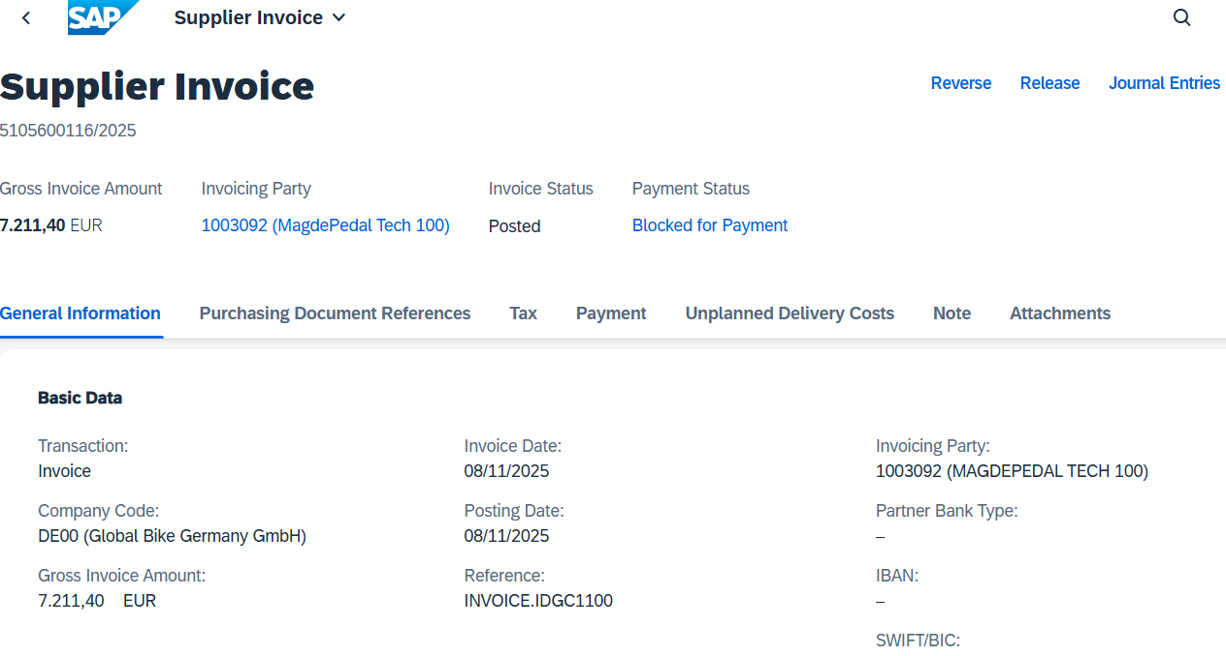
Click to return to the SAP Fiori launchpad.

 | Step 27: Display Document Flow
Task Display the document flow.  Description Check the goods receipt document and the document flow of your material.  Name (Job) Wilton Saban (Inventory Supervisor) |  | Time 5 min
Check the goods receipt document and the document flow of your material. |  | Scenario
To display the document history, use the Material Documents Overview app in the Inventory Supervisor role in the Materials Management area. |  | Initial Screen
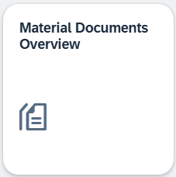
The app provides an overview of material documents. You can find your purchase order by using the assigned number. To do this, enter your material number IDGC1### in the Material field. If you do not see the search fields, click 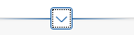 to expand the search fields. |  | IDGC1###
After entering the search term, click . Then click Settings 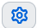. In the view settings, activate the Stock Type (Stock Transfer) column. Confirm with . |  | Stock Type (Stock Transfer).
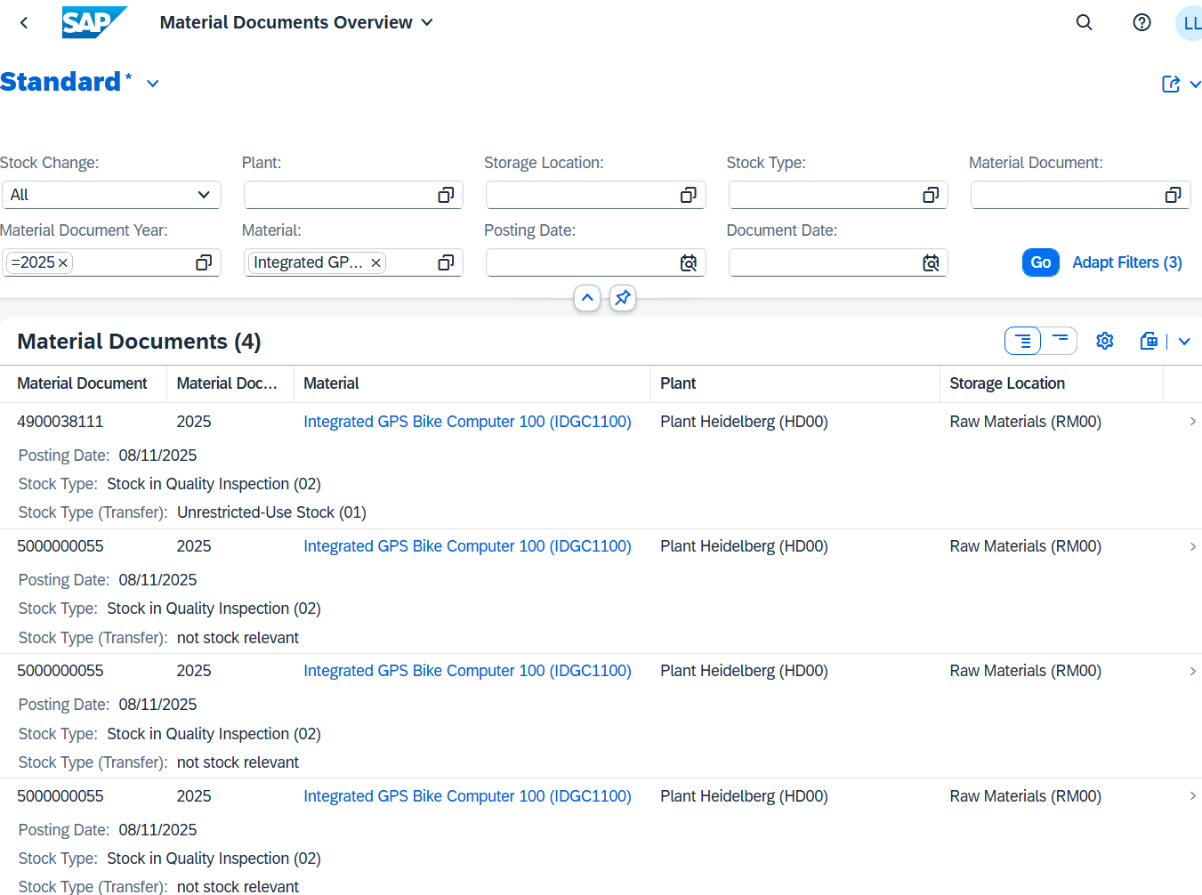
A new material document is created for each material movement. You see the material documents with your material IDGC1###.
On the one hand, the documents for the goods receipt for each item into stock in quality inspection. You can also see a document that was generated by the transfer posting of the material to unrestricted-use stock.
Identify the line with the stock type (Stock Transfer): Unrestricted-Use Stock (01).
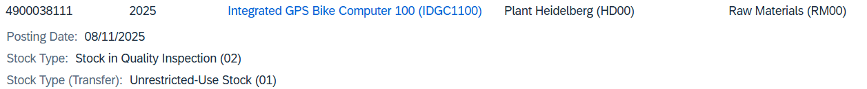
Click on this line. You can now see the general information about the document from the step where you confirmed the goods receipt.
Click the Process Flow area. In the process flow, you can see the transfer posting of the material from stock to quality inspection (02) to unrestricted-use stock (01).
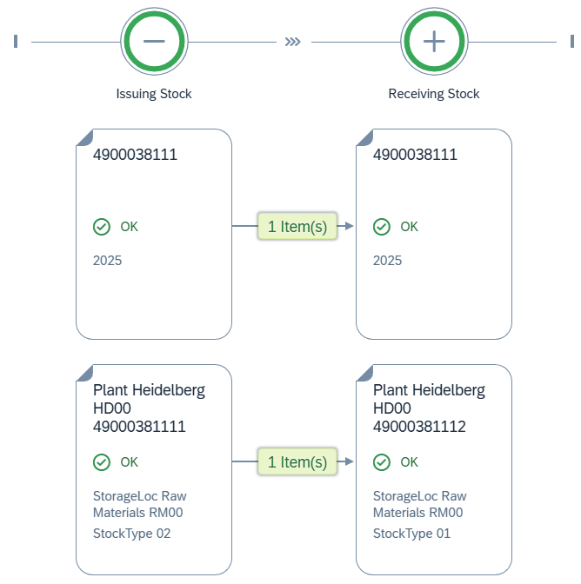
Click to return to the SAP Fiori launchpad.

 | Step 28: Post Outgoing Payment
Task Post the payments to a supplier.  Description Issue a payment to your supplier MagdePedal Tech ### to pay your liabilities. Note that the total amount matches your invoice. The created posting will clear the payable and debit your bank account.  Name (Job) Silvia Cassano (AP Accountant) |  | Time 10 min
To post the payment to a supplier, use the Post Outgoing Payments app in the Materials Management area in the Accounts Payable Accountant role. |  | Initial Screen
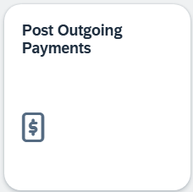
On the Post Outgoing Payments screen, choose Global Bikes Germany (DE00) as the company code, the current date as the posting date and journal entry date, INVOICE.IDGC### as the reference, and the current period. For G/L account, enter 1810000 (Bank 1) and the amount EUR 7,211.40. |  | DE00  current date  INVOICE.IDGC###  Current Period  1810000  EUR 7,140.00.
Ensure that the journal entry type KZ (Vendor Payment) is selected. Check your entries using the following screenshot. |  | KZ (Vendor Payment)
Under Open Item Selection, enter your vendor number for MagdePedal Tech ### as the account (use the F4 help if necessary). |  | MagdePedal Tech ###
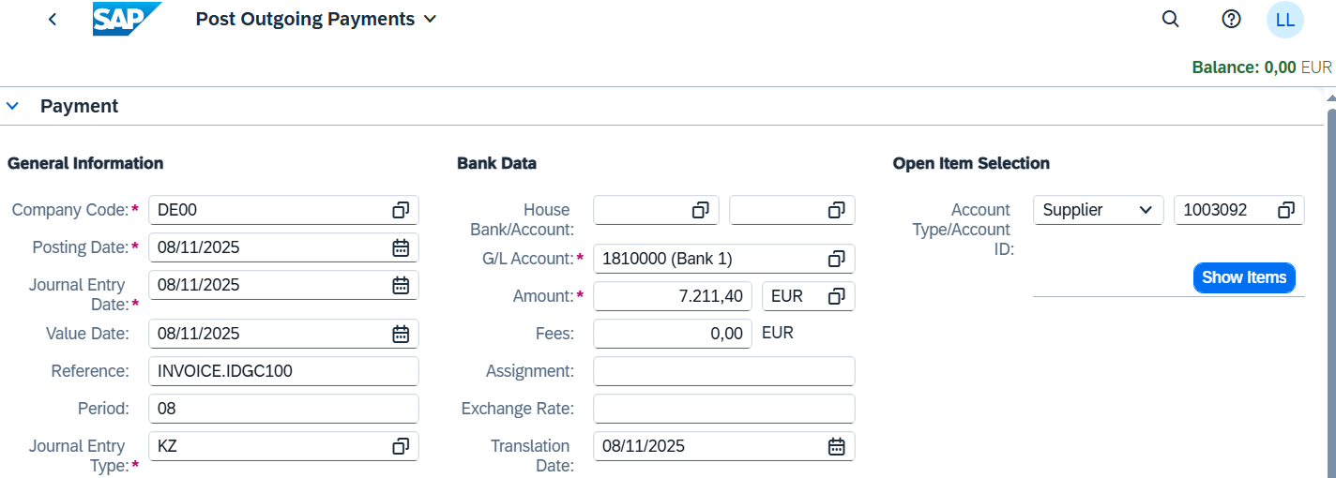
Click .
On the upper right, you can see that the open balance is USD 7,211.40.
On the Open Items tab page, you see the invoice for the delivery.
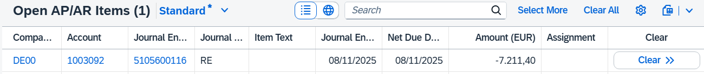
To pay the invoice, click on the button 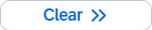
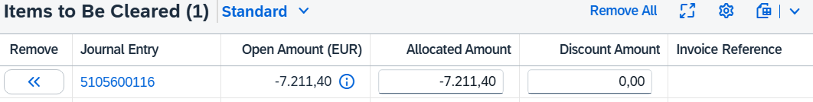
Note the confirmation that the item is now cleared.
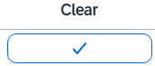
The open balance is now EUR 0.00.
Press to post your payments to MagdePedal Tech ###. The system will assign a unique document number to your supplier payment. Confirm any error messages.
You can use Display to view, edit, or cancel the booking you have made.
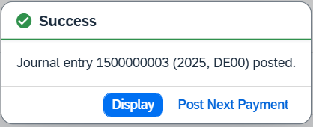
Click .
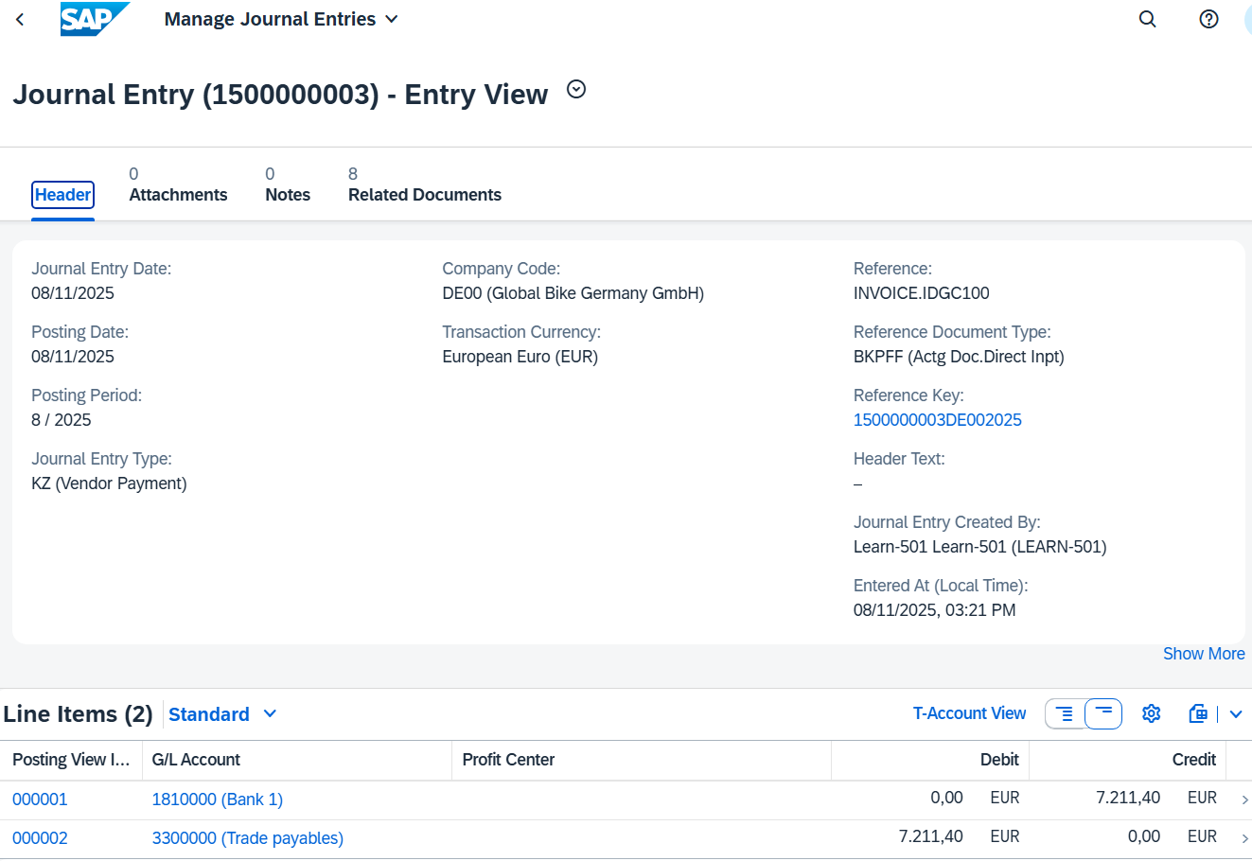
EUR 7,211.40 is debited from the bank (account 1810000) and posted at the same time as payment of payables from goods and services (account 33000000). This offsets the supplier's debt and reduces the bank balance accordingly.
Click to return to the SAP Fiori launchpad.

 | Step 29: Display Vendor Balance
Task Display the balances of a vendor.  Description View and confirm the activities and related balances related to your supplier MagdePedal Tech ###. You should see a debit and a credit posting generated by the invoice and the issuance of a payment to pay the payables to MagdePedal Tech ###.  Name (Job) Shuyuan Chen (Head of Accounting) |  | Time 5 min
To display the balances of a supplier, you use the Display Supplier Balances app in the Materials Management area in the Head of Accounting role. |  | Initial Screen
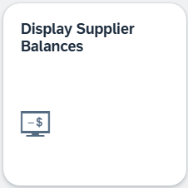
Use the in the Supplier field to find the number of your vendor. In the Search Term field, enter your number ### and in the City field, enter Heidelberg. Press . |  | ###
Select your supplier MagdePedal Tech ###.
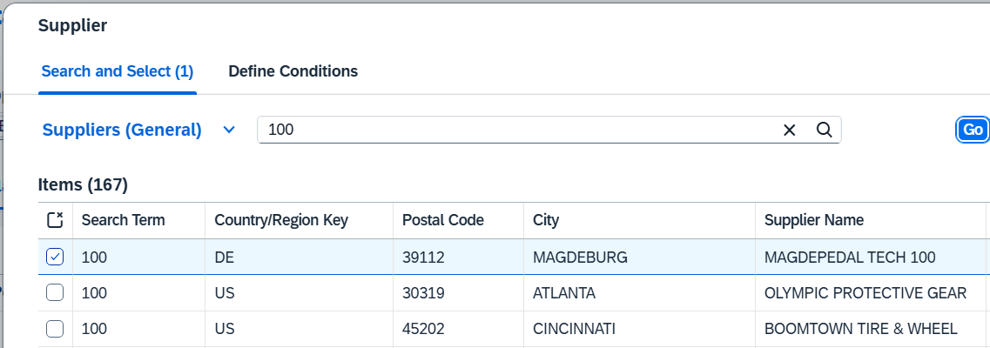
Confirm with . Back on the Display Supplier Balances screen, choose DE00 as the company code and the current year as the fiscal year. |  | DE00  Current Year
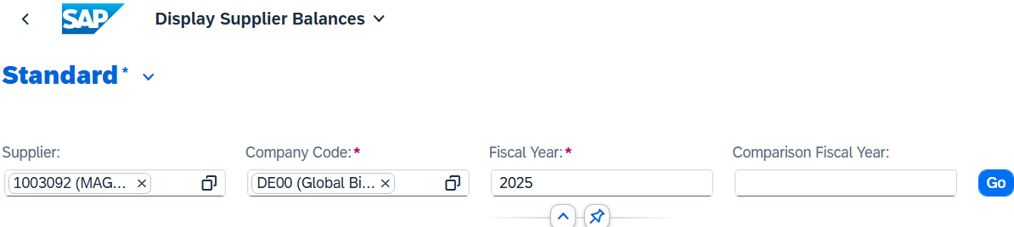
Then display the balances by choosing . You get a similar overview.
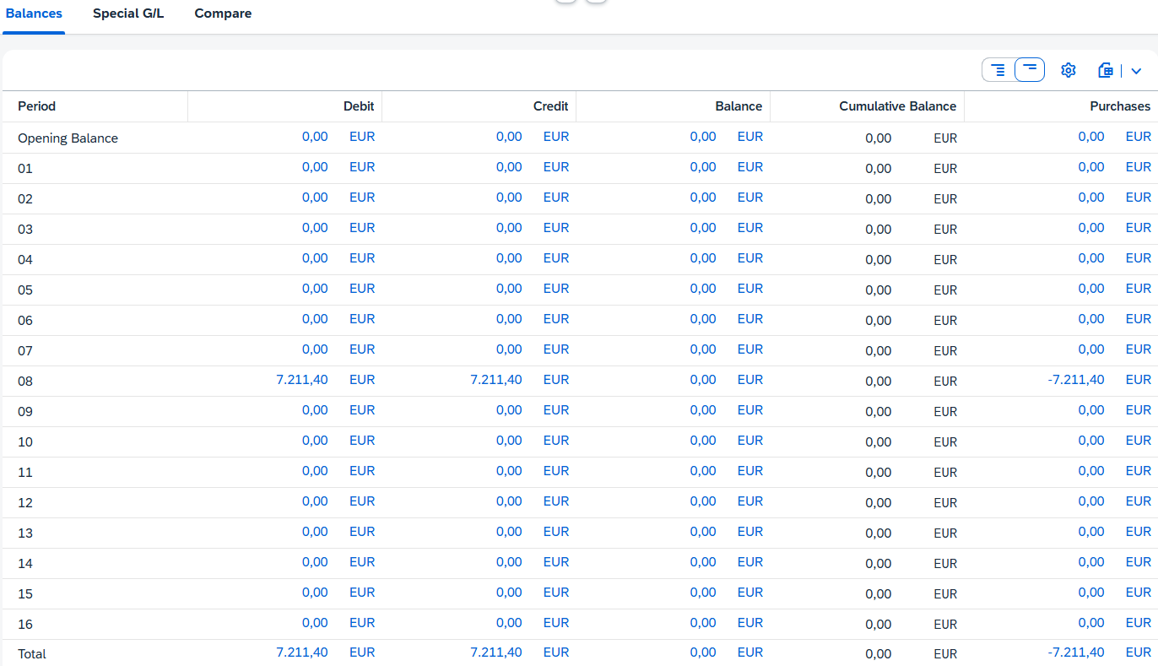
Click to return to the SAP Fiori launchpad.

 | Step 30: Display Purchase Order History
Task Display the purchase order history.  Description Revisit the status of your order of the bike computers. The Purchase Order History tab page was updated by further postings.  Name (Job) Wilton Saban (Inventory Supervisor) |  | Time 5 min
To display the purchase order history, in the Materials Management area, in the Inventory Supervisor role, use the My Purchasing Document Items - Professional app. |  | Initial Screen
The app provides you with an overview of all purchase requisitions, purchase orders, goods receipts, and supplier invoices.
In the Supplier field, enter the number of your supplier MagdePedal Tech ### and choose . |  | MagdePedal Tech ###
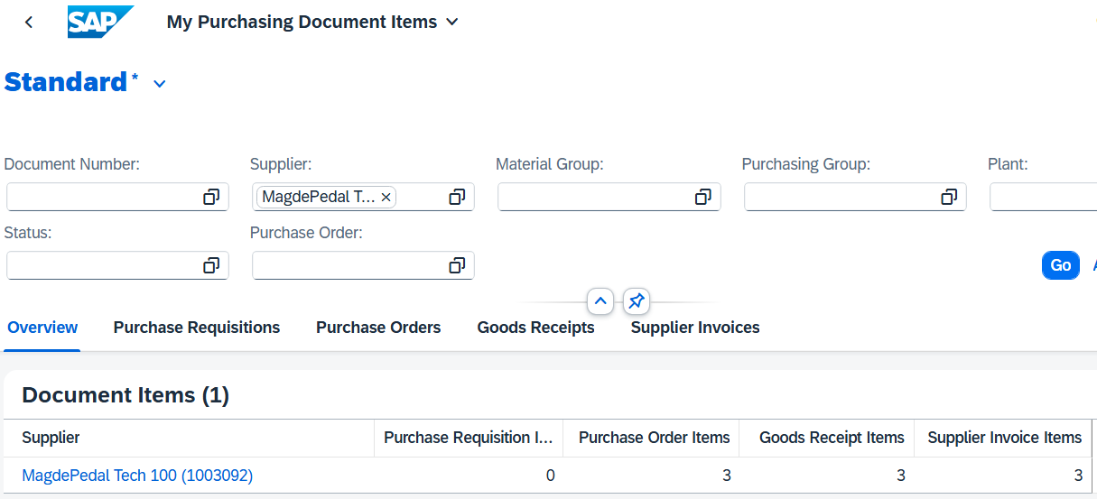
Click .
You may need to scroll down to see your supplier and purchase order.
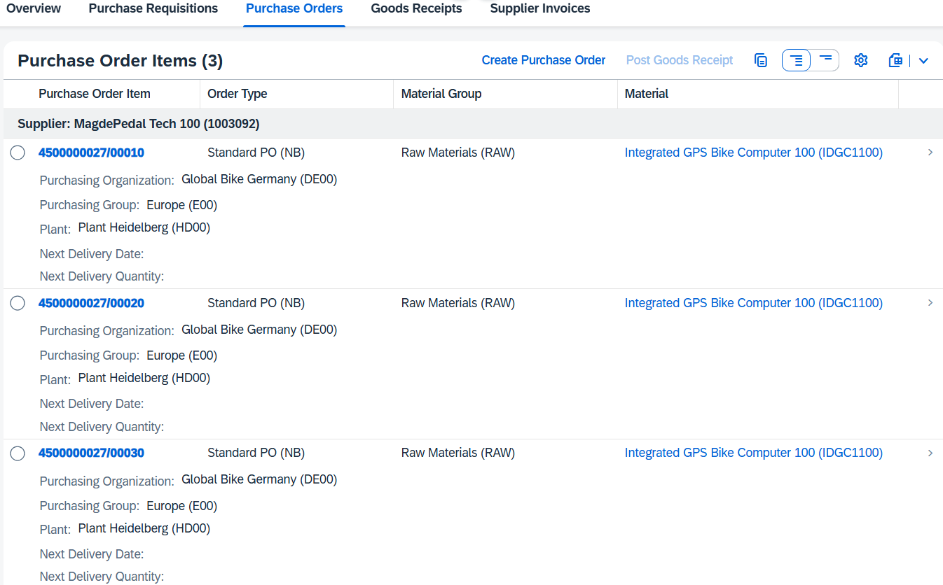
As you can see, no open quantities are displayed under Next Delivery Quantity.
Click . There, you can see the delivered bicycle computers divided by item.
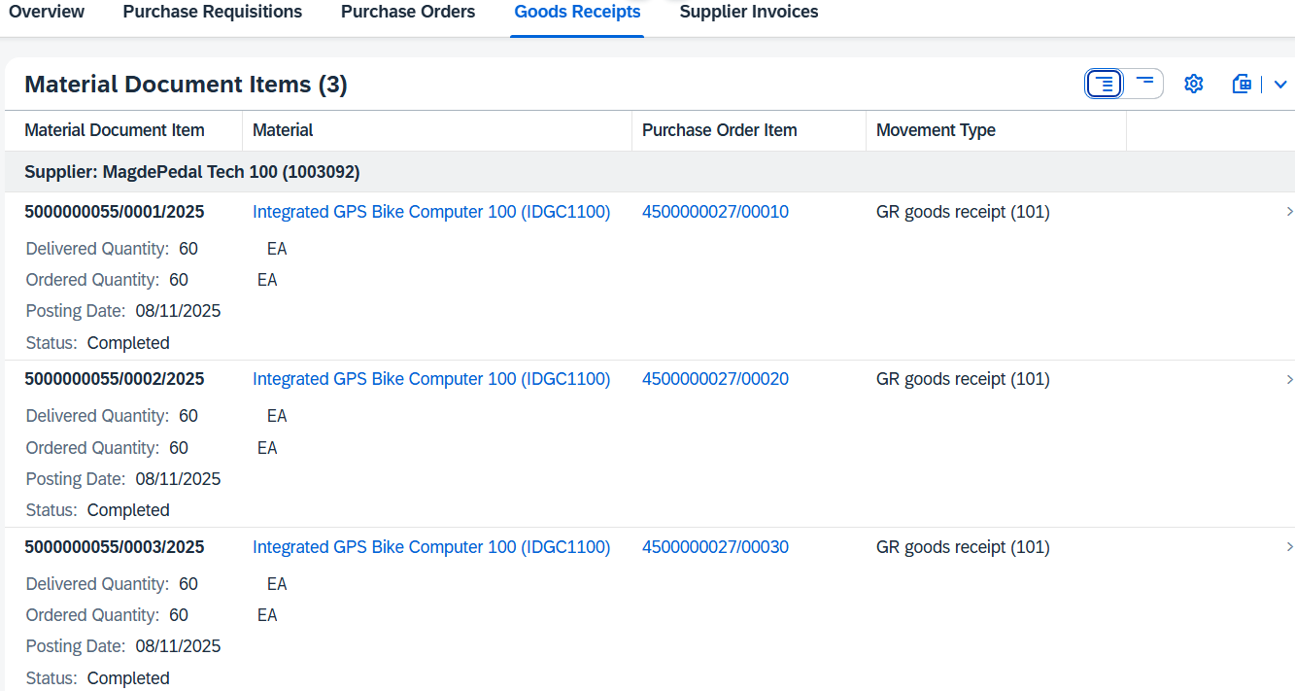
In the Supplier Invoice overview, you can see further activities that have been performed with reference to your purchase order.
Click . The invoice has been created and has the status Posted as a result of the payment.
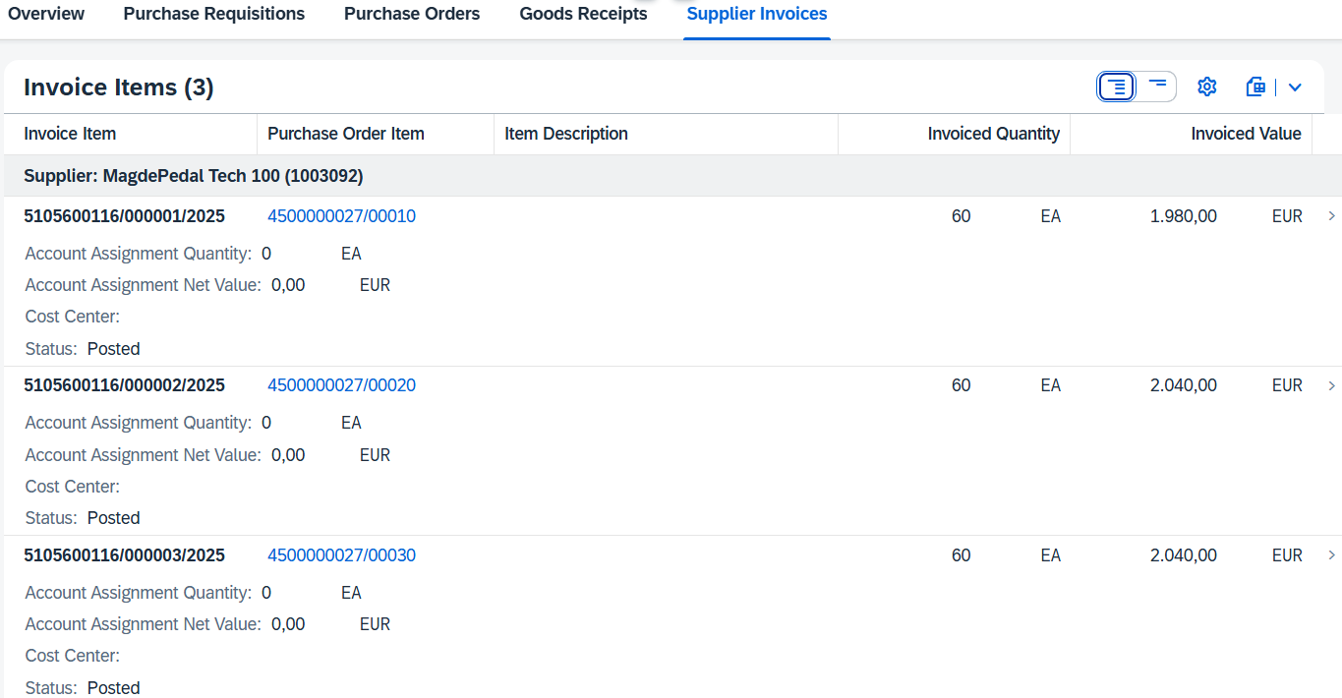
To display more information about the documents, you can click on the relevant row. This takes you to the financial document that was created when you created the supplier invoice.
Click to return to the SAP Fiori launchpad.

 | Step 31: Display Balance List and Line Item List
Task Display the balance and line item list of the general ledger.  Description Use G/L account numbers to display the activities and related balances for some accounts in your general ledger.  Name (Job) Shuyuan Chen (Head of Accounting) |  | Time 5 min
Use G/L account numbers to display the activities and related balances for some accounts in your general ledger. |  | Scenario
To display the balance and line item list, use the Balance Sheet/Income Statement app the Materials Management area in the Head of Accounting role. |  | Initial Screen
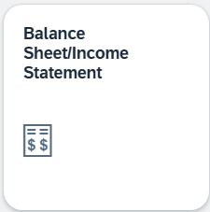
On the Balance Sheet screen, enter DE00 (Global Bikes Germany) for the company code, 0L for the ledger, and G### for the statement version. Make sure that the statement type is Normal (Actual - Actual) and the End Period is Current Period/Year and Comparison Period 01/2016. Compare your screen with the following screenshot. |  | DE00  0L  G###  Normal (Actual - Actual) Current Period/Year  1/2016
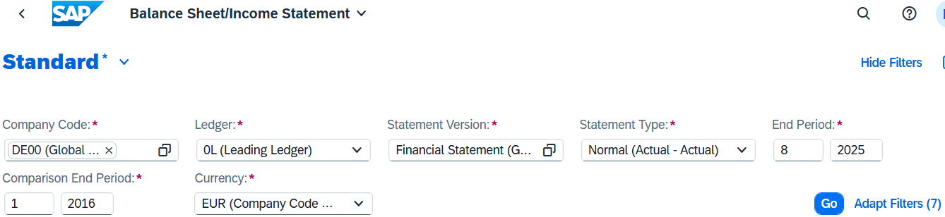
Choose . In the view, you can see all items of the accounts of Global Bikes in Germany. Expand Assets and the Intangible Assets item below.
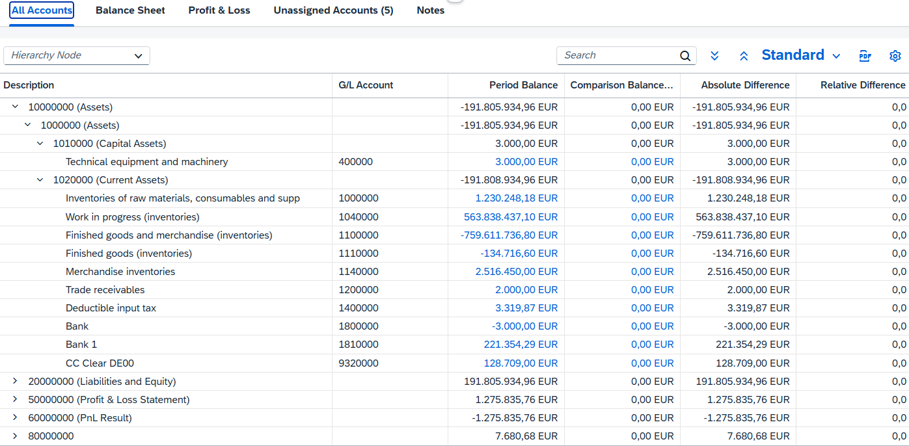
Note Since all participants in your course book to the same bank account, the number you see next to the bank account 1810000 used is different.
Note The procurement process of the bicycle computers is completed at this point.
Click to return to the SAP Fiori launchpad.
Process Progress
The procurement process of the bicycle computers is completed at this point.

Process Progress
Since the procurement process of the bike computer was completed with the previous step, the production planning process can now continue.
 | Step 32: Create Routing GCBK3### (from template)
Task Create Routing GCBK3### (from template)  Description Now also add a routing and a BOM for your material GCBK3###. Copy your material GCBK2###.  Name (Job) Jun Lee (Production Manager) |  | Time 15 min
To create the routing, use the Create Routing app in the Production Planning and Execution area in the Production Manager role. |  | Initial Screen
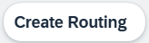
On the Create Routing: Initial Screen, enter material GCBK3### and plant HD00. |  | GCBK3###  HD00
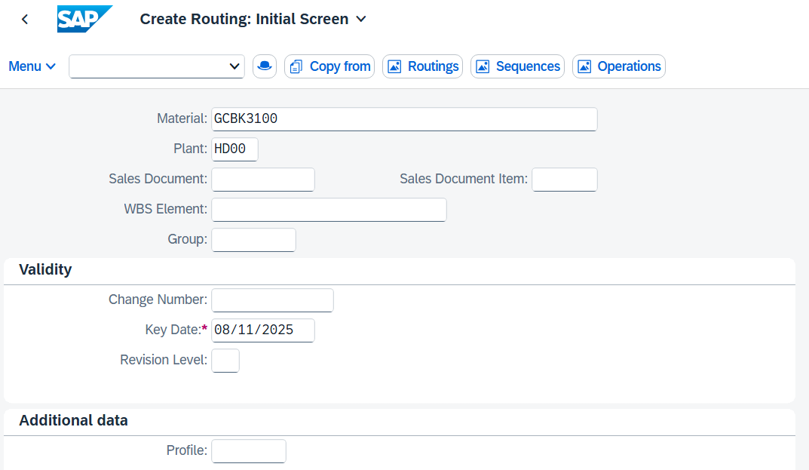
Choose 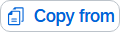.
In the dialog box that appears, select Routing and choose 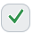. |  | Routing
In the Template Selection dialog box, enter the mountain bike GCBK2### as the material and enter HD00 as the plant. |  | GCBK2###  HD00
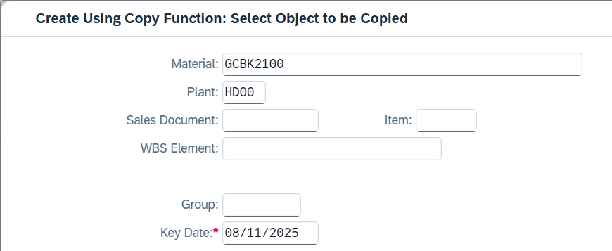
Click .
On the Create Routing: Header Data Check screen, use the F4 help for the Overall Status field and select 4 (Released (General)). |  | 4 (Released (general))
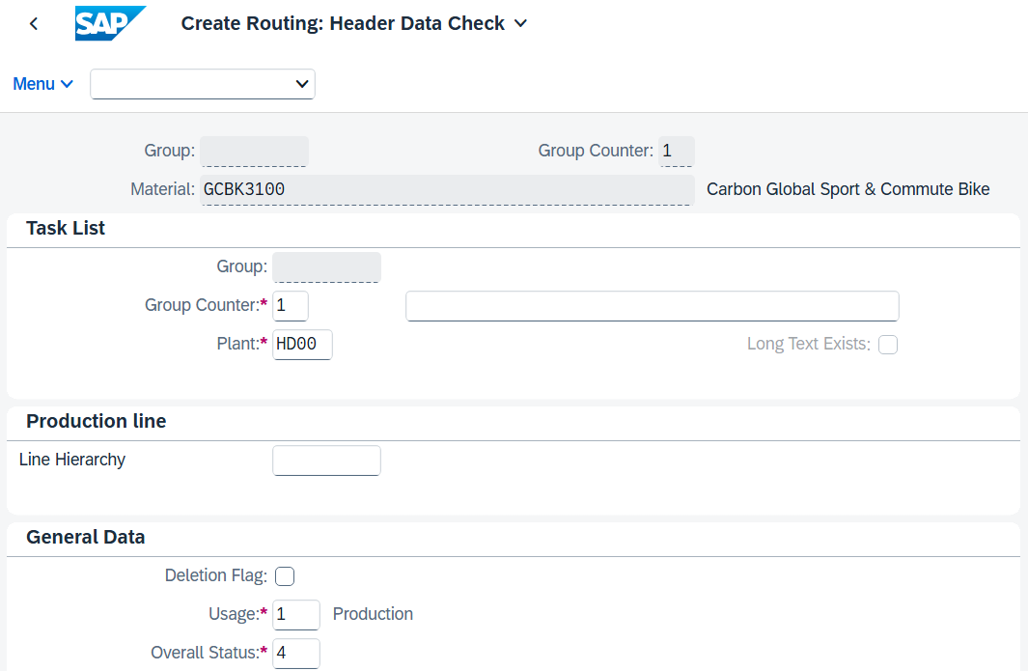
Press Enter.
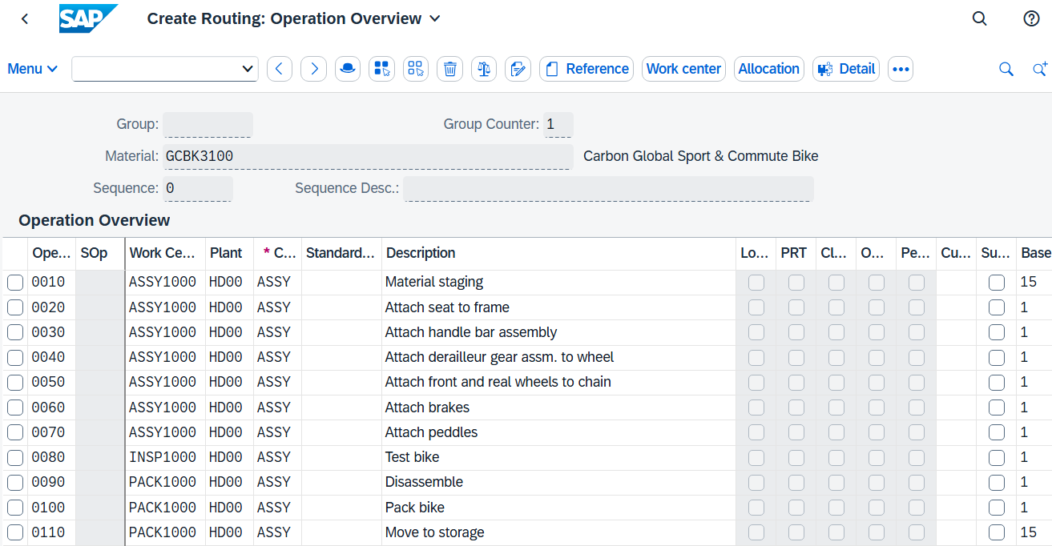
Choose 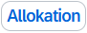 to display a list of all components. If the button is not displayed directly in the top bar, you can find the entry in the pull-down menu under More Allocation.
Since a BOM does not yet exist for your material, the system now asks you whether you want to create it. Confirm the message Material component assignment with Yes. |  | Yes
In the Usage field, enter 1 (Production). |  | 1 (Production)
Again, use the BOM of material GCBK2### as a template. Click .
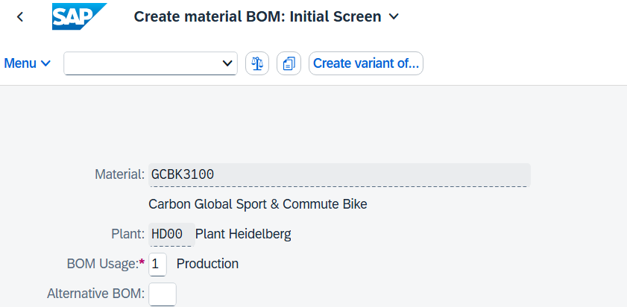
In the Copy from dialog box, enter material GCBK2###. And click
Select all BOM items using the button  and then choose .
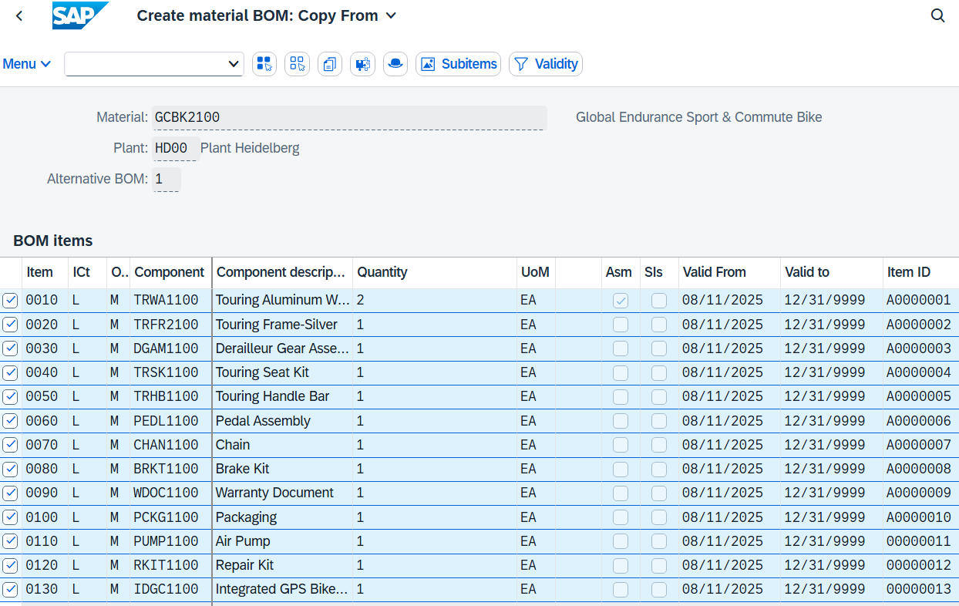
Change the component of the first line from TRWA1### to CCWA1### (Carbon Conposite Wheel Assembly). Confirm with Enter. |  | CCWA1###
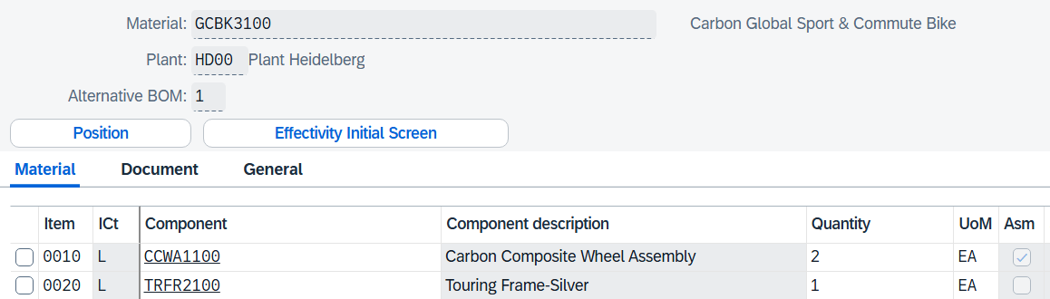
Click 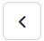 (back).
You get an overview of all used components, but they are not currently assigned to a specific activity.
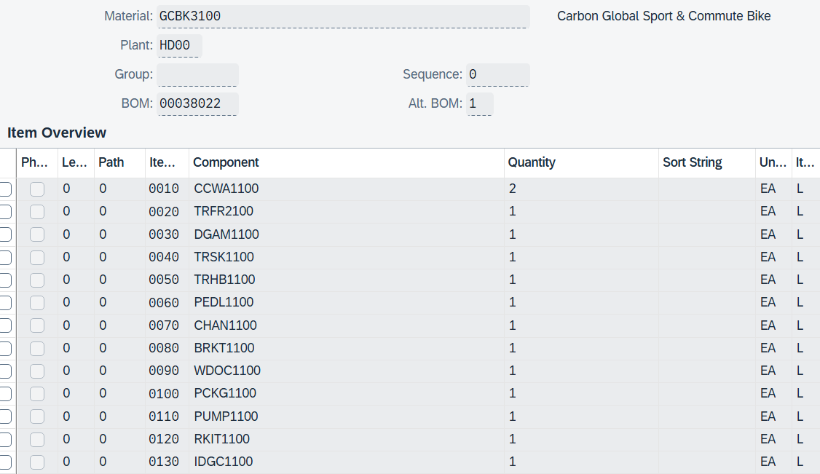
Select the line of component CCWA1### and press 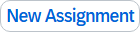. Alternatively, you can find the entry in the pull-down menu under More Reassign.
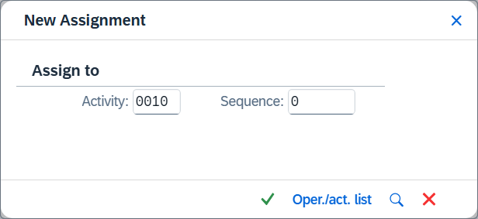
Assign your component to activity 0010. Press |  | 0010
You can now see that the component has been assigned to operation 0010.
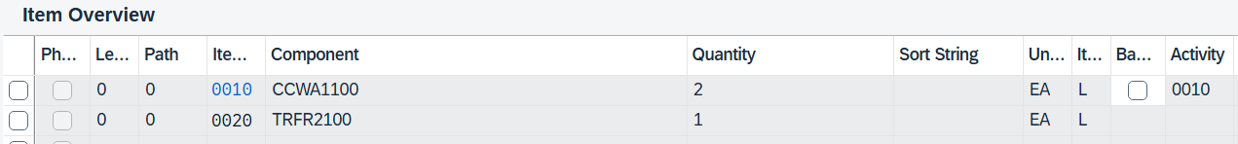
Repeat this process for all other components and assign them to the operations specified below.
The last assignments belong to the same transaction. Here, the affected components can also be selected together and assigned to the operation together.
Operation | Component
0010 | CCWA1### | 10 | CCWA1###
0020 | TRFR1### | 20 | TRFR1###
0040 | DGAM1### | 30 | DGAM1###
0020 | TRSK1### | 40 | TRSK1###
0030 | TRHB1### | 50 | TRHB1###
0070 | PEDL1### | 60 | PEDL1###
0050 | CHAN1### | 70 | CHAN1###
0060 | BRKT1### | 80 | BRKT1###
0100 | WDOC1### | 90 | WDOC1###
0100 | PCKG1### | 100 | PCKG1###
0100 | RKIT1### | 110 | RKIT1###
0100 | PUMP1### | 120 | PUMP1###
0030 | IDGC1### | 130 | IDGC1###

Finally, each component is assigned to an activity.
Now set the checkmark for a backflush for all components.
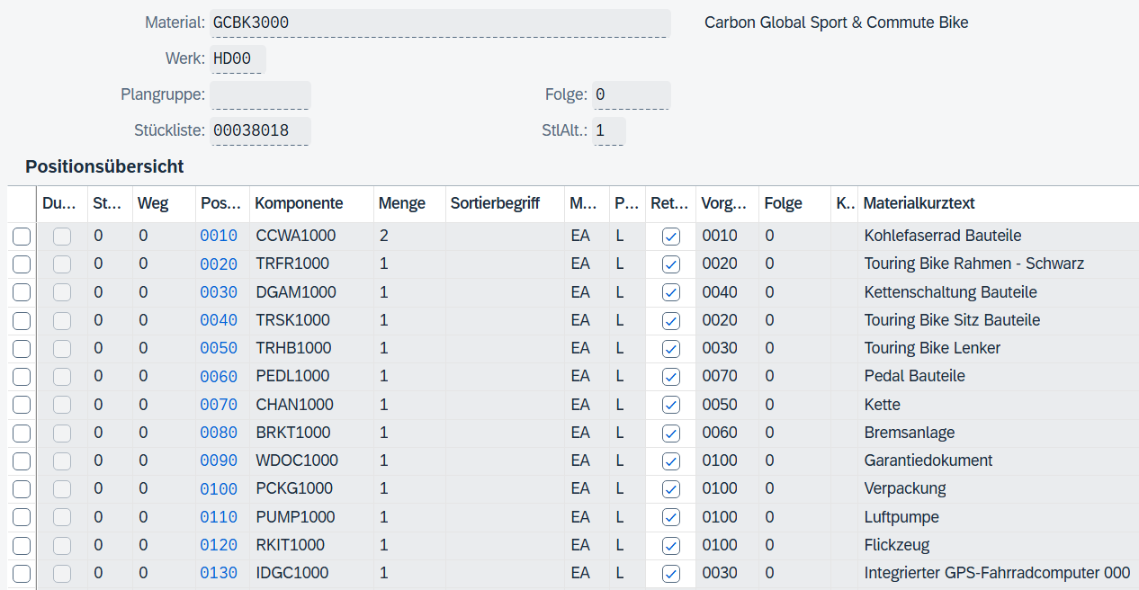
Apply your changes with . The system displays a message that the routing has been saved.
Click to return to the SAP Fiori launchpad.

 | Step 33: Create Production Version
Task Create Production Version  Description To convert the planned orders of the bicycles into production orders for the production planning process, the view of work scheduling must be added to the material master and the production version must be set. In this step, generate the production version.  Note The production version has already been generated for materials GCBK1### and GCBK2### by dispatching the production version in step 12. A production version was automatically created and inserted into the corresponding views of the material master.  However, since the MRP run (step 13) for material GCBK3### should be simplified, the production version of this material is only added manually at this point in an alternative way. You could also use the Schedule Mass Creation of Production Version app again.  Name (Job) Jun Lee (Production Manager) |  | Time 5 min
To enter the production version in the material master, use the search bar to find and execute the app Manage Production Versions - C223. |  | Initial Screen
Note A production version determines which BOM and routing are used to produce an article. It is important when converting planned orders into production orders because it enables a precise selection of manufacturing processes.
In the Production Version: Mass Processing view, enter HD00 as the plant and GCBK3### as the material. Press Enter. |  | HD00  GCBK3###
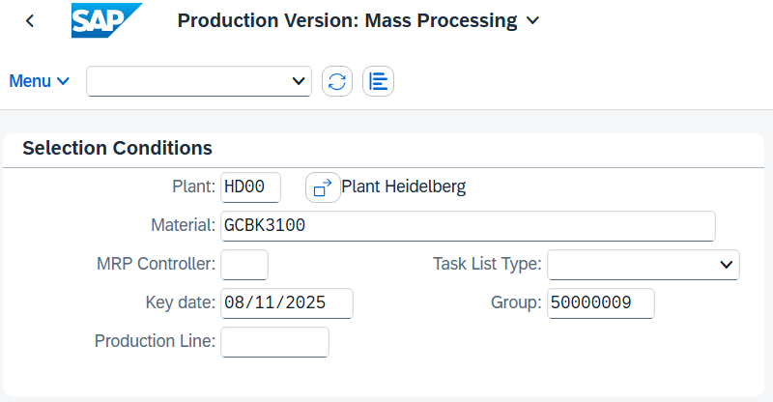
In the Production Version table, enter material GCBK3###, as production version 0001, as text for production version as GCBK3### production version and as Valid from today and Valid to 31.12.9999, and To lot size 99.999.999,000. |  | GCBK3###  0001  GCBK3### production version  Today  31.12.9999  99,999,999,000
Choose Enter to confirm your entries.
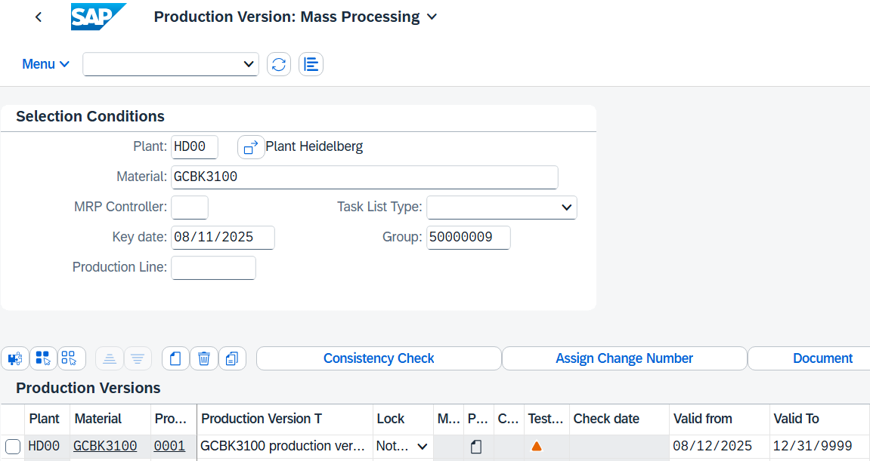
Click .
Confirm the message whether you want to save the production version by choosing Yes.
Click to return to the SAP Fiori launchpad.

 | Step 34: Display Material
Task Display the material master of your GCBK3###.  Description Display the material master of your GCBK3### and check whether the previously generated production version was added automatically.  Name (Job) Sergey Petrov (Warehouse Employee) |  | Time 5 min
To display the material, use the Display Material app in the Materials Management area in the Warehouse Employee role. |  | Initial Screen
Note If the app is not displayed, search for it using the search bar .
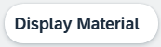
In the Display Material (Initial Screen) view, for material enter GCBK3###. Click . |  | GCBK3###
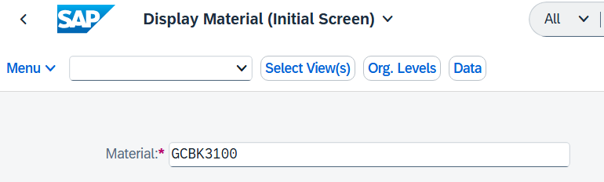
Select the MRP 4 and Work Scheduling views. Confirm with . |  | MRP 4 Work scheduling
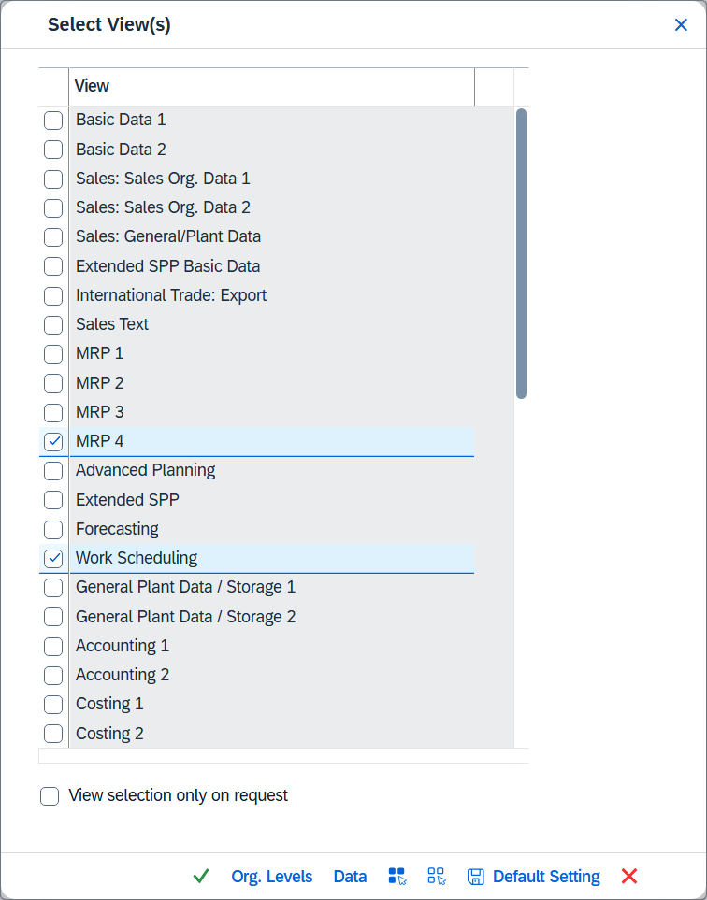
In the Organizational Levels dialog box, enter HD00 as the plant and choose Enter. |  | HD00
In the Work Scheduling view and the MRP 4 view, check that the production version is set.
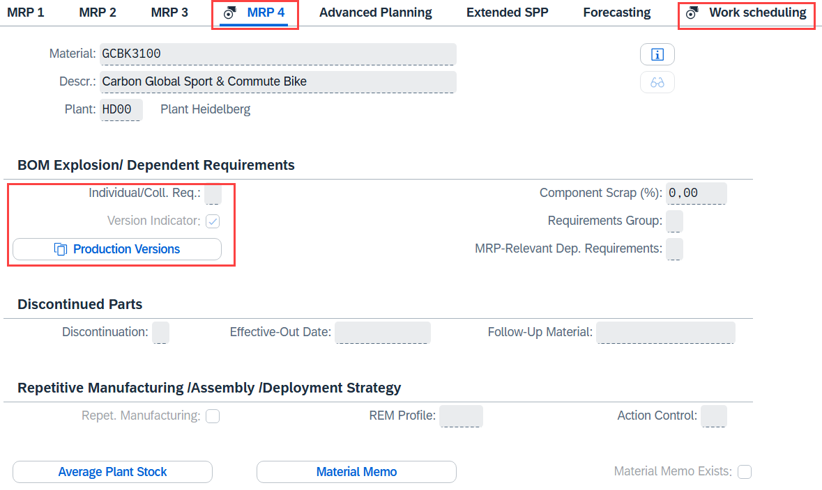
Click 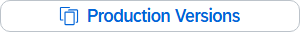. Compare the entries in the dialog box that appears with the following screenshot.
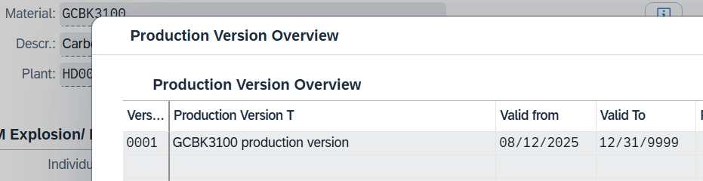
Click to return to the SAP Fiori launchpad.

 | Step 35: Planned Order in Production Order
Task Convert a planned order into a production order.  Description Convert the planned orders created by MRP for your sales order into a production order.  Do not yet use the remaining planned orders.  Name (Job) Lars Iseler (Shop Floor Worker 2) |  | Time 15 min
To convert a planned order to a production order, use the Monitor Stock/Requirements List app again in the Production Planning and Execution area in the Shop Floor Worker role. |  | Initial Screen
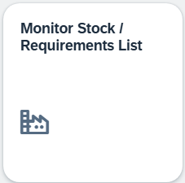
On the Individual access tab page, enter your material GCBK1### and plant HD00 and choose . |  | GCBK1###  HD00
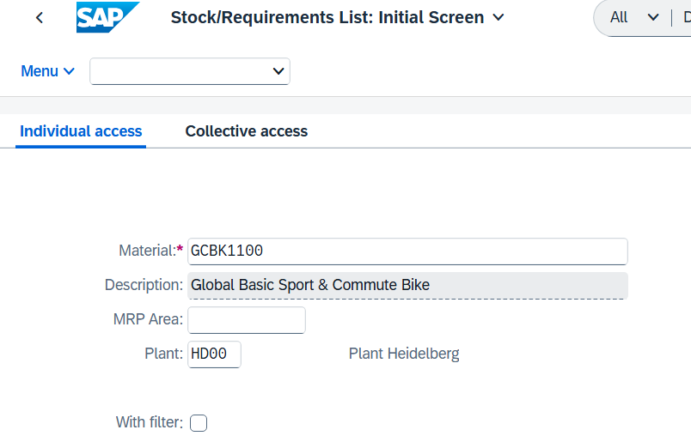
Choose at the beginning of the line of the planned order that is assigned to your sales order (the planned order has the same date as the sales order).
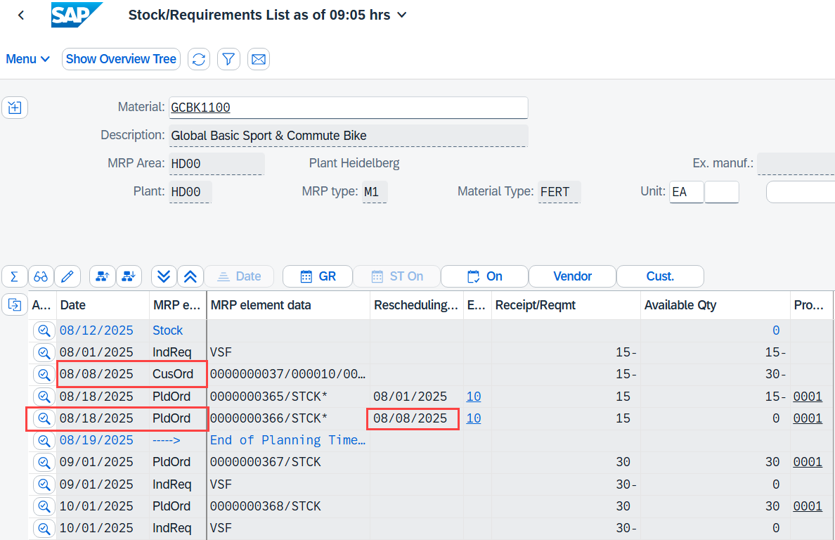
The system displays a dialog box with the details of the order.
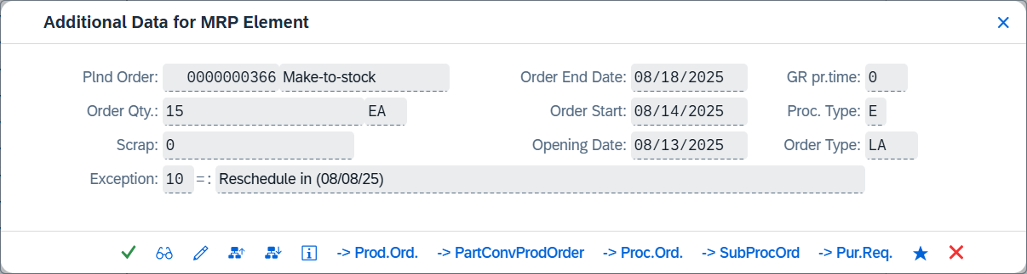
Press 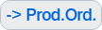 to convert the planned order into a production order.
Accept the upcoming Message with .
The system creates a temporary production order, identified by the generic order number.
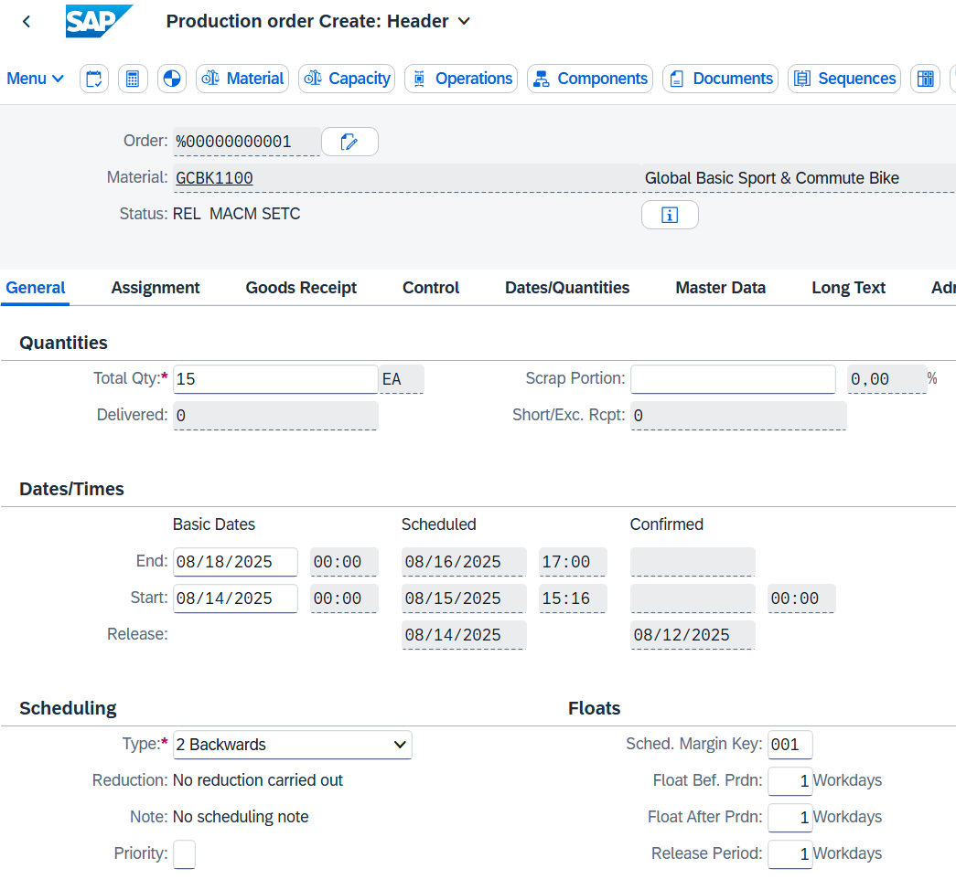
The status of your order is REL, SETC, and MACM.
Note Click for more information about the abbreviations.
You can see that the production order has been released automatically by the system, a settlement rule has been entered, and the material has already been checked and commited.
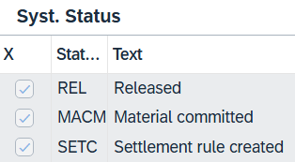
Please click on 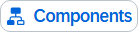.
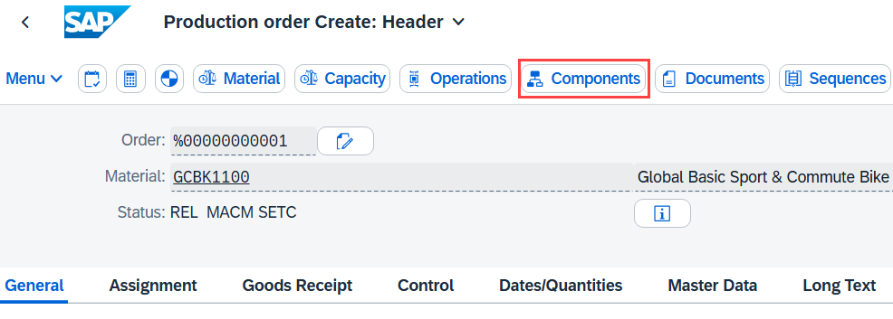
Make sure that the following storage location is maintained for all components:
Component | Storage Location | Plant
TRWA1### | SF00 | HD00
TRFR1### | RM00 | HD00
DGAM1### | RM00 | HD00
TRSK1### | RM00 | HD00
TRHB1### | RM00 | HD00
PEDL1### | RM00 | HD00
CHAN1### | RM00 | HD00
BRKT1### | RM00 | HD00
WDOC1### | RM00 | HD00
PCKG1### | RM00 | HD00
RKIT1### | TG00 | HD00
PUMP1### | TG00 | HD00
IDGC1### | RM00 | HD00

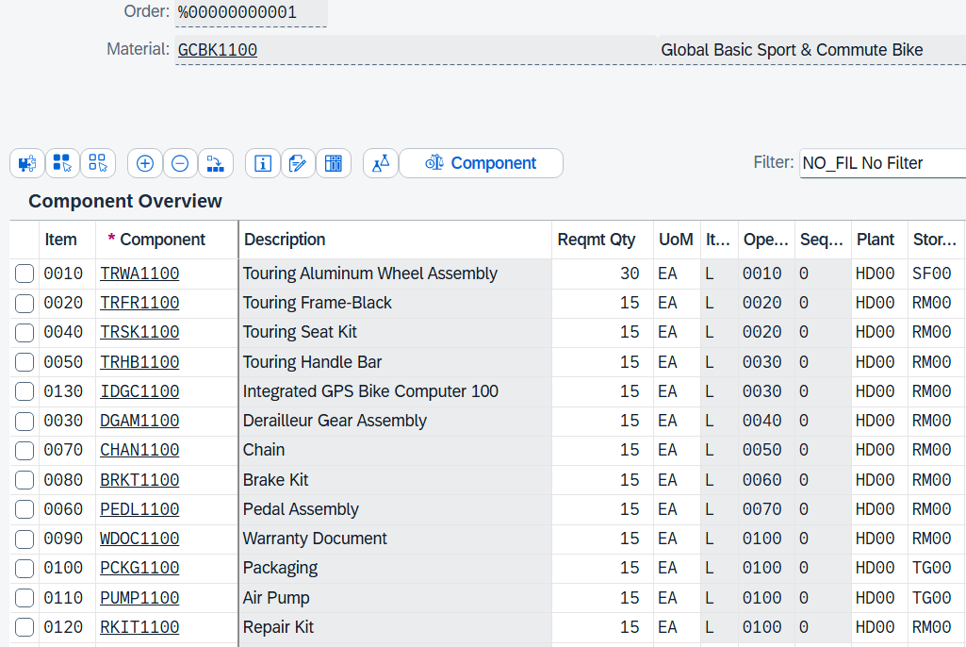
Click 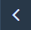 to return to the production order header. Complete the conversion by pressing .
The system returns you to the stock/requirements list and outputs the production order number of the created order.
Choose 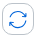 at the top of the screen to refresh the list. The planned order PldOrd that you had chosen now exists as production order PrdOrd. |  | PldOrd  PrdOrd
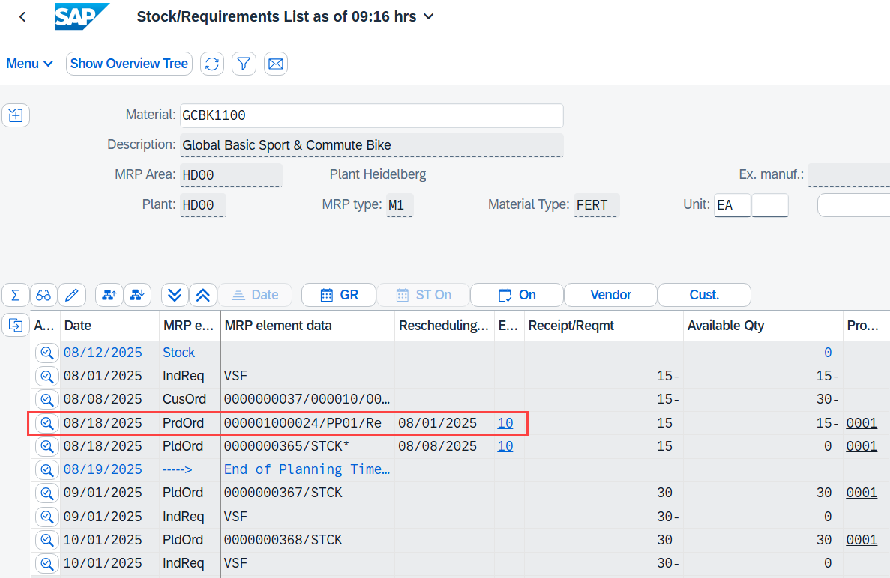
Repeat this step for your bike GCBK2###. |  | GCBK2###
Repeat this step also for bike GCBK3###. |  | GCBK3###
For the GCBK3###, only the planned order that is assigned to the sales order exists. Convert it to a production order.
Choose at the beginning of the line of the planned order.
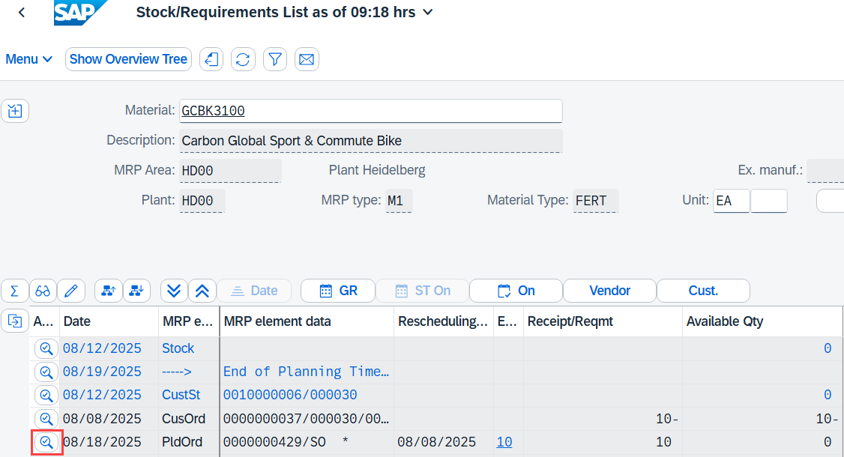
Press (Change Element) to add the production version generated in the previous step to your planned order.
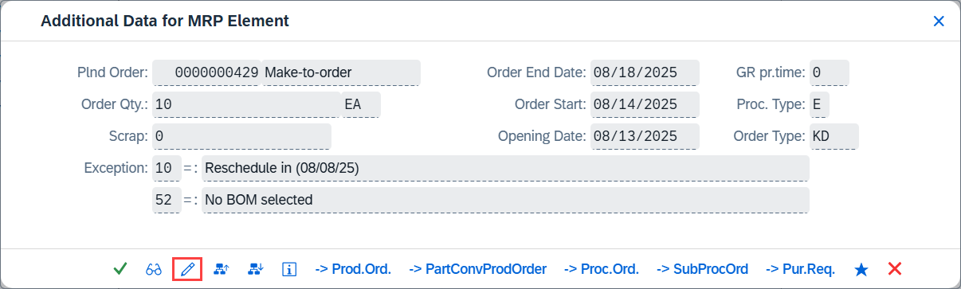
In the Change Planned Order: Individual customer order view, enter 0001 as the production version and click . |  | 0001
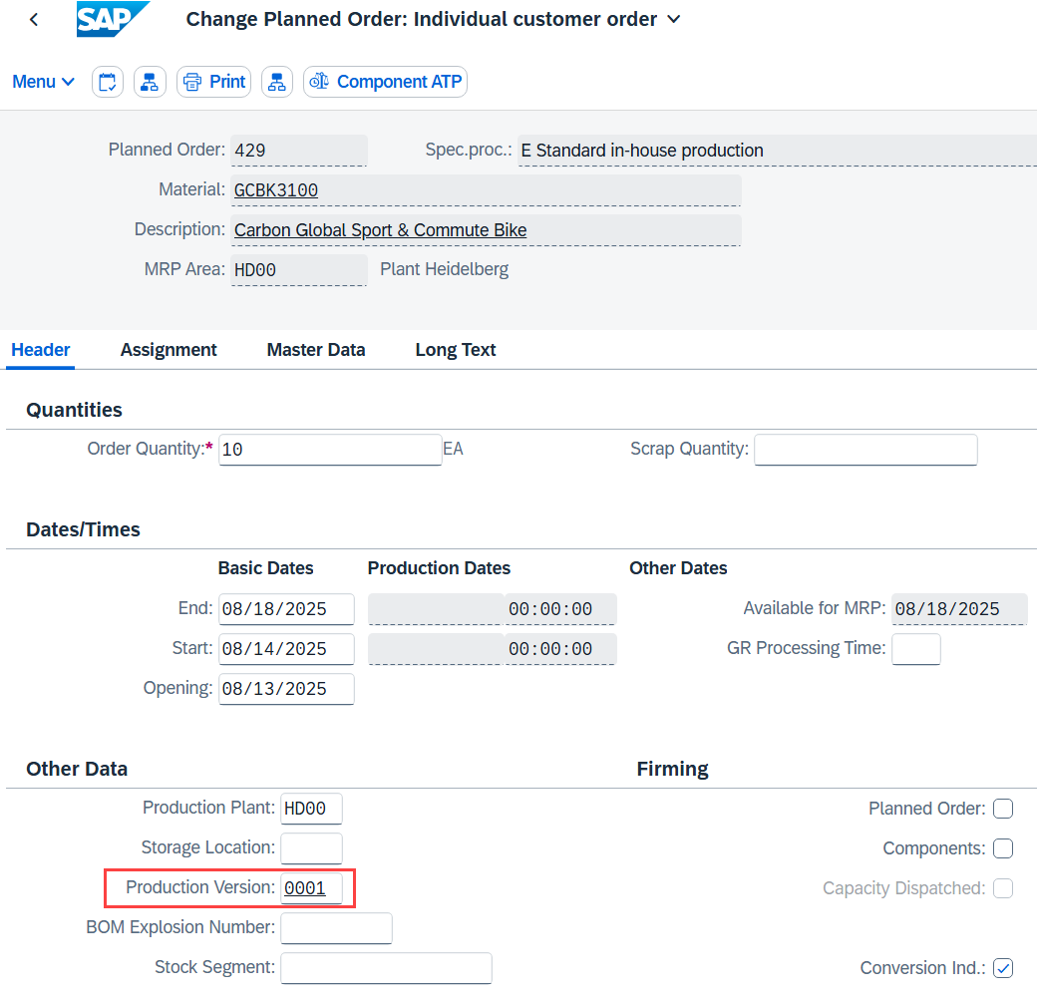
Back in the stock/requirements list of your material GCBK3###, choose again at the beginning of the line of the planned order.
Press to convert the planned order into a production order.
Confirm the incoming message by clicking on 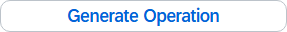.
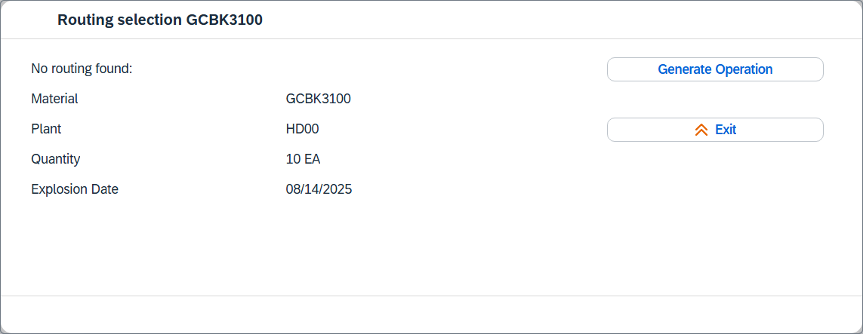
In addition, confirm the subsequent message with Enter.
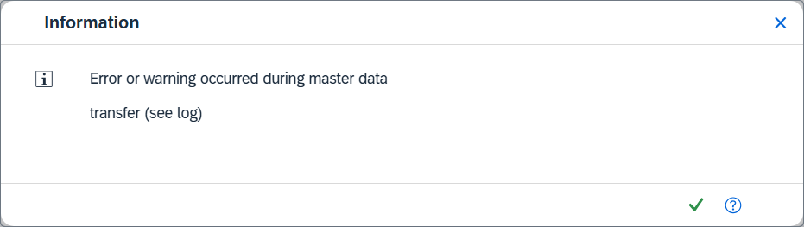
You are now in a temporary production order.
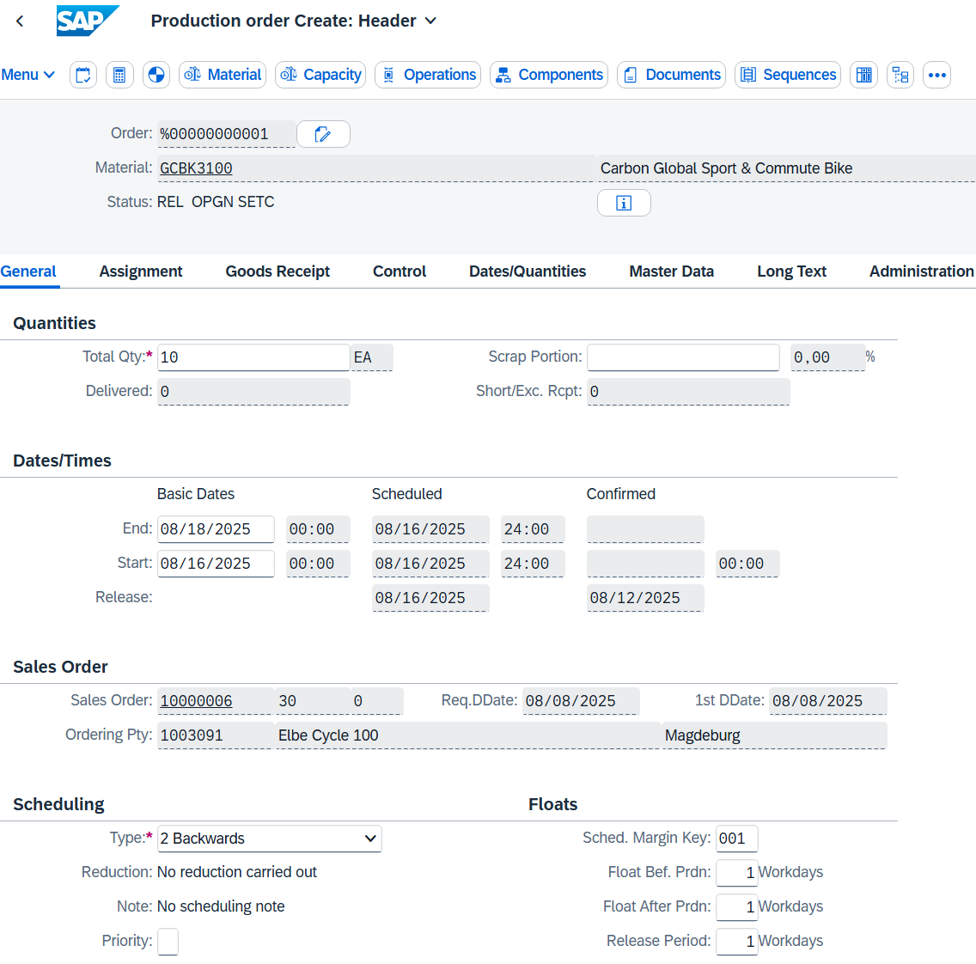
Navigate to the "Assignment" tab page. As you can see, the production order is explicitly assigned to a sales order. The reason for this is the setting of strategy group 20 (make-to-order production).
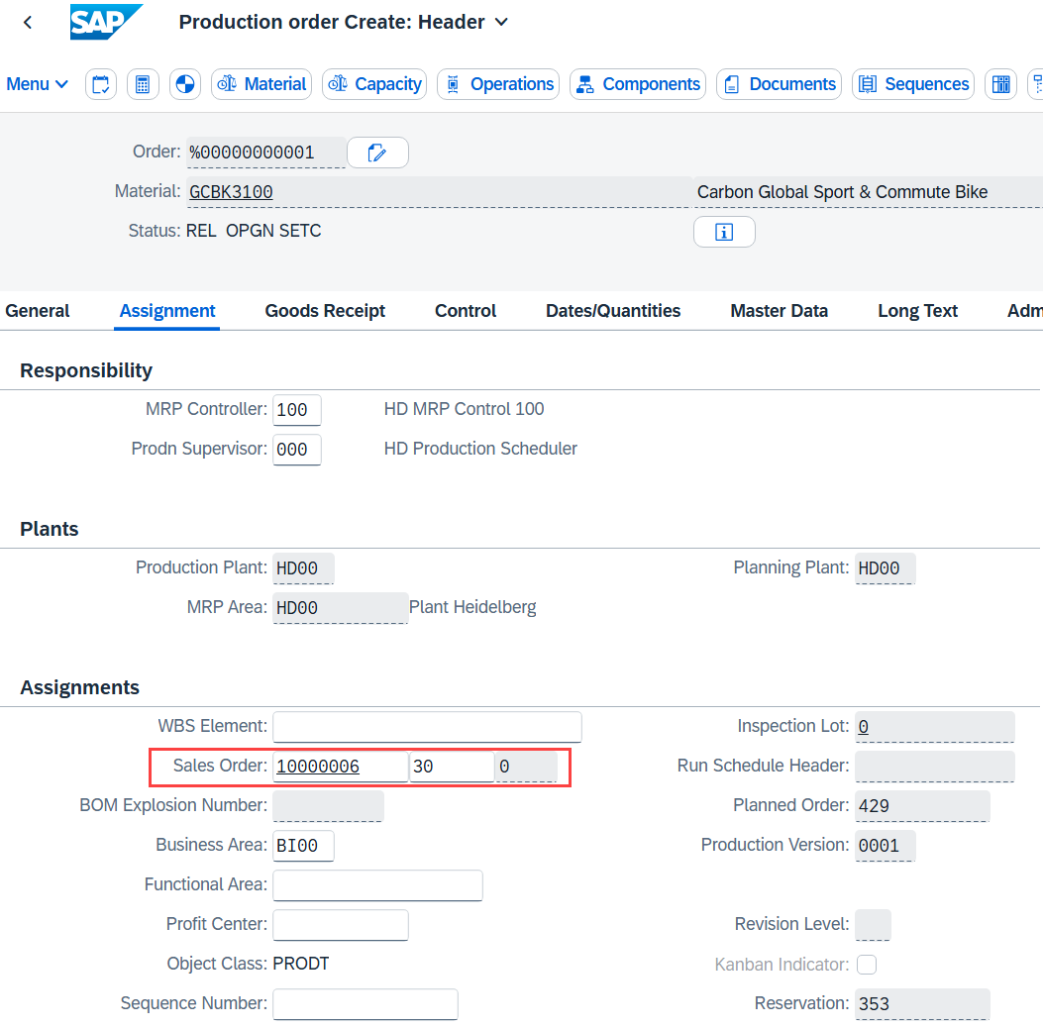
Click .
Click to return to the SAP Fiori launchpad.

 | Step 36: Display Production Order
Task Display the production order status.  Description Display the current production order with reference to the order status.  Name (Job) Michael Brauer (Shop Floor Worker 4) |  | Time 10 min
To display the production order status, use the Manage Production Orders app in the Production Planning and Execution area in the Shop Floor Worker role. |  | Initial Screen
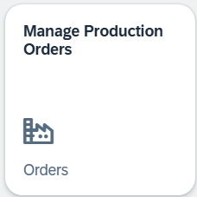
When you first open the app, you receive a welcome message informing you to select an area of responsibility. If you confirm this with , the system displays another dialog box.
No plant is currently assigned to you.
In the Production Supervisors area, select the Heidelberg plant by setting the status of the responsibility to green. (set to green).
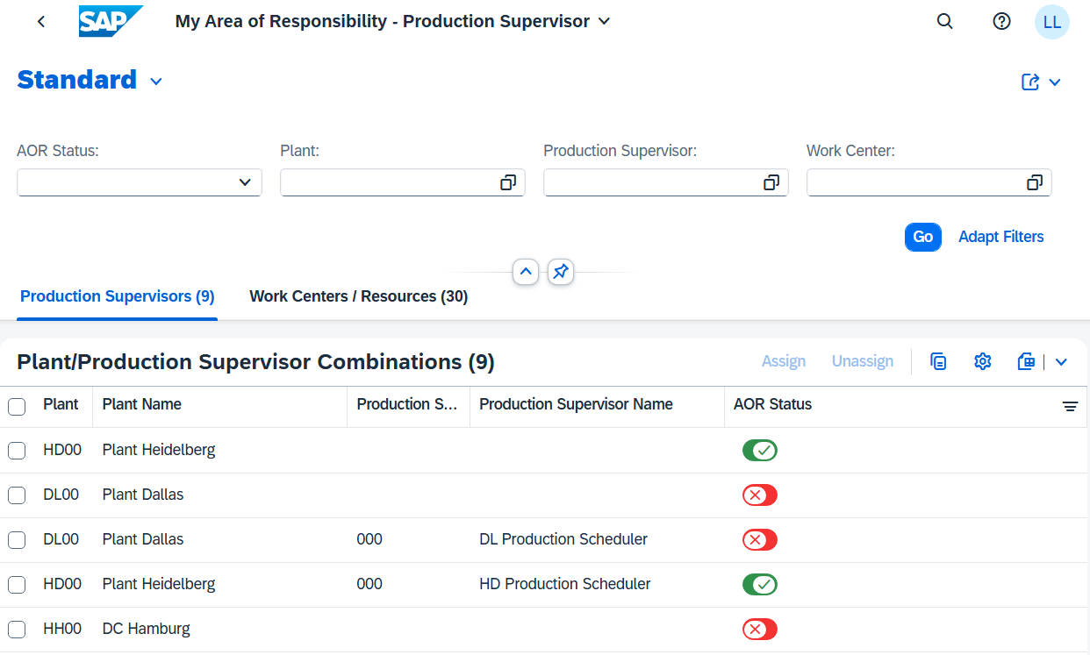
Navigate to the Work Centers/Resources tab page and activate the responsibilities in the Heidelberg plant (HD00) for HD Production (ASSEMBLY), HD Final Control (INSPECT), and HD Packaging (PACKING).
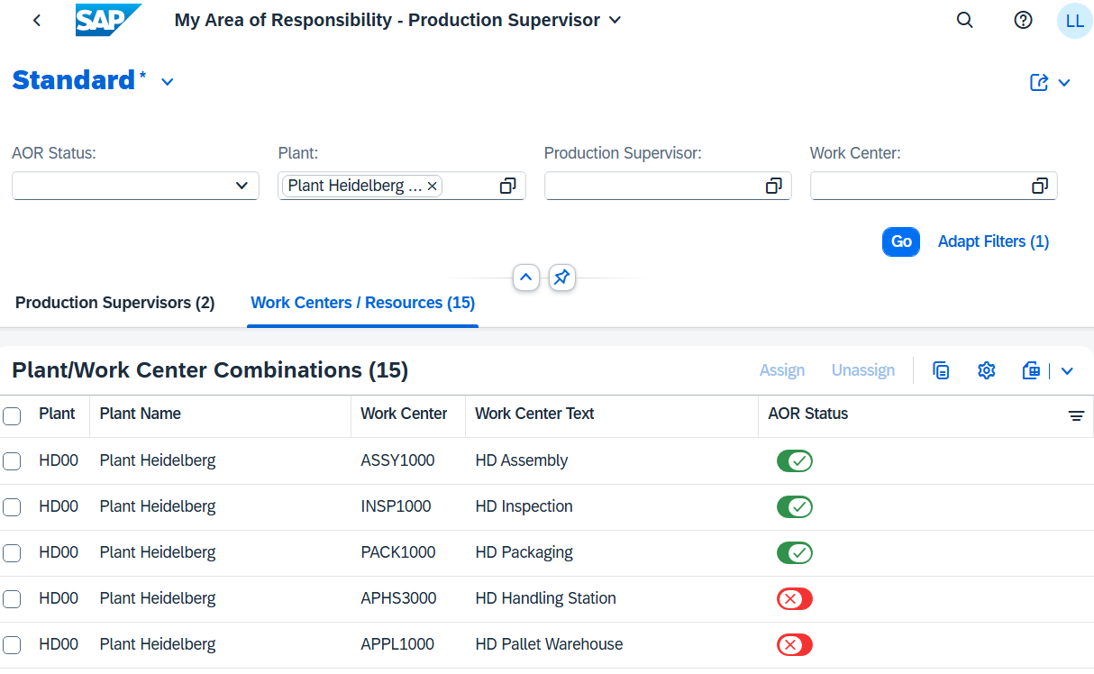
Your area of responsibility is now maintained. The values are saved automatically here. Go to the SAP Fiori launchpad and open the Manage Production Orders app again.
The system displays an overview of all existing orders. Depending on the progress of your course, there may be several production orders with different processing statuses.
In the Material Number field, enter your material GCBK1### and choose to display only your order. |  | GCBK1###
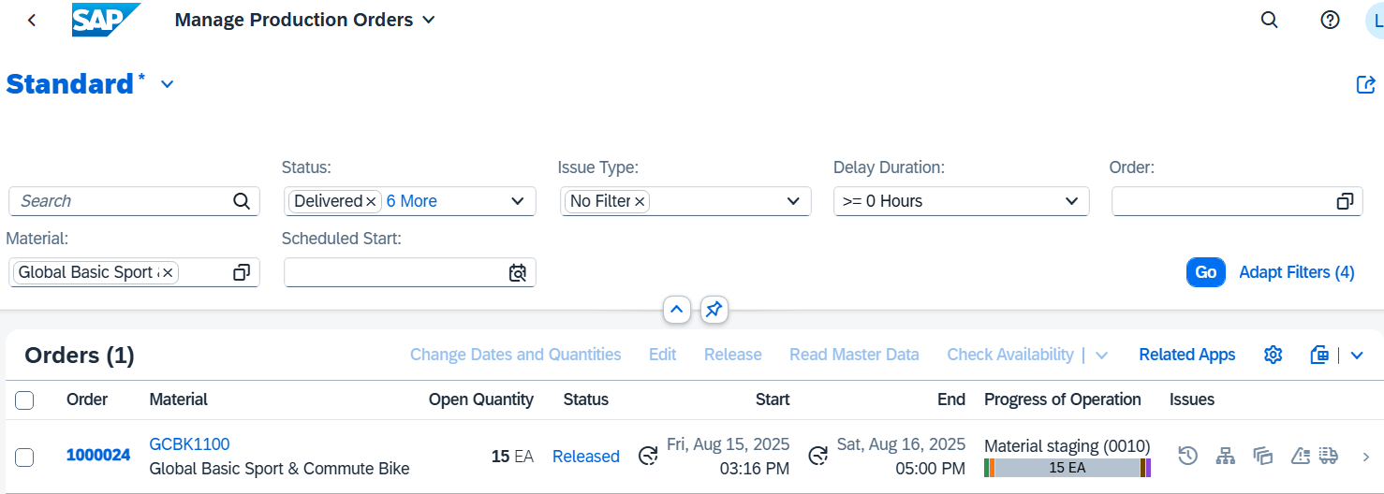
The tabular overview contains various information about your order, such as the current status and the current processing status.
For more information, select the entry and you will be directed to the details of the production order.
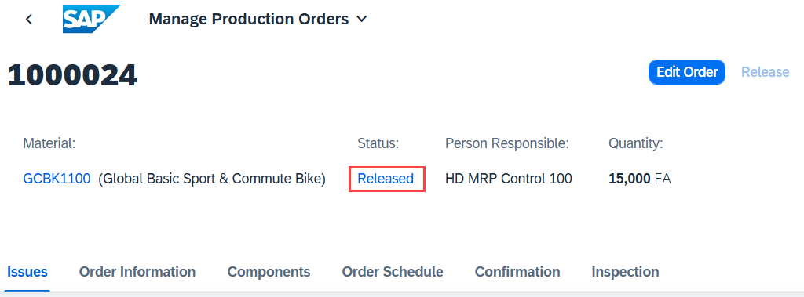
Click the status for more information. You can see that your production order still has the same status as when you created the production order.
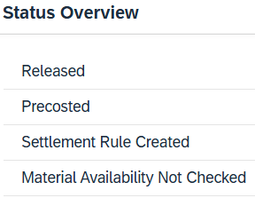
Now choose the "Components" tab page. The screen scrolls to the appropriate location.
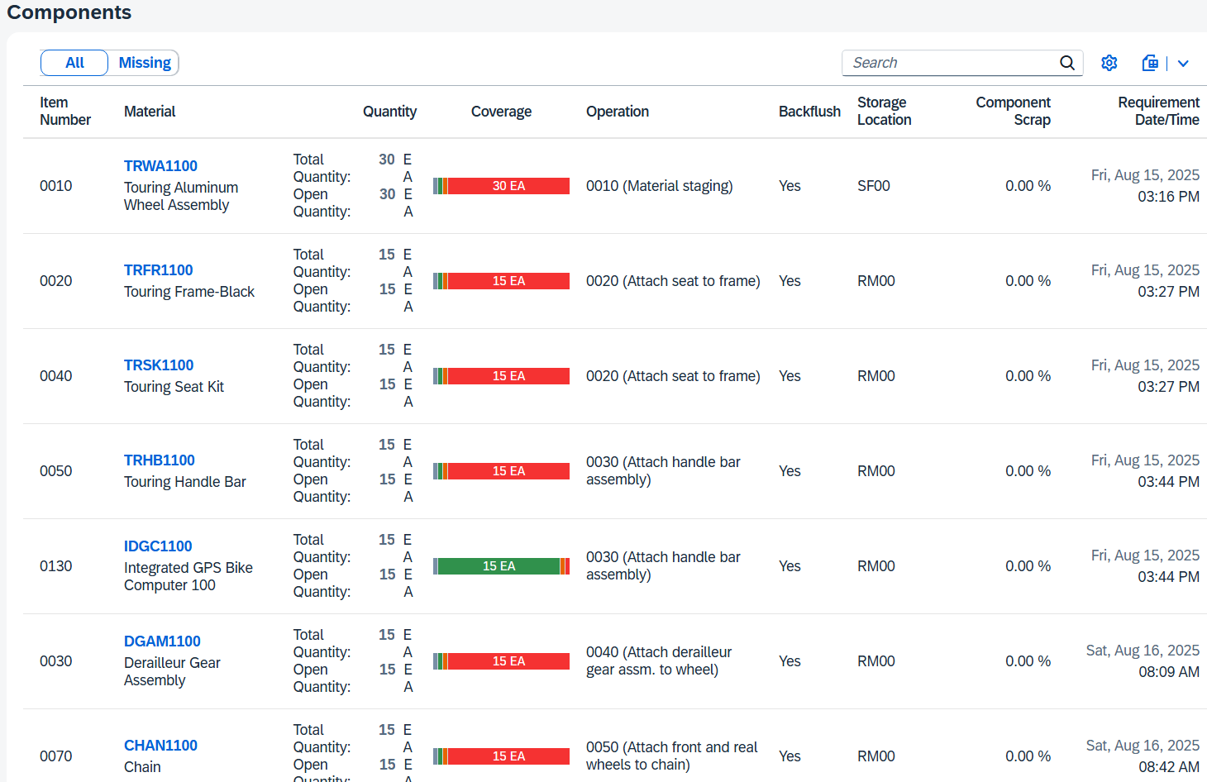
The quantities of the components are still open because they are not used until the production order is processed. However, it is important to check that no components have open quantities and that all availabilities are confirmed.
It is not necessary to post the goods issue beforehand because the components are posted automatically by a backflush. This occurs during the confirmation of the work step to which the respective material component is assigned.
Now click on the Order Schedule tab page. The screen scrolls to the appropriate location.
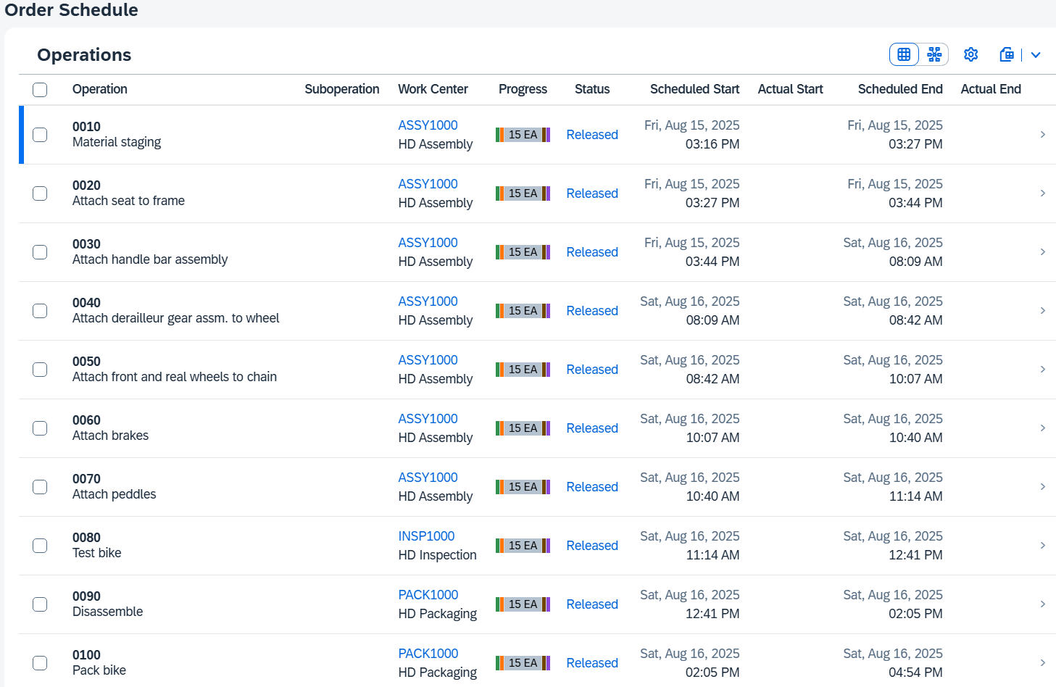
You see the routing of the production order and the current status for each work step. Currently, all work steps have been released but not yet started.
Click on the first step 0010 — Material staging to access its details.
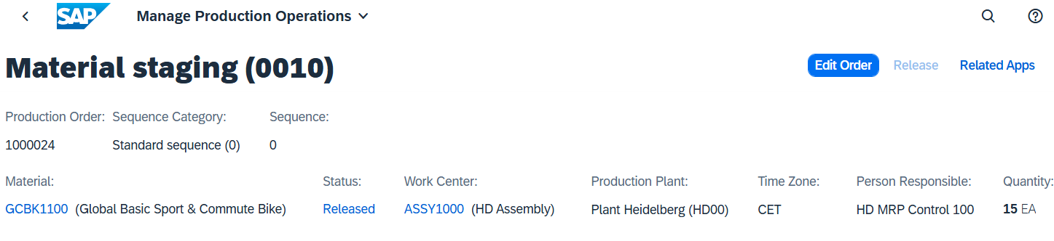
Click the Components tab. The screen scrolls to the appropriate location.
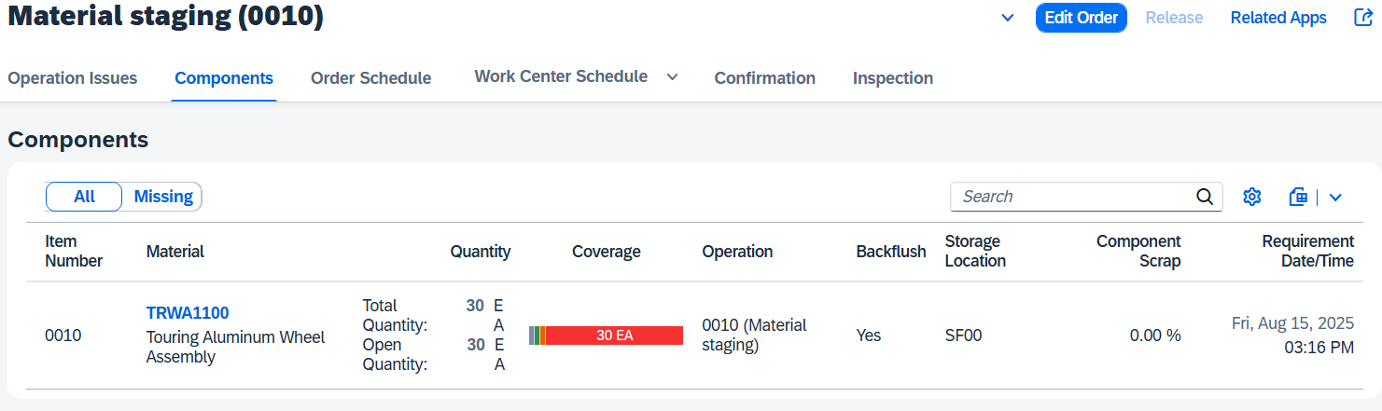
Here you can see which component is assigned to a work step.
You can now also display the production order for your second bike GCBK2### by repeating these steps.
Note There are no components defined for your bike GCBK3### for the production order. This is because the material did not yet have a routing, a BOM, or a production version in material requirements planning (step 13), which means that no requirements planning was carried out for its dependent requirements (components). The task list, BOM, and production version for material GCBK3### were added subsequently to be able to convert the planned order into a production order.
The reason for this process is the simplification of the case study process. At this point, reservations of the components would otherwise be created separately for the sales order, whereby all components would have to be procured again for the sales order.
Click to return to the SAP Fiori launchpad.

 | Step 37: Confirm Partial Production Completion
Task Confirm Partial Production Confirmation  Description While assembly is in progress for the current production order, part of the successfully completed operations and the quantity of finished goods already produced can be confirmed.  Name (Job) Michael Brauer (Shop Floor Worker 4) |  | Time 5 min
In the Production Planning and Execution area, in the Shop Floor Worker role, use the Enter Production Order Confirmation app to report the completion of a production order. |  | Initial Screen
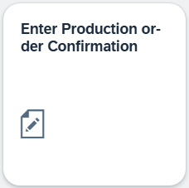
Determine your order number. Click in the Order field and choose the value help icon . In the dialog box for searching for production orders by material and routing, switch.
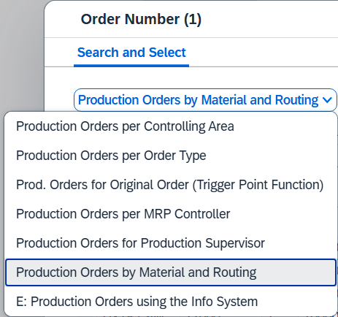
Enter your material number GCBK1### and click to execute the search. Select your order and then click 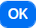. |  | GCBK1###
Your order number is added to the initial screen. Press  to continue.
A partial confirmation is now carried out on the Enter Confirmation for Production Order: Actual Data screen. Change the confirmation type to Partial confirmation, deselect Clear Open Reservs. and enter 10 of the planned quantity to be confirmed as yield quantity. |  | Partial Confirmation  Deselect clear open Reservations  10
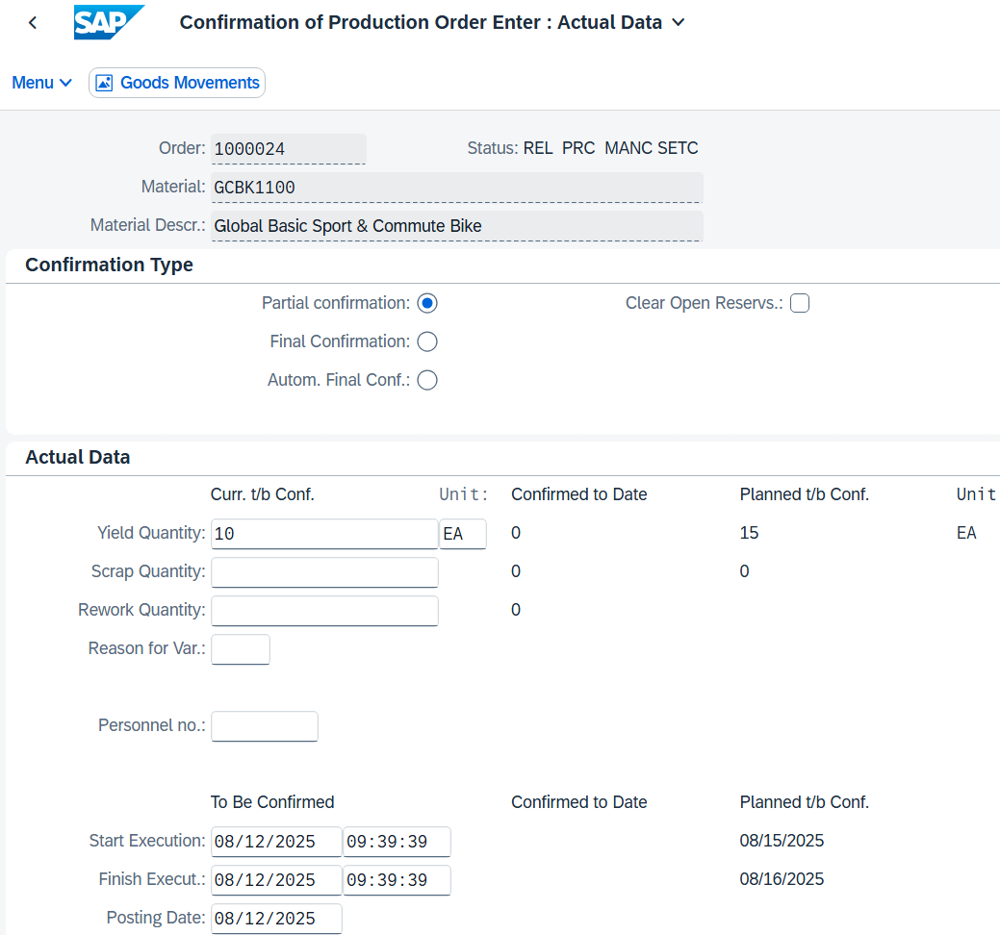
Press to save the confirmation.
Note If you receive failed goods movements at this point, you can use the ‘/nCOGI’ transaction to check where the problem with the goods movement lies.
To enter transactions in SAP Fiori, activate the OK field via Menu Settings Interaction Design Visualisation Header Area Select Show OK Code Field
Open transaction ‘/nCOGI’, select the line with the incorrect goods movement, and then click  .
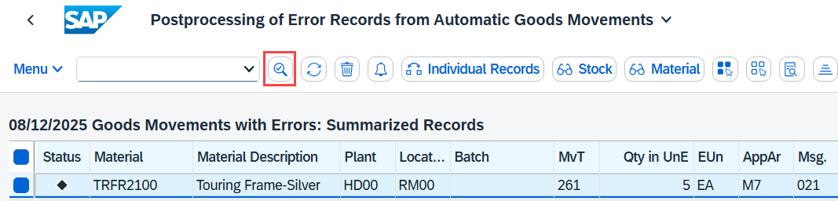
Now scroll to the right to the ‘Error text’ line. Here you will find a note explaining what caused the incorrect goods movement.
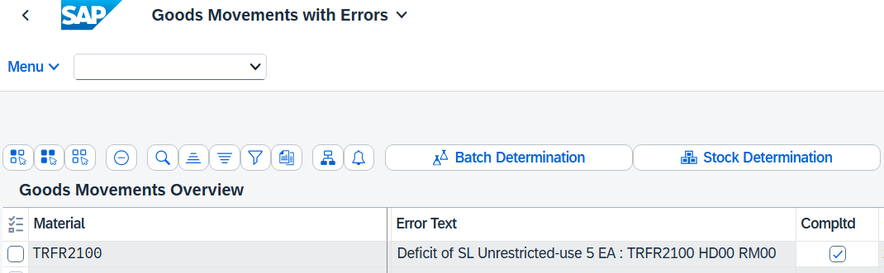
In our example, the incorrect goods movement was caused by insufficient freely usable stock of the material.
You can solve the problem by using transaction ‘/nMIGO’ to post a goods receipt (Other) with the missing quantity for the corresponding material in the corresponding plant and storage location.
Then return to transaction ‘/nCOGI’, select the line with your incorrect goods movement and click on  (refresh).
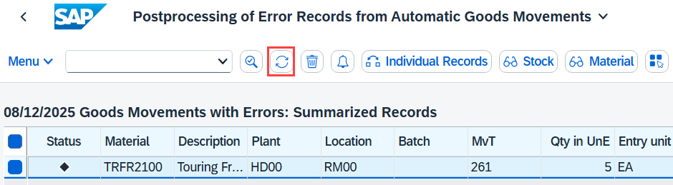
The incorrect goods movement should now have disappeared. You can now continue with the next step of the case study.
Click  to return to the SAP Fiori launchpad.

 | Step 38: Check Production Order
Task Review Production Order.  Description Display your production order and check its current status after the partial confirmation from production.  Name (Job) Michael Brauer (Shop Floor Worker 4) |  | Time 5 min
To display the production order status, use the Manage Production Orders app in the Production Planning and Execution area in the Shop Floor Worker role. |  | Initial Screen
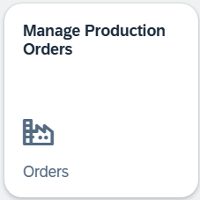
The system displays an overview of all existing orders. Depending on the progress of your course, there may be several production orders with different processing statuses.
In the Material Number field, enter your material GCBK1### and choose to display only your order. |  | GCBK1###
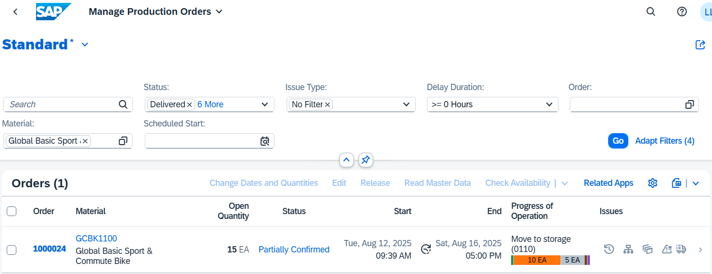
In the table overview, you can see that the current status and the processing status of the production order have changed.
Select the entry to display the details of the production order.
Now choose the "Components" tab page. The screen scrolls to the appropriate location.
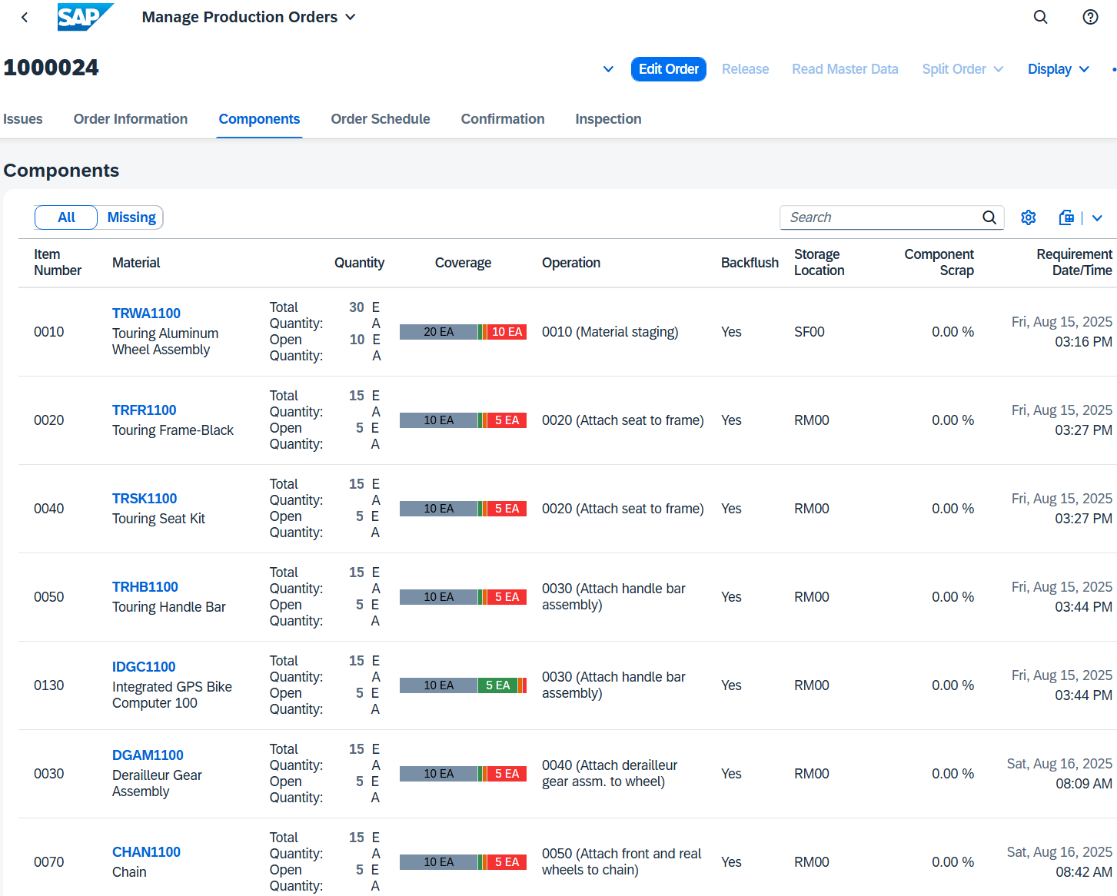
The quantities of the components are now two-thirds consumed and one-third open. The remaining components are consumed when the production quantity that is still open is produced.
Now choose the Confirmation tab page. The screen scrolls to the appropriate location.
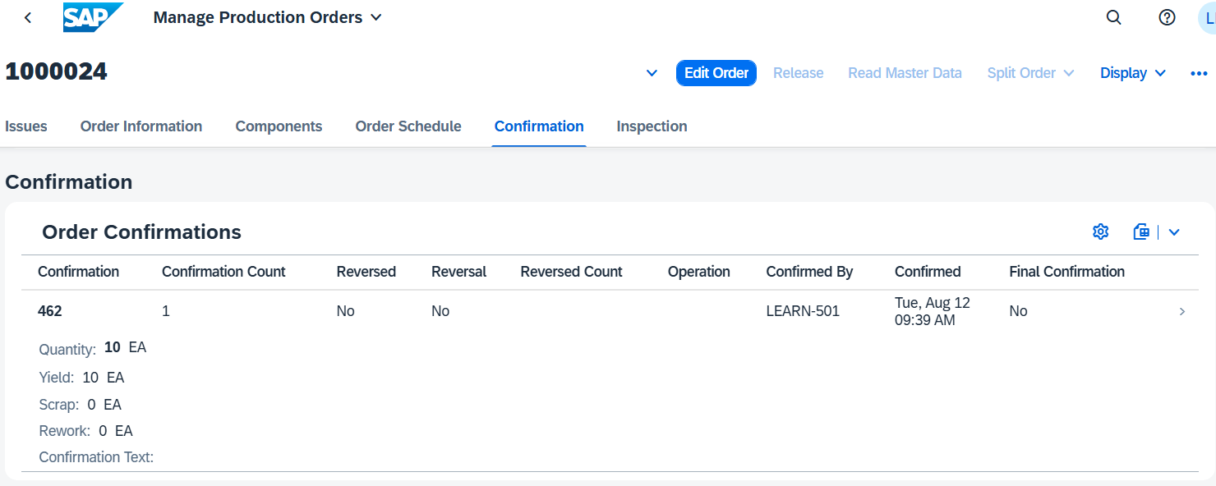
Here you can see your first confirmation, the confirmation quantity, and that it is not a final confirmation.
Click to return to the SAP Fiori launchpad.

 | Step 39: Confirm Complete Production Completion
Task Confirm Complete Production Completion.  Description The assembly of the current production orders is now completely completed. Confirm this by finally confirming your production orders.  Name (Job) Michael Brauer (Shop Floor Worker 4) |  | Time 5 min
In the Production Planning and Execution area, in the Shop Floor Worker role, use the Enter Production Order Confirmation app to report the completion of a production order. |  | Initial Screen
Determine your order number. Click in the Order field and choose the value help icon . In the dialog box for searching for production orders for the material and routing, switch.
Enter your material number GCBK1### and click to execute the search. Select your order and then click . |  | GCBK1###
Your order number is added to the initial screen. Press to continue.
On the Enter Confirmation for Production Order: Actual Data screen, the final confirmation is now carried out. Final confirmation should already be selected as the confirmation type, and Clear Open Reservation should be selected. |  | Final Confirmation
The reservations can only be cleared with the final confirmation.
Yield Quantity should be filled with the remaining 5 quantities to be confirmed. |  | 5
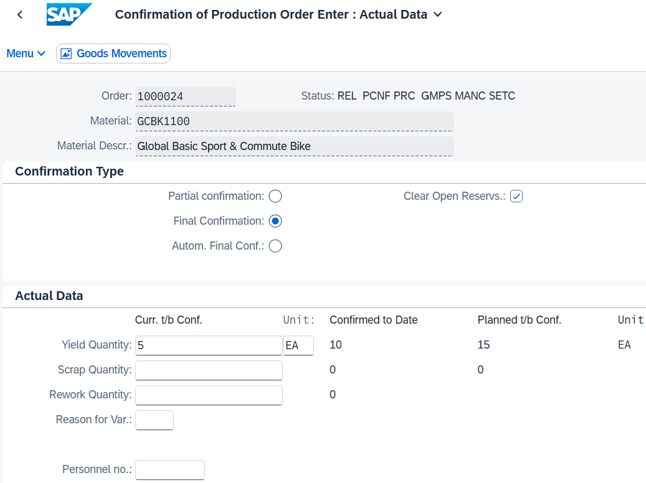
Press to save the confirmation.
Repeat this procedure for your production order of material GCBK2###. Make a final confirmation of 5 yield. |  | GCBK2### Final Confirmation  5
Repeat this procedure for your production order of material GCBK3###. Make a final confirmation of 10 yield. |  | GCBK3### Final Confirmation  10
Note You receive a message for material GCBK3### that the confirmation was saved, but not that there was a goods movement. Otherwise, the goods movement is triggered by the components that are used from the warehouse for production. However, since no dependent requirements have been determined for your material GCBK3###, no components are consumed from the warehouse for your material.
Click to return to the SAP Fiori launchpad.

 | Step 40: Check Production Order
Task Display the production order status.  Description Display your production order and check its current status after the complete confirmation from production.  Name (Job) Michael Brauer (Shop Floor Worker 4) |  | Time 5 min
To display the production order status, use the Manage Production Orders app in the Production Planning and Execution area in the Shop Floor Worker role. |  | Initial Screen
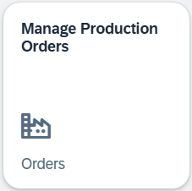
The system displays an overview of all existing orders. Depending on the progress of your course, there may be several production orders with different processing statuses.
In the Material Number field, enter your material *### and choose to display only your order. |  | *###
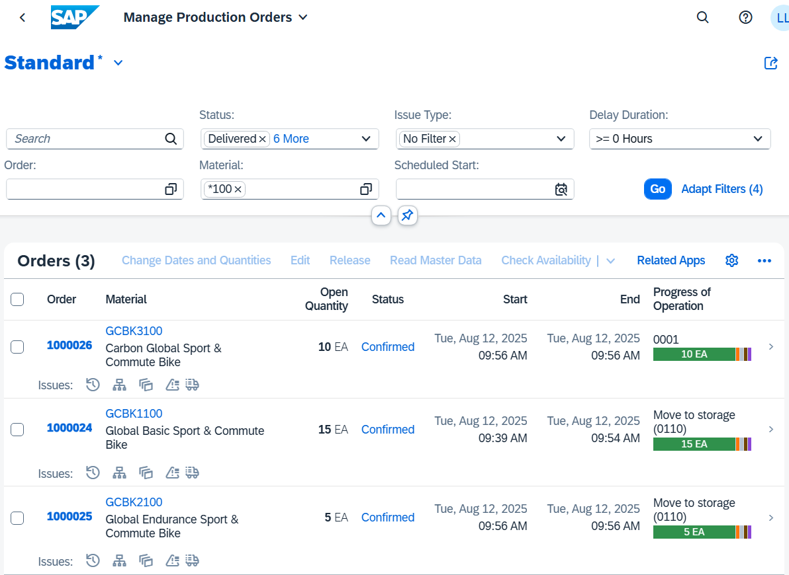
In the table overview, you can see that the current status and the processing status of the production order have changed again.
Select the entry for your GCBK1### bicycle to display the details of the production order.
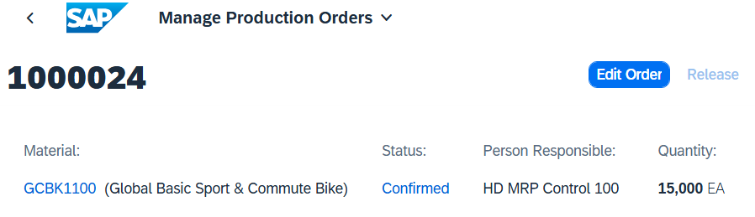
Now choose the "Components" tab page. The screen scrolls to the appropriate location.
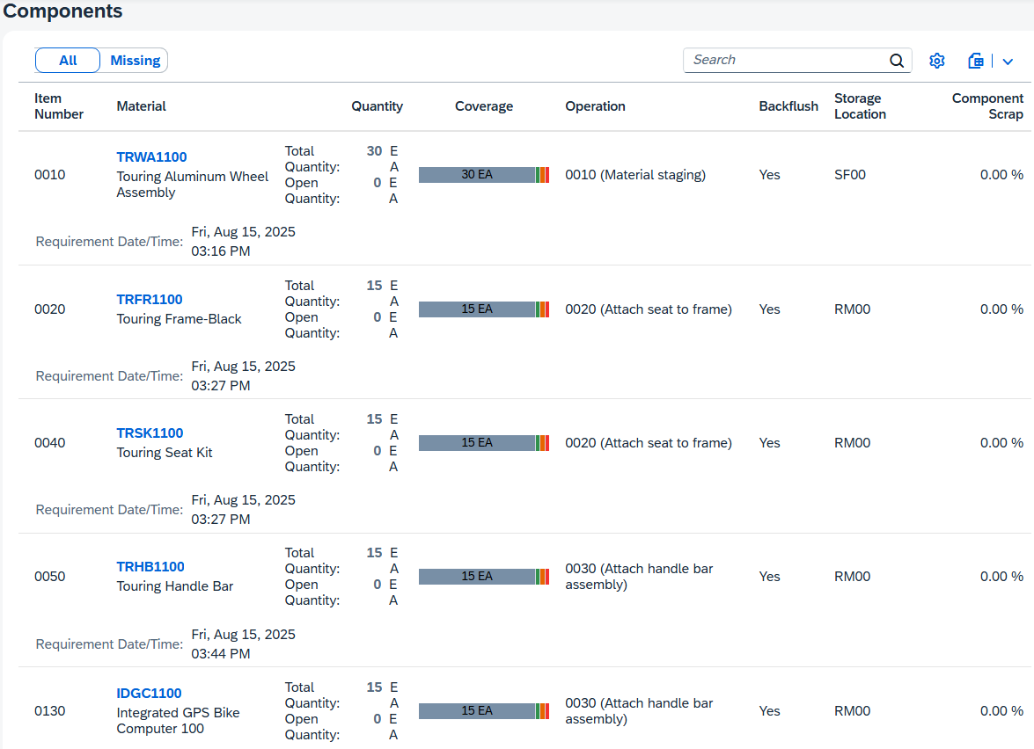
The quantities of the components are now completely consumed.
Now choose the Confirmation tab page. The screen scrolls to the appropriate location.
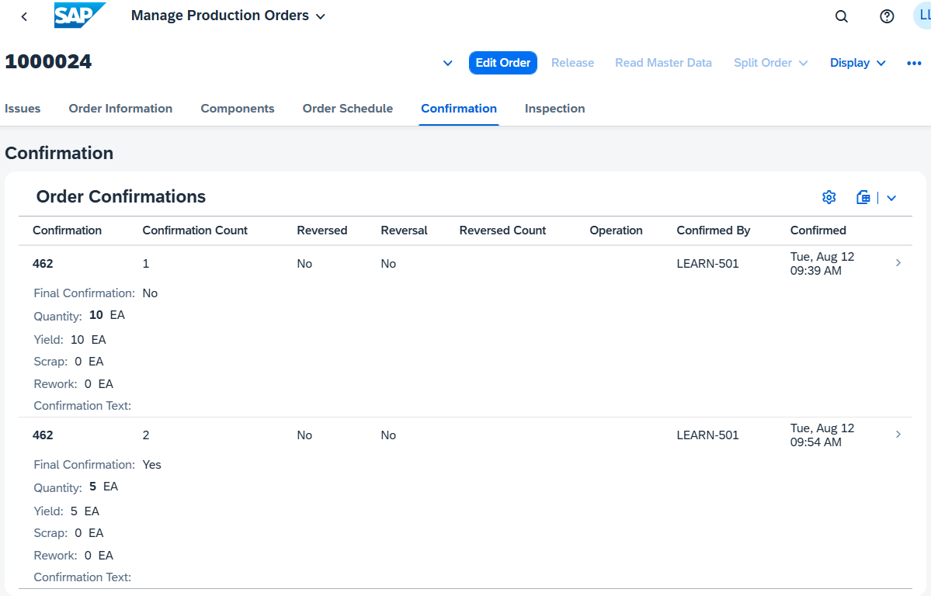
You see your two confirmations without scrap or rework and the second confirmation is the final confirmation.
Note Your production order is now completely confirmed, but not yet completely completed. The confirmations express that the products have been produced, but the goods receipt of the products still has to be posted.
Click to return to the SAP Fiori launchpad.

 | Step 41: Goods Receipt for Production Order
Task Post the finished goods to the warehouse.  Description Post the goods receipt for your production order. You receive the confirmed products in your finished goods warehouse. Check the proposed quantity with the quantity confirmed in the production order.  Name (Job) Susanne Castro (Goods Receipt Clerk) |  | Time 5 min
To post the goods issue, use the Post Goods Receipt for Production Order app in the role Goods Receipt Clerk in the area Production Planning and Execution. |  | Initial Screen
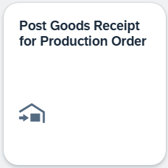
Determine your order number. Click the value help icon in the Production Order field. Enter your material GCBK1### and press . |  | GCBK1###
Select your production order, the system automatically displays the related General Information.
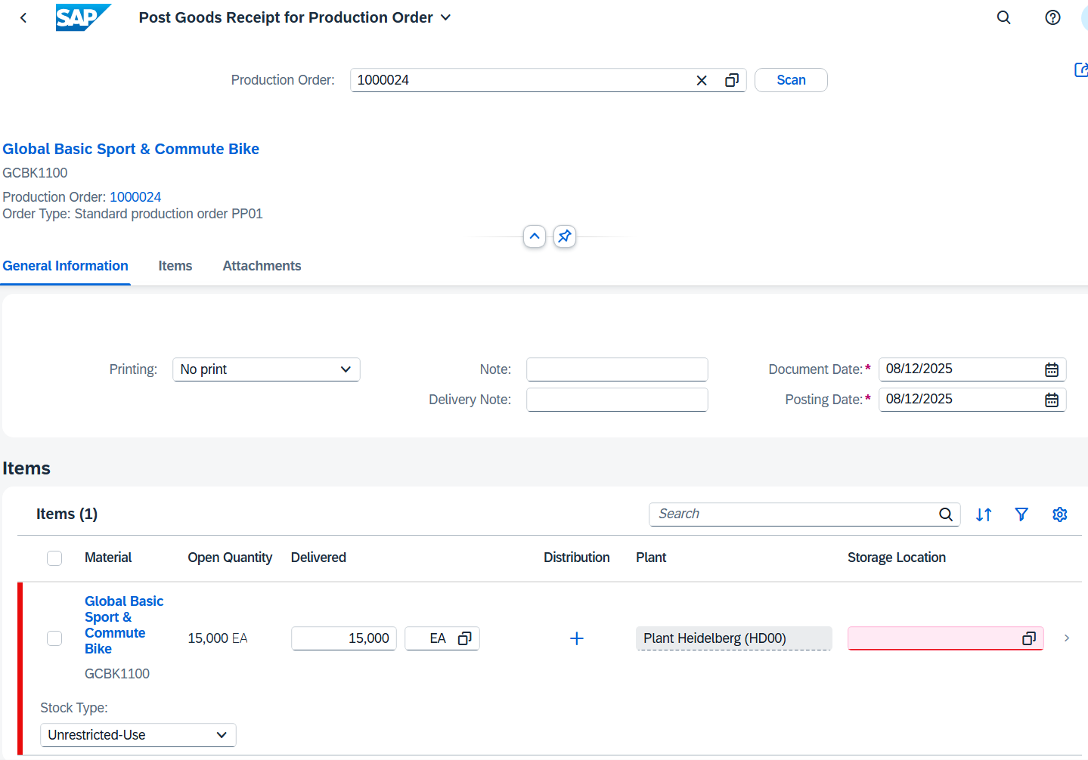
Make sure that Unrestricted Use is selected as the stock type and FG00 as the storage location. Select the entry for the material. |  | FG00  Unrestricted-Use
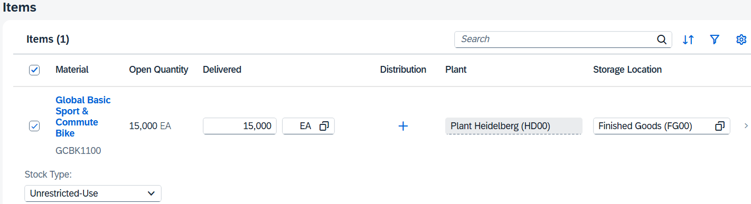
Save your goods receipt with . The SAP system assigns a unique number to the goods receipt and issues a corresponding message.
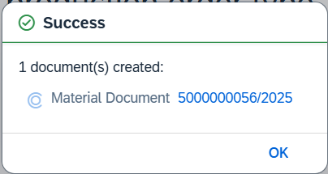
As a result, the current value of the produced material is updated in the production order. Confirm the message with 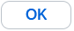.
Repeat this step for the production order of material GCBK2### and GCBK3###. |  | Retry  GCBK2###  GCBK3###
Click to return to the SAP Fiori launchpad.

 | Step 42: Analyze Production Costs
Task Display the assigned costs for your production order.  Description Display and review all costs that have been assigned to your production order.  Name (Job) Jamie Shamblin (Controller) |  | Time 5 min
To display the costs for a production order, use the Production Cost Analysis app in the Production Planning and Execution area in the Controller role. |  | Initial Screen
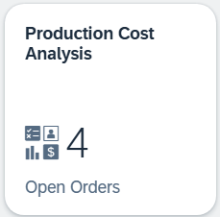
In the search for Product, enter GCBK1### and change the order status from Open to Closed. |  | GCBK1###  Closed
Press to execute the search. Your just completed production order is displayed.
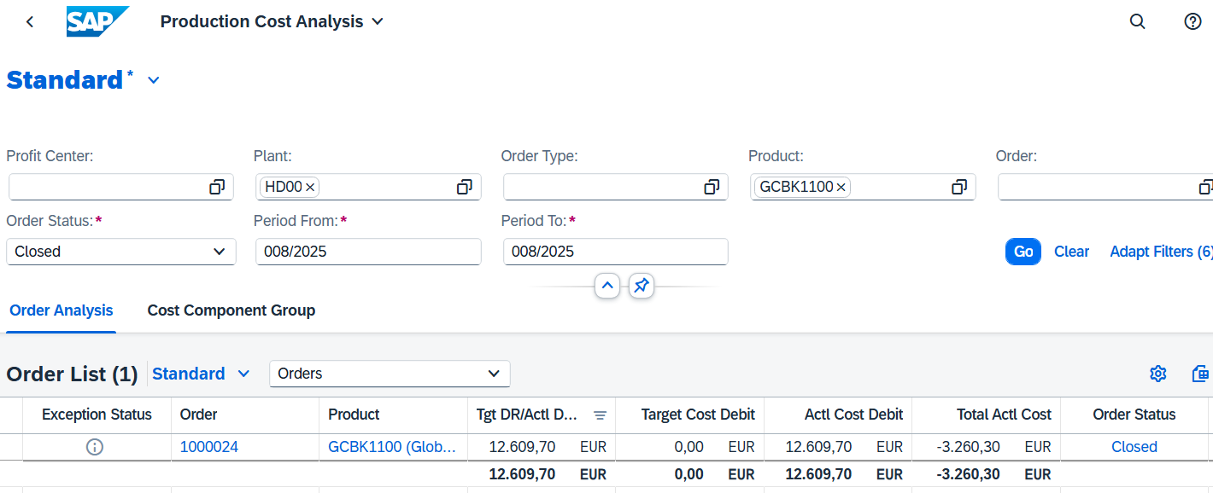
Note If you do not see any data, change the default value in your user settings for the controlling area from NA00 to EU00. Then reload the app and try the search again.
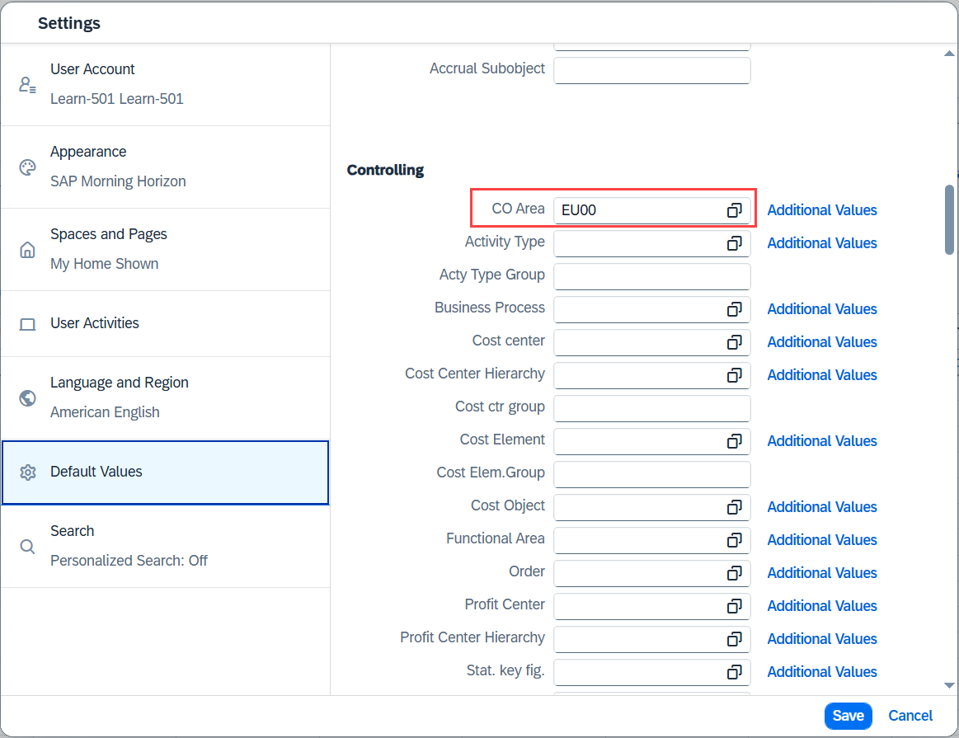
This overview lists the total target and actual costs and displays any variances.
Click at the end of the row to open the charge details.
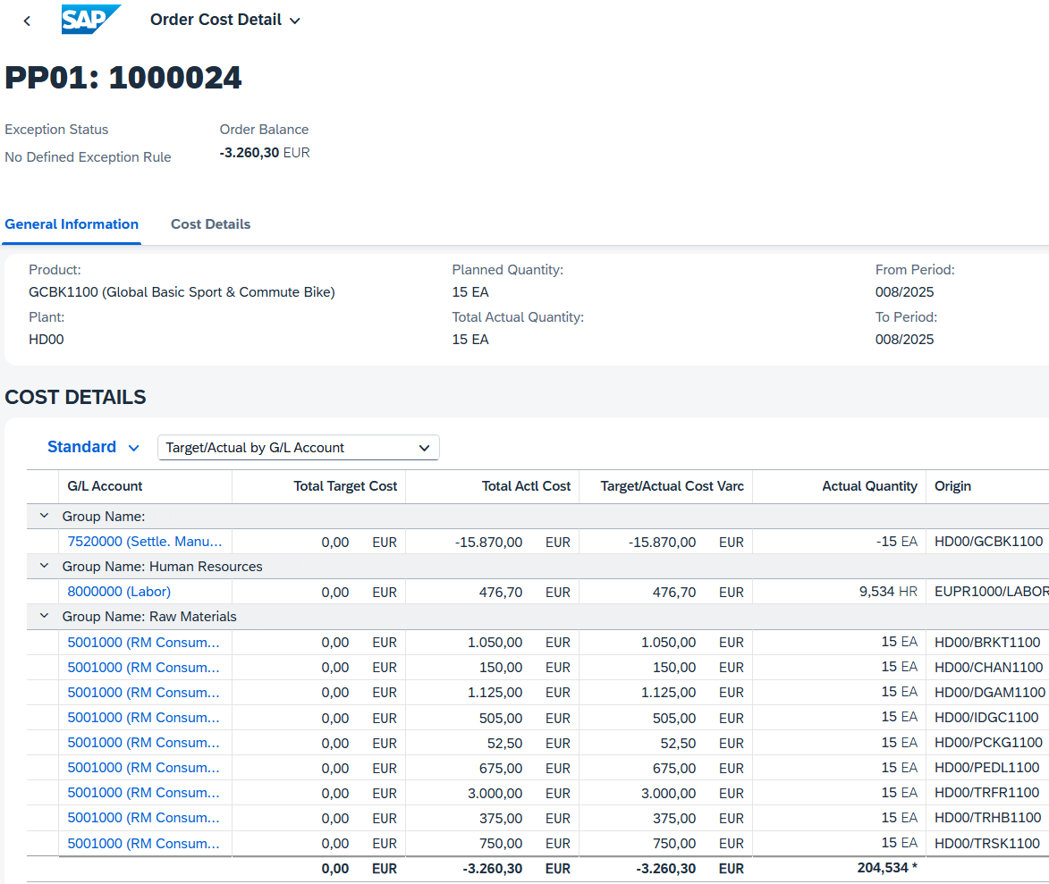
Now that the finished products have been received into the warehouse, the consumption of the values of all manufactured bicycles has been added.
Perform the production cost analysis for material GCBK2### as well.
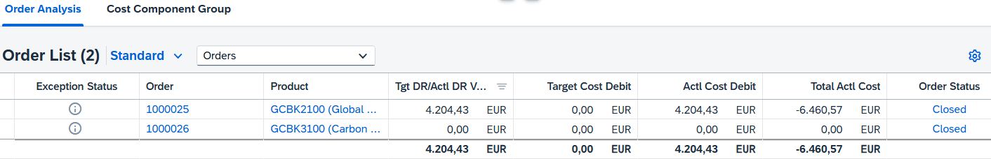
Click to return to the SAP Fiori launchpad.

 | Step 43: Execute Variance Calculation
Task Run the Variance Calculation.  Description In SAP, this is the process of comparing actual costs with planned or target costs (for example, in production orders or on cost centers) to identify and analyze differences (variances). This helps companies understand where costs deviate from expectations. Execute Variance Calculation = Compare the actual costs with the planned costs to calculate the difference.  Name (Job) Jamie Shamblin (Controller) |  | Time 5 min
To execute variance calculation, use the SPRO app in the Customizing area. Enter transaction code /nKKS2. Click Enter. |  | Initial Screen
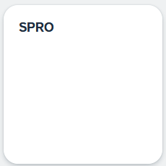
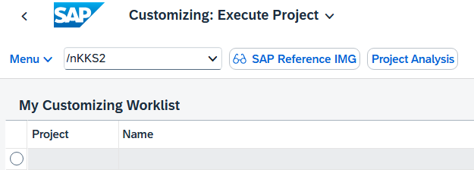
Note Transaction KKS2 is used in SAP to calculate variances for orders (usually production orders or process orders). It serves to determine the deviations produced during production (e.g. B. cost variances between target and actual).
On the Variance Calculation: Initial Screen, you can maintain or select an order. You can either select an existing order from the list and view or edit its details, or create a new order to record new business transactions. Use the available filter and search functions to search specifically for specific orders and to design your work processes efficiently.
Enter the order number for your material GCBK1### and enter the current period and fiscal year. Select All Target Cost Versions.
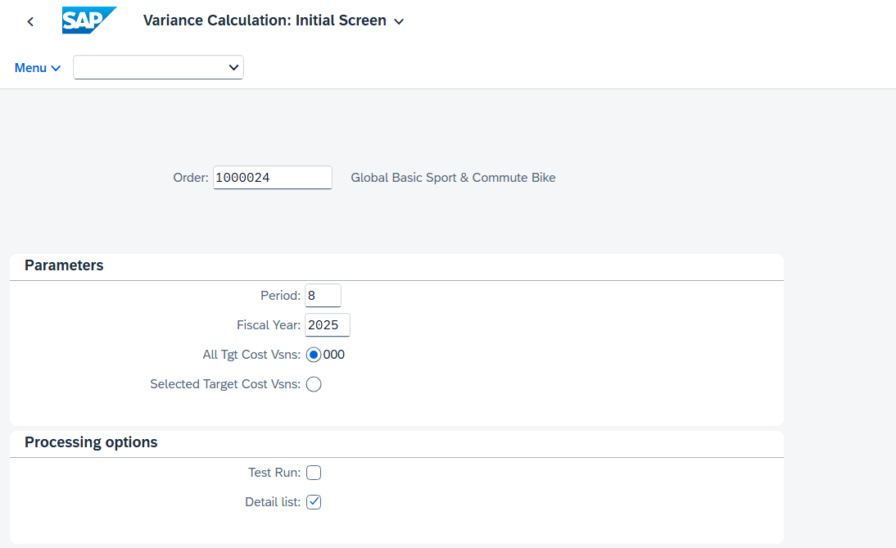
Click 'Execute' and ignore the warning by pressing Enter.
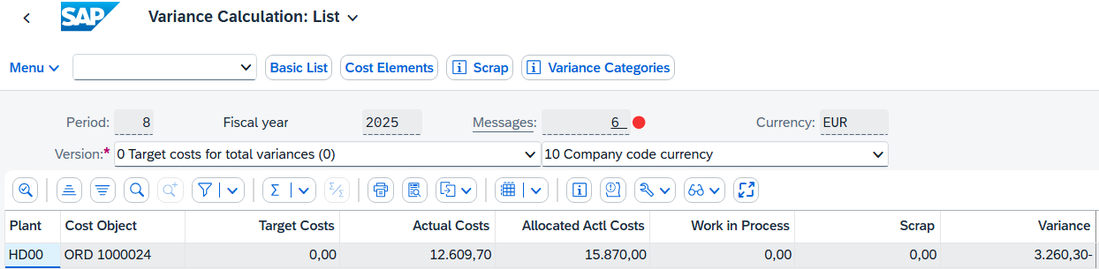
Repeat this procedure for the production order of material GCBK2###.
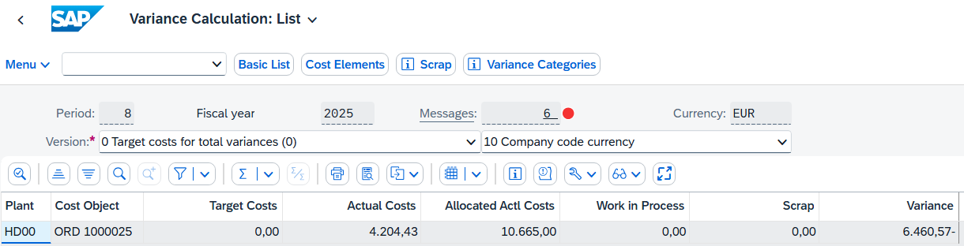
Note With this procedure, we have cleared the existing differences in the system. As a result, both the accounting documents and the document flow are consistent and correct again. The status of the delivery and invoice have been updated accordingly so that there are no more open or erroneous items. This procedure corresponds to the standard SAP processes and ensures clear and comprehensible accounting.
Now we can proceed with the step Settle Production Order. As a result, the costs of the production order are finally reposted to the corresponding cost centers or cost objects. At the same time, all open costs and variances are closed so that the production order is considered completed. This step is important to ensure correct cost distribution and clean accounting in the SAP system.
Click to return to the SAP Fiori launchpad.

 | Step 44: Settle production order
Task Settle the costs from your production order.  Description Settle the costs for production. These are temporarily entered in the production order and must now be assigned to a suitable cost object. Compare the actual costs with the target costs to identify variances or potential problems in this area.  Name (Job) Jamie Shamblin (Controller) |  | Time 15 min
To settle the costs from a production order, in the Production Planning and Execution area, in the Controller role, use the Run Actual Settlement app. |  | Initial Screen
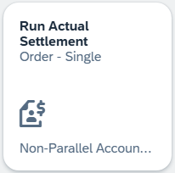
If you need to enter the controlling area, select EU00 and click . |  | EU00
Click in the Order field and choose the value help icon . Search for your order using your material GCBK1### and transfer it with . |  | GCBK1###
In the Parameters area, enter the current month (for example, 005 for May) as the settlement period and posting period, and the current year as the fiscal year. In addition, make sure that Test Run is selected. |  | Current Month Current Year  Test Run
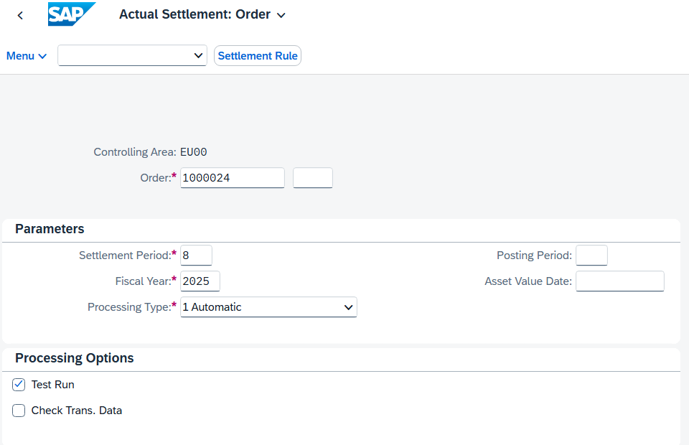
Press to continue. Choose Enter to confirm any message that may appear. The Actual Settlement Order Basic List screen appears.
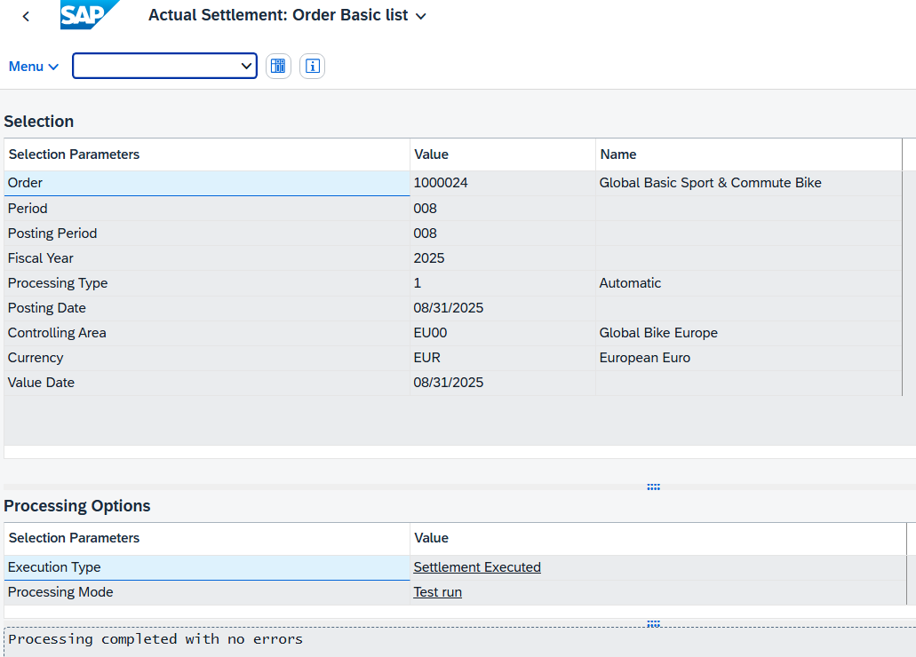
In the process control, you can see that this is only a test run.
Click 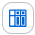 to open the detail lists.
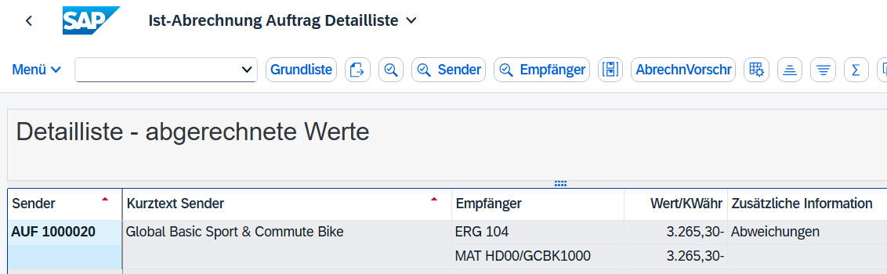
To view more reports, press 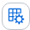.
A popup opens in which you can choose between several reports. Choose Actual/Plan/Variance and confirm your selection with . A corresponding report bundle is generated and displayed.
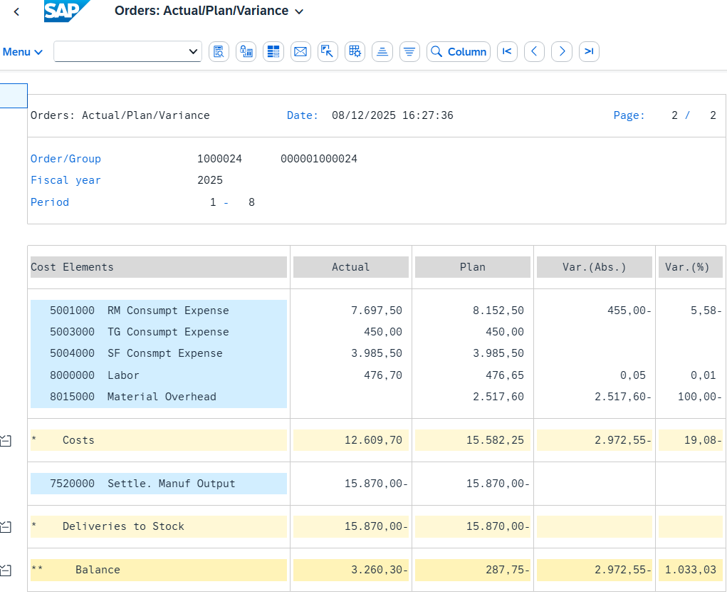
Press 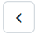 to go back. Confirm the prompt whether you want to exit the report with YES. Then choose twice to return to the Actual Settlement: Order initial screen.
Now deselect Test Run and execute again with . In contrast to the previous run, you can now see in the Processing Options area that this was an update run that was completed without errors. |  | Test Run
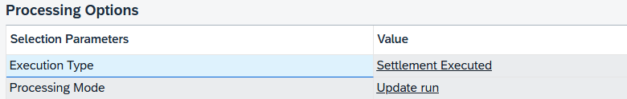
Call up the report Actual/Plan/Variance again by first clicking on and following the menu path Menu ► Environment ► Report.
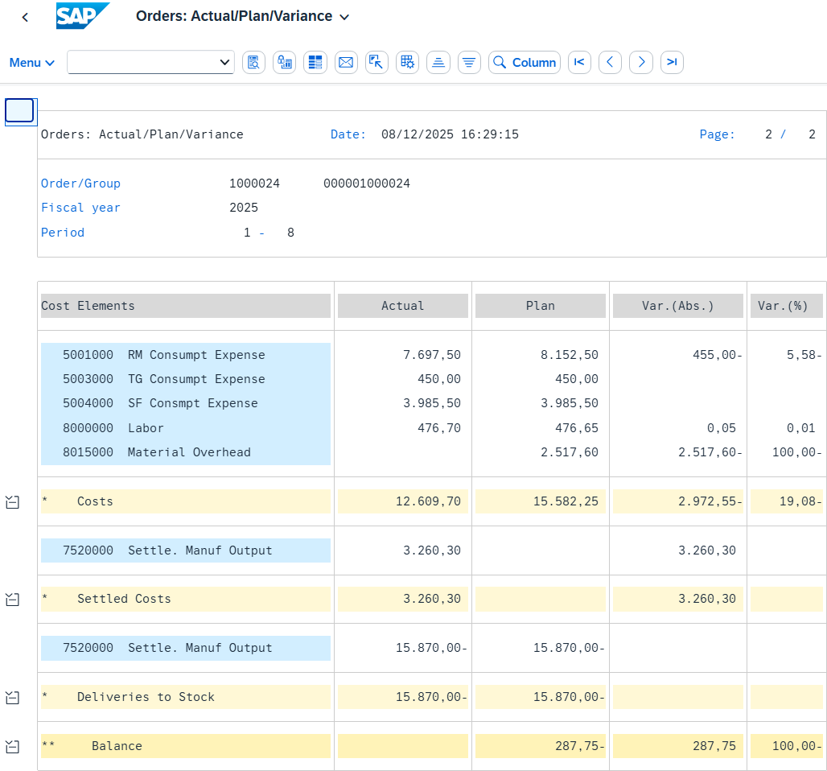
Repeat this step for the orders of your materials GCBK2### and GCBK3###.
The system issues the following message for your material GCBK3###:
Click to return to the SAP Fiori launchpad.
Process Progress
The production planning and production process is finished at this point.

Process Progress
Since the production planning and production process of the new bicycles has been completed with the previous step, the sales process can now continue.
 | Step 45: Display Stock
Task Display the stock of your materials again.  Description You want to make sure that there are enough mountain bikes in stock in the delivering plant to fulfill the Elbe Cycle ### order. Therefore, you use the SAP Fiori launchpad to check the material stock.  Name (Job) David Lopez (Sales Representative US East) |  | Time 5 min
To check the warehouse stock of a material, use the Stock – Multiple Materials app in the Sales and Distribution area in the Sales Representative role. |  | Initial Screen
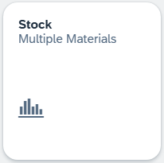
This takes you to the default view of the app. Due to the high quantity of materials, we recommend that you do not search without further restrictions. Therefore, use the input help symbol in the Material Number field.
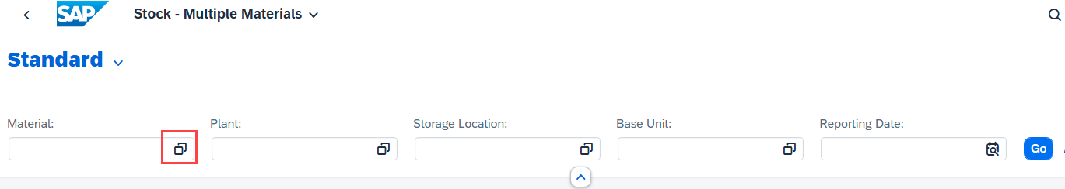
In the dialog box that appears, enter *### in the Material field and enter GCBK* as the description. |  | *###  GCBK*
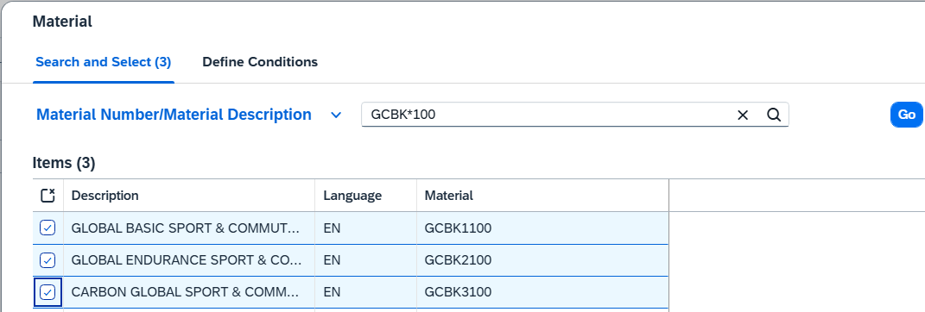
Choose to generate a results list of all materials that contains "Commute" and whose material key ends with "###". Select the Global Basic Sport & Commute Bike, the Global Endurance Sport Commute Bike and the Carbon Global Sport Commute Bike. Click  to apply the selection. |  | Global Basic Sport & Commute Bike  Global Endurance Sport Commute Bike  Carbon Sport Commute Bike
Back in Stock – Multiple Materials Overview screen, enter HD00 (Heidelberg) as the plant and FG00 (Finished Goods) as the storage location. Choose to display the corresponding warehouse stocks. |  | HD00  FG00
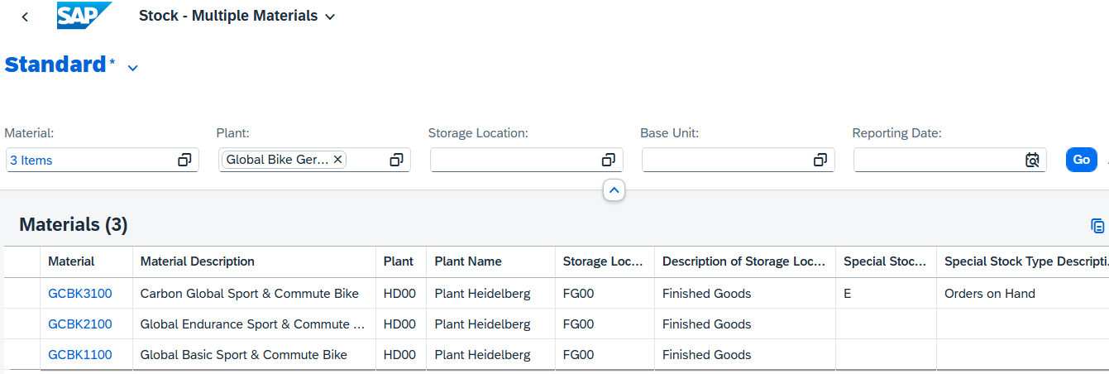
Note Special stock type "E" for orders on hand are materials that are procured or produced as part of a sales order and are directly assigned to a specific sales order. These materials are managed separately from the general warehouse stock because they are already "reserved" for a customer and are not to be used for other orders.
This report shows the stock levels for the plant in Heidelberg. Scroll to the right to see the unrestricted-use warehouse stocks.
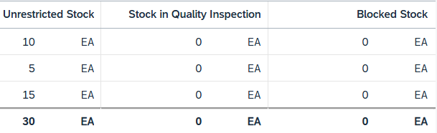
Click to return to the SAP Fiori launchpad.

 | Step 46: Track Sales Order
Task Track the processing status of the sales order.  Description Use the SAP Fiori launchpad to track the sales order.  Name (Job) David Lopez (Sales Representative US East) |  | Time 10 min
To track a sales order, you use the Track Sales Orders app in the Sales Representative role in the Sales area. |  | Initial Screen
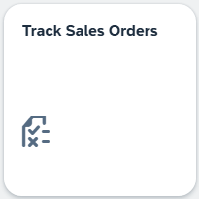
This takes you to the default view of the app. In the Cust. Reference field, enter your number (###) and press . |  | ###
Your standard order is displayed in the results list. Here, you can already see initial details such as the net value or the fulfillment status. You can also check the sold-to party in one of the columns at the bottom.
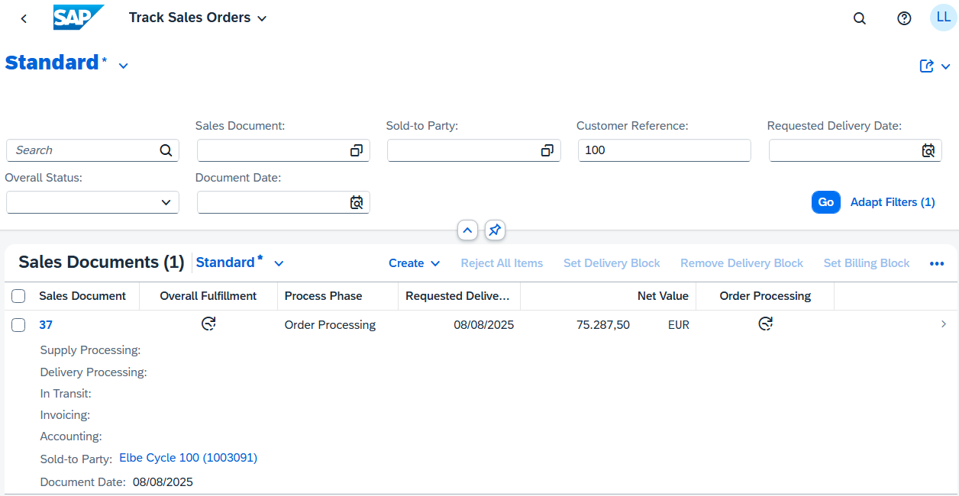
Click this line. You are navigated to Track Sales Order Details View where you can see all the details.
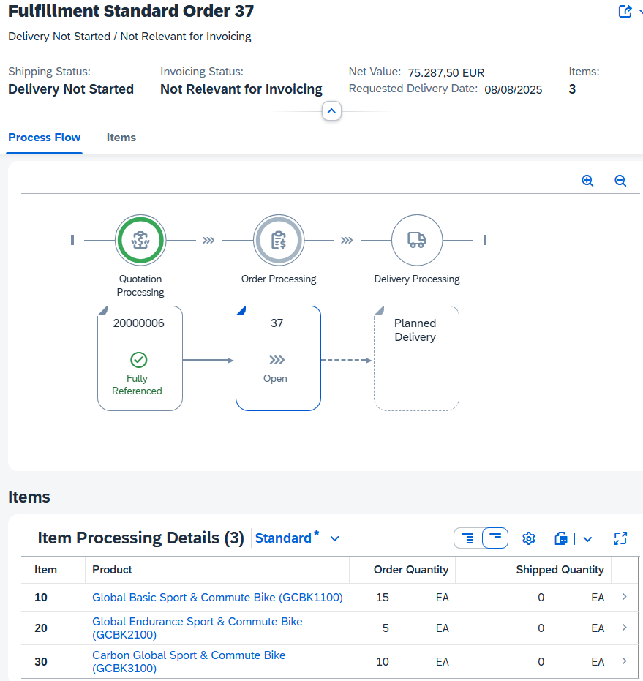
For example, you can see that the processing of the quotation is completely processed ("fully referenced"), but the processing of the forward order is currently still "open". You can also see the requested delivery date of the order and the planned delivery from the overview.
Click the Items tab. Here you can see a list of the ordered bicycles and the quantity of billed or already shipped quantity.
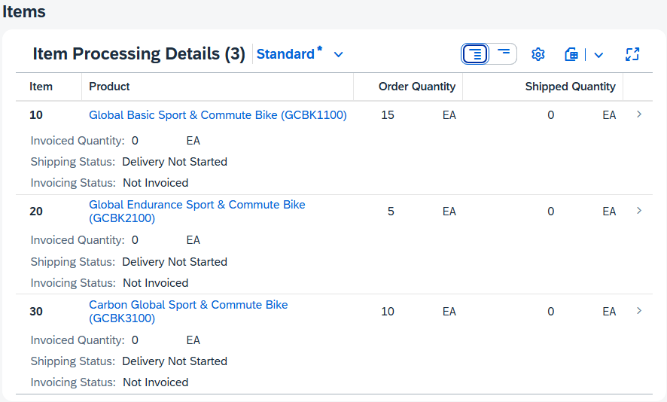
Go back to the Process Flow tab and click your standard order. The following context menu opens.
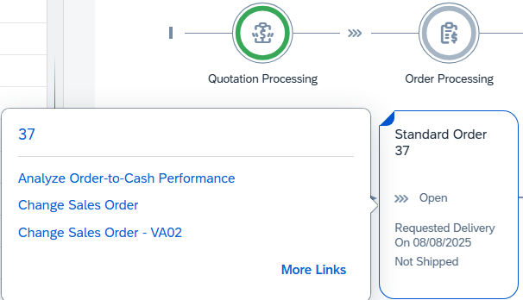
Choose and in the dialog box that opens, choose Display Sales Order – VA03. The related app opens automatically.
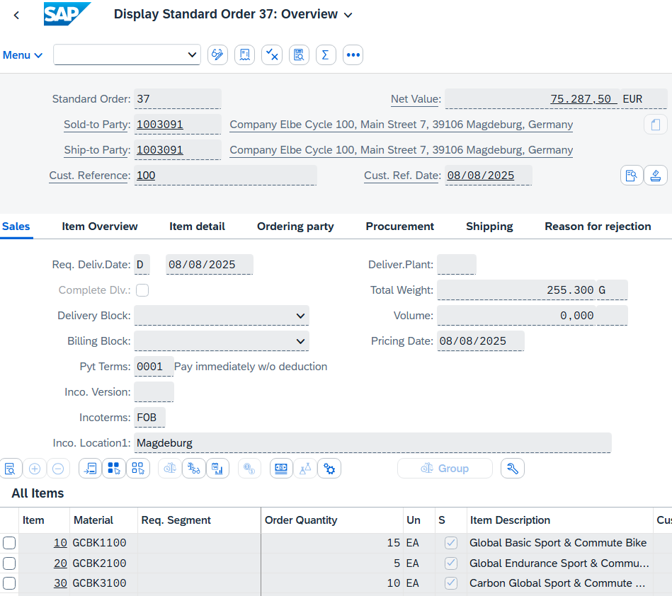
In the All Items area, select the row with the Global Endurance Sport & Commute Bike and click 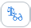 (Display Availability) to check the availability in detail. |  | Global Endurance Sport & Commute Bike
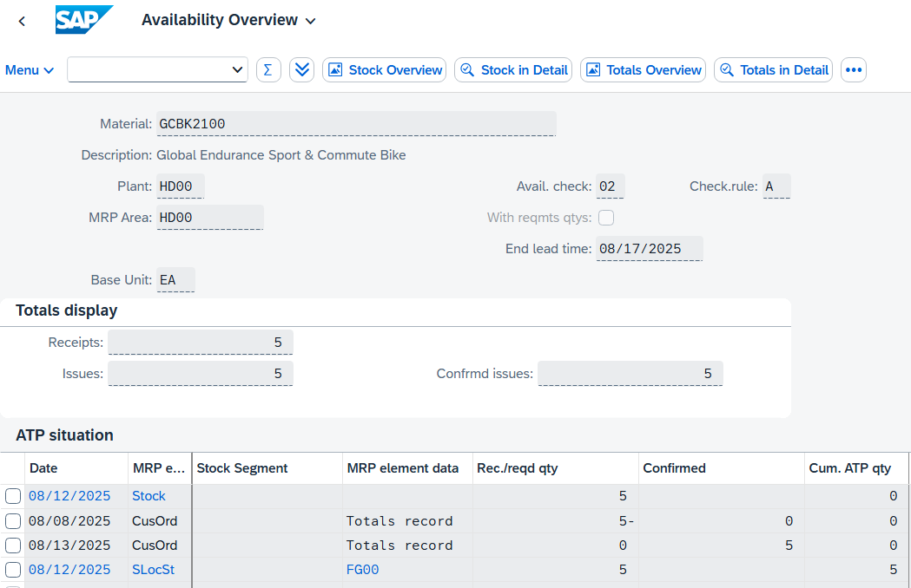
The availability overview shows that in this case, 5 bicycles exist in the plant stock and 5 would be issued for your sales order.
Note Your stock list might show different stock quantities.
Choose . If this is not displayed, you can find the entry in the pull-down menu under Menu ► Scope of Check. The subsequent window appears.
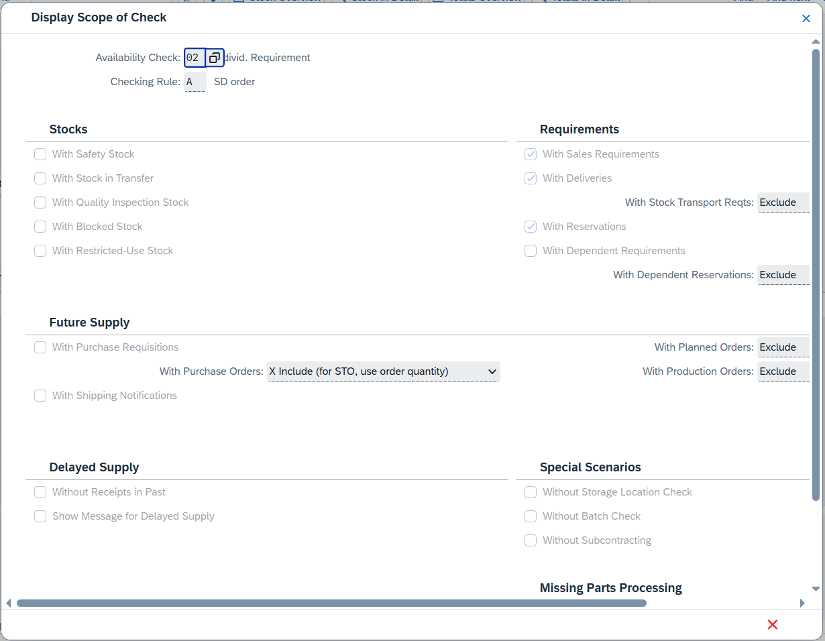
This screen shows the elements that are taken into account when the availability check is executed. For example, under Future Receipt, purchase orders are included, which means that a purchase order increases the available stock on the day of receipt. Click 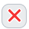 to close the popup and 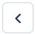 to return to the standard order overview.
When you display the availability overview for bike GCBK3###, you will notice that the materials do not exist in the plant stock, but in the sales order stock. This means that the material is intended for this sales order. Click to return to the overview of the standard order.
Select the Global Basic Sport & Commute Bike and click 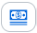 (Item Conditions) to view the conditions again. Note that the two discounts were applied manually to this item. |  | Global Basic Sport & Commute Bike
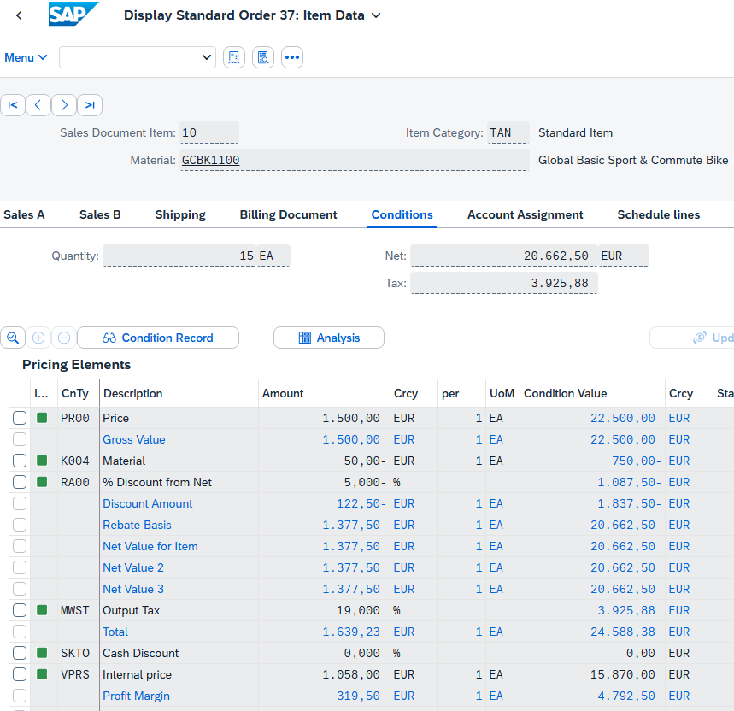
Click to return to the SAP Fiori launchpad.

 | Step 47: Create Outbound Delivery
Task Start the delivery process with the creation of an outbound delivery.  Description To start the delivery process that is to fulfill the sales order of Elbe Cycle ###, you need to trigger the outbound delivery and create an outbound delivery document. To do this, you use the SAP Fiori launchpad.  Name (Job) Sergey Petrov (Warehouse Employee) |  | Time 5 min
To start the delivery process, use the Create Outbound Deliveries - From Sales Orders app in the Warehouse Employee role of Sales. |  | Initial Screen
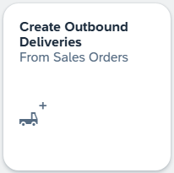
Shipping processes are triggered by the creation of deliveries. The responsible organizational unit for creating outbound deliveries is the shipping point. The shipping point can be a loading ramp, a post office, or a rail freight depot. Furthermore, the shipping point can, for example, consist of a group of employees who are responsible for organizing urgent deliveries.
The app starts with a collapsed header section. Expand it by clicking on .
On the search screen, in the Ship-to Party field, enter your business partner number (Elbe Cycle ###). |  | Business Partner Number (Customer)
Note If you have forgotten your BP number, alternatively, click the value help icon in the Ship-to Party field. The system displays a dialog box. In the Name 1 field, enter Elbe* and press .
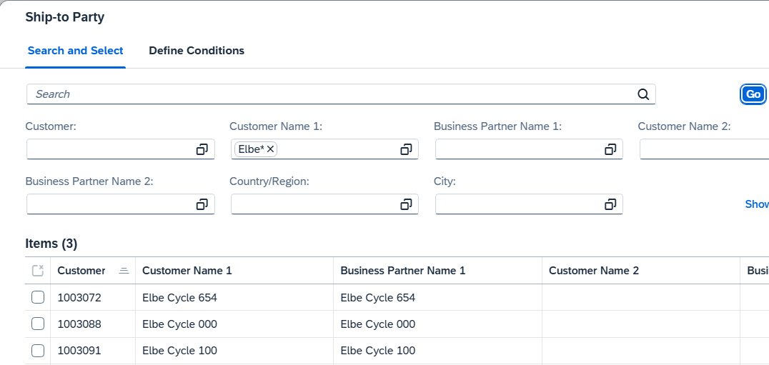
Select your customer and copy the entry with .
In addition, enter HD00 as the shipping point and remove the Planned Creation Date. Press to execute the search. The prepared sales order is displayed.
Select your sales order and choose the button. You can see that the sales order is no longer available. You receive a confirmation that your outbound delivery has been created.
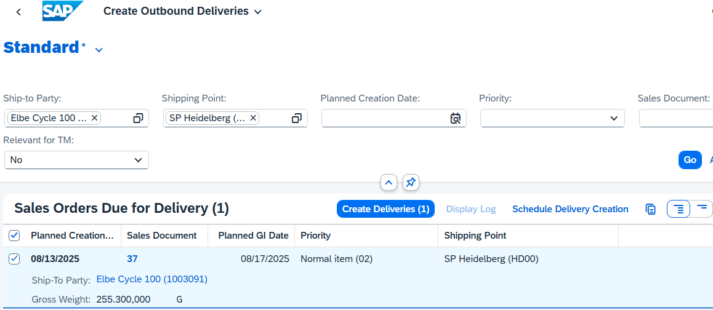
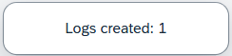
Click to return to the SAP Fiori launchpad.

 | Step 48: Track Sales Order
Task Track the processing status of the sales order.  Description As a Sales Representative, you want to know whether the colleagues from the warehouse have already triggered the outbound delivery. Therefore, you want to find out about the current status of the sales order again and use the tracking function of the SAP Fiori launchpad again.  Name (Job) David Lopez (Sales Representative US East) |  | Time 5 min
To track a sales order, you use the Track Sales Orders app in the Sales Representative role in the Sales area. |  | Initial Screen
This takes you to the default view of the app. In the Cust. Reference field, enter your number (###) and press . |  | ###
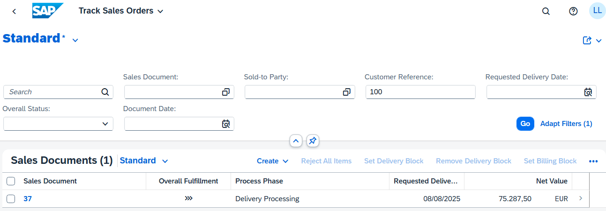
Your standard order is displayed. You can now also see changes to the previous state. The overall fulfillment is now Partially Processed and the processing of orders is completely processed.
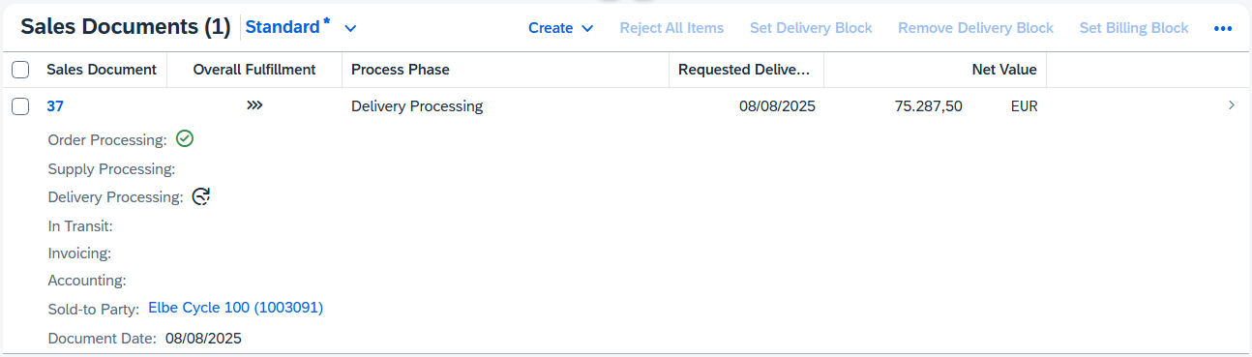
Click this line. You are navigated to Track Sales Order Details View where you can see all the details.
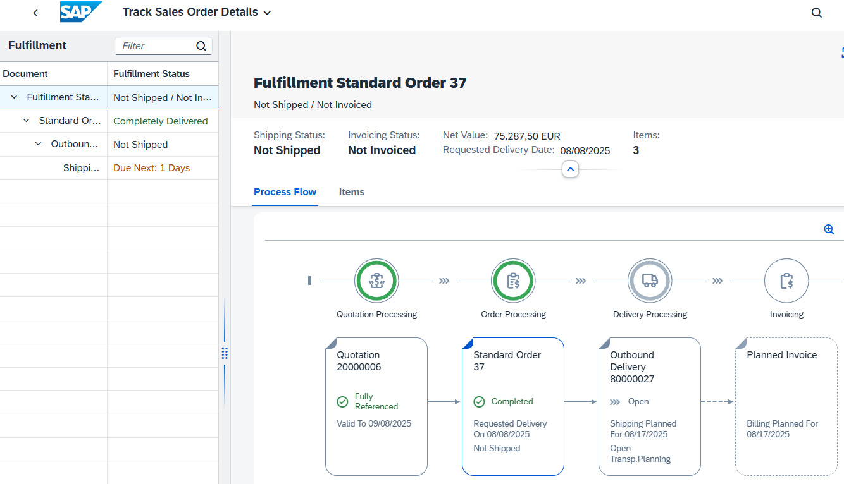
In the overview that opens, you can see the completed standard order and the delivery that is still open. In addition, billing has already been scheduled automatically by the system. In the header area, the shipping status (Not Shipped; Before: Delivery Not Started) and the invoicing status (Not Invoiced, previously: Not Relevant for Billing) have also changed.
Click to return to the SAP Fiori launchpad.

 | Step 49: Pick and Goods Issue
Task Pick the materials and post the goods issue.  Description During picking, the materials are withdrawn from the warehouse in the correct quantity. When you do this, the outbound delivery document is changed automatically. The goods issue then changes the ownership of the material from Global Bikes to Elbe Cycle ###.  Use the SAP Fiori launchpad to pick materials and post goods issue.  Name (Job) Sergey Petrov (Warehouse Employee) |  | Time 5 min
Picking a material changes the outbound delivery document, whereas the goods issue then changes the ownership of the material from Global Bike to Elbe Cycle. To do this, you use the Manage Outbound Deliveries app in the Warehouse Employee role in Sales and Distribution. |  | Initial Screen
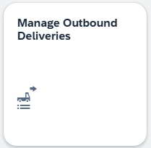
The app starts with a collapsed header section. Expand it by clicking on . In the Ship-to Party field, enter your business partner number. |  | Business Partner Number
Note If you have forgotten your BP number, proceed as described in the previous steps.
In addition, select All Open Deliveries as the overall status. To execute the search, press . Your outbound delivery is now displayed. |  | All Open Deliveries
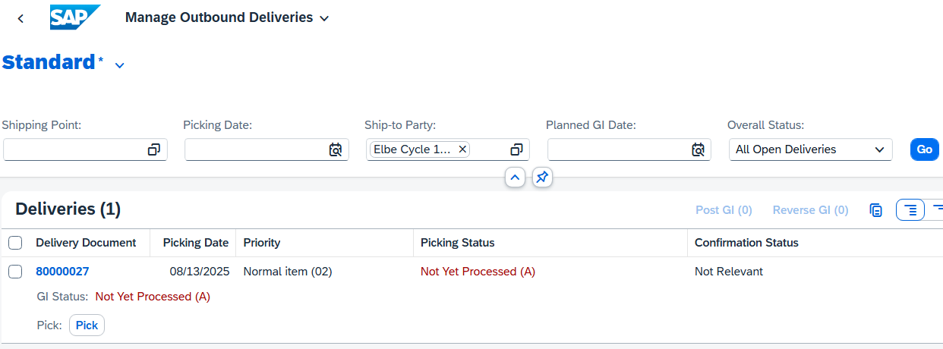
You can see that neither picking nor goods issue have been processed so far.
Then choose to start picking. The Pick Outbound Delivery app opens automatically. Your outbound delivery is already preselected.
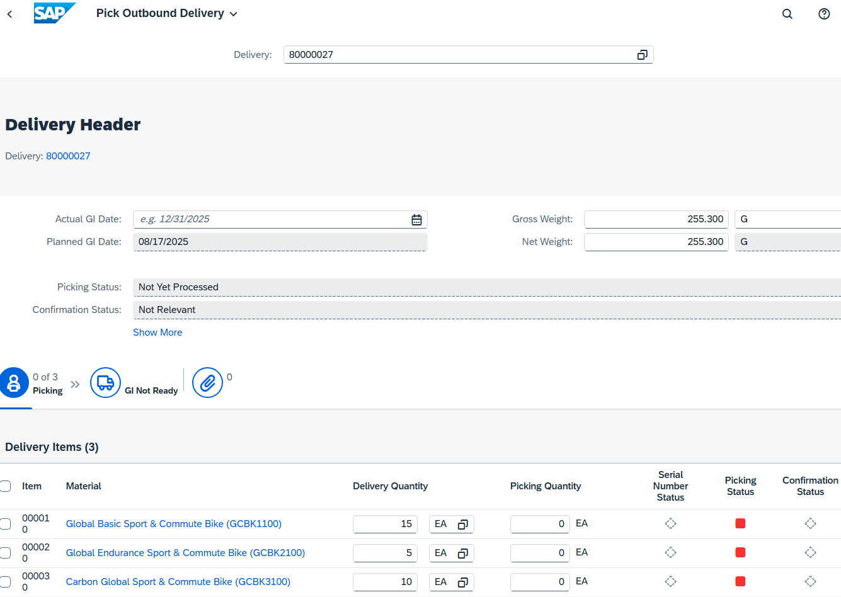
In the Delivery Items area, enter the appropriate quantities in the Picking Quantity field: for your GCBK1### 15, for your GCBK2### 5, and for GCBK3### 10. |  | 15  5  10
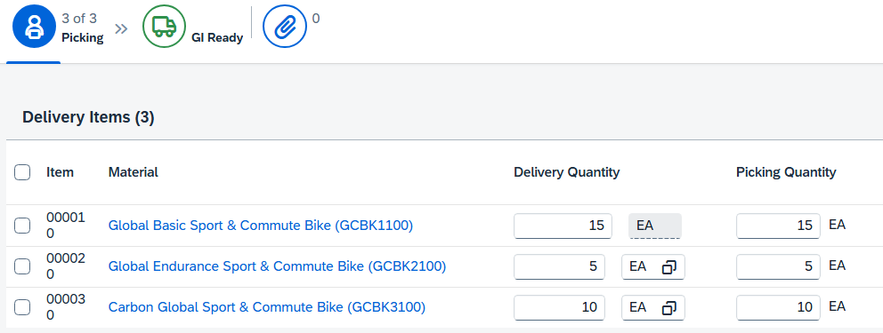
Picking is the process of preparing or staging goods for delivery to the customer, with special attention to data, quantity, and quality.
At the end of the line of the Global Basic Sport & Commute Bikes, choose .
In the Delivery Item 1 of 3 window, in the Storage Location field, enter FG00 (Finished Product). |  | FG00
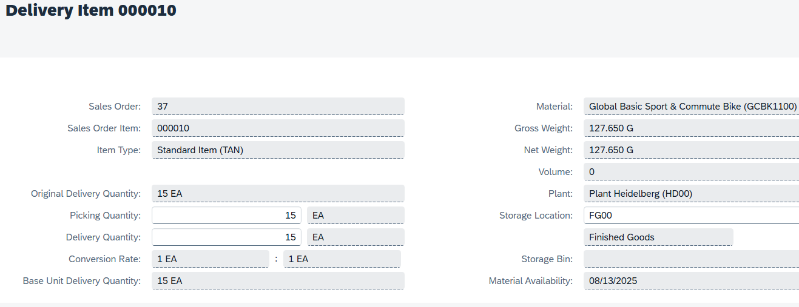
Click and repeat this step for materials GCBK2### and GCBK3###. |  | GCBK2###  GCBK3###
Back on the Pick Outbound Delivery screen, choose . You receive a corresponding message from the system. In addition, the page content changes. Picking is now complete, goods issue is ready.
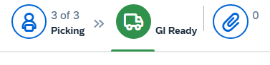
In the lower part of the screen, you can now click on to post the goods issue. The page content changes again. Both picking and goods issue are now completed.
Click to return to the SAP Fiori launchpad.

 | Step 50: Display stock
Task Display the stock of your materials again.  Description She now wants to know what effect the goods issue has on the warehouse stock. Therefore, you use the SAP Fiori launchpad to recheck the material stock.  Name (Job) David Lopez (Sales Representative US East) |  | Time 5 min
To check the warehouse stock of a material in the sales order for The Bike Zone, use the Stock – Multiple Materials app in the Sales and Distribution area in the Sales Representative role. |  | Initial Screen
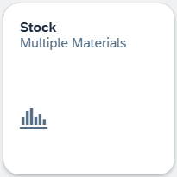
This takes you to the default view of the app. Due to the high quantity of materials, we recommend that you do not search without further restrictions. Therefore, use the input help symbol in the Material Number field.
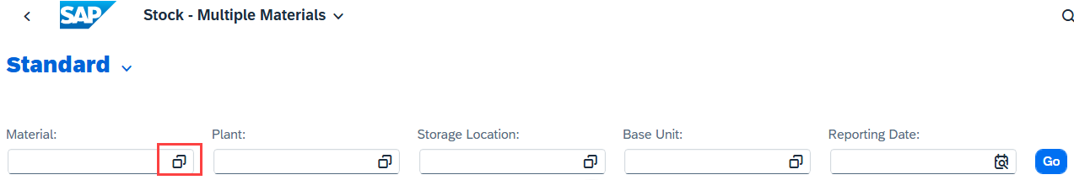
In the dialog box that appears, enter *### in the Material field and enter GCBK* as the description. |  | *###  GCBK*
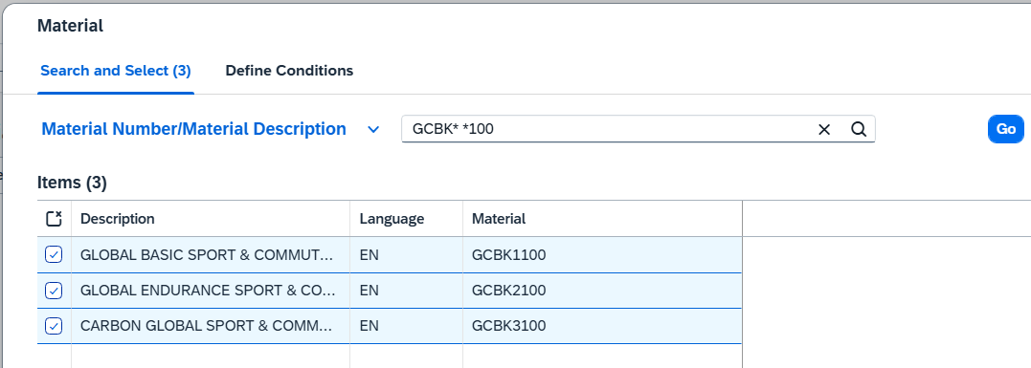
Choose to generate a results list of all materials that contains GCBK and whose material key ends with ###. Select the Global Basic Sport & Commute Bike, the Global Endurance Sport & Commute Bike and the Carbon Global Sport & Commute Bike. Click to apply the selection. |  | Global Basic Sport & Commute Bike  Global Endurance Sport & Commute Bike  Carbon Global Sport & Commute Bike
Back in Stock – Several Materials Overview screen, enter HD00 (Heidelberg) as the plant and FG00 (Finished Goods) as the storage location. Choose to display the corresponding warehouse stocks. |  | HD00  FG00
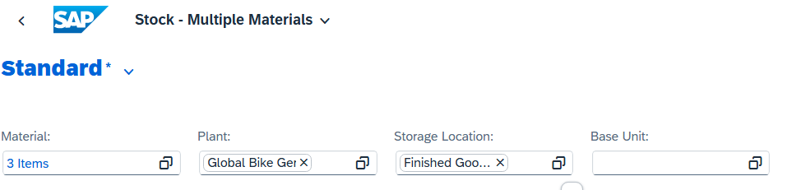
You will notice that the system does not find any data. This is because you have booked out all the products that have been produced and were in stock to fulfill the sales order.
Note Alternatively, you can also display the stock of your materials using the Stock - Single Materials app. In this app, you would keep information that 0 materials are available after goods issue.
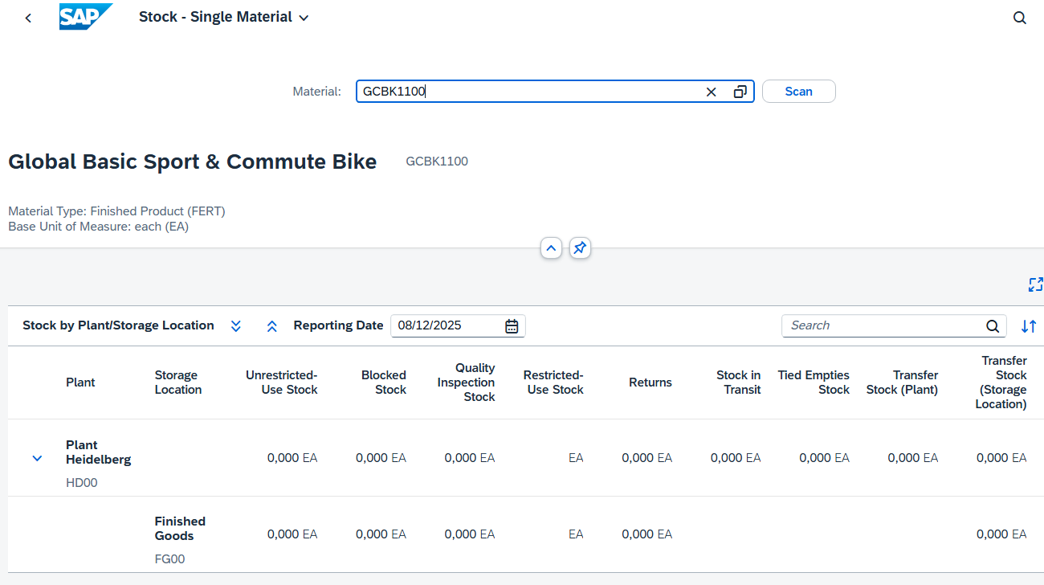
Click to return to the SAP Fiori launchpad.

 | Step 51: Create Customer Invoice
Task Create a customer invoice.  Description After the materials are fully delivered, accounting is informed. Now an invoice can be created. However, it is not yet sent or posted.  Use the SAP Fiori launchpad to create the invoice for customer Elbe Cycle ###  Name (Job) Stephanie Bernard (AR Accountant) |  | Time 5 min
With the complete delivery, an invoice can be created for the customer. To do this, you use the Create Billing Documents app in the role Accounts Receivable Accountant in the area of Sales and Distribution. |  | Initial Screen
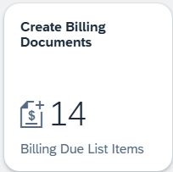
In the Create Billing Documents view, all billing due list items are automatically listed. For a better overview, the list is restricted. To do this, enter your business partner number in the Sold-To Party field. |  | Business Partner Number (Customer)
Note If you have forgotten your BP number, proceed as described in the previous steps.
Apply the new filter, click . Now your SD document is displayed.
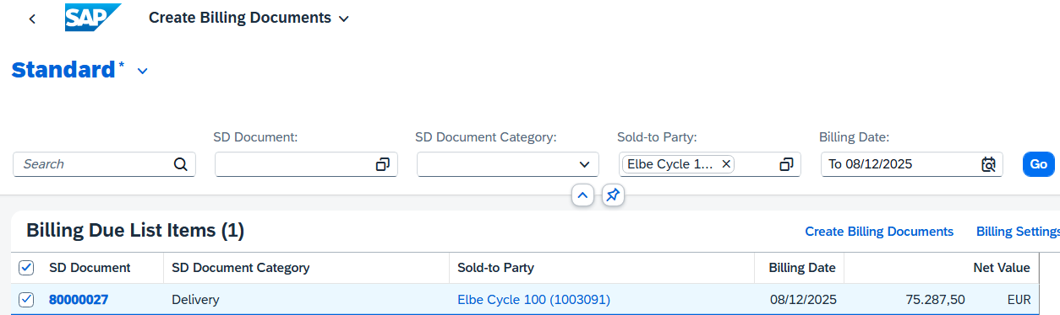
Select your SD documents and choose . The system prepares the customer invoice: the date and sold-to party are copied from the previous selection.
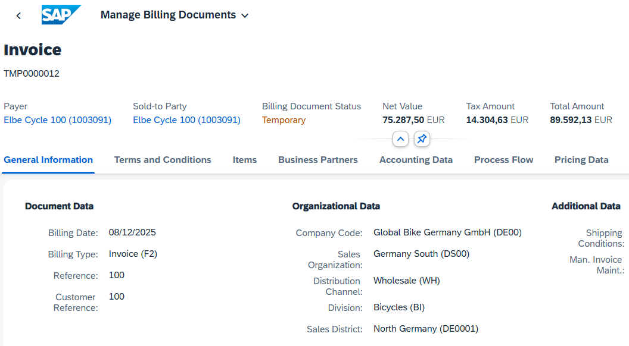
In particular, take a look at the total amount (incl. Tax) and keep it in mind. Select the Process Flow tab. Here, you can track the pre-executed steps that are relevant for the customer invoice.
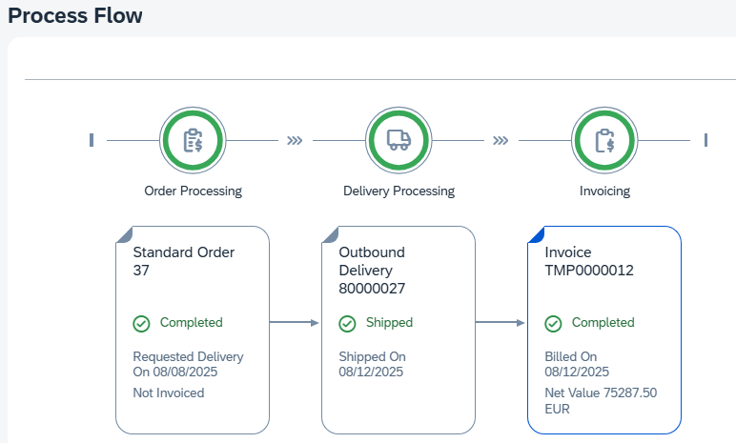
Proceed to the "Price Elements" tab page. As a billing clerk, you can see the discounts granted during quotation creation and how the total price is calculated. Take a look at the overview. To save the customer invoice, choose .
After checking the invoice items and saving, the temporary invoice is transferred to an official invoice. However, the process flow informs you that a journal entry has not yet been created because the invoice has not yet been posted.
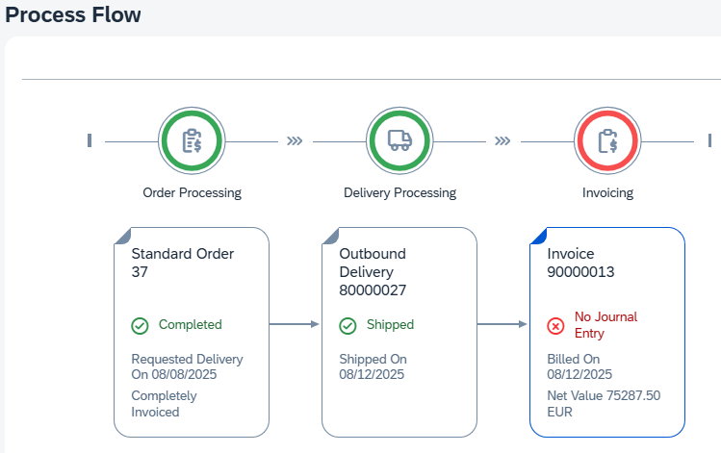
Click to return to the SAP Fiori launchpad.

 | Step 52: Post Customer Invoice
Task Display the customer invoice and then post it.  Description The invoice for Elbe Cycle ### has just been created. Now use the SAP Fiori launchpad to display and post them.  Name (Job) Stephanie Bernard (AR Accountant) |  | Time 5 min
After the invoice has been sent to Elbe Cycle, it must now be posted. You can do this in the area of Sales and Distribution in the Accounts Receivable Accountant role using the Manage Billing Documents app. |  | Initial Screen
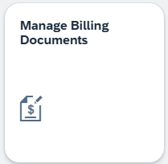
In the subsequent Manage Billing Documents window, enter your business partner number in the Sold-To Party field. |  | Business Partner Number
Alternatively, in the Sold-To Party field, click the value help icon and search for your business partner using your number (###), as in the previous step. |  | ###
Choose to display your invoice.
Your billing document now has the status "To Be Posted". Select your entry and choose . This sends the invoice to the customer.
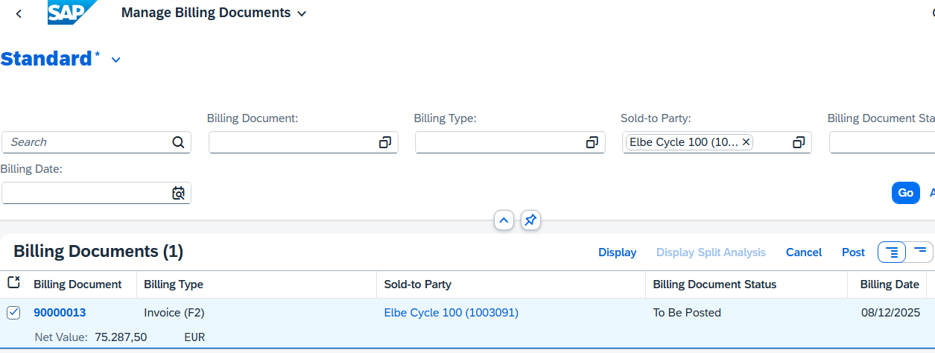
You can then call up the invoice again by clicking on the line. Navigate to the Process Flow area. You will notice that the invoice is now highlighted in green instead of red and that a journal entry has already been created.
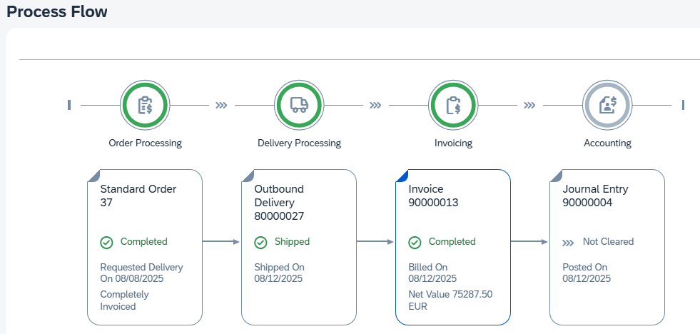
Click to return to the SAP Fiori launchpad.

 | Step 53: Post Incoming Payment
Task Post an incoming payment from the customer.  Description Use the SAP Fiori launchpad to post the incoming payment of a customer.  Name (Job) Stephanie Bernard (AR Accountant) |  | Time 15 min
You have since received the payment from Elbe Cycle ###. For entry, use the Post Incoming Payments app in the Accounts Receivable Accountant role in Sales and Distribution. |  | Initial Screen
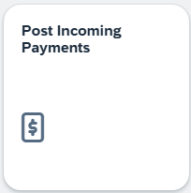
In the General Information area, enter DE00 (Global Bikes Germany) as the company code. In the Posting Date and Journal Entry Date fields, use (Open Selection) to enter the current date. In the Period field, also select the current period (for example, 09 for September). Ensure that DZ (Customer Payment) is selected as the journal entry type. |  | DE00  Current date  Current Period  DC
Under Bank Data, select 1810000 (Bank 1) as the G/L account. In addition, add EUR 89,592,13 (including 19% tax) as the amount. Under Open Item Selection, on the other hand, you select Customer as the account type and your business partner number in the field directly next to it. Compare your entries with the following screenshots. |  | 1810000  EUR 89,592,13  Customer  Business Partner Number
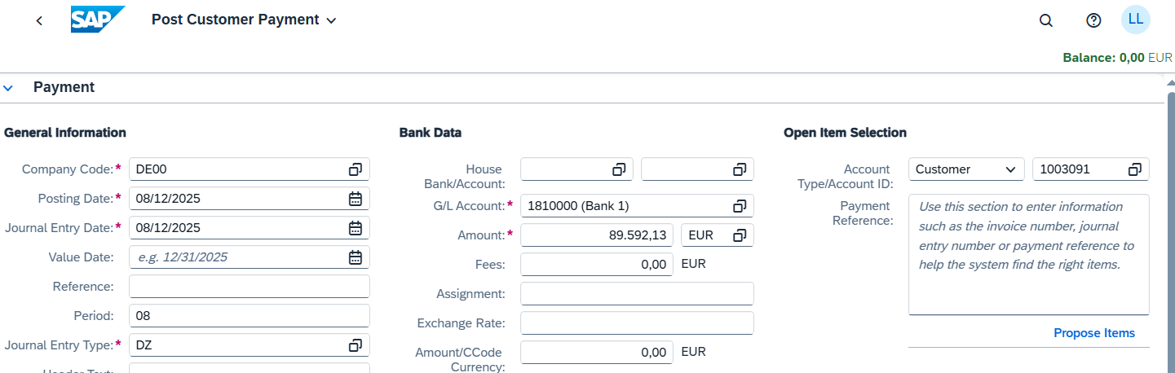
Click . In the upper part of the screen, you can see that the balance has changed. This is at due to the open customer invoice. In the Open Items section, the system also proposes the journal entry from the previous steps.
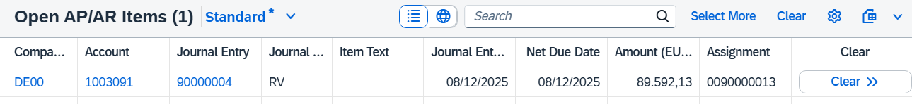
Choose 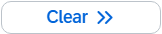 in the row of the journal entry. The open items are added to the items to be cleared and cleared with the incoming payment entered.
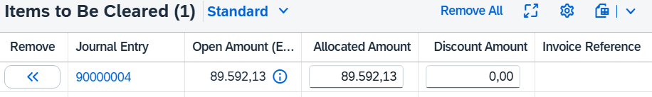
Since the incoming payment covers the entire amount, the balance is cleared again with . Click to save the incoming payment. The system will automatically assign a number to it.
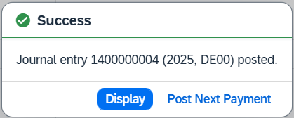
Choose  to display the journal entry in addition. In the Manage Journal Entries view, you can view the individual posting items.
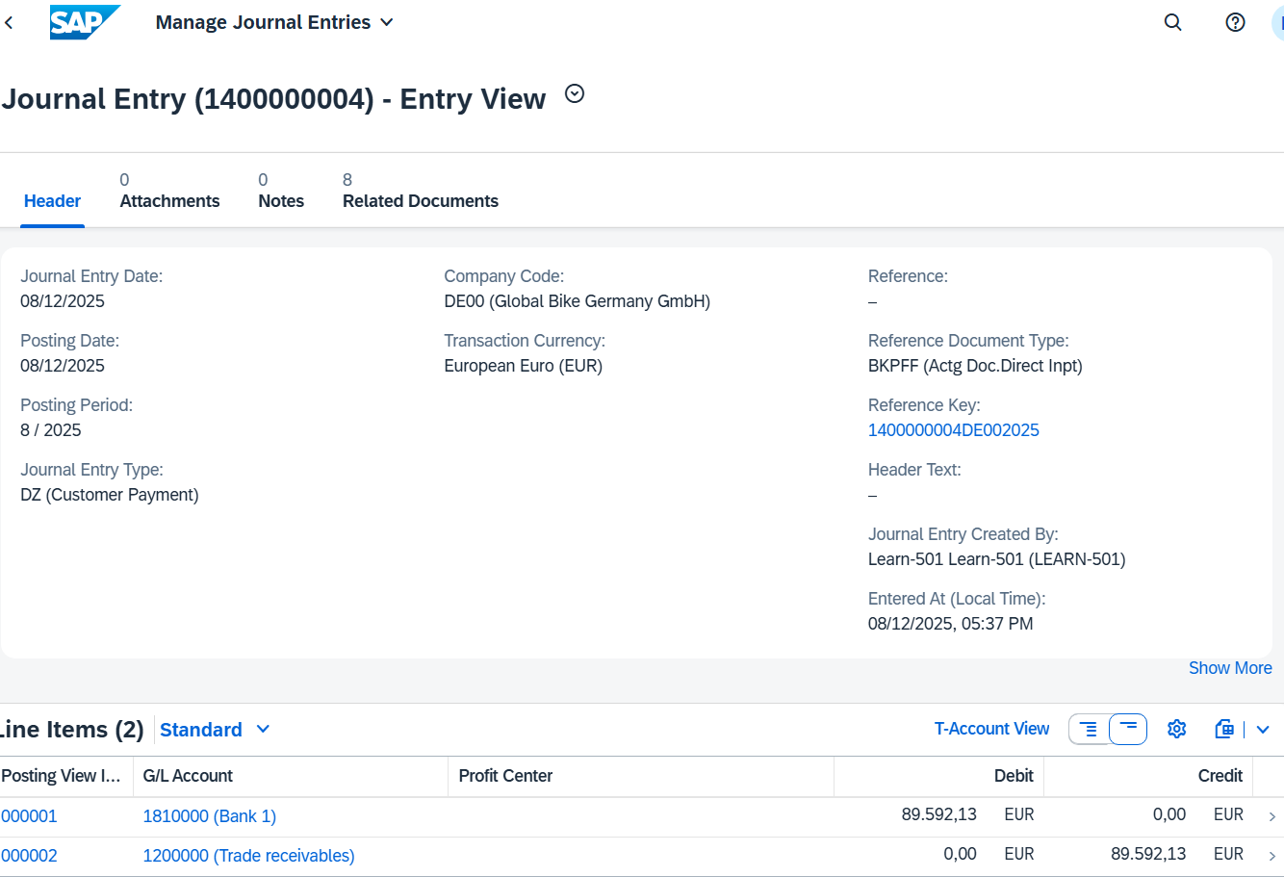
Note Global Bikes has received a payment from customer Elbe Cycle ### in the amount of EUR 89,592.13. Therefore, this amount is credited to the bank account (debit). At the same time, this amount is deducted from the open receivables (credit) because the customer's debt was paid by the payment. The postings adhere to the principle of double-entry bookkeeping, in which each business transaction is entered in both debit and credit so that the balance sheet of the company is correctly reflected.
Click to return to the SAP Fiori launchpad.

 | Step 54: Display Document Flow
Task Display the document flow of the sales order.  Description Finally, as a Sales Representative, you want to summarize the entire order. To do this, you can use the document flow. This tool connects all documents used in the Elbe Cycle ### sales order. There are some ways to access the document flow tool.  Use the SAP Fiori launchpad to access and analyze the document flow using a sales order document.  Name (Job) David Lopez (Sales Representative US East) |  | Time 15 min
To track a sales order, you use the Track Sales Orders app in the Sales Representative role in the Sales area. |  | Initial Screen
This takes you to the default view of the app. In the Cust. Reference field, enter your number (###) and press . |  | ###
Your standard order is displayed and you can see that its overall fulfillment is now Fully Processed. Also note the processing of deliveries, billing, and accounting.
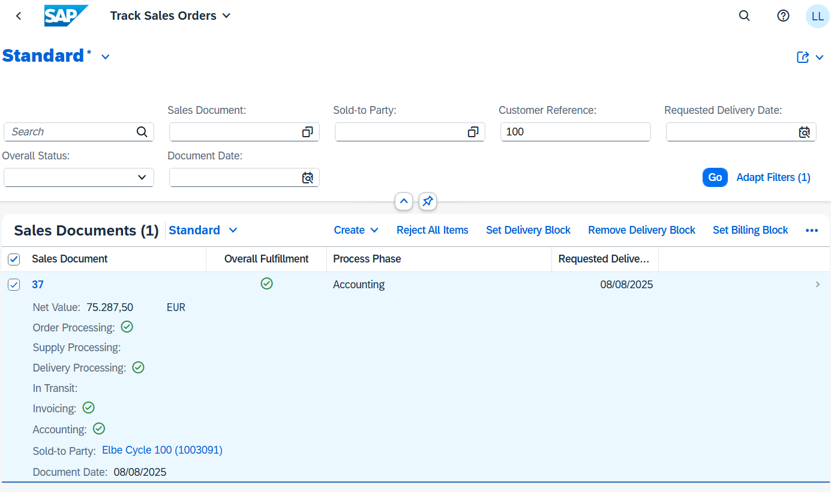
Click this line. You are navigated to Track Sales Order Details View where you can see all the details. For example, the Fulfillment section displays the document flow for the sales order. All related documents have been created and entered completely.
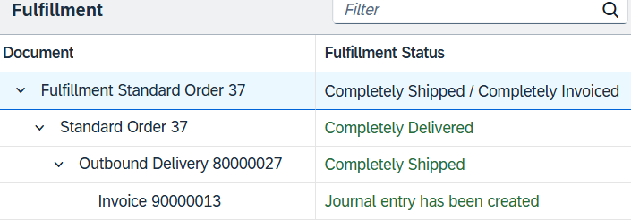
Depending on which document is selected, the content of the right-hand side of the screen changes. In this way, information about the outbound delivery or invoice can be viewed directly. When the standard order is fulfilled, the steps from quotation to invoice are also represented as a process flow. The respective documents can also be called from here.
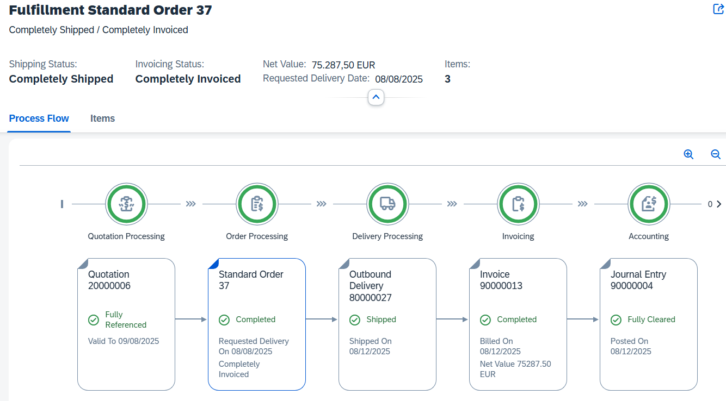
As you can see, in the header section, both the shipping status (Fully Shipped) and the invoicing status (Completely Invoiced) have changed again. On the Process Flow tab page, choose the journal entry to open the context menu. Click Manage Journal Entries to open the corresponding app. |  | Manage Journal Entries
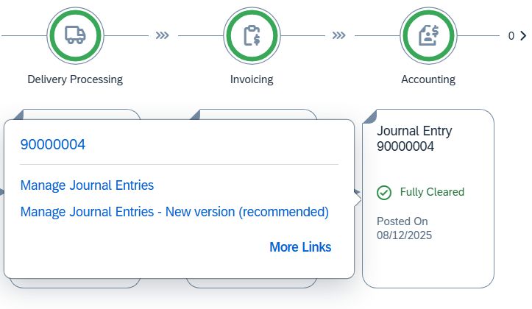
In the header data of the journal entry, you can view the line items. Here you can track each posting that has been made. On the other hand, you will notice that a “Granted Discounts” booking has been made several times. This is the 5% discount on the entire sales order for each individual order item, as well as the 50€ discount for the material GCBK1###.
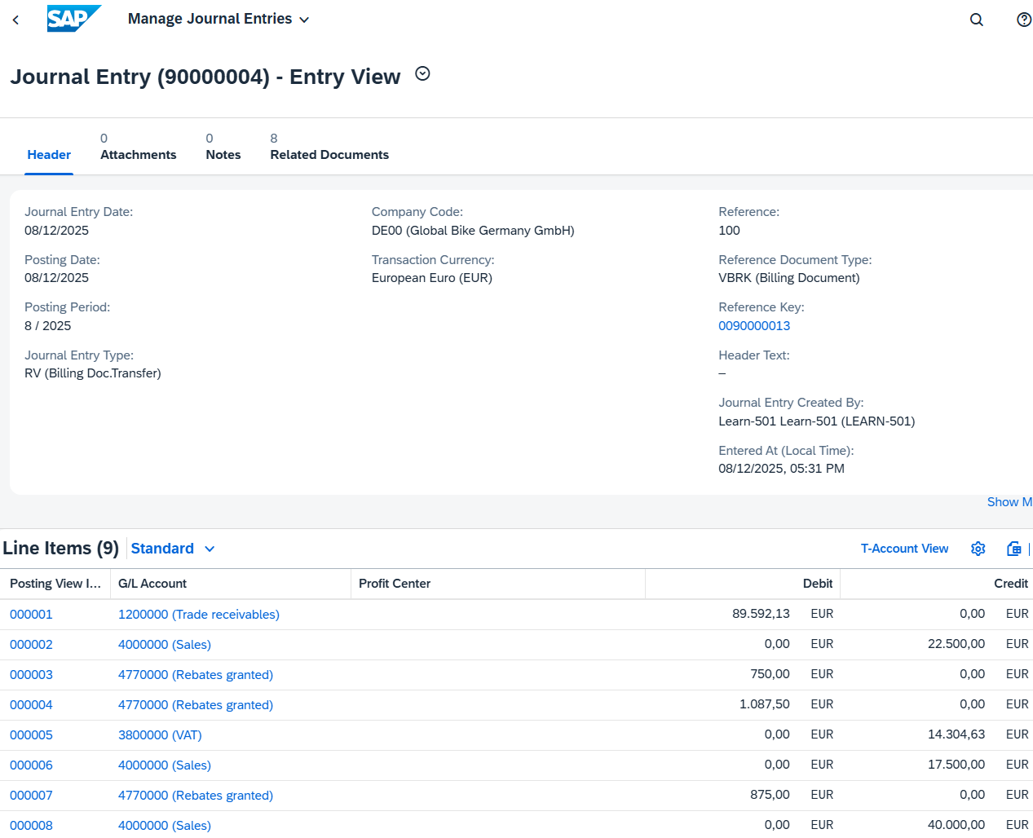
Switch to the Related Documents tab page. Then expand the document flow completely. |  | Related Documents
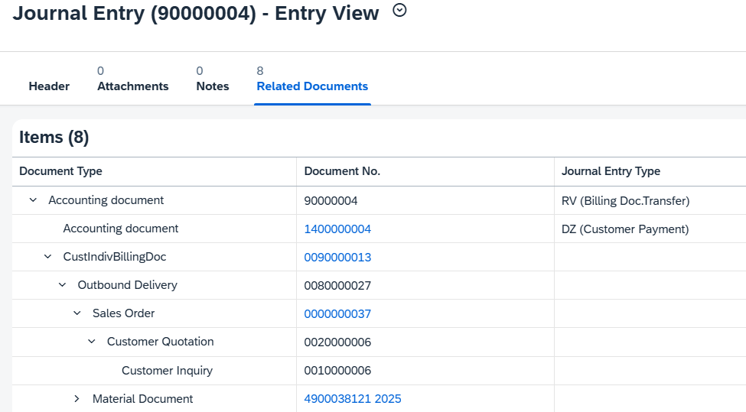
With the exception of the incoming payment, you can see all documents generated for the sales order. This also includes the sales inquiry and the material document including the accounting document of the outbound delivery.
Click the document number of the sales order to open the context menu. Click and in the dialog box that opens, select the Display Document Flow app.
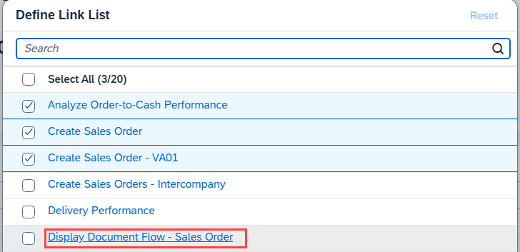
On the following screen, you can see both the operational document flow and the general ledger document flow.
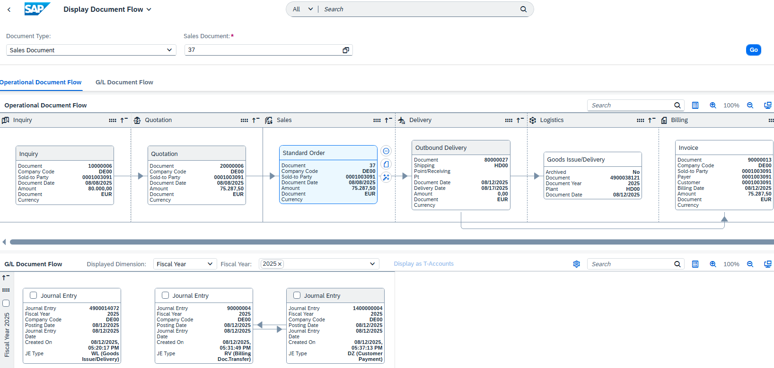
Also display the document flow for production order GCBK1### once. To do this, change the document type to Production Order and enter your production order number.
Since you have partially confirmed your production order for material GCBK1### once and finally confirmed once, two journal entries have been created here and a goods issue has also been posted twice. Another journal entry was created by the goods receipt in the finished goods warehouse.
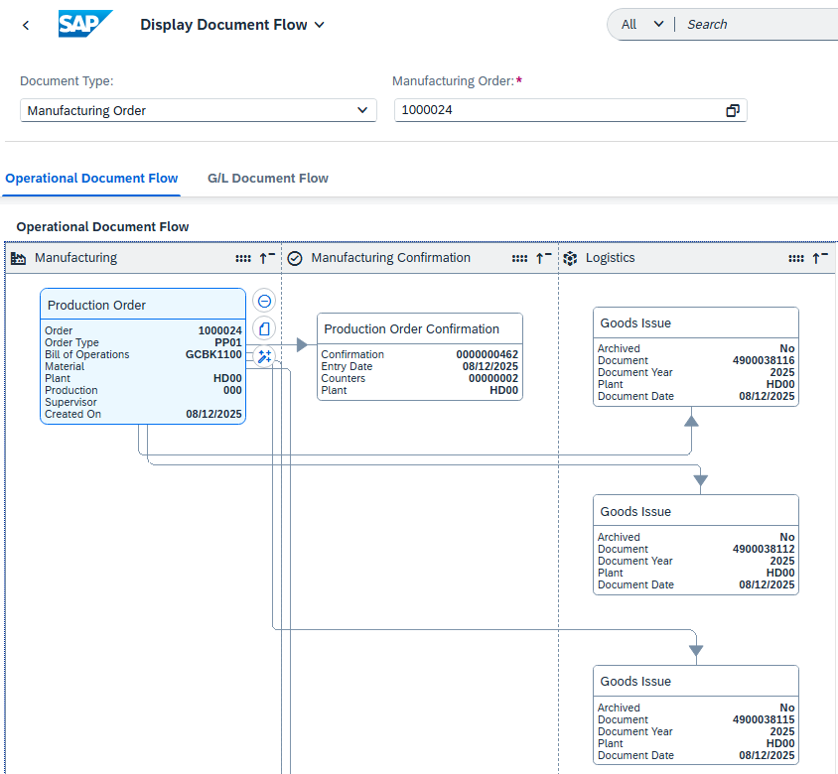
Also display the document flow for production order GCBK3### once.
You will notice that this production order is linked to the sales order and that there are links between the sales order and the production order in each journal entry.
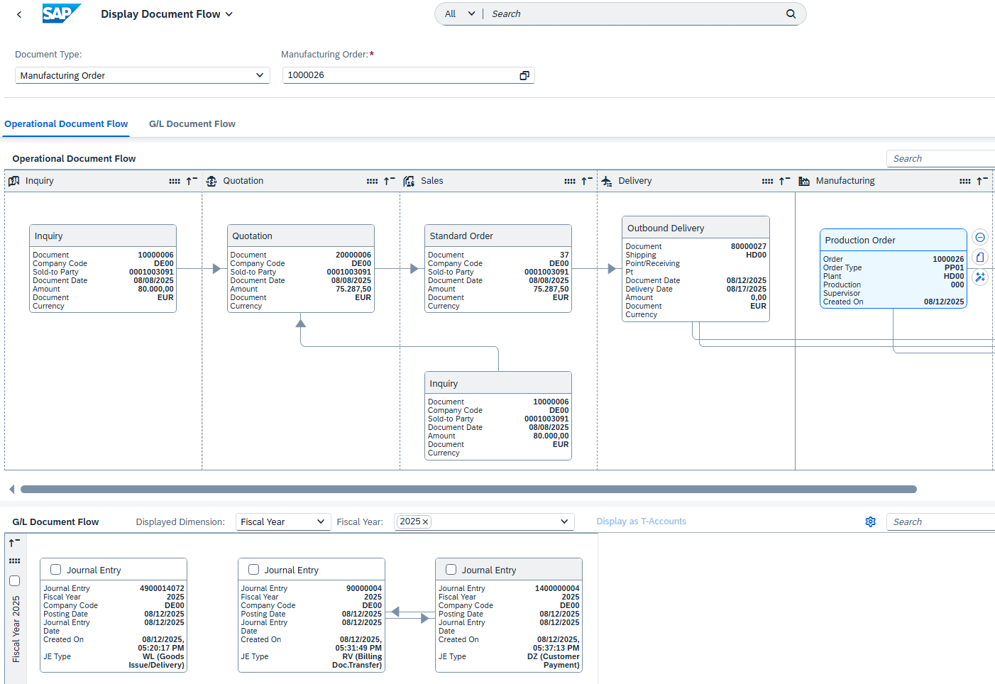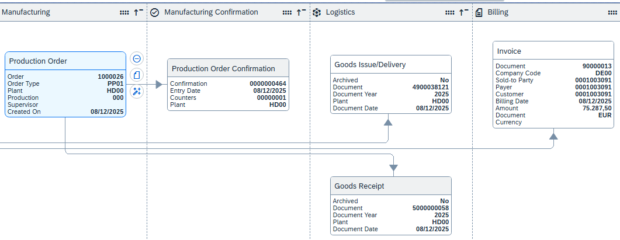
Click the invoice and then click (Details).
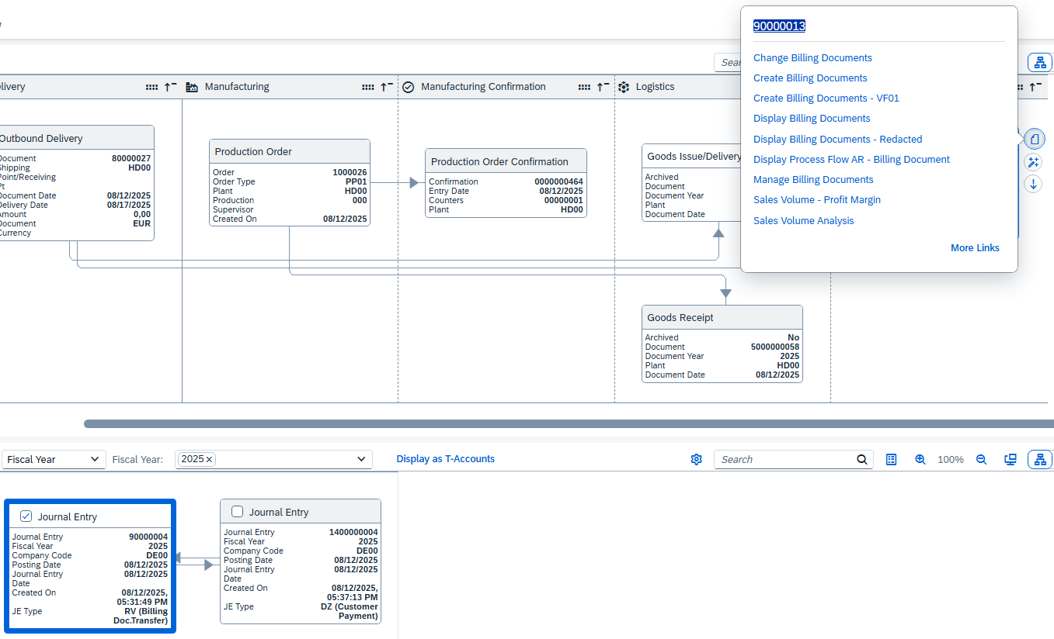
In the dialog box that appears, choose the Display Billing Documents app.
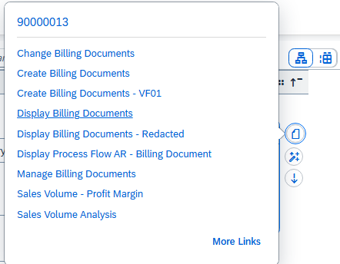
Scroll to the right in the table of your invoice. You will find that the initiator for the invoice item of your GCBK3### is the sales order.
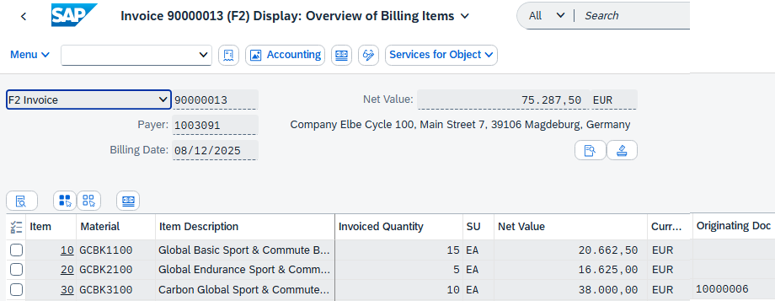
Call the Display Document Flow app again. |  | Display Document Run
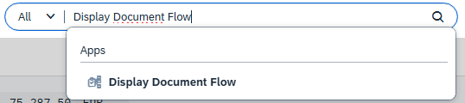
Also display the document flow for the purchase requisition for your bike computers. To do this, change the document type to Purchase Requisition and enter your purchase requisition number.
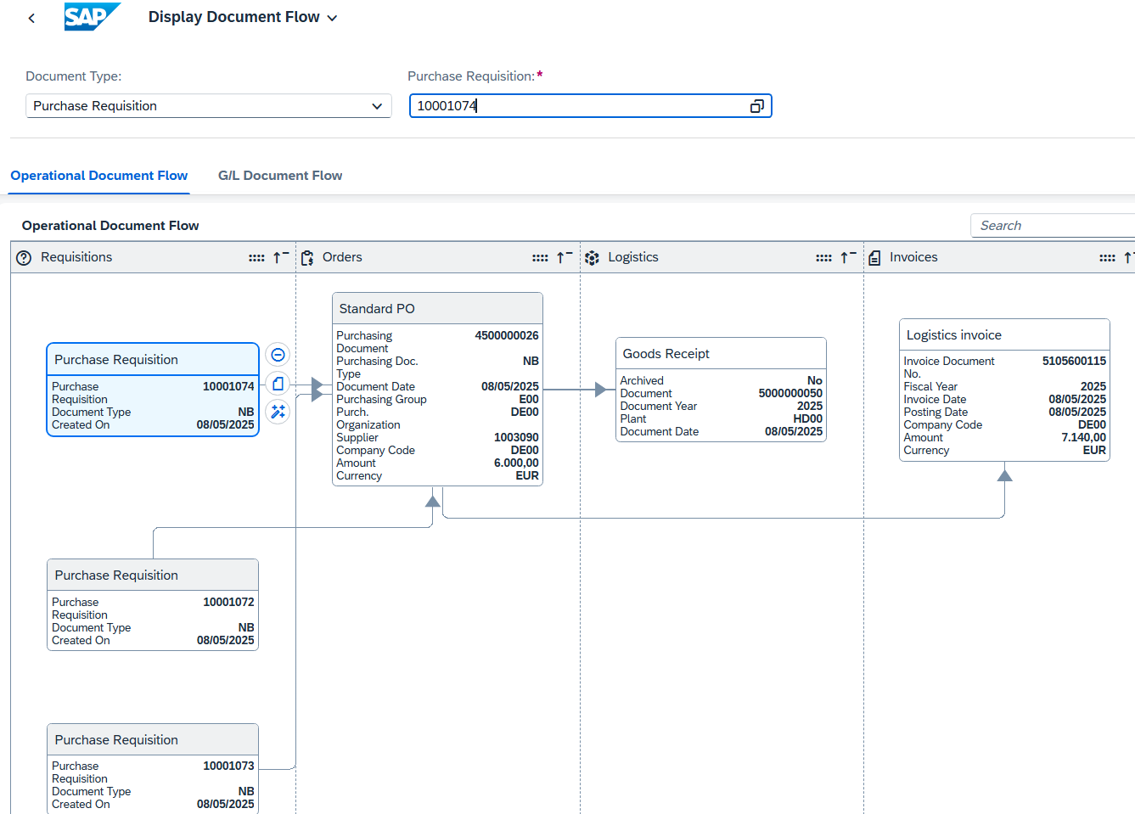
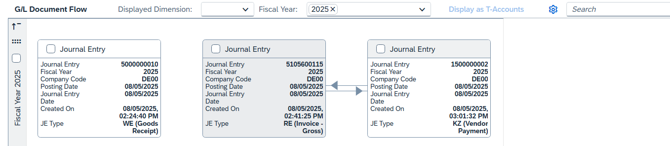
Click to return to the SAP Fiori launchpad.

