Global Bike Go (Beta)
General Instruction
This document is intended to support the instructors managing Global Bike Go. The main focus lies on admin user interface and the general game structure.

Product  SAP S/4HANA 2022  Global Bike  Fiori 3.0  Level  Instructor  Focus  General Instruction  Author  Robert Häusler  Version  4.2  Last Update  August 2023 | MOTIVATION  The learning objectives of these business games are to understand simple (business) mechanisms and to make decisions in the areas of procurement, production and sales. Gamification elements are used to improve user engagement and learning success.  The main objective of this document is to support instructors managing Global Bike Go. Particularly, the admin user interface is explained and the general game structure is depicted. In addition, important functions as well as information for both game master and players are described. |  | NOTES  Global Bike Go (Beta) is only available for the Global Bike data set, which has exclusively been created for SAP UA global curricula.

Quickstart Guide
Note The following simple description can be used as a short introduction to Global Bike Go. Nevertheless, it is recommended to read all lecturer notes once to get the necessary background knowledge.
Game Master: Open „Global Bike Go – Admin Cockpit“ app
Login to the SAP system (Fiori Launchpad) by using one of the game master users (e.g. TEACH-###). Navigate to the Apps for Lecturers page and open the Global Bike Go app to get into the admin user interface (browser based).
Game Master: Add course and create new game
Choose the button at the top of the screen to add a new course (including description and number of companies). Thus, you can create any Explore Module for this course.
Game Master: Explain the procedure for the players
As soon as the first game is initialized, player user accounts are created. All necessary information for them (Company ID, Username, Initial Password) can be displayed in the “Company” tab. The players can use the generated user and the initial password to login to the SAP system (Fiori Launchpad). By opening the respective app, they will get to the player user interface. In the detail view, the players have the possibility to set input values and display their results.
Player: Set input values
In the first tab, players can set the input values for the next round. They will get a success message after saving. The players will be able to change the input values multiple times. The last saved ones will be used during the simulation.
Game Master: Simulate round
When all players have set their input values, you can simulate the next round by using the button in the bottom of your browser window. The results will be generated and can be reviewed in the respective tabs.

Game Structure of Global Bike Go
Note The following chapter is used to depict and describe the general game structure of Global Bike Go.
Process figure
The following simplified process illustration shows the structure of any Explore Module.
Process description
As soon as the game master adds a new course and determines the number of competing companies, player user accounts will be automatically generated by the system. The general structure of a round is the following: Players will set their input values, the game master simulates a round and afterwards the players can display their result of the generated round. After any number of simulated rounds, the game master can finish the game.

Perform Prerequisites
Note The following steps need to be performed, if you want to administer Global Bike Go with a user other than TEACH-###.
Assign roles
In case the game master is using one of the TEACH-### users, no changes to the assigned roles need to be performed. However, if the game master is using a different user, several roles need to be added.
Apps for Lecturers User Maintenance (Single User) > select the corresponding user press Change select Roles tab
Assign the following roles and save your changes.
- Z_S4HANA_LECTURE_UCCMD_FIORI
to activate the „Apps for Lecturers“ page
- ZUCC_GO_ADMIN
to access and use the Admin Cockpit
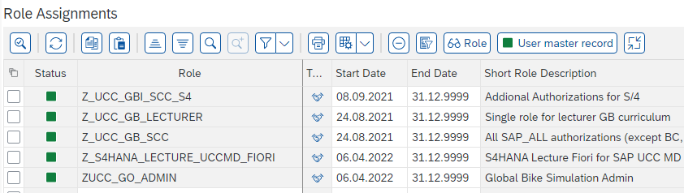
Create player user accounts
Player user accounts will be automatically generated after initialization of the course. No further preparations are needed for the setup of the player user accounts. Any users, which were created through this process, can only access the three Global Bike Go apps to open the player user interface.
Open „Global Bike Go – Admin Cockpit“ app
In order to create and administer courses as well as games, you have to open the Global Bike Go – Admin Cockpit app within the Apps for Lecturers page of the Fiori Launchpad. After successfully starting the app, you will get to the admin user interface (Course Overview).

Administer Courses and Games
Note Perform the following steps to add a new course, create a new game or continue an existing one.
Add course
After successfully starting the “Global Bike Go – Admin Cockpit” app, you will get to the admin user interface (Course Overview).
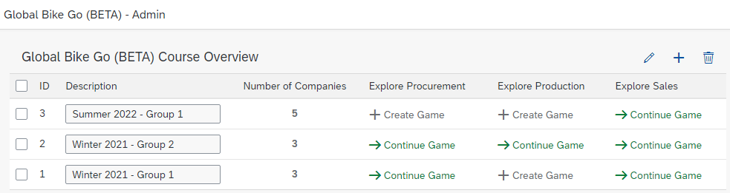
Choose the button at the top of the screen to add a new course. In the following screen, enter a description and specify the number of participating companies. An example can be found in the following screenshot.
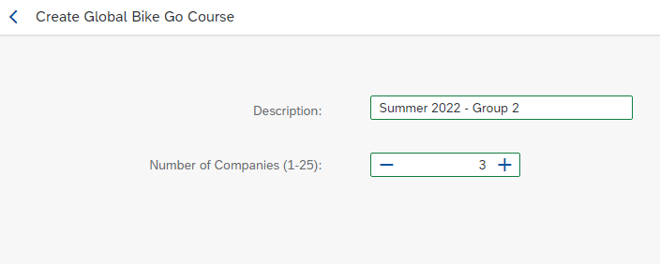
Complete this process with a click on the button . As soon as the course has been successfully added, you will return to the course overview. Afterwards, you can start any Explore Module for the course you have created.
Edit course(s)
You can switch to the change mode by selecting the button . Now you can edit the course descriptions. Save your changes by clicking the corresponding button at the bottom of the screen.
Create new game / Explore Module
In order to create a new game or an Explore Module for your course, select the corresponding button . Use this step of the General Instruction as a starting point to the other lecturer notes (of the Explore Modules) to familiarize yourself with the respective game parameters. You can find the documents for Explore Procurement, Explore Production and Explore Sales within the same folder.
Continue selected game
If you want to resume a game that has already been created and played, select the appropriate button . You will be redirected to the details screen of this game.
Delete selected course(s)
If you want to delete a course, select it using the checkbox and click on the button at the top of the screen. By deleting a course, all game data will also be lost. Therefore, please make sure to select the correct courses. A recovery is not possible for technical reasons.

Procedure for the Players
Note This section describes the necessary steps to play the game, from a player’s perspective.
Login to the SAP system (Fiori Launchpad)
As soon as the first game is initialized, player user accounts are created. All necessary information (Company ID, Username, Initial Password) can be looked up in the “Company” tab.
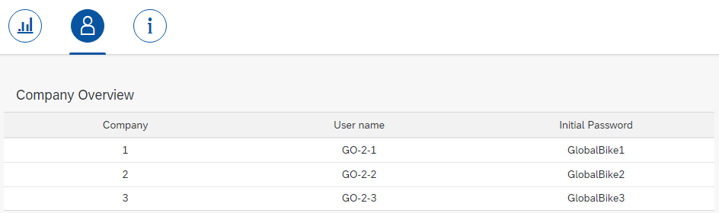
Please distribute the credentials. Players have to use the generated user and the initial password to log in the SAP system (Fiori Launchpad). There will be a prompt, which requests them to change their password.
Make sure that the groups really use the GO-#-## users. Otherwise, the players will not be able to participate in the game. If, for example, the browser has already saved the login data of a LEARN user, the players may have to open an incognito window or use another browser.
Open “Global Bike Go” app
After successfully logging in to the Fiori Launchpad, players will see the following screen.
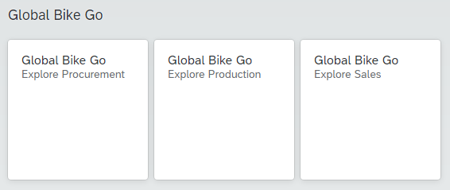
By opening any app, the players will get to the respective player user interface. In the detail view, the players have the possibility to set input values and display their results. Module-specific information on the input values can be found in the lecturer notes of the respective Explore Module.
Set input values
In the first tab of the respective app, players can set the input values for the next round. They will get a success message after saving. The players will be able to change the input values multiple times. The last saved ones will be used during the simulation.
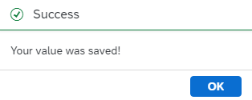
Display results of the simulated round
In the second tab, the players can display the results of the simulated round. After successfully completing the simulation, they have to use the refresh button of the browser.

Simulate Next Month
Note Perform this step to simulate a new round. Please make sure that all players have set their input values.
When all players have set their input values, you can simulate the next round by using the button in the bottom of your browser window. The results will be generated, displayed grouped by month and can be reviewed in the respective tabs.
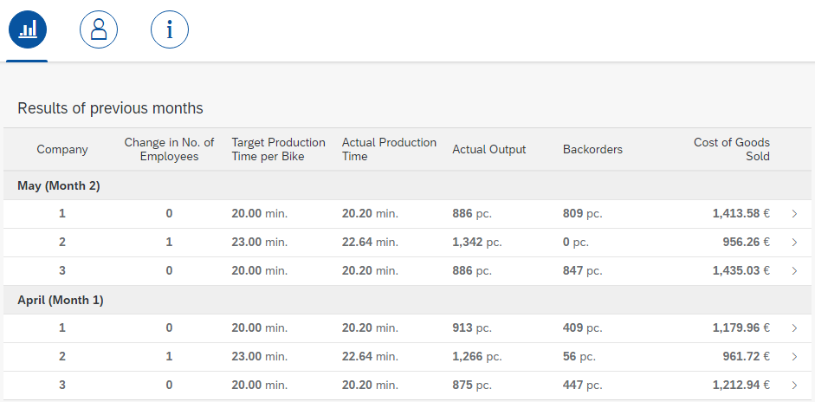

[OPTIONAL] Play Global Bike Go on your own (without involvement of any learner)
Note This optional step describes how Global Bike Go can be played on your own (without the involvement of any learner). This is useful to test all functionalities in preparation for the lecture use.
Usage of both user interfaces (admin and player)
To test all functionalities for the game master and player, both interfaces have to be opened. For the first login (e.g. as game master), your login data will be cached by the browser. That is the reason why there is no additional login (e.g. as player) possible in the same browser session. In order to test both interfaces (admin and player) at the same time, please use another browser or rather use the private mode of your standard browser.
Therefore, login to the SAP system (Fiori Launchpad). Open the “Global Bike Go – Admin Cockpit” app to go to the game master interface. There you can create a test course including test games.
Note When creating a game for the first time, the necessary programs (transactions) within the system will be compiled. This could take a few minutes.
Create another session for the Fiori Launchpad using the suggestions above. However, this time log in with a player user (see example credentials below).
Test: Enter input values and simulate rounds
On the one hand, please use the player interface to set the different input values. On the other hand, use the admin interface to simulate some test rounds. For this, refer to the instructions above.

