## MM

1. Which of the following three processes describes the process of purchasing? (To increase the size of the picture, click on the particular picture)
   1. Picture 1.
   2. Picture 2.
   3. Picture 3. (correct)
2. Movement Type 101 describes…
   1. The goods receipt for purchase order. (correct)
   2. The returns for purchase order.
   3. The return deliveries to vendor.
3. Which one of the following steps takes place at the beginning of the purchasing process?
   1. Display Stock/Requirements List. (correct)
   2. Create Request for Quotation.
   3. Display Purchase Order.
4. Which of the following steps is part of the module FI in purchasing process?
   1. Create new Vendor.
   2. Create Invoice Receipt from Vendor. (correct)
   3. Evaluate Quotations on Price.
5. Where are vendors utilized?
   1. FI.
   2. Purchase.
   3. FI and Purchase. (correct)
6. A request for quotation is legally binding.
   1. True.
   2. False. (correct)
7. Which of the following statements is correct?
   1. Goods shall remain the property of the supplier until complete payment. (correct)
   2. After delivery, ownership always passes on to the costumer.
   3. Both statements are wrong.

Picture 1:

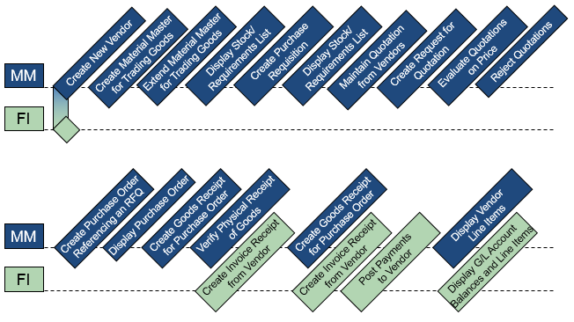

Picture 2:

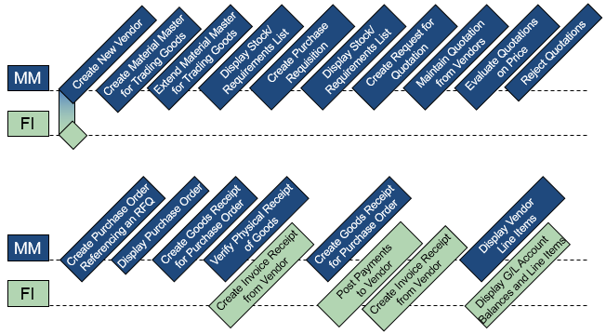

Picture 3:

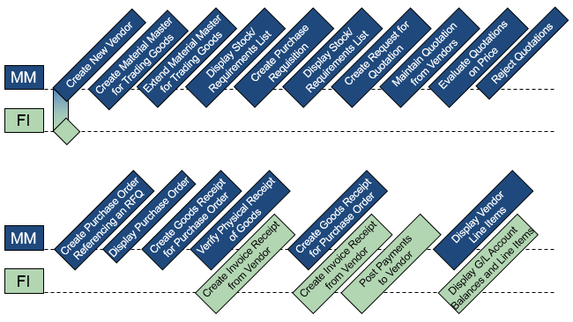

SD

1. Which of the following three processes describes a customer order? (To increase the size of the picture, click on the particular picture)
   1. Picture 1.
   2. Picture 2.
   3. Picture 3. (correct)
2. Which of the following processes happens in the module distribution in business process customer order? If you don’t know the answer, take a look at the graphic from the case study again.
   1. Create Invoice for Customers.
   2. Post Goods Issue.
   3. Create Customer Inquiry. (correct)
3. Which one of the following processes takes place in the business process customer order at the beginning?
   1. Pick Materials On Delivery Note.
   2. Create Customer Quotation.
   3. Create Customer Inquiry.
4. Are customer numbers clearly assigned for every customer in an SAP system?
   1. Yes. (correct)
   2. No.
5. Is a request for quotation legally binding?
   1. Yes, a request for quotation is legally binding.
   2. No, a request for quotation is not legally binding.
6. Every material out of the stock is in unrestricted use.
   1. False. (correct)
   2. True.
7. The stock subsides with the picking of a material.
   1. True.
   2. False.
8. Customers are …
   1. Debtors of deliveries and services. (correct)
   2. Creditors of accounts receivable trade.
9. Vendors are…
   1. Creditors of accounts receivable trade. (correct)
   2. Debtors of deliveries and services.
10. Which of the following components is not part of a sales document?
    1. Document header.
    2. Document feed. (correct)
    3. Document items.
11. The document header consists of data…
    1. That is valid for the complete sales document. (correct)
    2. Of the individual goods that are listed in the sales document.
12. The purchase order number and the document number are generated automatically while compiling the document.
    1. True.
    2. False. (correct)
13. Which one of these two is generated automatically?
    1. Purchase order number.
    2. Document number. (correct)
14. Which of the following can be the cause of picking?
    1. Costumer orders.
    2. Production orders.
    3. Costumer and production orders. (correct)
15. Deliveries can only be picked completely.
    1. True.
    2. False. (correct)
16. Customer master data are entertaining data.
    1. True.
    2. False. (correct)

Picture 1:

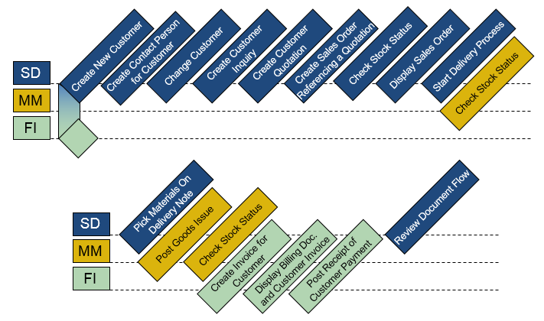

Picture 2:

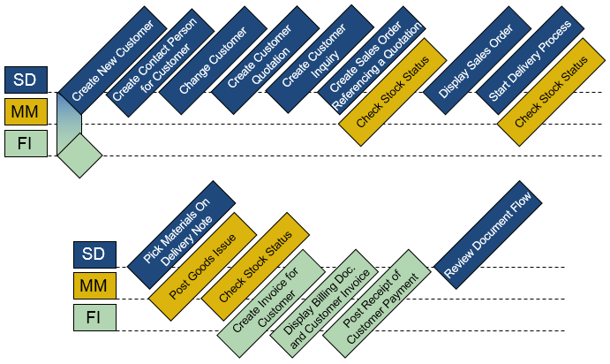

Picture 3:

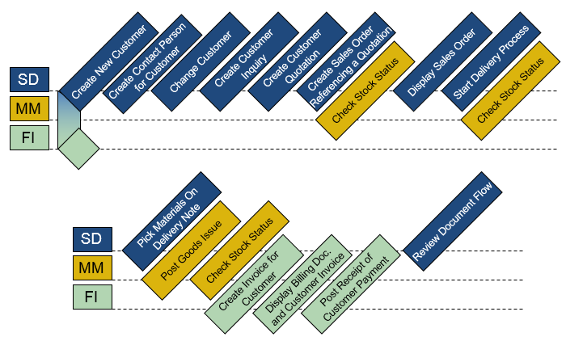

# CO

1. Cost centers are organizational units, in which costs occur.
   1. True. (correct)
   2. False.
2. Which of the following statements is true?
   1. Primary cost types are used to establish links between FI and CO and enable the exchange of information between financial accounting and controllers. (correct)
   2. Primary cost types are exclusively for internal accounting.
3. Which of the following statements is true?
   1. Secondary cost types are used to distribute and / or allocate expenses.
   2. Secondary cost types allocate costs to the respective polluters, exclusively within the controlling.
   3. Both statements are true. (correct)
4. Cost categories facilitate work with primary account types only.
   1. True.
   2. False. (correct) (secondary account types as well)
5. Fixed assets, balance sheet accounts and material accounts are …
   1. G/L account types.
   2. Account groups. (correct)
6. Which of the following is no type of G/L account?
   1. Secondary costs.
   2. Non-operating profit and expenses.
   3. Reconciliation accounts. (correct)
7. Which of the following three processes describes a process in product cost controlling? (To increase the size of the picture, click on the particular picture.)
   1. Picture 1.
   2. Picture 2. (correct)
   3. Picture 3.
8. Which of the following two statements is true?
   1. In product cost controlling, the production costs and the prime costs per unit are calculated. (correct)
   2. Production costs must be calculated manually using the BOM and the work plan. (Automatically calculated using the BOM and workflows from production planning)
9. Using price updating, the result of the product costing is transferred to the material master record.
   1. True. (correct)
   2. False.
10. Which of the following three processes describes a cost center accounting process? (To increase the size of the picture, click on the particular picture).
    1. Picture 1. (correct)
    2. Picture 2.
    3. Picture 3.
11. Which of the following three processes takes place at the beginning of a cost center accounting process?
    1. Create activity type
    2. Create cost center
    3. Examine effects price determination
12. The cost center represents an organizational unit within a costing area and specifies a set of locations for cost incurrence.
    1. True.
    2. False. (correct) (…specifies a well-defined place of cost incurrence.)
13. The differentiation of cost centers occurs only spatially.
    1. True.
    2. False. (correct) (Functional, billing related, spatially or according to cost responsibility)
14. Internal cost and performance flows are always billed using secondary cost elements in the SAP ERP system.
    1. True. (correct)
    2. False.
15. A cost type classifies the purpose-driven and rated consumption of production factors within a costing area.
    1. True. (correct)
    2. False.
16. Activity types are organizational units within the controlling area, which classify the performance of the cost center.
    1. True. (correct)
    2. False.

# EAM

1. Inventories with a mobile character are defined as a technical place in the SAP system.
   1. True.
   2. False. (correct) (Inventory with mobile character is defined as equipment in the SAP system.)
2. Equipment is generally assigned to a technical location, which itself has an immobile character.
   1. True. (correct)
   2. False.
3. Which of the following three processes describes an integrated maintenance process? (To increase the size of the picture, click on the particular picture.)
   1. Picture 1.
   2. Picture 2.
   3. Picture 3. (correct)
4. Workload and operation duration are used as synonyms.
   1. True.
   2. False. (correct)
5. Which of the following tasks takes place at the beginning of an integrated maintenance process?
   1. Feedback order.
   2. Create malfunction report. (correct)
   3. To settle the order.
6. The overall completion confirmation is used to maintain additional data in addition to the working time.

FI

1. Which of these two statements is true?
   1. Each company code must be assigned to a chart of accounts. (correct)
   2. Each chart of accounts must be assigned to a company code.
2. Which of the following statements is false?
   1. In the SAP System, postings in the subsidiary ledger are posted simultaneously in the general ledger.
   2. In the general ledger, reconciliation accounts are maintained for each secondary accounting.
   3. Totals from secondary accounting must be transferred to General Ledger Accounting before the balance sheet creation. (correct)
3. Which of the following three processes describes a process of external accounting? (To get a larger view, just click on the picture.)
   1. Picture 1. (correct)
   2. Picture 2.
   3. Picture 3.
4. Which of the following processes takes place at the beginning of a process of external accounting?
   1. Create a bank account in the general ledger. (correct)
   2. Create balance sheet/ P&L.
   3. Post payment to tenants.
5. Which of the following statements takes place at the end of a process of external accounting?
   1. Create the reconciliation account in the general ledger.
   2. Invoice for rental expenses.
   3. Create balance sheet/ P&L. (correct)
6. Reconciliation accounts connect the general ledger with the subsidiary ledger, which are maintained, for example, for customers and vendors.
   1. True. (correct)
   2. False.
7. The reconciliation account is posted directly.
   1. True.
   2. False. (correct)
8. A vendor master record is the diverting data of the vendor.
   1. True.
   2. False. (correct)

HCM

1. To which organizational structure belong the objects post and individuals?
   1. Corporate structure.
   2. Personnel structure
   3. Structural organization. (correct)
2. Which element is not part of the corporate structure?
   1. Personell subarea.
   2. Human resources.
   3. Employee class. (correct) (belongs to the personnel structure)
3. Which of the following three processes describes the recruitment process? (To get a larger view, just click on the particular picture.)
   1. Picture 1.
   2. Picture 2. (correct)
   3. Picture 3.
4. Which of the following processes takes place at the beginning of a recruitment process?
   1. Recruit employee.
   2. Create post.
   3. Set requirement.
5. Posts are filled by…
   1. Machines.
   2. Employees. (correct)
   3. Machines and employees.
6. A post is vacant if it is occupied.
   1. True.
   2. False. (correct)
7. A tender number is always assigned manually.
   1. True.
   2. False.
8. Career planning consists of all the posts, which an employee could theoretically occupy.
   1. True. (correct)
   2. False.

NAV

1. From an organizational point of view, which unit represents the client in a SAP System?
   1. The highest unit. (correct)
   2. The middle unit. (correct)
   3. The lowest unit. (correct)
2. The displayed menus are in the menu bar are…
   1. Action and transaction-dependent. (correct)
   2. Action and transaction-independent.
3. How can transactions can be called up in the SAP System?
   1. Through the tree structure.
   2. Through transaction codes.
   3. Through the tree structure and transaction codes. (correct)
4. Transactions reflect operational processes.
   1. True. (correct)
   2. False.
5. The quickest possible access for transactions in the SAP System is

a) navigation through the tree structure.

b) the entry of transaction codes. (correct)

1. A key uniquely identifies a material, for example.
   1. True. (correct)
   2. False.

# PP

1. Which of the following components does not contain a BOM for a particular product?
   1. Description
   2. amount
   3. Unit of measure
   4. None of the answer options above is correct. (correct)
2. BOMs can only be displayed in variable lists.
   1. True.
   2. False. (correct) (*Piece List Hierarchical Graphic??)*
3. A work schedule is a series of successive operations carried out to produce a final product.
   1. True. (correct)
   2. False.
4. Work schedules only contain information about which steps have to be completed and the time allocated to the work process.
   1. True.
   2. False. (correct) (Also where the process is executed.)
5. Which of the following three processes describes the manufacturing process? (To get a larger view, just click on the particular picture.)
   1. Picture 1.
   2. Picture 2.
   3. Picture 3. (correct)
6. Which of the following processes takes place in the module PP in the integrated manufacturing process? If you do not know the answer, look at the graphic from the case study.
   1. Post goods issue for the production order.
   2. Display Costs Manufacturing order.
   3. Display programme planning. (correct)
7. Which of the following processes takes place in the integrated manufacturing process at the beginning?
   1. Display Production Order Status and subsequent documents.
   2. Create Sales and Production Planning (SOP). (correct)
   3. Display Programme Planning.
8. On which level of aggregation does a product group support planning?
   1. On the lowest.
   2. On the middle.
   3. On the highest.
9. Programme planning is the tool used to divide planning data from high-level plans to a detailed planning level.
   1. True. (correct)
   2. False.
10. What is the order in the manufacturing process?
    1. Convert a planned order to a production order.
    2. Convert a production order to a planned order.
11. What happens in an SAP system when a planned order is converted to a production order?
    1. Scheduling and reservation of material according to the BOM.
    2. Scheduling and availability check.
    3. Scheduling, availability check and reservation of material according to the BOM. (correct)

# PS

1. The project planning board is an interactive bar graph.
   1. True. (correct)
   2. False.
2. The project planning board is particularly suitable for…
   1. Scheduling.
   2. Resource planning.
   3. Scheduling and resource planning. (correct)
3. For automated scheduling of transactions ...
   1. Mainly the resources of the processes are important.
   2. Mainly the duration of the processes is important. (correct)
4. A WBS element describes ...
   1. A concrete task.
   2. A partial task.
   3. Either a concrete task or a partial task. (correct)
5. Milestones characterize …
   1. Completed project sections.
   2. Small project sections.
   3. Significant project sections. (correct)
6. What is not directly displayed in the structure overview?
   1. Earliest start of an element.
   2. Actual costs.
   3. Duration of an element. (correct)
7. Which of the following three processes describes integrated project planning? (To get a larger view, just click on the particular picture.)
   1. Picture 1. (correct)
   2. Picture 2.
   3. Picture 3.
8. The project structure and the network of a project are the same.
   1. True.
   2. False. (correct)
9. Each operation in the network has exactly one predecessor.
   1. True.
   2. False. (correct)
10. An operation in the network can have several successors.
    1. True. (correct)
    2. False.
11. Milestones fulfill tasks of pure information, but also have functional properties.
    1. True. (correct)
    2. False.
12. The release of subordinate WBS elements of the project structure releases all higher-level objects.
    1. True.
    2. False. (correct)
13. Using the WBS the project structure as well as dates, costs and revenues can be evaluated.
    1. True.
    2. False. (correct) (through the structure information system)
14. In the implementation phase, actual data is updated on the project.
    1. True. (correct)
    2. False.

# WM

1. Which of the following statements about a storage location in the SAP system is incorrect?
   1. A storage location is the smallest space unit in a warehouse.
   2. A storage location identifies the exact location within a warehouse where goods are stored.
   3. A storage location can no longer be divided into several sections. (correct)
2. A quant is used to identify the material stock of a particular category at a storage location.
   1. True. (correct)
   2. False.
3. Different materials (quants) cannot be stored in the same section.
   1. True.
   2. False. (correct)
4. Which of the following processes does not take place during the warehousing process with external goods in the Warehouse Management module?
   1. Create Transport Order
   2. View bin status report
   3. Goods Receipt
5. Stock transfers, dummy orders, and frame orders are order types.
   1. True. (correct)
   2. False.
6. An order is the same as a transfer order.
   1. Right. (correct) (Technically, you buy the goods from another plant, but it is a transport, since both are assigned to the same booking circle.)
   2. False.
7. Which of the following three processes describes a stock sale process? (To get a larger view, just click on the particular picture.)
   1. Picture 1.
   2. Picture 2. (correct)
   3. Picture 3.
8. The creation of a customer order reduces the stock of material in unrestricted use.
   1. True.
   2. False. (correct)
9. An activation of the inventory document leads to the blocking of all storage areas listed in the document in the following step.
   1. True. (correct)
   2. False.